**Social Media App (MERN)**

**Introduction:**

Tired of outdated social media? Introducing a revolutionary app that redefines connections. Seamless messaging, saved discoveries, and top-notch security - all in one place! Get ready to connect and explore like never before.

**Description:**

Introducing our revolutionary social media app! Designed to redefine online connections, our platform offers an intuitive and innovative space for seamless communication and engagement.

Break down barriers and enhance collaboration with real-time messaging. Whether you're sharing ideas, collaborating on projects, or simply having fun conversations, our messaging feature allows for seamless interaction and understanding.

Never miss a moment with our convenient post saving functionality. Capture important posts, articles, or inspiring content for later access and sharing with your followers. Your valuable discoveries are preserved, ensuring nothing gets lost in the vast social media landscape.

Your privacy and security are paramount. Our app employs robust encryption to safeguard your data, ensuring all communications remain confidential and protected from unauthorized access.

Step into a new era of online connections and communication. Discover the unmatched convenience of seamless messaging, in-app notifications, stories– all within our game-changing social media app. Connect, engage, and explore more together!

**Scenario based use case:**

Imagine you're a student working on a group project. You can use the app to:

* **Break down barriers and enhance collaboration:** Discuss ideas and project details seamlessly through real-time messaging. Brainstorm, share files, and delegate tasks all within the app.
* **Never miss a moment:** Find a fascinating research article online? Save it with the post saving functionality to easily reference it later and share it with your group for a collaborative understanding.
* **Your privacy and security are paramount:** No need to worry about information leaks. The app's robust encryption ensures your discussions and shared files stay confidential.

This is just one example! With its comprehensive features, the app empowers you to connect, engage, and explore effectively in any online interaction.

**Technical Architecture:**

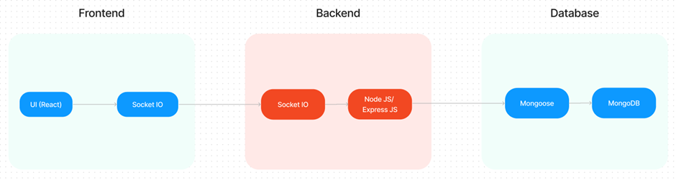

The technical architecture of our social media app follows a client-server model, with a REST API used for the initial client-server connection. The frontend serves as the client and incorporates socket.io-client for establishing real-time communication with the backend server. The backend utilizes socket.io and Express.js frameworks to handle server-side logic and facilitate real-time messaging, post uploading, story uploading, and more.

The frontend includes the user interface and presentation layer, as well as the socket.io-client for establishing a persistent socket connection with the server. This enables real-time bidirectional communication, allowing for instant updates and seamless interaction between users.

Authentication is handled through the REST API, which securely verifies user credentials and provides access tokens or session cookies for subsequent requests. Once authenticated, the client establishes a socket connection with the backend to enable real-time features.

Real-time messaging is facilitated through the socket.io library, enabling instant exchange of messages between users. Users can engage in chats with there friends, sharing text, emojis, images, etc., in real-time.

Uploading posts and stories is also supported through the socket connection. Users can create and upload posts or stories, including text, images, videos, or a combination of media. The server receives and processes these uploads, ensuring they are associated with the correct user and made available for other users to view and interact with in real-time.

The backend utilizes Express.js to handle the REST API endpoints, routing requests to the appropriate controllers and services. User data, including profiles, posts, stories, and other relevant information, is stored and retrieved from a database such as MongoDB, ensuring efficient storage and retrieval of data.

Together, the frontend, backend, REST API, socket.io, Express.js, and database (e.g., MongoDB) form a comprehensive technical architecture for our social media app. This architecture enables real-time messaging, seamless post and story uploading, authentication, and secure data storage, providing users with a dynamic and interactive social media experience.

**ER Diagram:**

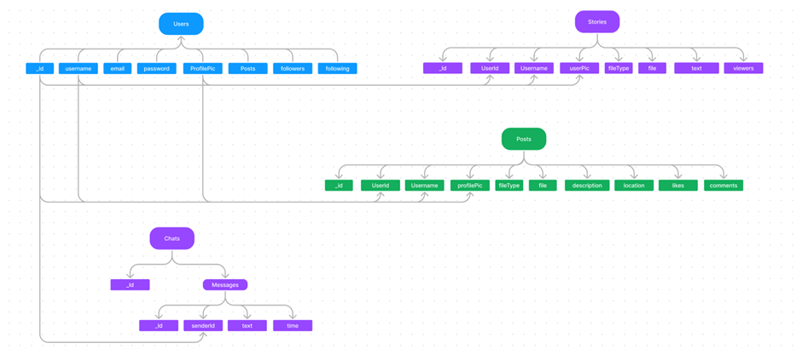

In our social media app, the ER diagram showcases entities such as users, posts, and interactions. It illustrates how these entities relate to each other, helping us understand the underlying database structure and the flow of information within the app.

The ER diagram represents the relationship between users and posts, highlighting how users can create, share, and interact with posts within the app. It also captures the relationships between users and their followers, indicating the ability for users to follow and be followed by others.

Additionally, the diagram represents interactions such as likes, comments, etc., showcasing how users can engage with posts and interact with each other's content. These interactions contribute to the overall user experience and social engagement within the app.

By visualizing the relationships between entities, the ER diagram helps us understand the overall structure of the database and the interconnectedness of different components within the social media app. It provides a valuable tool for designing and optimizing the app's functionality and data management.

**Key features:**

1. **Real-time Updates:** Stay up to date with the latest activities and posts from your connections. Receive instant notifications for likes, comments, and mentions, ensuring you never miss out on important interactions.

1. **Explore & Discover:** Explore a vast world of content and discover new ideas, trends, and communities. Engage with trending posts, discover new accounts, and connect with like-minded individuals.

1. **Messaging and Chat**: Engage in private conversations and group chats with friends and followers. Share messages, emojis, photos, and videos, fostering real-time communication and connection.

1. **Interactive Features**: Interact with posts through likes, comments, and shares. Express your thoughts, provide feedback, and engage in lively discussions with your network.

1. **Follow and Connect**: Follow your favourite accounts and connect with influencers, brands, and individuals who inspire you. Build a vibrant network of connections and discover new opportunities.

1. **Data privacy and Security**: We prioritize the protection of your personal information and data. Our app employs robust security measures, ensuring that your interactions, posts, and personal details remain secure and confidential.

These key features collectively enhance your social media experience, providing a dynamic and interactive platform for real-time communication, discovery, and connection with others.

**PRE-REQUISITES**:

Here are the key prerequisites for developing a full-stack application using Node.js, Express.js, MongoDB, React.js, Socket.io:

1. **Node.js and npm**:

Node.js is a powerful JavaScript runtime environment that allows you to run JavaScript code on the server-side. It provides a scalable and efficient platform for building network applications.

Install Node.js and npm on your development machine, as they are required to run JavaScript on the server-side.

* Download: <https://nodejs.org/en/download/>
* Installation instructions: <https://nodejs.org/en/download/package-manager/>

1. **Express.js**:

Express.js is a fast and minimalist web application framework for Node.js. It simplifies the process of creating robust APIs and web applications, offering features like routing, middleware support, and modular architecture. Install Express.js, a web application framework for Node.js, which handles server-side routing, middleware, and API development.

Installation: Open your command prompt or terminal and run the following command:

**npm install express**

1. **MongoDB**:

MongoDB is a flexible and scalable NoSQL database that stores data in a JSON-like format. It provides high performance, horizontal scalability, and seamless integration with Node.js, making it ideal for handling large amounts of structured and unstructured data.

Set up a MongoDB database to store your application's data.

* Download: <https://www.mongodb.com/try/download/community>
* Installation instructions: <https://docs.mongodb.com/manual/installation/>

1. **React.js**:

React.js is a popular JavaScript library for building user interfaces. It enables developers to create interactive and reusable UI components, making it easier to build dynamic and responsive web applications.

Install React.js, a JavaScript library for building user interfaces.

Follow the installation guide: <https://reactjs.org/docs/create-a-new-react-app.html>

1. **Socket.io**:

Socket.io is a real-time bidirectional communication library that enables seamless communication between the server and clients. It allows for real-time data exchange, event-based messaging, and facilitates the development of real-time applications such as chat, collaboration, and gaming platforms.

Install Socket.io, a real-time bidirectional communication library for web applications.

Installation:

* Open your command prompt or terminal of server and run the following command: **npm install socket.io**
* Open your command prompt or terminal of client and run the following command: **npm install socket.io-client**

1. **HTML, CSS, and JavaScript**: Basic knowledge of HTML for creating the structure of your app, CSS for styling, and JavaScript for client-side interactivity is essential.

1. **Database Connectivity**: Use a MongoDB driver or an Object-Document Mapping (ODM) library like Mongoose to connect your Node.js server with the MongoDB database and perform CRUD (Create, Read, Update, Delete) operations. To Connect the Database with Node JS go through the below provided link:

• [https://www.section.io/engineering-education/nodejs- mongoosejs-mongodb/](https://www.section.io/engineering-education/nodejs-%20mongoosejs-mongodb/)

1. **Front-end Framework**: Utilize Angular to build the user-facing part of the application, including products listings, booking forms, and user interfaces for the admin dashboard.

1. **Version Control**: Use Git for version control, enabling collaboration and tracking changes throughout the development process. Platforms like GitHub or Bitbucket can host your repository.

• Git: Download and installation instructions can be found at: <https://git-scm.com/downloads>

1. **Development Environment**: Choose a code editor or Integrated Development Environment (IDE) that suits your preferences, such as Visual Studio Code, Sublime Text, or WebStorm.

• Visual Studio Code: Download from <https://code.visualstudio.com/download>

• Sublime Text: Download from <https://www.sublimetext.com/download>

• WebStorm: Download from [https://www.jetbrains.com/webstorm/download](https://www.jetbrains.com/webstorm/download%20)

To run the existing Social media App project downloaded from google drive:

Firstly, download the code from the google drive link provided below

<https://drive.google.com/drive/folders/1y9OI8R3OHP7KwYv-c91JNrD-ZQ--ZqC6?usp=sharing>

**Install Dependencies:**

• Navigate into the cloned repository directory:

**cd SocialeX**

• Install the required dependencies by running the following commands:

**cd client**

**npm install**

**cd ../server**

**npm install**

1. **Start the Development Server**:

• To start the development server, execute the following command:

**npm start**

• The video conference app will be accessible at http://localhost:3000

1. **Access the App:**

• Open your web browser and navigate to [http://localhost:3000](http://localhost:3000/).

• You should see the video conference app's homepage, indicating that the installation and setup were successful.

You have successfully installed and set up the social media app on your local machine. You can now proceed with further customization, development, and testing as needed.

**Project structure:**

* Inside the SocialeX (social media app) directory, we have the following folders
* 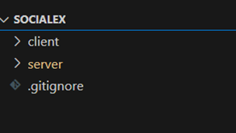
* **Client directory:**

The below directory structure represents the directories and files in the client folder (front end) where, react Js is used along with Api’s such as socket.io.

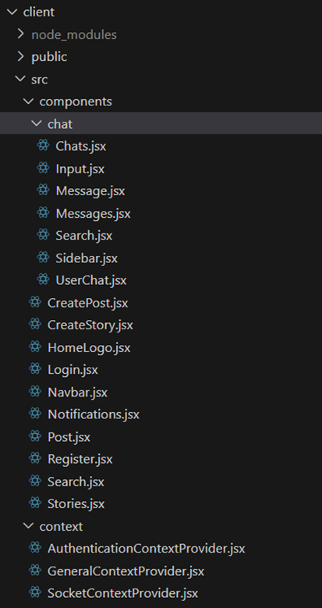

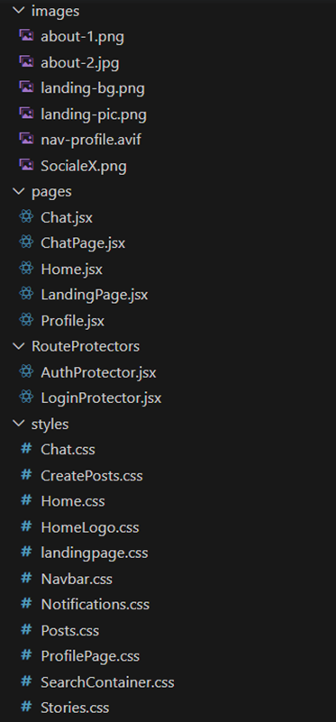

* **Server directory:**

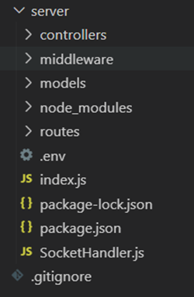

The below directory structure represents the directories and files in the server folder (back end) where, node js, express js and mongodb are used along with socket.io.

**Application flow:**

**User:**

1. Create and manage a personal profile.
2. Share posts, photos, videos, and stories with their network.
3. Engage in conversations through comments, likes, and shares.
4. Follow other users and discover new accounts, topics, and trends.
5. Explore and discover new content, communities, and opportunities.
6. Interact with notifications and stay updated with the activities of their connections.
7. Utilize messaging and chat features to communicate with friends and followers.

**Project Flow:**

**Project demo:**

Before starting to work on this project, let’s see the demo.

Demo link:

https://drive.google.com/file/d/1JTXiS-r3wDOiIHKfQ241QayrrwVvwwTU/view?usp=sharing

Use the code in:

https://drive.google.com/drive/folders/1lp7H_E7WtRE6e7ElAhIH4-EfHTBsszbP?usp=sharing

**Milestone 1: Project setup and configuration.**

* **Folder setup**:

## Now, firstly create the folders for frontend and backend to write the respective code and install the essential libraries.

* + Client folders.
  + Server folders

* **Installation of required tools**:

Open the frontend folder to install necessary tools. For frontend (client), we use:

|  |  |
| --- | --- |
| Tools/libraries | Installation command |
| React Js | npx create-react-app . |
| Socket.io-client | npm install socket.io-client |
| Bootstrap | npm install bootstrap |
| Axios | npm install axios |
| Firebase | npm install firebase |
| uuid | npm install uuid |

Open the backend folder to install necessary tools. For backend (server), we use:

|  |  |
| --- | --- |
| Tools/libraries | Installation command |
| Express Js | npm install express |
| Mongoose | npm install mongoose |
| Bcrypt | npm install bcrypt |
| Body-parser | npm install body-parser |
| Cors | npm install cors |
| Dotenv | npm install dotenv |
| Http | npm install http |
| Socket.io | npm install socket.io |

**Milestone 2: Backend development**

#### Set Up Project Structure:

* Create a new directory for your project and set up a package.json file using npm initcommand.
* Install necessary dependencies such as Express.js, Mongoose, and other required packages.

#### Set Up Project Structure:

* + Create a new directory for your project and set up a package.json file using npm init command.
  + Install necessary dependencies such as Express.js, Mongoose, and other required packages.

#### Create Express.js Server:

* + Set up anExpress.js server to handle HTTP requests and serve API endpoints.
  + Configure middleware such as body-parser for parsing request bodies and cors for handling cross-origin requests.

#### Define API Routes:

* + Create separateroute files for different API functionalities such as authentication, create post, upload stories, chats, etc.,
  + Implement route handlers using Express.js to handle requests and interact with the database.

#### Implement Data Models:

* + Define Mongoose schemas for the different data entities like posts, chats, users, etc.,
  + Create corresponding Mongoose models to interactwith the MongoDB database.
  + Implement CRUD operations (Create, Read, Update, Delete) for each model to performdatabase operations.

#### User Authentication:

* + Implement user authentication using strategies like JSON Web Tokens (JWT) or session-based authentication.
  + Create routes and middleware for user registration, login,and logout.
  + Set up authentication middleware to protect routesthat require user authentication.

#### Handle new chats and posts:

* + Allow users to chat with other users using the userId.
  + Also the users will make the posts on social timeline.

#### Error Handling:

* + Implement error handling middleware to catch and handle any errors that occur duringthe API requests.
  + Return appropriate error responses with relevant error messages and HTTP status codes.

Reference video for backend code:

<https://drive.google.com/file/d/19J2FH9sfmXMEcgdLhxZQjgoXPMPnU3BB/view?usp=sharing>

**Milestone 3: Database development:**

* Set up a MongoDB database either locally or using a cloud-based MongoDB service like MongoDB Atlas.
* Create a database and define the necessary collections for users, posts, stories, chats, etc.,

The code for the database connection to the server is

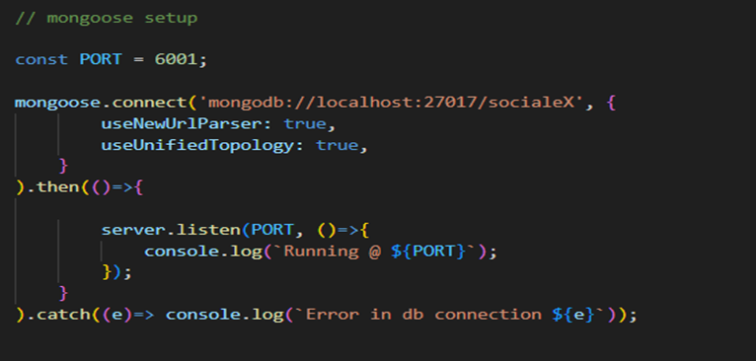

The code for the schemas in the database is provided below

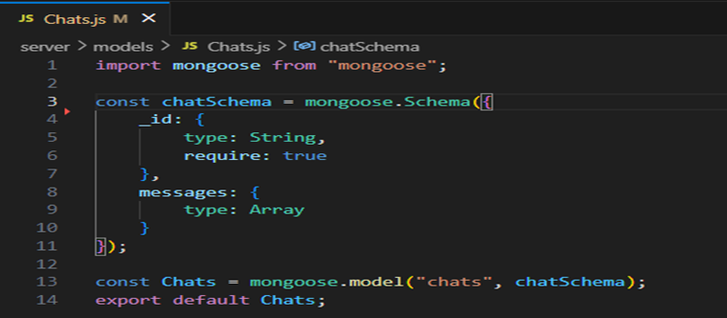

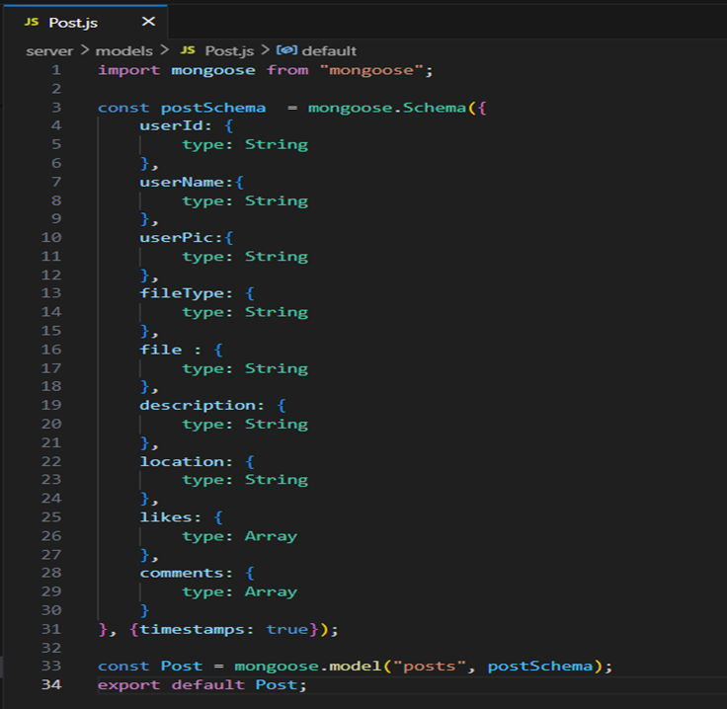

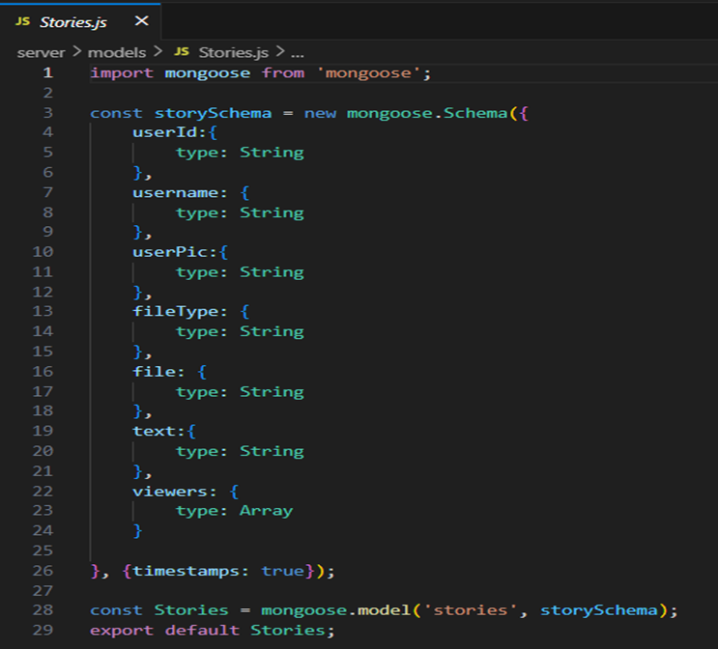

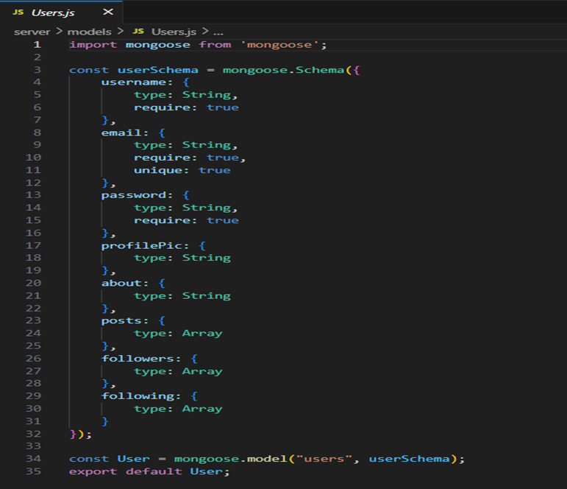

**Milestone 4: Frontend development & Integration**

* **Create socket.io connection**

* + After the successful authentication, establish a socket connection between the client and the server.
  + Use socket.io connection to update data on user events seamlessly.
  + Use socket.io in chat feature as it helps to retrieve data in real-time.

* **Add create post feature**

* + Allow the user to create a post (photo/video).
  + Upload the media file to firebase storage or any other cloud platform and store the data and file link in the MongoDB.
  + Retrieve the posts and display to all the users.

* **Add profile management**

* + Add a profile page for every individual user.
  + Display the user details and posts created by the user.
  + Allow user to update details such as profile pic, username and about.
* **Add chat feature**
  + Create an in-app chat feature.
  + Use socket.io for real-time updates.
  + Allow users to share media files in the chat.

* **Add stories/feed**
  + Stories became one of the popular features of a social media app nowadays.
  + Create the UI to display the stories.
  + Allow users to add stories.
  + Delete stories automatically when the uploaded time reaches 24hrs.
  + Display stories to the followers.

Reference for frontend code:

<https://drive.google.com/file/d/1BnE4Ou0UneKwBx6DgaDYCmitem5wPqxc/view?usp=sharing>

**Milestone 5: Project Implementation:**

On completing the development part, we then run the application one last time to verify all the functionalities and look for any bugs in it. The user interface of the application looks a bit like the one’s provided below.

* **Landing page**

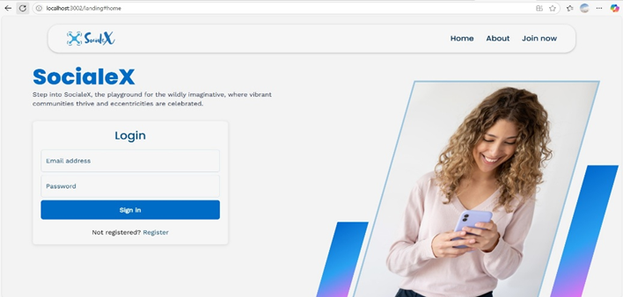

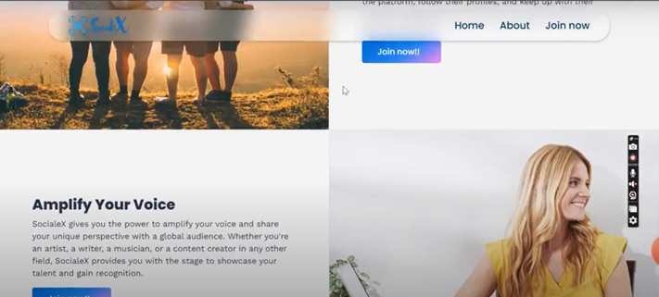

* **Home page**

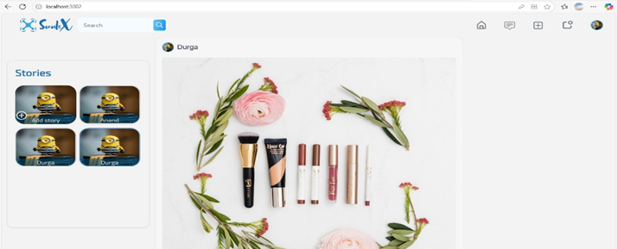

* **Create posts**

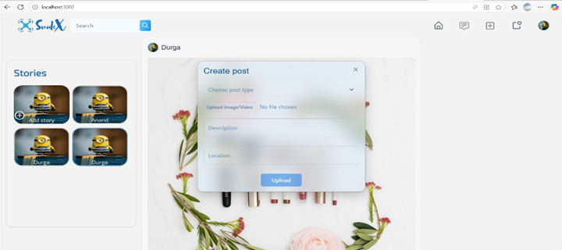

* **Update profile**

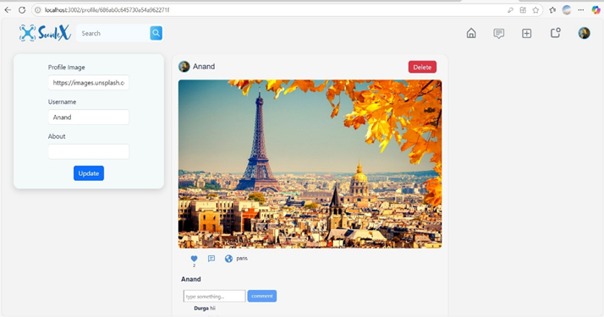

* **Profile**

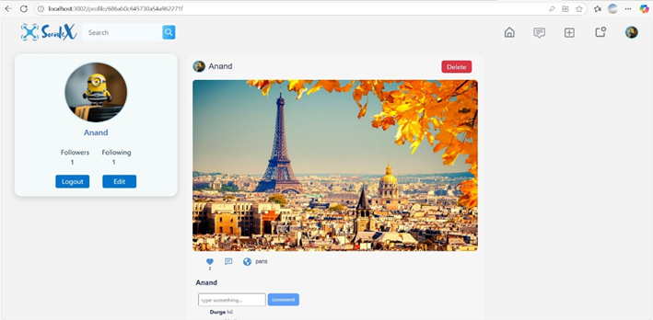

* **Chats**

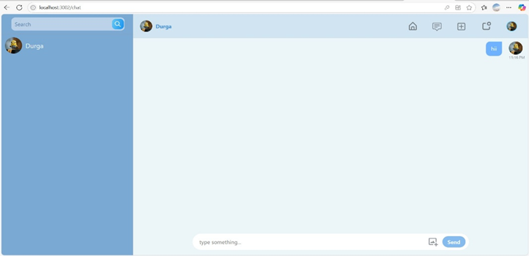

Finally, for any further assistance, use the links below:

Demo link:

https://drive.google.com/file/d/1JTXiS-r3wDOiIHKfQ241QayrrwVvwwTU/view?usp=sharing

Use the code in:

https://drive.google.com/drive/folders/1lp7H_E7WtRE6e7ElAhIH4-EfHTBsszbP?usp=sharing

**\*\*\* Happy coding!! \*\*\***