Mobile user Location Tracking Technologies

A Term Paper

Presented to

CMPS 5373: Swift Programming

Department of Computer Science

Midwestern State University

By

Veeravalli Ramakrishna

Spring 2015

**ABSTRACT**

Services provided to users based on their location are called Location Based Services (LBS).LBS are important to everyone in today's world. LBS can be offered using mobile phones. LBS can use the user's geographical location. User geographic location can be generated by Global Positioning System (GPS). LBS are used in many sectors as health care, entertainment and navigation systems, personal life, etc. LBS can be used to track a person, track vehicle or track object, or to find a nearest bank location, to advertise customers based on their location, or send alerts to users based on their location, etc. Privacy is important for LBS users. GPS will measure the latitude and longitude of a user’s location with the help of satellites. Three satellites are enough to calculate the location of a mobile device. The Google earth integrates GPS and GSM technologies to offer LBS. GPS works well in outdoor environments and not well suited for indoor and closed environments. By using Wi-Fi or Bluetooth technology, LBS will be offered for indoors and closed environments. GPS service providers have to maintain the privacy of the user.

1. **INTRODUCTION**

Mobiles are mostly used by everyone in today's world. Mobile user location can be tracked by using Global Positioning System (GPS). Initially, GPS was designed and operated by the US Military. GPS provides location and time information by using the GPS Satellites. GPS consists of three major parts i.e. Space, User, and Control. Space part consists of satellites continuously revolving around the earth. The control segment consists of tracking stations established around the world. The user segment consists of GPS-receivers placed on mobile phones or cars. GPS-receiver will calculate its distance from the satellite and figure out its location. GPS services are mostly used in vehicle tracking and providing location-based services to the user. The market size of LBS is predicted to reach $3.8 billion by 2018 in North America alone [4].

**2. OUTDOOR LOCATION BASED SERVICES**

Location based services are mostly used by mobile users. To track a mobile user, the mobile device has to find the nearest base station available to the mobile network and uses GPS. GPS finds the accurate position of a user’s location in terms of coordinates (latitude and longitude). GPS is capable to track location in open space areas only. A GPS receiver presents inside the mobile device. GPS Receiver uses information from the GPS Satellites. The GPS system contains 27 satellites that continuously revolving around the earth. Each satellite has its own path to revolve around the earth and ensures that at least 4 satellites are visible from any point on the earth at any time. At Least 4 satellites has to be visible from any point on the earth to calculate mobile location using GPS. GPS satellites fly in medium Earth orbit (MEO) at an altitude of approximately 20,200 km (12,550 miles) [1]. Each satellite circles the Earth twice a day. Fig 1 illustrates the 24-slot satellite constellation.

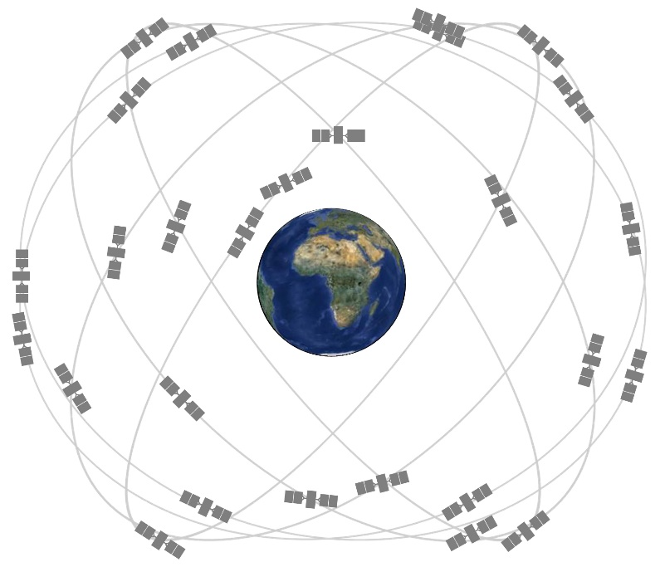

Fig 1: GPS Satellite constellation [1]

GPS Receiver must be able to calculate its distance from multiple satellites to find a user’s location. GPS satellites have an accurate time keeping mechanism. Every satellite’s time must be same to produce accurate location, GPS Satellite's clock and Receiver’s clock must be highly synchronized. GPS Receiver will not limit itself to four satellites.

By using GPS, the user can be able to know his present location coordinates and when the user moves, his location coordinates (latitude and longitude) will be updated on the mobile device. Examples of location-based services are navigation tools used to reach your destination and find nearby business or events. GPS helps in providing services available in the specific location such as a restaurant or hospital near to this location. Mobile network information is also used to calculate accurate mobile location. From social networking to navigation to banking, consumers are being offered a range of new location-based services [1]. A company offering these services may collect user data, from where the user is, where the user goes and what the user does while they are using the location based services.

GPS takes more time to calculate the accurate location of a device. To calculate the location, at least four satellites must be found. If GPS is unable to calculate the location, the location can be calculated using a network provider. GPS signals do not work in indoor environments because GPS signals are blocked by physical obstacles like buildings, walls, etc. Indoor based localization was not an extension of outdoor localization. For the indoor environment, vision-based, accelerometer based, wireless-based localization techniques can be used.

**3. INDOOR LOCALIZATION TECHNIQUE**

Indoor location-based services can be used for navigating purpose in large shopping malls or complex and unfamiliar places for new users. By using indoor location based services, a user can find nearby places in a large building, and can also find a restroom or desired place easily. Indoor localization technique (ILT) is helpful for impaired persons and robot navigation too. User able to know his current location easily and he can easily go wherever he likes within the building by using ILT.ILT is also helpful in emergency situations. ILT enabled devices helps rescuers and patrons to locate their position and shows the shortest path to go away from risk.

***3.1 Vision-based indoor localization technique***

Cameras are used to capture images of special texture on the walls. By analyzing the distortion of the captured texture, the system can easily deduce relative locations from the walls. Vision-based localization technique uses more computing resources and power.

***3.2 Wireless based indoor localization technique***

Wireless signals are not blocked by physical obstacles. Wireless signals cover the entire building. The location is measured using the intensity of received signal strength (RSS). Power and resource consumption is better when compared to vision-based technique. It is a most popular technique used by many vendors. This technique requires two parts, the beacon stations used to emit signals and user devices to receive signals. Wireless signals propagation is influenced by scattering, reflections and diffraction. The strength of the signal will be affected by multi-path fading and shadow fading. In an Indoor environment, walls and physical obstacles and people located in the building can affect the propagation of wireless signals and introduce variance to the wireless signal receiver.

Evaluating a localization System depends on the following factors. Accuracy, it indicates how accurately the system is able to calculate the location. Accuracy is the mean of the distance error. Precision, it indicates the correctness of the location. Coverage, it indicates the area covered to determine an accurate location. Different wireless technologies will cover different distances. Update Interval, it indicates how frequently the system is able to update the location information. Computational cost, it indicates how much power and resources are used to calculate the location.

Frequency Modulation (FM), GSM/CDMA technologies are also used for long-distance wireless communication. FM uses very high frequency. FM signals are less affected by weather and obstacles. The FM receiver is cheap and consumes less power. GSM/CDMA technologies are used in cellular network communication. Wi-Fi and ZigBee are used for middle distance wireless communication. Bluetooth, UWB (Ultra-Wide Band) and RFID (Radio Frequency Identification) technologies are used for short distance wireless communication.

**4. CONCLUSION**

Localization based service has a potential market. GPS mainly supports localization service for the outdoor environment and not suitable for indoor environments. The GPS deduces the location by communicating with satellites. Indoor localization is mostly implemented in large buildings. A user can easily know his current location in a large building and can also go to his desired place in that building by using indoor localization techniques. Indoor environment localization is helpful for impaired persons and also used for robot navigation in a building. Wireless technologies like Wi-Fi are most suitable for indoor environment localization. Vision- based localization techniques consume more power and more resources when compared to wireless based localization techniques. To improve performance of indoor localization, multiple wireless technologies can be integrated.

**REFERENCES**

[1]. Abhijeet, T.,Ahemad, T.,Ravindra, S., Pranay, D., Mobile Tracking Application for Locating Friends using LBS, *International Journal of Innovative Research in Science, Engineering and Technology* (April 2013, MH, IND), 303-308.

[2]. Junjie, L., Wireless based indoor localization technologies. *Proceedings of the current issues in wireless and mobile networking* (April 2014, MO, USA), 1-17.

[3]. Michael, K.,McNamee, A.,Michael, MG., The Emerging Ethics of Humancentric GPS Tracking and Monitoring, *Proceedings of the International Conference on Mobile Business* (June 2006, CH, Denmark), 943-954.

[4]. Radhika, K.,Jyotshna, K.,Mobile Tracking Application, *International Journal of Innovative*  *Research in Science, Engineering and Technology* (March 2013, MH, IND), 617-623.

[5]. Sourabh, P., Pushkar, M., Tracking and positioning of mobile systems in telecommunication networks. *International journal of engineering research and applications* (May 2014, NY, USA), 1080-1087.