Business Sales Performance Analytics Report

Overview
This project analyzes Superstore sales data to identify sales trends, top-performing categories, profitable regions, and high-selling products.

Data Cleaning
The dataset was cleaned by checking for duplicate records, verifying date formats, and ensuring numerical consistency.

Key Performance Indicators
Total Sales: $2297200.86
Total Profit: $286397.02
Total Orders: 5009

Analysis & Visualizations

Sales by Category
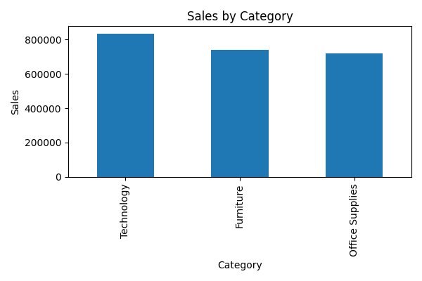

Sales by Region
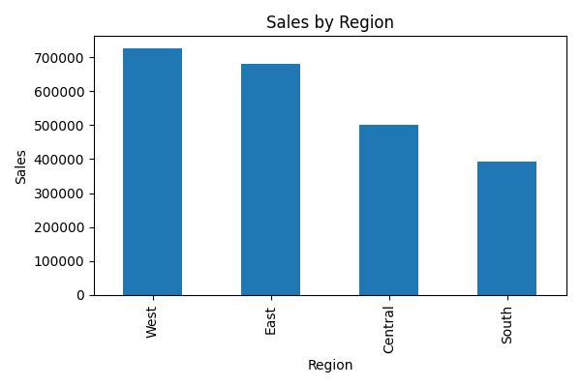

Top 10 Products
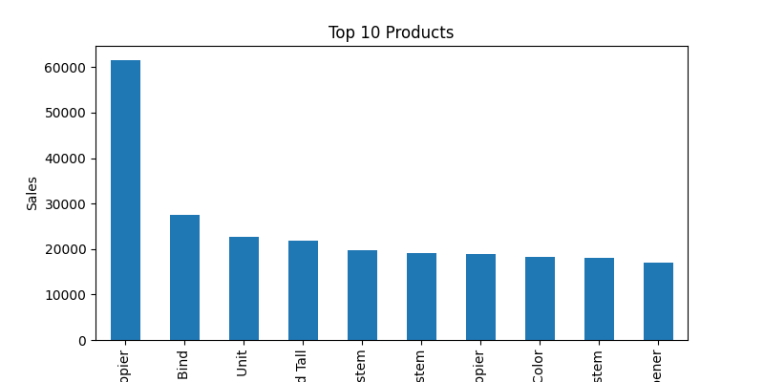

Monthly Sales Trend
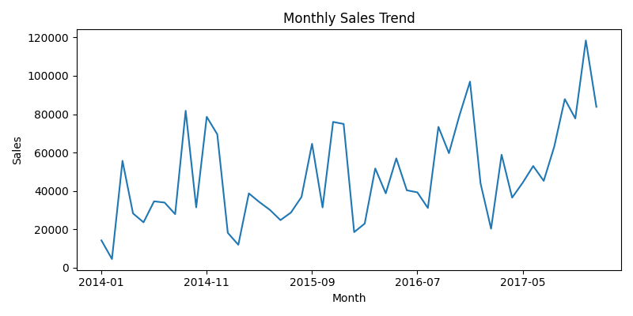

Business Insights
• Technology category generated the highest sales revenue.
• The West region performed best in overall sales.
• Certain products contributed significantly to total revenue.
• Sales showed fluctuations over time, indicating seasonal business trends.

Recommendations
• Focus marketing efforts on high-performing categories.
• Expand business strategies in profitable regions.
• Monitor low-profit products and optimize discounts.
• Use seasonal trends for better inventory planning.

