Marketing Funnel & Conversion Performance Analysis

Overview
This project analyzes marketing campaign and conversion performance using banking campaign data.

Data Cleaning
The dataset was cleaned by removing duplicate records and validating customer information.

Key Metrics
Total Customers: 45211
Overall Conversion Rate: 11.7%

Charts & Visualizations

Top Job Segments by Conversion
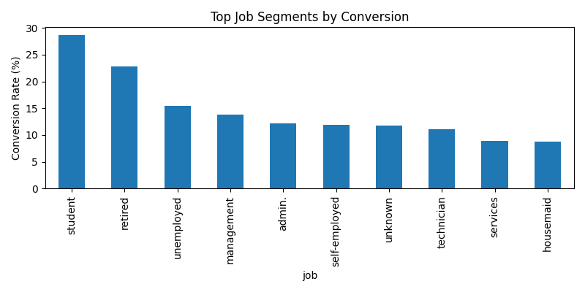

Conversion by Contact Method
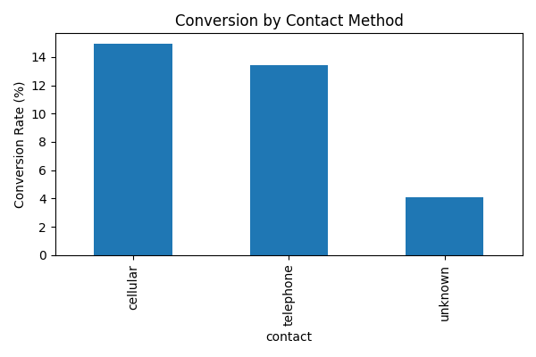

Monthly Conversion Trend
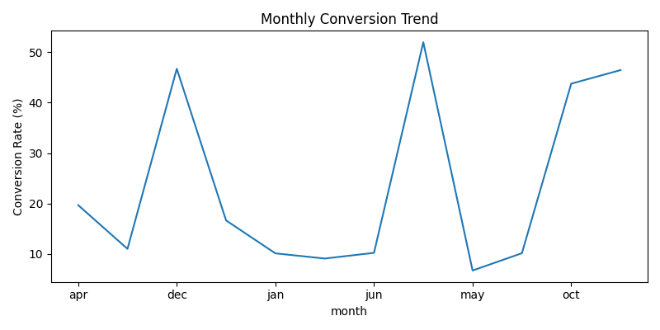

Conversion by Education Level
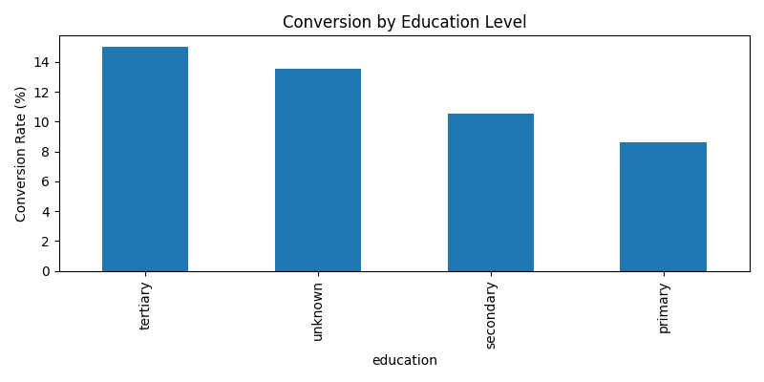

Key Insights
• Some job categories responded better to campaigns.
• Communication method influenced customer conversion rates.
• Conversion trends varied across different campaign months.
• Education level affected customer engagement behavior.

Recommendations
• Focus campaigns on high-converting customer groups.
• Improve communication strategies for low-performing segments.
• Run campaigns during high-conversion periods.
• Use customer segmentation for targeted marketing.

