Customer Retention & Churn Analysis Report

Overview
This project analyzes customer churn and retention patterns in a telecom subscription business.

Data Cleaning
The dataset was cleaned by removing duplicates, handling missing values, and converting numerical fields.

Key Metrics
Total Customers: 7043
Churn Rate: 26.54%
Average Customer Tenure: 32.37 months
Average Monthly Charges: $64.76

Visual Analysis

Churn by Contract Type
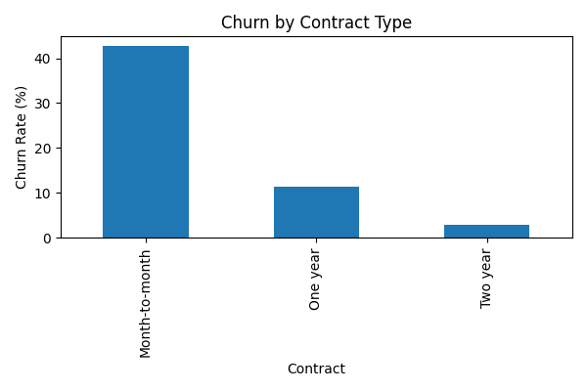

Churn by Internet Service
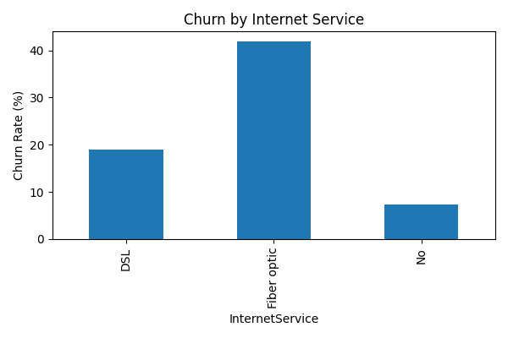

Customer Lifetime Trend
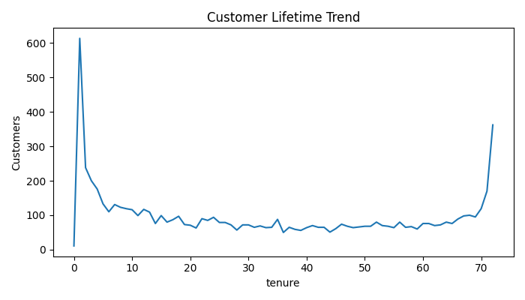

Churn by Payment Method
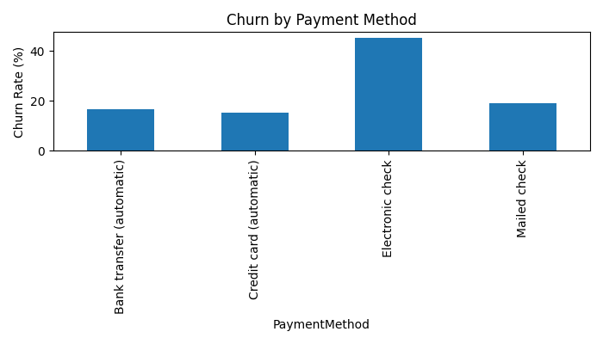

Key Insights
• Month-to-month customers showed the highest churn rate.
• Fiber optic users experienced comparatively higher churn.
• Customers with longer tenure were more likely to stay.
• Electronic check users had higher churn behavior.

Recommendations
• Promote long-term subscription plans with discounts.
• Improve customer engagement for short-tenure customers.
• Enhance customer support for high-risk groups.
• Review pricing and service quality strategies.

