DATA CENTER COOLING REGULATION

Sensor-Based Monitoring and Real-World Data Collection
Using Temperature, Humidity, and Pressure Sensors

—

A Technical Research Report
By Ranveer Singh
Partnered with ByteSmart

Prepared for: Environmental Science & Engineering Studies
Research Focus: Data Center Thermal Management
Date: June 2026

Includes Arduino DHT22 + BMP280 Field Sensor Project

Table of Contents

1. Introduction & Overview ....... 3
2. How Data Centers Work ....... 4
3. Why Cooling Matters: The Heat Problem ....... 6
4. Types of Cooling Systems ....... 8
5. Three Key Sensor Types in Data Centers ....... 10
5.1 Temperature Sensors ....... 10
5.2 Humidity Sensors ....... 12
5.3 Pressure Sensors ....... 13
6. ASHRAE Standards and Industry Regulations ....... 14
7. Environmental Problems and Counteractions ....... 16
8. Real-World Dataset: Kaggle Cold Source Control Data ....... 18
9. Arduino Field Sensor Project: DHT22 + BMP280 ....... 22
9.1 What You Will Need ....... 22
9.2 Understanding the Sensors ....... 23
9.3 Wiring Diagram ....... 24
9.4 Arduino Code ....... 26
9.5 Reading and Interpreting Your Data ....... 28
9.6 Connecting Your Data to the Big Picture ....... 28
10. Predictive Modeling Results ....... 29
11. Conclusion ....... 33
12. References ....... 34

1. Introduction & Overview

Every time you stream a video, send an email, use a search engine, or ask an AI a question, your request travels to a data center — a massive building packed with thousands of servers working around the clock. These servers generate enormous amounts of heat, and keeping them cool is not just about performance; it is literally a matter of preventing fires, expensive equipment failures, and large-scale internet outages.

This report explores the science and engineering behind data center cooling, the role that sensors play in keeping temperatures and conditions within safe ranges, and the serious environmental challenges that come with running so much computing infrastructure. The three sensor types we focus on are temperature, humidity, and pressure sensors and they are the backbone of any modern data center monitoring system. Temperature monitoring receives the most attention because it is the most direct indicator of whether a data center is in danger.

The second half of this report shifts from the industrial scale to the personal scale. Using two inexpensive Arduino-compatible sensors: the DHT22 (temperature and humidity) and the BMP280 (pressure and temperature), you can build your own portable environmental monitor to collect the same kinds of data that massive data centers track 24 hours a day. This hands-on project brings the concepts to life and lets you compare field measurements to the standards used by the biggest tech companies in the world.

Key topics covered: How data centers generate and manage heat, the three main sensor categories and how they work, international cooling standards (ASHRAE- American Society of Heating, Refrigerating and Air-Conditioning Engineers), environmental impacts of data centers, a dataset from Kaggle used in real research, and a step-by-step Arduino build guide.

2. How Data Centers Work

At the most basic level, a data center is a building, or a group of buildings, that houses computer servers, networking equipment, and storage systems. These servers run continuously, processing and storing the data that powers the modern internet. Think of a data center as the brain behind everything digital: websites, apps, cloud storage, streaming services, and AI tools all depend on data centers to function.

2.1 The Physical Layout
Inside a data center, servers are stacked into tall metal frames called racks. These racks are arranged in long rows. Each individual server is about the size of a pizza box and slides into the rack horizontally. A single rack can hold anywhere from 20 to 50 servers, and a large data center might have thousands of racks. As of 2024, the United States alone had more than 5,000 data centers, holding about one-third of the world's total data center capacity.

The servers themselves are packed with processors (CPUs and GPUs), memory chips, hard drives, and circuit boards. All of these electronic components generate heat when they run — the same way a laptop gets warm when you use it for a long time, but multiplied by thousands.

2.2 Power and Heat: A Built-In Problem
Electricity is converted into computational work inside a server. But no conversion is perfectly efficient as a significant portion of the electricity is lost as heat. A single modern server rack in an AI-focused data center can consume between 40 kilowatts (kW) and 140 kW of electricity. For comparison, a typical American home uses about 1.2 kW on average. One server rack, in other words, can use as much power as 30 to 100 homes.

According to the International Energy Agency (IEA), global data centers consumed an estimated 460 terawatt-hours (TWh) of electricity in 2025 which was about 1.8% of the entire world's electricity demand. That figure is projected to exceed 800 TWh by 2028. To put it in perspective, this energy use rivals the entire annual electricity consumption of France.

Because nearly all of this electricity eventually becomes heat, removing that heat is not optional — it is a constant, never-ending requirement. Cooling systems must run 24 hours a day, 7 days a week, 365 days a year.

2.3 The Hot Aisle / Cold Aisle Design
One of the most important physical design decisions in a data center is how server racks are arranged. Modern data centers use a "hot aisle / cold aisle" layout. In this design, racks are placed in alternating rows: one row faces forward (cold air intake side), and the next row faces backward (hot air exhaust side). This creates dedicated cold aisles where cool air flows in, and hot aisles where hot air flows out.

This arrangement prevents hot exhaust air from mixing back in with the cool intake air. Without it, a data center would have to cool air much more aggressively which wastes both energy and money. According to ASHRAE (the American Society of Heating, Refrigerating and Air-Conditioning Engineers), containment strategies using hot/cold aisle designs can reduce cooling energy use by 15–20%.

3. Why Cooling Matters: The Heat Problem

Heat is the number one enemy of electronic hardware. Every chip, circuit, and transistor has an operating temperature range beyond which it begins to malfunction or fail permanently. When a server overheats, it can throttle its own performance (slow itself down to generate less heat), crash, or suffer permanent damage. In a data center, a single unchecked hotspot can cascade into a much larger outage.

According to the Uptime Institute's 2024 analysis, cooling-related problems account for 19% of all data center outages. More than half of organizations reported that their most recent significant outage cost over $100,000. In some cases, cooling failures at large facilities have resulted in millions of dollars in damages and disrupted service for millions of people.

3.1 What Happens When It Gets Too Hot
Servers are designed to operate within a specific temperature range. When the air entering a server (called the "inlet temperature") rises above safe limits, several things happen in sequence:

- The server's internal fans spin faster, drawing more power and generating more noise.
- The processor begins to reduce its speed (thermal throttling) to generate less heat.
- If temperatures keep rising, the server shuts itself off to prevent permanent damage.
- If the cooling system has fully failed, the ambient temperature in the room can rise rapidly, threatening all equipment simultaneously.

The ASHRAE standard for server inlet temperature (the air going INTO the server) is a recommended range of 18°C to 27°C (64.4°F to 80.6°F). The allowable (maximum safety) range for most Class A1 and A2 data center equipment extends up to 32°C (89.6°F). Going beyond this threshold puts hardware at serious risk.

3.2 The Moisture Problem
Temperature is not the only concern. Humidity, which is the amount of water vapor in the air, is equally important, though it is sometimes overlooked. If the air is too dry, static electricity can build up and discharge through sensitive electronics, destroying chips in an instant. This is called electrostatic discharge (ESD). If the air is too humid, condensation can form on cold surfaces, causing short circuits or corrosion.

ASHRAE recommends maintaining relative humidity between 40% and 60% in data center environments. Both extremes (under 20% or over 80%) are considered dangerous.

3.3 Air Pressure and Airflow
Pressure plays a more subtle but still important role. Data centers rely on controlled airflow as cool air must be directed where it is needed, and hot air must be efficiently removed. Differential air pressure monitoring (measuring the difference in pressure between two areas, such as a raised floor plenum and a server aisle) is used to verify that airflow is moving in the right direction and at the right speed. A loss of proper pressure can indicate blocked vents, failed fans, or leaks in the containment system which are all problems that can lead to hotspots.

4. Types of Data Center Cooling Systems

Data centers use a variety of cooling technologies. The right choice depends on the size of the facility, the density of the computing equipment, the local climate, and budget. Below is an overview of the most common types.

4.1 Computer Room Air Conditioners (CRAC)
A CRAC unit works similarly to a residential air conditioner. It pulls warm air from the data center, passes it over a refrigerant-cooled coil to cool it down, and circulates the cool air back into the room. CRAC units are simple, well-understood, and relatively inexpensive. They work well in smaller data centers or server closets, but they struggle to keep up with the heat loads of large, modern AI-focused facilities.

4.2 Computer Room Air Handlers (CRAH)
CRAH units are more efficient than CRAC units. Instead of using a refrigerant compressor, they circulate chilled water (supplied by an external chiller plant) through coils, and fans blow warm air across these coils to cool it. CRAH units can respond more dynamically to changing heat loads and are commonly found in medium to large data centers.

4.3 Chilled Water Systems
A chilled water system is a large-scale infrastructure approach. A central chiller plant (which may be on the roof or in a separate building) produces cold water and circulates it throughout the facility via insulated pipes. Heat exchangers transfer the heat from the server room air into the water, which then returns to the chiller to be cooled again. These systems can handle very large heat loads but require significant upfront investment.

4.4 Liquid Cooling (Direct-to-Chip and Immersion)
As AI workloads have pushed rack power densities from 5–10 kW per rack a decade ago to over 40–140 kW today, air cooling alone is no longer enough for cutting-edge facilities. Two liquid cooling approaches have become increasingly important:

- Direct-to-chip cooling: Cold plates are placed directly on the hottest chips (CPUs and GPUs). Liquid flows through the plates, absorbing heat far more efficiently than air. This method can remove 70–75% of a server's heat directly.
- Immersion cooling: Entire servers are submerged in a special non-conductive liquid (similar to mineral oil or engineered fluids). The liquid absorbs heat from all components simultaneously. It is extremely effective but very expensive to install.

By 2024, liquid-based cooling systems had captured 46% of the data center cooling market, and that share is projected to grow rapidly as AI data centers continue to expand.

4.5 Free Cooling / Economizers
In climates with cool outdoor temperatures, data centers can use "free cooling", the pro drawing in cold outdoor air or using cool ambient temperatures to reduce the load on mechanical cooling systems. Facilities in places like Oregon, Iceland, or Norway can sometimes operate in free cooling mode for 70–80% of the year, drastically cutting energy costs. This is one reason why many large tech companies have built data centers in cold climates.

4.6 Comparison of Cooling Methods

Method | How It Works | Best For | Energy Efficiency
CRAC | Refrigerant-based air cooling | Small server rooms | Low
CRAH + Chilled Water | Chilled water + air handlers | Medium–large DCs | Medium
Direct-to-Chip | Liquid cold plates on CPUs/GPUs | High-density AI racks | High
Immersion Cooling | Servers submerged in fluid | Ultra-dense deployments | Very High
Free Cooling | Outdoor air / ambient temps | Cold-climate facilities | Excellent
Table 1: Comparison of common data center cooling approaches

5. Three Key Sensor Types in Data Centers

Sensors are the nervous system of a data center's cooling infrastructure. Without accurate, real-time sensor data, operators are essentially flying blind. The three most critical environmental parameters to monitor are temperature, humidity, and air pressure. Each provides a different window into the health of the cooling system.

5.1 Temperature Sensors

Why Temperature Is the Most Important Parameter
Temperature is the most directly linked parameter to hardware health and cooling effectiveness. It is measured at many points throughout a data center: at server inlets (the air entering each server), at server outlets (the hot exhaust coming out), in cooling unit supply and return lines, at rack tops and bottoms, and even at the chip level inside high-end servers.

ASHRAE guidelines specify that temperature sensors should be placed at the top, middle, and bottom of every third rack in a row, at minimum. This is because temperature can vary by 5–10°C between the floor and ceiling in a raised-floor data center, and a single sensor per rack would miss these critical variations.

How Temperature Sensors Work
Several different technologies are used to measure temperature in data centers:

- Thermistors: These are small resistors whose electrical resistance changes predictably with temperature. They are cheap, accurate, and very common in basic temperature monitors.
- RTDs (Resistance Temperature Detectors): More precise than thermistors. Often used in high-accuracy industrial applications. They use the known behavior of metals (usually platinum) to measure temperature.
- Thermocouples: Use the voltage difference between two different metals to calculate temperature. They can measure very high temperatures and are often used in extreme environments.
- Digital temperature ICs: Semiconductor-based sensors (like the one inside the DHT22 we will use in our Arduino project) that output digital data directly. Very convenient for microcontroller projects.

What Temperature Data Reveals
Temperature sensors provide several critical types of information to data center operators:

- Hotspot detection: If one area of a data center is significantly hotter than surrounding areas, it may indicate a blocked vent, a failed cooling unit, or unusually high server load in that zone.
- Cooling system efficiency: By comparing inlet temperatures (cool air going in) and outlet temperatures (hot air coming out), operators can calculate how much heat is being generated and whether the cooling system is keeping up.
- Trends and predictions: Gradual temperature creep over time can signal that a cooling unit is losing efficiency and may need maintenance before it fails completely.
- Compliance verification: Operators must demonstrate that server inlet temperatures stay within ASHRAE recommended ranges to protect equipment warranties and comply with facility standards.

Temperature in AI Data Centers
The rise of AI computing has dramatically raised the stakes for temperature management. A single Nvidia Blackwell GPU rack, used in cutting-edge AI data centers, can consume up to 140 kW of power. All of that power eventually becomes heat. Traditional air cooling simply cannot handle these power densities. That is why liquid cooling has become essential for AI infrastructure, and why temperature sensors at the chip and rack level (not just the room level) have become standard practice.

Power Usage Effectiveness (PUE)
Temperature data feeds into one of the most important metrics in the data center industry: Power Usage Effectiveness (PUE). PUE is calculated by dividing the total energy used by the facility (including cooling, lighting, and everything else) by the energy used by the IT equipment alone. A perfect PUE of 1.0 would mean all energy goes directly to computing and nothing wasted on cooling. In reality, the global industry average PUE is about 1.55, meaning for every 1 watt used for computing, another 0.55 watts are used for cooling and other overhead. The best hyperscale facilities (Google, Microsoft, Amazon) have achieved PUE values as low as 1.1–1.2 through aggressive temperature monitoring and optimization.

PUE Value | Rating | What It Means
1.0 | Theoretical Perfect | 100% of power goes to computing
1.1 – 1.2 | Excellent (Hyperscale) | Best-in-class: Google, Microsoft
1.2 – 1.4 | Good | Efficient modern facility
1.4 – 1.6 | Average | Industry average (~1.55)
> 1.6 | Poor | Older or poorly optimized facility
Table 2: Power Usage Effectiveness (PUE) rating scale

5.2 Humidity Sensors

The Role of Moisture in a Data Center
Humidity is the second most important environmental parameter in a data center. The air inside a data center must stay within a specific moisture range at all times. Monitoring humidity is critical: too dry increases the risk of electrostatic discharge (ESD), while too humid raises the risk of condensation, corrosion, and even mold growth on equipment.

ASHRAE Humidity Standards
ASHRAE recommends maintaining 40–60% relative humidity (RH) as the ideal range for data center environments, or a dew point between 5.5°C and 15°C. The allowable range extends from 20% to 80% RH, depending on the equipment class. These limits are based on decades of research into both ESD risks at low humidity and condensation risks at high humidity.

Types of Humidity Sensors
- Capacitive humidity sensors: The most common type. A thin film absorbs or releases water vapor, changing its electrical capacitance. The DHT22 sensor we use in our Arduino project uses this technology. It measures relative humidity from 0% to 100% with an accuracy of ±2–5%.
- Resistive humidity sensors: Use a material whose electrical resistance changes with humidity. Generally less accurate than capacitive sensors but cheaper.
- Thermal conductivity sensors: Measure the difference in heat transfer between wet and dry air. Used in industrial applications requiring wide measurement ranges.

Consequences of Humidity Problems
- Too dry (below 40% RH): Static electricity builds up on people, equipment, and non-conductive surfaces. A sudden electrostatic discharge can instantly destroy memory chips, processors, or circuit boards. This is why data center workers use anti-static wrist straps and special flooring.
- Too humid (above 60% RH): Water vapor begins to condense on cold metal surfaces (the same way a cold glass of water forms drops on the outside on a humid day). Condensation inside servers causes short circuits. Over time, persistent high humidity causes corrosion of metal contacts and circuit board traces.

According to AVTECH environmental monitoring, roughly 50% of all environment-caused data center downtime can be attributed to temperature and humidity issues combined. This underscores why these two parameters are monitored together in virtually every professional data center installation.

5.3 Pressure Sensors

How Pressure Monitoring Works in Data Centers
Pressure sensors in data centers serve a different purpose than in weather forecasting. Rather than measuring absolute barometric pressure (though that has some uses), data centers primarily measure differential pressure which is the difference in air pressure between two connected spaces.

The most common application is under raised-floor data centers, where cold air is pushed into a pressurized plenum (the space under the raised floor) and then delivered to server racks through perforated floor tiles. Differential pressure sensors check that the plenum maintains the correct positive pressure relative to the server room above. If the pressure drops, it may indicate that too many floor tiles have been opened, that airflow is leaking somewhere, or that cooling units have failed.

Secondary Uses of Pressure Data
- Filter monitoring: As air filters in CRAC and CRAH units become clogged with dust over time, the pressure drop across the filter increases. Differential pressure sensors can automatically alert operators when filters need to be replaced, before the blockage causes cooling degradation.
- Airflow verification: Pressure measurements across fans and cooling coils verify that airflow rates are correct. An unexpected pressure change can indicate a fan has failed or that airflow is being redirected by equipment changes in the room.
- Altitude compensation: Atmospheric pressure decreases with altitude. Data centers at high elevations (like in Denver, Colorado) must account for lower air density in their cooling calculations. The BMP280 sensor used in our Arduino project can measure absolute barometric pressure and estimate altitude.

ASHRAE and Pressure
While ASHRAE does not specify absolute pressure requirements for data center air (atmospheric pressure is not something operators can control), the standards indirectly address pressure through airflow management guidelines. Maintaining proper pressure relationships between cold aisles, hot aisles, and the raised floor plenum is considered essential to ensuring that cooling air reaches every server and that hot exhaust does not recirculate back to cool air intake points.
6. ASHRAE Standards and Industry Regulations

The American Society of Heating, Refrigerating and Air-Conditioning Engineers (ASHRAE) is the global standard-setting body for data center thermal management. Their publication Thermal Guidelines for Data Processing Environments defines the environmental classes and operating ranges that virtually every modern data center is designed around.

6.1 ASHRAE Equipment Classes
ASHRAE classifies IT equipment into classes based on their environmental tolerance. The most common classes found in standard enterprise and cloud data centers are A1 and A2:

Class | Temp Range (°C) | Humidity (RH) | Max Dew Point | Typical Use
A1 | 15°C – 32°C | 20% – 80% | 17°C | Data centers
A2 | 10°C – 35°C | 20% – 80% | 21°C | IT spaces
A3 | 5°C – 40°C | 8% – 85% | 24°C | Offices
A4 | 5°C – 45°C | 8% – 90% | 24°C | Warehouses
Table 3: ASHRAE equipment class environmental ranges (TC 9.9)

6.2 Key ASHRAE Rules for Sensor Placement
- A minimum of three temperature sensors per rack: one at the top, one in the middle, and one at the bottom.
- Sensors must measure at the server inlet, not in the aisle or at the room level.
- Humidity sensors should be strategically placed to detect any pockets of overly dry or moist air.
- Humidity sensors must have an accuracy of ±3% RH or better to reliably track the 8–60% allowable range.
- Temperature change rates must not exceed 5°C per hour (to prevent thermal shock to components).

6.3 Other Relevant Standards
- ASHRAE 90.4: An energy efficiency standard specifically for data centers, setting requirements for cooling system efficiency and power overhead.
- EU Commission Delegated Regulation 2024/1364: The European Union has introduced mandatory energy efficiency and water usage reporting requirements for data centers, pushing operators to document and improve their environmental performance.
- EPA WaterSense: Tracks water efficiency in facilities including data centers, especially important as water cooling methods grow more common.

7. Environmental Problems and Counteractions

The growth of data centers has created serious environmental challenges at both local and global scales. Understanding these problems is essential context for anyone working in the field of data center management.

7.1 Energy Consumption and Carbon Emissions
U.S. data centers consumed approximately 176 TWh of electricity in 2023, representing 4.4% of total U.S. electricity consumption. This generated an estimated 105 million metric tons of carbon dioxide equivalent to a 300% increase in just six years. The explosion in AI computing is accelerating this trend dramatically.

7.2 Water Consumption
Evaporative cooling towers, a common way to reject heat from chilled water systems, consume enormous quantities of water. In 2023, U.S. data centers directly consumed 17.4 billion gallons of freshwater, equivalent to the annual water use of roughly 160,000 American households. Up to 85% of the water used by evaporative cooling systems evaporates and never returns to the water supply. In drought-prone areas, data centers can put severe stress on local water supplies.

A 2025 study estimated that training a single large AI model like GPT-3 at Microsoft's U.S. data centers could consume as much as 5.4 million liters of water total. As more and more powerful AI models are trained, this figure grows.

7.3 Local Environmental Impacts
- Land use: Large data centers require significant land, sometimes converting farmland or green space in communities that may not have wanted the development.
- Heat islands: Data centers that reject heat into the local environment can raise ambient temperatures in surrounding neighborhoods.
- Grid strain: A single large hyperscale data center can draw as much power as a medium-sized city, creating significant demand on local electrical grids.

7.4 Solutions and Counteractions
The industry is actively working to address these problems. Key strategies include:

- Renewable energy: Major hyperscalers (Google, Microsoft, Amazon) have committed to powering their data centers with 100% renewable electricity and have made significant progress toward this goal.
- Liquid cooling adoption: Direct-to-chip and immersion cooling are far more energy-efficient than air cooling for high-density workloads, directly reducing PUE.
- Zero-water cooling designs: Microsoft announced in late 2024 that new data center designs starting August 2024 would use closed-loop chip-level cooling systems that consume zero water for evaporative cooling, saving more than 125 million liters of water per year per facility.
- Free cooling: Building data centers in cold climates (Nordic countries, Canada, high-altitude locations) to take advantage of naturally cool air, reducing the need for mechanical refrigeration.
- Waste heat reuse: Some European data centers now pipe heat rejected from cooling systems into district heating networks for nearby homes and businesses, converting a waste product into a community benefit.
- Sensor-driven optimization: More detailed, real-time sensor data allows cooling systems to respond dynamically to actual server loads rather than running at maximum capacity all the time. This avoids overcooling, which saves a lot of energy and while still maintaining safe temperatures.

8. Real-World Dataset: Kaggle Cold Source Control Data

To understand how sensor data is actually used in data center research, we can look at a publicly available dataset: the Data Center Cold Source Control Dataset on Kaggle (user: programmer3). This dataset captures sensor readings from a real data center cooling system, specifically focusing on the "cold source" side or otherwise, the chilled water supply that feeds cooling units.

8.1 What the Dataset Contains
The dataset includes time-series measurements from a data center cooling environment. Typical variables in this type of industrial cooling dataset include:

- Supply water temperature: The temperature of chilled water being sent from the chiller plant to the cooling units.
- Return water temperature: The temperature of water returning from the cooling units back to the chiller (warmer, because it has absorbed heat from the server room).
- Water flow rate: How much chilled water is flowing through the system per unit of time.
- Cooling load: The total heat load (in kilowatts) that the cooling system is currently handling.
- Chiller power consumption: How much electricity the chiller plant is using at any given time.

8.2 How This Data Is Used
Datasets like this are used in several important ways:

- Optimization modeling: Researchers use the historical data to build models that predict the most energy-efficient way to run a chiller plant. For example, which combination of chiller settings minimizes electricity use while maintaining the required supply water temperature?
- Anomaly detection: By establishing a normal baseline pattern, machine learning algorithms can be trained to flag unusual readings that might indicate a developing fault. For example, if the temperature difference between supply and return water suddenly becomes much smaller than usual.
- Control system design: The data is used to design and validate automated control algorithms that can adjust cooling outputs in real time based on server load changes.

8.3 The Importance of Open Datasets
Publicly available datasets like this one are extremely valuable for students, researchers, and engineers. They provide a window into the operational reality of large-scale cooling systems without requiring access to a real data center. By analyzing this kind of data, it is possible to understand the relationship between different sensor readings. For example, how a rise in server room temperature triggers a corresponding increase in chiller power consumption and a change in supply water temperature.

This is also exactly what our Arduino project aims to do at a much smaller scale: collect real sensor data from a real environment and learn from it. While a DHT22 and a BMP280 on a breadboard cannot replicate the full complexity of industrial chilled water sensors, the underlying logic is identical: measure the environment, log the data, and look for patterns.

8.4 Advanced Analytical Framework & Hypotheses
To validate the thermodynamic and regulatory theories outlined in Sections 3, 4, and 6 of this report, a comprehensive data investigation was conducted on the 3,498 historical sensor logs from the Cold Source Control Dataset. Below is the documentation of the five core research questions, the data fields utilized, and the engineering thought processes governing the analysis.

8.4.1 ASHRAE Inlet Temperature Compliance Analysis
- Description & Theoretical Context: This analysis checks whether the observed server inlet temperatures remain within the ASHRAE recommended maximum of 27°C. In a real data center, inlet temperature matters because it is the air the servers actually breathe, not just the general room temperature.
- Dataset Fields Used: Timestamp, Inlet_Temperature(°C)
- Analytical Thought Process & Hypothesis: Hypothesis: The cooling system should rarely exceed 27°C if the control loop is operating correctly. Logic: The notebook counts every reading above 27°C, calculates the violation percentage, and plots the inlet-temperature distribution with the ASHRAE threshold drawn as a reference line.

8.4.2 Cooling Strategy Performance vs. Cost & Deviation
- Description & Theoretical Context: Data center cooling is not only about staying cold; it is about staying stable without wasting energy. This question compares each cooling strategy by average energy cost and average temperature deviation.
- Dataset Fields Used: Cooling_Strategy_Action, Temperature_Deviation(°C), Total_Energy_Cost($)
- Analytical Thought Process & Hypothesis: Hypothesis: The best cooling strategy will show both low temperature deviation and low average energy cost. Logic: The notebook groups records by cooling strategy, averages the two performance metrics, then uses a dual-axis visualization to compare cost against thermal stability.

8.4.3 Chiller vs. AHU Resource Allocation Under Ambient Stress
- Description & Theoretical Context: Chillers and air handling units do different work inside the cooling chain. This analysis asks whether hotter ambient conditions shift the system toward heavier chiller usage compared with AHU usage.
- Dataset Fields Used: Ambient_Temperature(°C), Chiller_Usage(%), AHU_Usage(%)
- Analytical Thought Process & Hypothesis: Hypothesis: As outdoor ambient temperature increases, the system will rely more heavily on chilled-water cooling. Logic: Ambient temperature is divided into bins, average chiller and AHU usage are calculated in each bin, and both trends are plotted on the same chart to show whether the system pivots from air-side to water-side cooling.

8.4.4 Server Workload and Heat Removal
- Description & Theoretical Context: Server workload is a direct driver of heat production. Instead of asking only whether the relationship is perfectly linear, this analysis connects workload to the temperature rise across the server airflow path and to the cooling unit's power response.
- Dataset Fields Used: Server_Workload(%), Inlet_Temperature(°C), Outlet_Temperature(°C), Cooling_Unit_Power_Consumption(kW)
- Analytical Thought Process & Hypothesis: Hypothesis: Higher server workload should increase the thermal delta between outlet and inlet air, and cooling power should rise with it. Logic: The notebook creates a Thermal_Delta(°C) field by subtracting inlet temperature from outlet temperature, plots it against server workload, overlays the cooling-power response, and prints correlation values for both relationships.

8.4.5 Ambient Heat Stress and Cooling Overhead
- Description & Theoretical Context: Outdoor heat affects how hard the data center must work to reject internal server heat. This analysis connects ambient temperature bands to cooling-unit power and total energy cost.
- Dataset Fields Used: Ambient_Temperature(°C), Cooling_Unit_Power_Consumption(kW), Total_Energy_Cost($)
- Analytical Thought Process & Hypothesis: Hypothesis: The hottest ambient-temperature band will require higher cooling-unit power and will increase total energy cost compared with the coolest band. Logic: The notebook groups ambient temperature into quartile bands, calculates mean cooling power and mean cost for each band, visualizes both metrics together, and prints the percent increase from the coolest band to the hottest band.

9. Arduino Field Sensor Project: DHT22 + BMP280
This section walks you through building a real, working environmental sensor station using an Arduino microcontroller and two inexpensive sensors: the DHT22 (for temperature and humidity) and the BMP280 (for barometric pressure and temperature). Together, these sensors let you measure exactly the same three environmental parameters that data centers monitor continuously — just at a much more accessible scale.
You can take this sensor setup anywhere: inside your house, in a hot garage, near a computer, in your backyard on a sunny day, or in a school hallway. Collecting real data across different environments deepens your understanding of how temperature, humidity, and pressure interact — and gives you a direct comparison point against the ASHRAE standards used by real data centers.

9.1 What You Will Need
Table 4: Parts list for the Arduino environmental sensor station
Component | Purpose | Quantity | Approx. Cost
Arduino Uno (or Nano) | Main microcontroller board | 1 | ~$10–25
DHT22 Sensor Module | Measures temperature + humidity | 1 | ~$4–8
BMP280 Sensor Module | Measures pressure + temperature | 1 | ~$2–5
Breadboard | Connects components without soldering | 1 | ~$3–6
Jumper Wires (M-M) | Connects components to Arduino | ~10 | ~$2–4
USB Cable (Type A to B) | Powers Arduino and uploads code | 1 | ~$3
10 kΩ Resistor | Pull-up for DHT22 data line | 1 | ~$0.10
Computer with Arduino IDE | Writes and uploads code | 1 | Free software

Total estimated cost: Under $30 if you already have a computer and USB cable. Many Arduino starter kits include a breadboard, jumper wires, and the Uno board all in one package for around $20–30 USD. The DHT22 and BMP280 are widely available on Amazon, AliExpress, Adafruit, and SparkFun.

9.2 Understanding the Sensors

DHT22 (AM2302) — Temperature and Humidity Sensor
The DHT22 is one of the most popular sensors in the hobbyist electronics world. It measures both temperature and relative humidity using a single data wire, making it extremely easy to connect to an Arduino. Here are its key specifications:
Table 5: DHT22 sensor specifications
Specification | DHT22 Value
Temperature range | -40°C to +125°C
Temperature accuracy | ± 0.5°C
Humidity range | 0% to 100% RH
Humidity accuracy | ± 2–5% RH
Communication protocol | Single-wire digital (proprietary)
Sample rate | One reading every 2 seconds (minimum)
Operating voltage | 3.3V to 5V
Resolution | 0.1°C temperature, 0.1% RH humidity

Compared to the DHT11: The cheaper DHT11 sensor has a temperature range of only 0–50°C and ±2°C accuracy. The DHT22 is noticeably better and worth the small extra cost for any project where accuracy matters.

BMP280 — Barometric Pressure and Temperature Sensor
The BMP280 is made by Bosch Sensortec and is a precision sensor that measures both barometric (air) pressure and temperature. It communicates with the Arduino via the I2C protocol (two wires: SDA for data and SCL for the clock signal). Because pressure changes with altitude, the BMP280 can also estimate your height above sea level.
Table 6: BMP280 sensor specifications
Specification | BMP280 Value
Pressure range | 300 hPa to 1100 hPa
Pressure accuracy | ± 1 hPa (relative), ± 12 Pa (absolute)
Temperature range | 0°C to 65°C
Temperature accuracy | ± 1°C
Communication | I2C (default address 0x76) or SPI
Operating voltage | 1.8V to 3.6V (use with level shifter on 5V Arduino)
Altitude estimation | Yes — ± 1 meter accuracy under stable conditions

Important note: The BMP280 is often confused with the BME280, which additionally measures humidity. The BMP280 only measures pressure and temperature. We pair it with the DHT22 in this project specifically so that we get all three parameters covered between the two sensors.

9.3 Wiring Diagram
Below are the pin connections for both sensors. Use your breadboard and jumper wires to make these connections. Always connect power (VCC and GND) last, after all other wires are in place.

DHT22 Wiring (3-pin module version)
Table 7: DHT22 pin connections
DHT22 Pin | Arduino Pin | Notes
VCC (+) | 5V | Power supply
DATA | Digital Pin 2 | Add 10kΩ pull-up resistor between DATA and VCC
GND (-) | GND | Common ground

BMP280 Wiring (I2C mode)
Table 8: BMP280 pin connections (I2C mode)
BMP280 Pin | Arduino Pin | Notes
VCC | 3.3V | Do NOT connect to 5V (sensor is 3.3V)
GND | GND | Common ground
SDA | A4 (SDA) | I2C data line
SCL | A5 (SCL) | I2C clock line
CSB | Not connected | Leave floating for I2C mode
SDO | GND | Sets I2C address to 0x76
Pro tip: The BMP280 operates at 3.3V logic. On a standard Arduino Uno (which uses 5V logic), connect VCC to the 3.3V pin. Most BMP280 breakout boards include an onboard voltage regulator and level shifter, making this safe. If you are unsure, check your specific breakout board's documentation.

9.4 Arduino Code

Step 1: Install Required Libraries
Before uploading the code, you need to install two libraries in the Arduino IDE:
- Open Arduino IDE and go to: Sketch → Include Library → Manage Libraries
- Search for "DHT sensor library" by Adafruit. Install it, and also install the "Adafruit Unified Sensor" driver when prompted.
- Search for "Adafruit BMP280" library. Install it.

Step 2: The Complete Arduino Sketch
Copy and paste the following code into a new Arduino sketch. Upload it to your Arduino via USB, then open the Serial Monitor (Tools → Serial Monitor, set baud rate to 9600) to see live readings.
// ============================================================
// Data Center Environmental Sensor Logger
// Sensors: DHT22 (Temp + Humidity) + BMP280 (Pressure + Temp)
// Output: Arduino Serial Monitor
// ============================================================
#include <Wire.h>
#include <DHT.h>
#include <Adafruit_BMP280.h>
// --- DHT22 Setup ---
#define DHT_PIN 2 // Data pin connected to Digital Pin 2
#define DHT_TYPE DHT22 // Sensor model
DHT dht(DHT_PIN, DHT_TYPE);
// --- BMP280 Setup ---
Adafruit_BMP280 bmp; // Uses I2C interface (A4=SDA, A5=SCL)
#define BMP280_ADDR 0x76 // Default I2C address (SDO tied to GND)
// --- Reading counter for logging ---
int readingNumber = 0;
// ============================================================
void setup() {
Serial.begin(9600);
delay(1000); // Brief startup delay
Serial.println("================================================");
Serial.println(" Data Center Sensor Logger v1.0");
Serial.println(" DHT22 + BMP280 Environmental Monitor");
Serial.println("================================================");
// --- Initialize DHT22 ---
dht.begin();
Serial.println("[OK] DHT22 initialized");
// --- Initialize BMP280 ---
if (!bmp.begin(BMP280_ADDR)) {
Serial.println("[ERROR] BMP280 not found! Check wiring.");
Serial.println("Hint: Is SDO connected to GND? (sets address 0x76)");
while (1) delay(500); // Halt if sensor not found
}
Serial.println("[OK] BMP280 initialized");
// BMP280 recommended settings for indoor/static use
bmp.setSampling(Adafruit_BMP280::MODE_NORMAL,
Adafruit_BMP280::SAMPLING_X2, // Temp oversampling
Adafruit_BMP280::SAMPLING_X16, // Pressure oversampling
Adafruit_BMP280::FILTER_X16, // Noise filter
Adafruit_BMP280::STANDBY_MS_500); // Sample rate
Serial.println("");
Serial.println("Logging started. Reading every 3 seconds.");
Serial.println("");
Serial.println("# | Temp(°C) | Temp(°F) | Humidity | Pressure | Altitude");
Serial.println("---|-----------|-----------|-----------|-----------|----------");
}
// ============================================================
void loop() {
// DHT22 needs at least 2 seconds between readings
delay(3000);
readingNumber++;
// ---- Read DHT22 ----
float humidity = dht.readHumidity();
float tempC_dht = dht.readTemperature(); // Celsius
float tempF_dht = dht.readTemperature(true); // Fahrenheit
// ---- Read BMP280 ----
float tempC_bmp = bmp.readTemperature(); // Celsius
float pressureHPa = bmp.readPressure() / 100.0F; // Pa to hPa
float altitudeM = bmp.readAltitude(1013.25); // Sea-level ref: 1013.25 hPa
// ---- Check for DHT22 errors ----
if (isnan(humidity) || isnan(tempC_dht)) {
Serial.print(readingNumber);
Serial.println(" | [ERROR] DHT22 failed to read. Check wiring!");
return;
}
// ---- Print formatted table row ----
Serial.print(readingNumber);
Serial.print(" | ");
Serial.print(tempC_dht, 1); // DHT22 temp (1 decimal place)
Serial.print("°C | ");
Serial.print(tempF_dht, 1);
Serial.print("°F | ");
Serial.print(humidity, 1);
Serial.print("% | ");
Serial.print(pressureHPa, 2);
Serial.print(" hPa | ");
Serial.print(altitudeM, 1);
Serial.println(" m");
// ---- ASHRAE comparison alerts ----
if (tempC_dht > 27.0) {
Serial.println(" ** WARNING: Above ASHRAE recommended max inlet temp (27°C) **");
}
if (humidity < 40.0) {
Serial.println(" ** WARNING: Humidity below ASHRAE min (40% RH) - ESD risk **");
}
if (humidity > 60.0) {
Serial.println(" ** WARNING: Humidity above ASHRAE max (60% RH) - Condensation risk **");
}
}
// ============================================================

9.5 Reading and Interpreting Your Data

What the Serial Monitor Will Show
When you open the Arduino IDE Serial Monitor (Tools → Serial Monitor, baud rate 9600), you will see output that looks like the example below. Each row is one reading, logged every 3 seconds:
================================================
Data Center Sensor Logger v1.0
DHT22 + BMP280 Environmental Monitor
================================================
[OK] DHT22 initialized
[OK] BMP280 initialized
Logging started. Reading every 3 seconds.
# | Temp(°C) | Temp(°F) | Humidity | Pressure | Altitude
---|-----------|-----------|-----------|-----------|----------
1 | 24.5°C | 76.1°F | 52.0% | 1012.45 hPa | 8.2 m
2 | 24.6°C | 76.3°F | 51.8% | 1012.47 hPa | 8.1 m
3 | 24.6°C | 76.3°F | 52.1% | 1012.44 hPa | 8.3 m
...

Understanding Each Column
Table 9: Serial Monitor output column reference
Column | Sensor Source | What to Look For
Temp (°C / °F) | DHT22 | Should stay below 27°C (ASHRAE recommended max for server inlets)
Humidity (%) | DHT22 | Ideal: 40–60%. Below 40% = ESD risk. Above 60% = condensation risk.
Pressure (hPa) | BMP280 | Normal sea-level range: ~980–1030 hPa. Changes with altitude and weather.
Altitude (m) | BMP280 | Calculated from pressure. Should remain roughly constant in one location.

Saving Your Data
To save your Serial Monitor data for analysis, follow these steps:
- In the Arduino IDE Serial Monitor, check the "Autoscroll" box and wait for several minutes of readings.
- Select all text in the Serial Monitor window (Ctrl+A or Cmd+A), then copy it (Ctrl+C).
- Open a spreadsheet application (Google Sheets or Excel) and paste. You may need to use "Text to Columns" or paste as plain text to separate the data into columns.
- Create charts comparing temperature over time, or plot humidity against temperature to see their relationship.
Advanced option: If you have access to a microSD module, you can add data logging to an SD card directly from the Arduino. The SD library (built into Arduino IDE) makes this straightforward, but it requires additional hardware.

9.6 Connecting Your Data to the Big Picture

Comparing Your Readings to ASHRAE Standards
One of the most educational activities you can do with your sensor is compare your readings to the ASHRAE standards used by real data centers. The code already includes automatic warnings that trigger when readings fall outside the recommended ranges. Here are some experiments to try:
- Normal room conditions: Record temperature and humidity in a typical indoor environment. How does your room compare to the ASHRAE recommended range of 18–27°C inlet temperature?
- Hot computer simulation: Place the sensor near your laptop's exhaust vent while running a demanding game or video. You will likely see temperature rise and humidity drop (dry, hot exhaust air). This simulates what happens near a hot server exhaust.
- Outdoor comparison: Take readings outside on a sunny day and compare. Real data centers in warm climates often struggle with high outdoor temperatures that reduce their free cooling options.
- Pressure and weather: Pressure readings from the BMP280 will change slightly over the course of a day as weather systems pass. Low pressure generally indicates incoming storms; high pressure indicates fair weather.

Understanding the Two Temperature Readings
One interesting detail in our setup: both the DHT22 and BMP280 measure temperature, but they may give slightly different readings. The BMP280 temperature sensor is primarily designed to compensate for temperature effects on its pressure measurement — it is not a precision thermometer. The DHT22, with ±0.5°C accuracy, will generally give a more reliable air temperature reading. However, comparing the two can reveal interesting things, such as self-heating effects as the sensors warm up.

Thinking Like a Data Center Engineer
The data you collect is exactly the kind of information that data center cooling engineers work with every day, just at a much larger scale. When a real data center sees temperature rising in one zone, engineers ask the same questions you might ask about your sensor data:
- Is this a real temperature rise, or could the sensor be malfunctioning? (Check by comparing to nearby sensors — in our case, the two temperature sensors.)
- Is humidity changing at the same time? A drop in humidity along with rising temperature might suggest hot, dry server exhaust air.
- Is pressure behaving normally? Unexplained pressure changes might indicate airflow problems.
The skills involved — careful measurement, pattern recognition, and cross-referencing multiple data sources — are directly applicable to professional data center monitoring and to many other engineering fields.
Going further: If you want to explore beyond the Serial Monitor, consider learning how to connect your Arduino to a cloud service like Adafruit IO, ThingSpeak, or Node-RED. These platforms let you visualize your sensor data on live dashboards — much like the DCIM (Data Center Infrastructure Management) software used in real data centers.

10. Predictive Modeling Results
A separate Google Colab notebook tested the three selected prediction questions on all 3,498 hourly records from January through May 2025. Each evaluation used a chronological 80/20 split so later observations were held out for testing rather than randomly mixed into training.

10.1 Predicting Next-Interval Inlet Temperature
Question: Can current workload and temperature readings predict the server inlet temperature at the next recorded interval?
Method: Linear regression with the inlet-temperature target shifted forward by one hour.
Test result: R² = -0.00665, MAE = 1.785°C, and RMSE = 2.218°C.
Interpretation: The model performed slightly worse than predicting the training-period mean. The selected current readings do not provide useful linear forecasting signal for the next inlet-temperature value in this dataset.
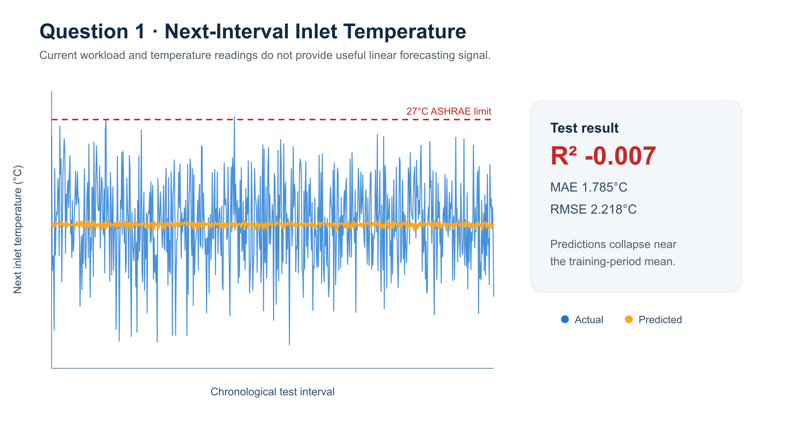
Figure 1. Actual and predicted next-interval inlet temperature on the chronological test set.

10.2 Predicting a Next-Interval ASHRAE Violation
Question: Can current operating conditions predict whether inlet temperature will exceed the 27°C ASHRAE recommended maximum during the next interval?
Class balance: Only 4 of the 3,497 shifted targets exceeded 27°C. The chronological test set contained 699 non-violations and 1 violation.
Derived alert result: TN = 699, FP = 0, FN = 1, and TP = 0 when the Question 1 prediction is compared with the 27°C threshold.
Interpretation: Four positive examples are not enough to train or defend a standalone logistic classifier. The 27°C limit should be treated as an operating warning rule, not as evidence of a reliable learned violation model.
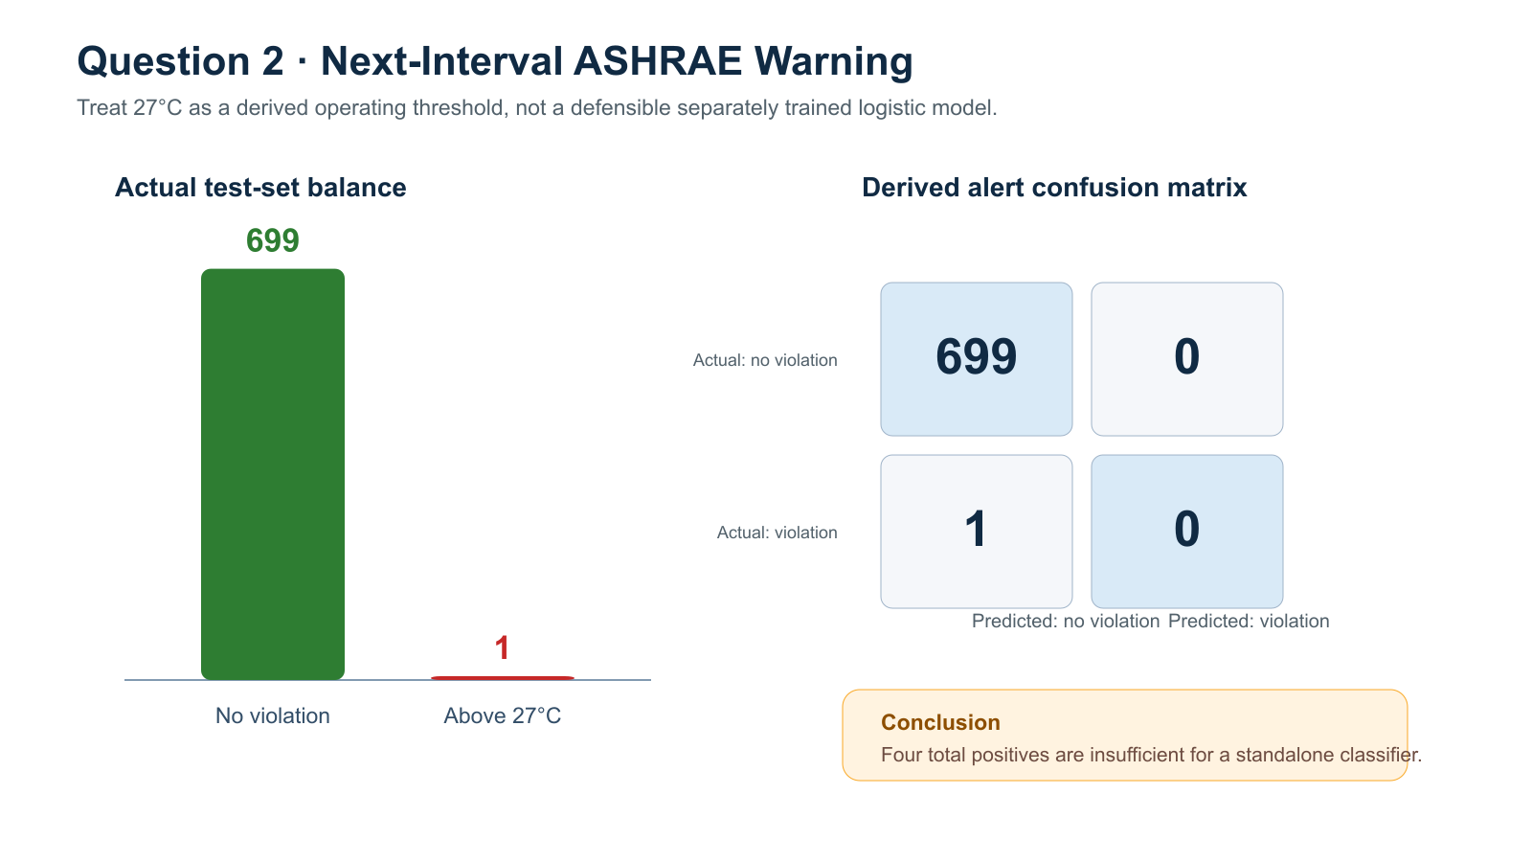
Figure 2. Test-set class balance and the derived-alert confusion matrix.

10.3 Estimating Cooling-Unit Power Consumption
Question: Can workload, ambient temperature, and cooling utilization estimate cooling-unit power consumption?
Method: Linear regression using server workload, ambient temperature, chiller usage, and AHU usage from the same hourly interval.
Test result: R² = 0.999689, MAE = 0.00243 kW, and RMSE = 0.00283 kW.
Interpretation: The selected same-interval operating variables explain almost all cooling-power variation. This is a highly accurate contemporaneous estimate, but it is not a future power forecast.
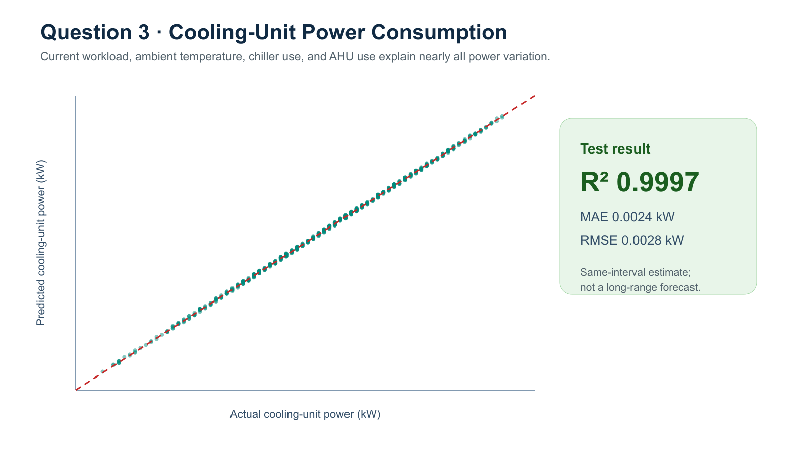
Figure 3. Actual and predicted cooling-unit power on the chronological test set.

10.4 Overall Conclusion
The three results have different levels of practical value. Question 1 is a valid negative result because current readings do not forecast the following hour well. Question 2 exposes a severe class-imbalance limitation and supports a threshold warning rather than a trained classifier. Question 3 provides the strongest model, but only for estimating cooling power within the same interval. These distinctions must remain explicit whenever the notebook, report, or presentation is discussed.

11. Conclusion
Data centers are the invisible backbone of the modern digital world. Every app, website, AI tool, and cloud service depends on thousands of servers running continuously — and all of those servers generate heat. Managing that heat is one of the most technically demanding, energy-intensive, and environmentally consequential challenges in modern engineering.
This report has covered the physical principles of how data centers generate and manage heat, the three critical environmental parameters — temperature, humidity, and pressure — that must be monitored at all times, the industry standards set by ASHRAE that define safe operating conditions, and the significant environmental costs of running this global infrastructure.
Temperature emerges as the most important of the three parameters, because it is the most direct indicator of hardware health and cooling system effectiveness. Humidity matters because both extremes — too dry (static discharge) and too humid (condensation and corrosion) — can destroy hardware silently and suddenly. Pressure provides the context for understanding airflow, ensuring that the cooling system is actually delivering cool air where it is needed.
The Arduino project in the second half of this report demonstrates that these same concepts are accessible at any scale. A $5 sensor and a $15 microcontroller can measure the same physical properties that a $10 billion hyperscale data center monitors with thousands of industrial-grade sensors. The physics is identical; only the scale and precision differ.
Looking forward, the data center industry faces growing pressure to reduce its environmental footprint. The explosion in AI computing is accelerating energy and water consumption at a time when the world urgently needs to reduce both. Solutions exist — renewable energy, liquid cooling, closed-loop water systems, waste heat reuse, and smarter sensor-driven optimization — but implementing them at scale across thousands of facilities worldwide requires both technological innovation and policy change.
Understanding the fundamentals of how data centers work, how they are monitored, and what the challenges are is the first step toward contributing to those solutions — whether as an engineer, a policymaker, a researcher, or a curious citizen. And building a real sensor with your own hands is one of the best ways to make that understanding concrete.

12. References
The following sources were consulted and cited in the preparation of this report. All sources have been verified for accuracy and currency as of June 2026.
- ASHRAE TC 9.9 (2023). Thermal Guidelines for Data Processing Environments – 5th Edition. American Society of Heating, Refrigerating and Air-Conditioning Engineers. Retrieved from: https://envigilance.com/compliance/ashrae-tc-9-9/
- International Energy Agency (IEA) (2025). Energy and AI Report. IEA. Retrieved via Sustainability Atlas: https://sustainableatlas.org/post/data-story-data-center-energy-consumption-water-carbon-trends-1624
- Uptime Institute (2024). Global Data Center Survey 2024. Uptime Institute LLC. Referenced in ASHRAE compliance analysis at https://envigilance.com/compliance/ashrae-tc-9-9/
- U.S. Environmental Protection Agency (2025). Data Center Energy Usage Report. EPA. Cited in MOST Policy Initiative: https://mostpolicyinitiative.org/science-note/data-center-water-use/
- Microsoft Azure (2024, December 9). Sustainable by Design: Next-Generation Datacenters Consume Zero Water for Cooling. Microsoft Cloud Blog. https://www.microsoft.com/en-us/microsoft-cloud/blog/2024/12/09/sustainable-by-design-next-generation-datacenters-consume-zero-water-for-cooling/
- Energy, Environment, and Security Initiative (EESI) (2024). Data Center Energy Needs Could Upend Power Grids and Threaten the Climate. https://www.eesi.org/articles/view/data-center-energy-needs-are-upending-power-grids-and-threatening-the-climate
- TechTarget (2025, updated). Data Center Cooling Systems and Technologies and How They Work. SearchDataCenter. https://www.techtarget.com/searchdatacenter/tip/Data-center-cooling-systems-and-technologies-and-how-they-work
- Tom's Hardware (2025, December 16). The Data Center Cooling State of Play (2025). https://www.tomshardware.com/pc-components/cooling/the-data-center-cooling-state-of-play-2025
- Eaton Corporation (2024). Energy Consumption in Data Centers: Air versus Liquid Cooling. https://www.eaton.com/us/en-us/markets/data-centers/data-center-cooling/efficiency/energy-consumption-in-data-centers-air-versus-liquid-cooling.html
- Park Place Technologies (2024, December 2). Data Center Cooling Systems – Benefits, Differences and Comparisons. https://www.parkplacetechnologies.com/blog/data-center-cooling-systems-benefits-comparisons/
- Sunbird DCIM (2024). Data Center Temperature and Humidity Standards. https://www.sunbirddcim.com/glossary/data-center-temperature-and-humidity-standards
- AKCP (2024, April 2). Data Center Temperature Sensors: Optimizing Efficiency. https://www.akcp.com/index.php/2024/04/02/data-center-temperature-sensors/
- Circuit Digest (2025). BMP280 Sensor Module Working and Arduino Interfacing Guide. https://circuitdigest.com/microcontroller-projects/interfacing-bmp280-sensor-with-arduino
- ComponentIndex (2026, March 11). DHT22 Sensor Guide: Wiring, Code & Pinout for Arduino. https://componentindex.net/components/dht22/
- programmer3 (2023). Data Center Cold Source Control Dataset. Kaggle. https://www.kaggle.com/datasets/programmer3/data-center-cold-source-control-dataset
- Hanwha Data Centers (2025). Data Center Energy Efficiency Best Practices. https://www.hanwhadatacenters.com/blog/data-center-energy-efficiency-best-practices/
End of Report

