Week 1
Started out expanding groups with new organisms. The main limiting factor was genome availability as it had to be sequenced, assembled and annotated if it was to be useful.

Resources used are NCBI, Ensembl, GigaDB, Wikipedia (for finding animals in group), Anage (to find lifespan)

Along with the common names, scientific names and the lifespan of the organisms the place where their (annotated) genomes could be found were saved. Of these genome assemblies several statistics were looked up to determine quality. The depth or coverage, total assembly length, number of protein coding genes and the N50 of the contigs and scaffolds.

After reviewing the list it was decided that any assembly with a coverage <10X was not of sufficient quality to use for finding orthologs/d_{N}/d_{S}. These organisms were not discarded but saved as they might be of use later on when genes of interest have been established. These genomes could be checked for the presence or absence of interesting genes even though their quality is inferior.
The list at this point was comprised of:
- 5 whales (1 low coverage)
- 13 birds (2 low coverage)
- 11 primates (5 low coverage)
- 12 rodents (1 low coverage)
- 11 fish (1 low coverage)
- 6 bats (2 low coverage)

Annotation quality of these genomes still had to be checked.

Week 2
Part of the organisms collected in week 1 were available on ensembl. Ensembl provided an easy way to identify ortholog genes between two organisms using Biomart. For the groups that have a majority of the members available on ensembl a reference species was chosen (the longest lived species available). The ortholog genes that every member of the group has with the reference organism were collected along with the type of orthology (one:one, one:many, many:one, many:many).

Many of the species collected in week 1 were not available on Ensembl. Especially the birds, whales and bats had either none or only a small part of their members available on Ensemble. To use these species orthology needed to be established. This was done using a toolset called OthoMCL. It is comprised of a number of scripts to prepare a MySQL (or Oracle) database, adapt fasta files to the right format and process the results of an all vs. all protein BLAST.

The steps for OrthoMCL are described here;
- Installing MySQL (or Oracle)
- Installing MCL (used for clustering the results)
- Use orthomclInstallSchema to load the necessary tables into your database
- Collect protein fasta files for the species you want to examine
- Use orthoAdjustFasta to create fasta files compatible with the rest of OrthoMCL
- Use orthomclFilterFasta to remove proteins that are too small or contain too many stop codons. (use minimum length of 10 and maximum stop codon percentage of 20)
- Run an all vs. all BLAST using the filtered fasta
- Use orthomclLoadBlast to load the tab separated file into the database and construct indexes
- Use orthomclPairs to find protein pairs and predict orthology in these protein pairs
- Use orthomclDumpPairsFiles to get ortholog, coortholog and inparalog files
At first the organisms were all compared in a pairwise manner. One organism per group as the reference and the rest compared to that one. For this orthomclFilterFasta was used on pairs of fasta files followed by makeblastdb for the combined files where a local protein db was created to use when blasting. This way a pairwise blast was performed for all birds, bats, whales and some fish.

Week 3
Collecting blast results and using orthomcl to find potential ortholog pairs in these all v all blast results. Some protein files turned out to have multiple transcripts per gene in them. This had the result that orthomcl found pairs for every isoform of the gene and produced 50k+ orthologs for organisms with +/- 20k protein coding genes. This was fixed by using a python script to find the longest transcript of every gene and use those instead of the full file.

Week 4
This week I received the scripts used by Sharlie. The pipeline was heavily dependant on very specific input format. This did not match the data I got from orthomcl. Sharlie had used a bunch of other scripts to convert her orthomcl output. These, however, contained large amounts of hardcoded names for things like files and organisms. When working with the amount of organisms she did this is still doable but seeing as I have several times as many this wasn’t feasible anymore. To combat this I have rewritten almost the entire pipeline to be able to use the output straight from orthomcl. Aside from that the script now has better documentation, commentary, cleans up after itself and is more than 10x more efficient. After dnds ratios are calculated you’re left with a file containing the identifiers used in the cds with their dn, ds, dn/ds and ortholog. The annotations were used to find ensembl stable IDs and gene names for every ortholog.

Steps for organism in Ensembl:
- get orthologs between reference organisms and another (only geneIDs)
- download cds file
- use removeDuplicateTranscripts.py to remove short isoforms of genes from cds
- use orthologs file, fixed cds of borth organisms and dndsRewritten.py to find dnds ratios
- ???

Steps for other organisms:
- get protein fasta
- walk trhough all orthomcl steps > orthologs file
- get cds
- if necessary run cds through removeDuplicateTranscripts.py (only if input contained multiple transcripts per gene)
- run dndsRewritten.py to get dnds values
- get GFF (if you need gene names)
- run genesFromAnnotation.py to get gene names and ensembl IDs
- ???

Blast query: blastall -z 29168 -i goodProteins.fasta -d apla_db -m 8 -p blastp -F 'm S' -v 100000 -b 100000 -e 1e-5 -o apla_blastout.tsv
Done so far:
collecting data from various sources
prepping the data for processing
using OrthoMCL to establish orthology
written a pipeline which calculates dnds ratios with the help of lastz and pamls codeml tool
ran data through the pipeline
some preliminary visualization

to do:
Kwaliteitszorg/arbo
alter all the scripts to work without gaps and stopcodons in the alignments (they throw off the dnds ratios it seems) ← and rerun the data
try to get access to the beaver genome to compare it to the naked mole rat as they both live in hypoxic enviroments and are both quite long lived.
Build evolutionary trees per group to see if observations make sense.
Write script to check the presence of specific (aging) genes like cebp alpha/beta.
Combine with evolutionary trees to see where genes are present and where they're lost.
Look for genes present in long lived organism that are absent in the short lived organisms.
Check to make sure genes are truly absent and not just scattered in the short lived organisms.
This could give an idea about interesting genes to knock out/in in killifish
writing the report ← and making plots/diagrams to go with the data (in R)
making a pretty poster

Scripts:

dndsRewritten.py
flags:
-h/--help → Display all flags and a short explanation
-o/--orthologs → Name of the file containing ortholog genes
-i/--referenceIndex → Index of the reference organism in the ortholog file (0 or 1)
-c1/--cds1 → CDS of the reference organism
-c2/--cds2 → CDS of the ortholog organism
-of/--outfile → Output file name

All flags are mandatory, a typical program call could be:

python3 dndsRewritten.py –orthologs /data/cau_aan_orthologs.txt -i 0 –cds1 /data/cau_cds.fa –cds2 /data/aan_cds.fa –outfile ./output/dnds_results.tsv

order:
- run orthomcl steps
- collect cds (or retrieve sequences from genbank with genbankToCds.py)
- run removeDuplicateTranscripts.py on cds
- calculate dnds with getDnds.py
- assign gene names with geneNames.py
- use intersections.py along with a file containign known ageing genes to check wich are present in the data

normally dnds ratios are 1 = neutral selection <1 purifying selection >1 positive selection. For initial visualization and checks histograms were made. But to be able to see anything a log transformation was performed. After this 0 is neutral selection, <0 is purifying and >0 would be positive. The histograms are expected to show two peaks, one on purifying selection and one on positive. For rodents this was a very clear picture;
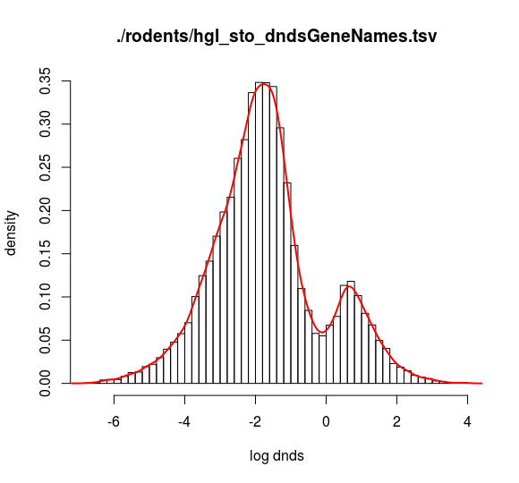

For the other groups the outcome wasnt as clear.
Primates:
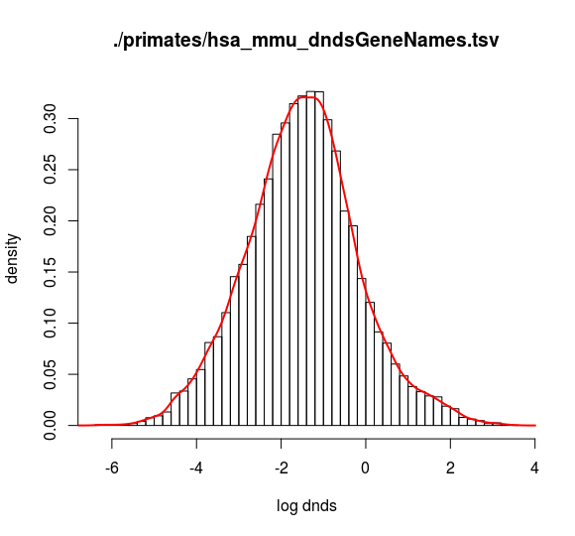

Birds are a mixed bag with plots looking like expected and plots only having a little “bump”

