SIMATS ENGINEERING
SAVEETHA INSTITUTE OF MEDICAL AND TECHNICAL SCIENCES
NAME: Y. Veerendar Reddy
DATE:20/10/2026
LAB EXP: 25
Reg Mo: 192325102
Course Code/ Name: DSA0601 / Data Handling and Visualization
Set 25: Website Traffic Analysis
Dataset: Website Traffic
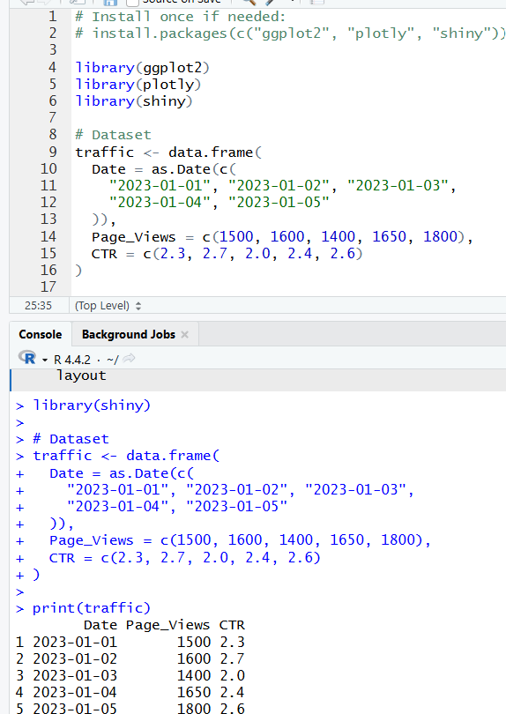
1. In Tableau, create a line chart to visualize the trend in page views over time. Label the axes and title the chart.
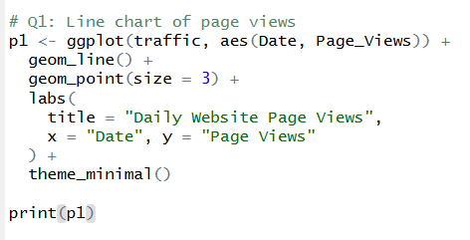
OUTPUT:
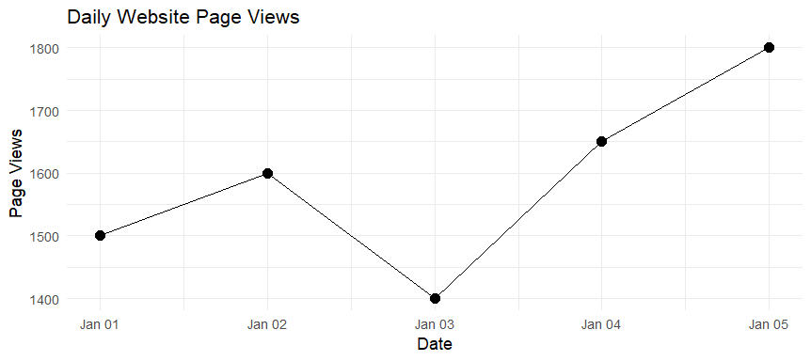

2. In R, generate a bar chart to show the top N days with the highest click-through rates. Label the chart elements.
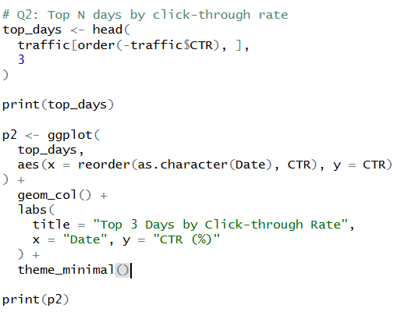
OUTPUT:
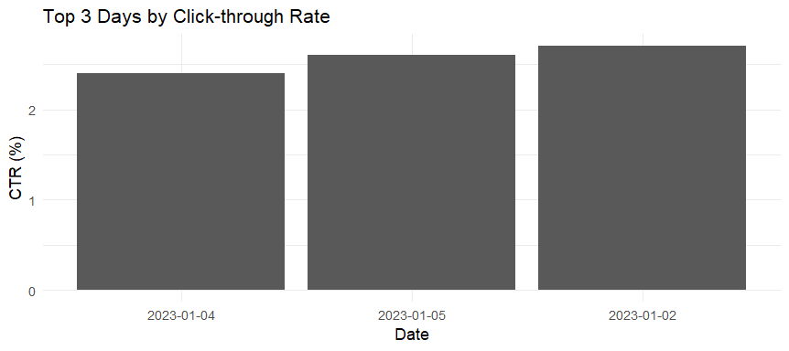

3. In R, build a stacked area chart to display the distribution of user interactions (likes, shares, comments) on the website.
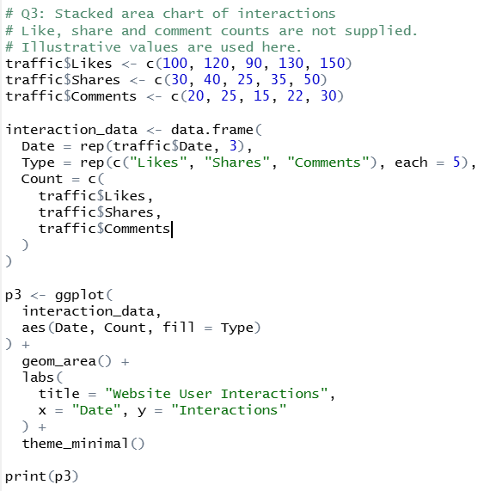
OUTPUT:
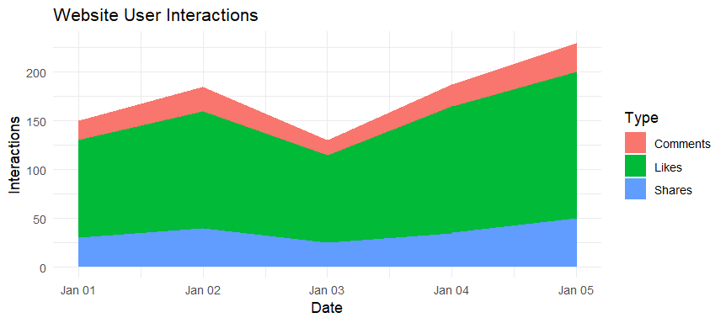

4. In Tableau, create a dashboard with an interactive map showing traffic sources and a bar chart displaying page views by source.
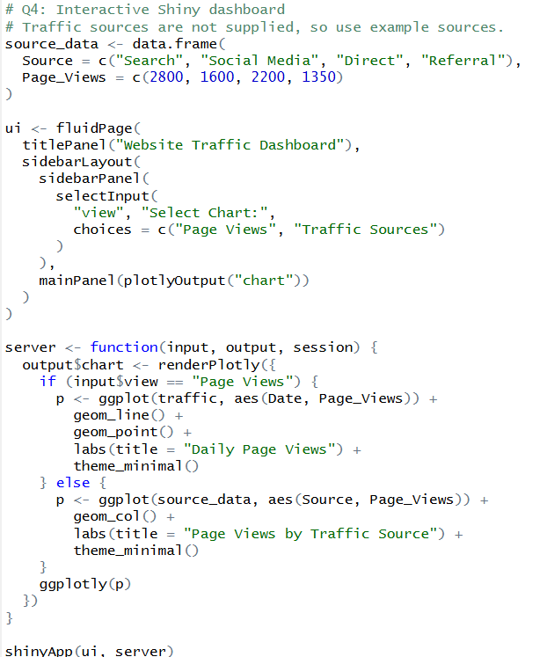
OUTPUT:
