SIMATS ENGINEERING
SAVEETHA INSTITUTE OF MEDICAL AND TECHNICAL SCIENCES
NAME: Y. Veerendar Reddy
DATE:20/10/2026
LAB EXP: 26
Reg Mo: 192325102
Course Code/ Name: DSA0601 / Data Handling and Visualization
SET 26
Dataset: Student_Mini_Data.csv
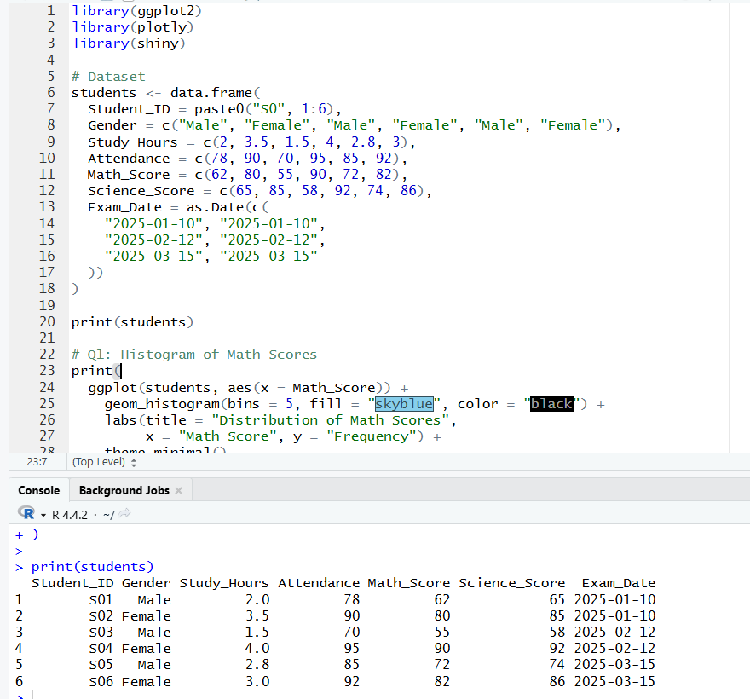
1. Import the dataset in R. Plot a histogram for Math_Score. Draw a boxplot of Science_Score by Gender. Add proper title and labels. Interpret the results.
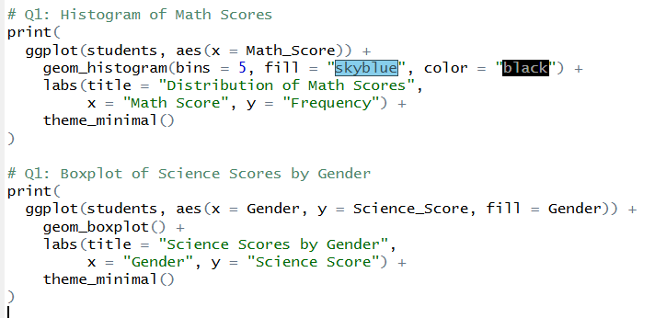
OUTPUT:
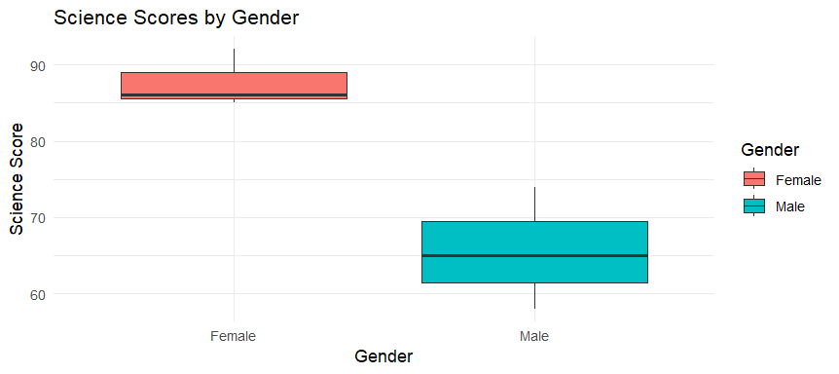

2. Create a scatter plot using R programming between Study_Hours and Math_Score. Use different colors for Gender. Add a regression line. Explain the relationship between study time and performance.
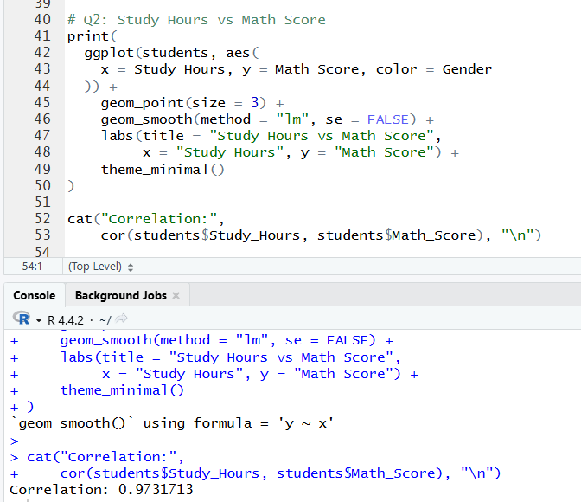
OUTPUT:
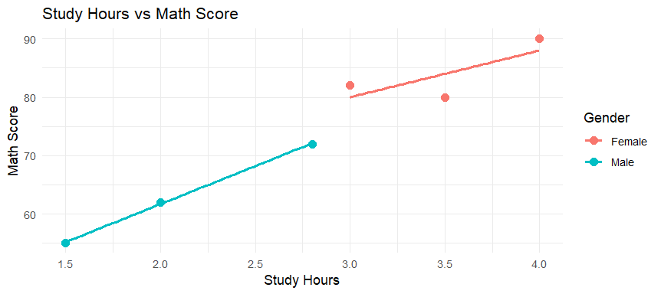

3. Using R, Convert Exam_Date into Date format. Calculate monthly average Math scores. Plot a line chart for the trend. Apply moving average smoothing. Identify any increasing or decreasing pattern.
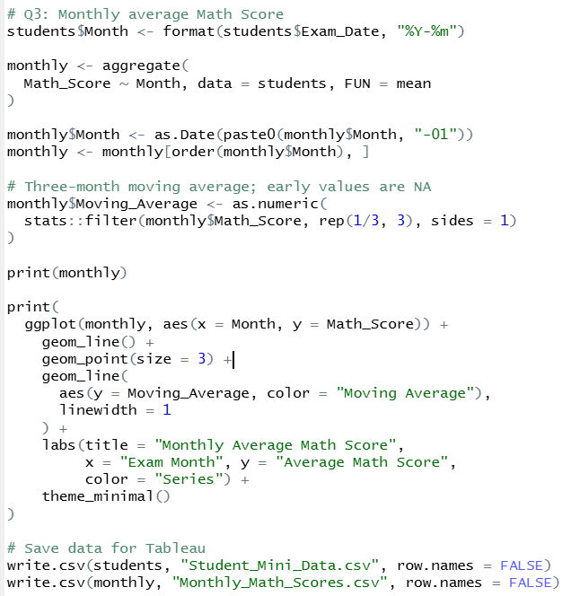
OUTPUT:
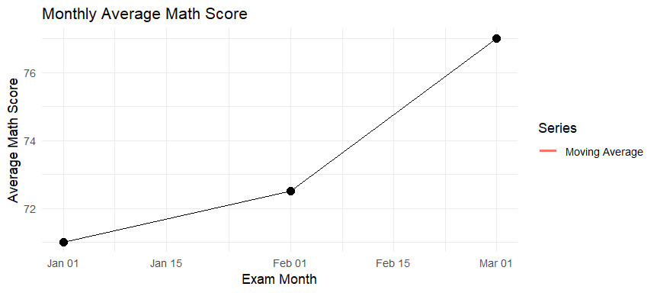
4. Import Student_Mini_Data.csv into Tableau. Create a bar chart showing average Math scores by Gender. Create a line chart for score trends over time. Add a filter for Exam_Date. Design a simple interactive dashboard.
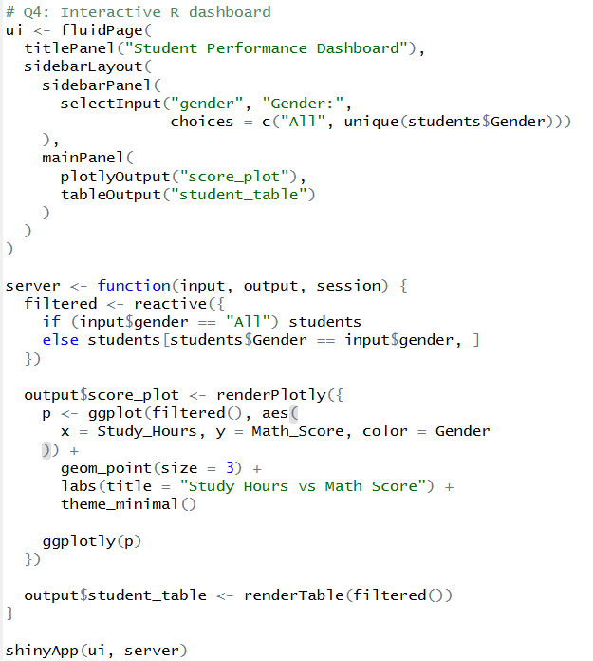
OUTPUT:
