SIMATS ENGINEERING
SAVEETHA INSTITUTE OF MEDICAL AND TECHNICAL SCIENCES
NAME: Y. Veerendar Reddy
DATE:20/10/2026
LAB EXP: 27
Reg Mo: 192325102
Course Code/ Name: DSA0601 / Data Handling and Visualization
SET 27
Dataset: Student_Mini_Data.csv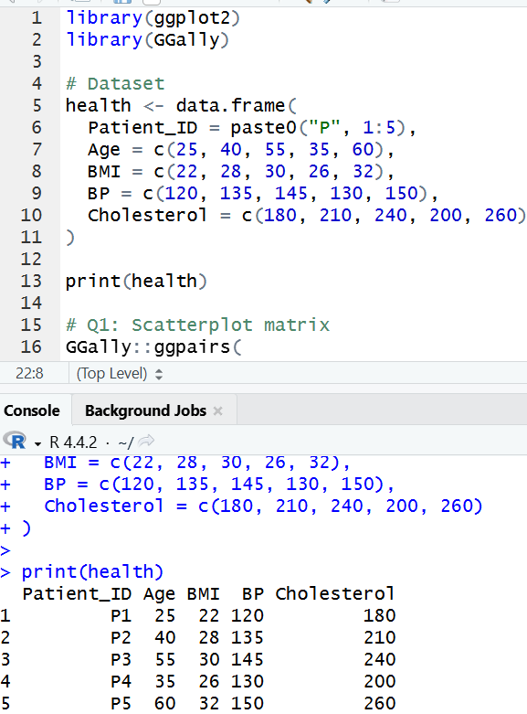
1. Using R, create a scatterplot matrix for Age, BMI, BP, and Cholesterol.Examine pairwise relationships to identify strong correlations, clusters, or potential risk patterns.
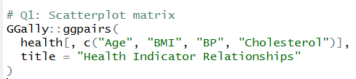
OUTPUT:
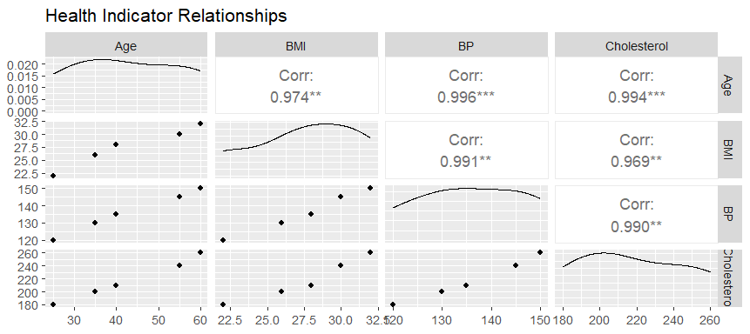

2.Construct Q-Q plot and ECDF for Cholesterol levels to assess distribution behaviour. Comment on normality assumption and skewness.
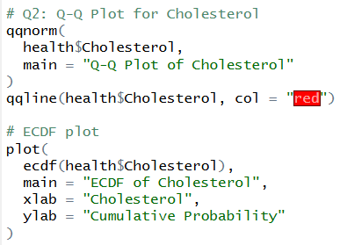
OUTPUT:
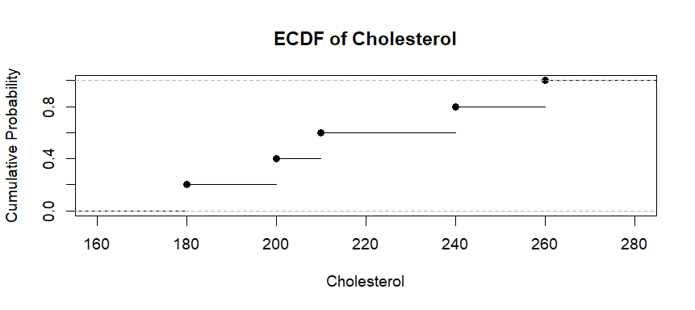

3. Using R, create a bar chart showing the average values of each health indicator (Age, BMI, BP, Cholesterol). Include axis labels, a descriptive title, and distinct colors for each bar. How do these averages relate to general patient health risk
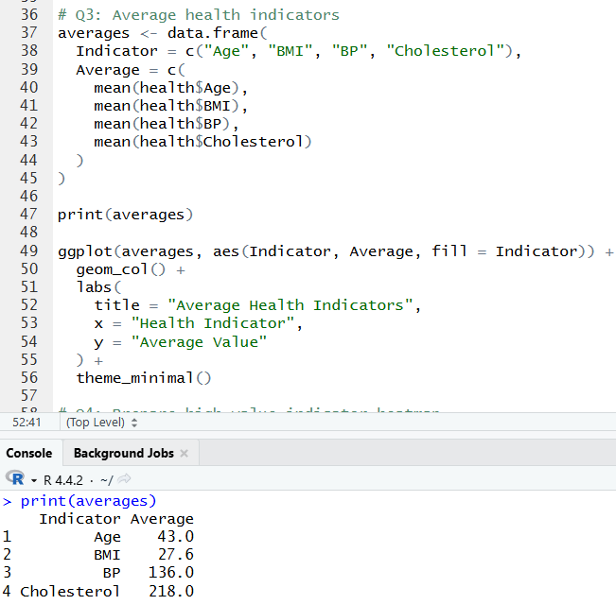
OUTPUT:
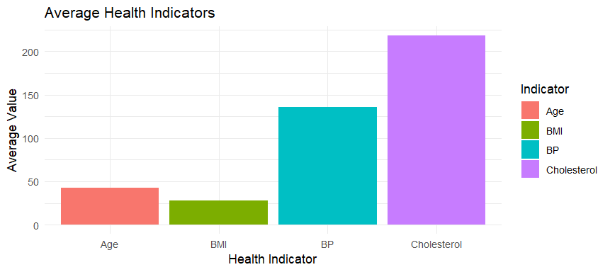
4. Create an interactive Tableau dashboard with a heatmap highlighting high-risk patients and an Age filter for exploring risk patterns. Include hover tooltips showing all health indicators. Analyze which patients are highest risk, how age affects risk, and how this dashboard can aid healthcare professionals in prioritizing care.
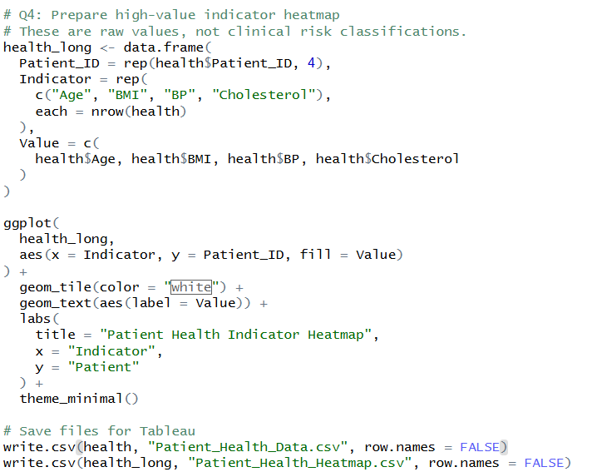
OUTPUT:
