SIMATS ENGINEERING
SAVEETHA INSTITUTE OF MEDICAL AND TECHNICAL SCIENCES
NAME: Y. Veerendar Reddy
DATE:29/09/2026
LAB EXP: 1
Reg Mo: 192325102
Course Code/ Name: DSA0601 / Data Handling and Visualization
Set 1: Monthly Sales Data
Dataset: Monthly Sales
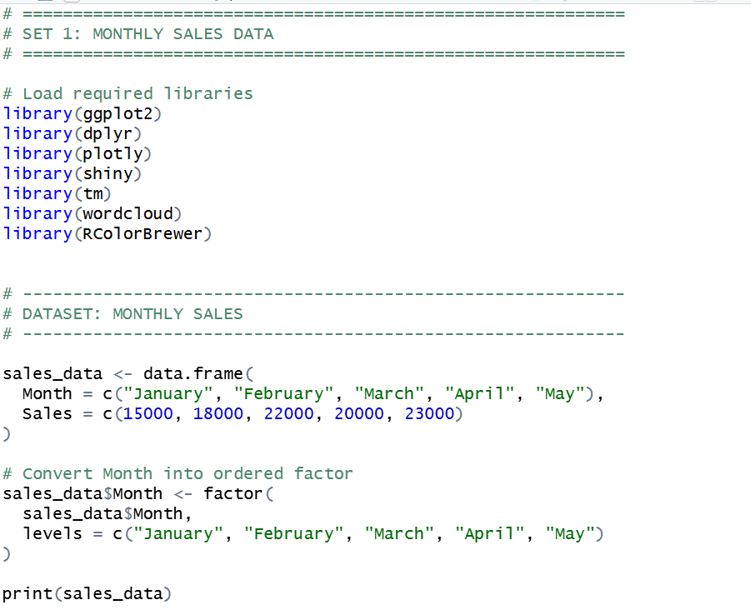
OUTPUT:-
> print(sales_data)
Month Sales
1 January 15000
2 February 18000
3 March 22000
4 April 20000
5 May 23000

1. Create a line chart to visualize the monthly sales. Label the axes and title the chart appropriately.

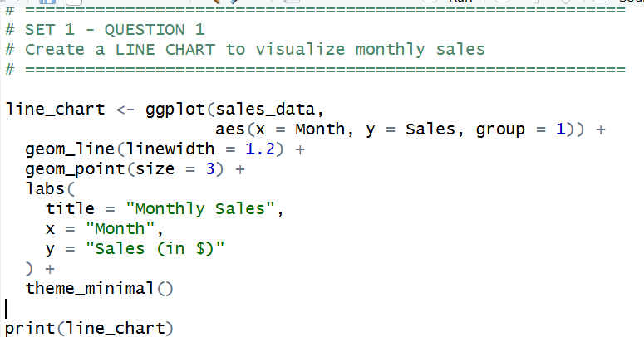
OUTPUT:-

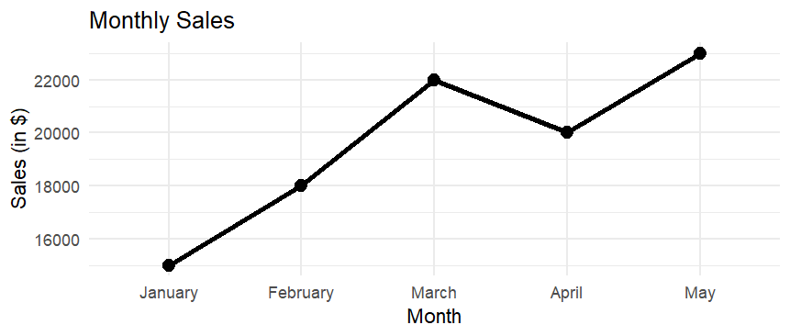

2. Generate a bar chart to display the top-selling products for the year. Label the chart elements.
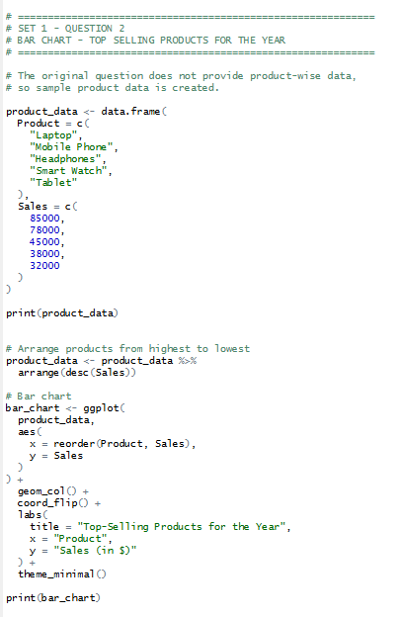

OUTPUT:-
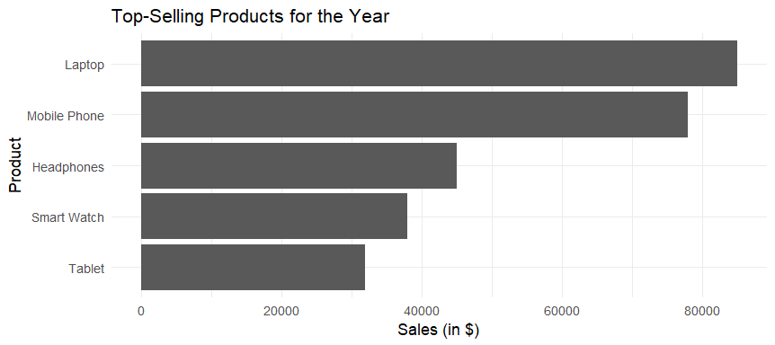

3. Develop a scatter plot to explore the relationship between advertising budget and monthly sales.
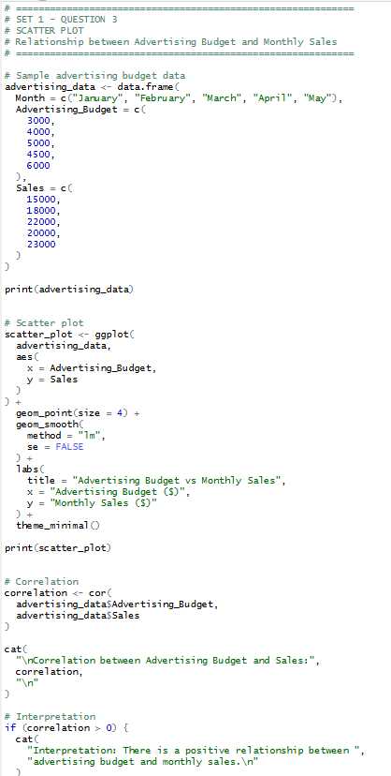
OUTPUT:- 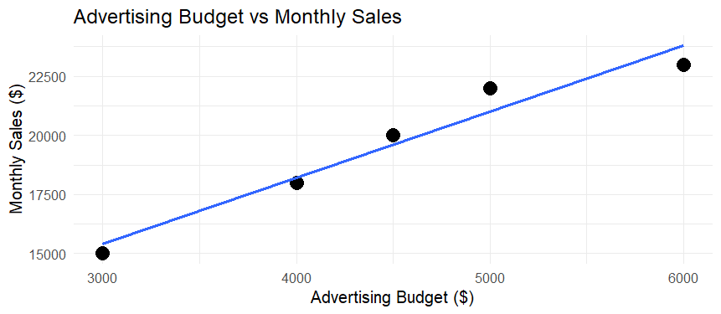

4. Build an interactive dashboard combining the line chart and bar chart to allow users to explore sales data interactively.
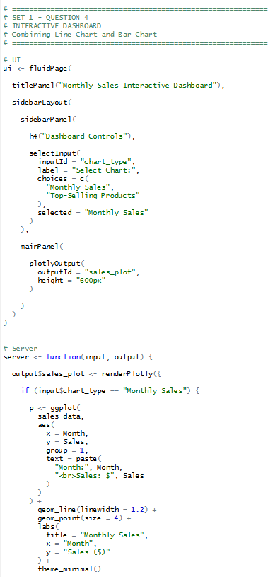
OUTPUT:-
