SIMATS ENGINEERING
SAVEETHA INSTITUTE OF MEDICAL AND TECHNICAL SCIENCES
NAME: Y. Veerendar Reddy
DATE:01/10/2026
LAB EXP: 5
Reg Mo: 192325102
Course Code/ Name: DSA0601 / Data Handling and Visualization

Set 5: Website Analytics
Dataset: Website Traffic
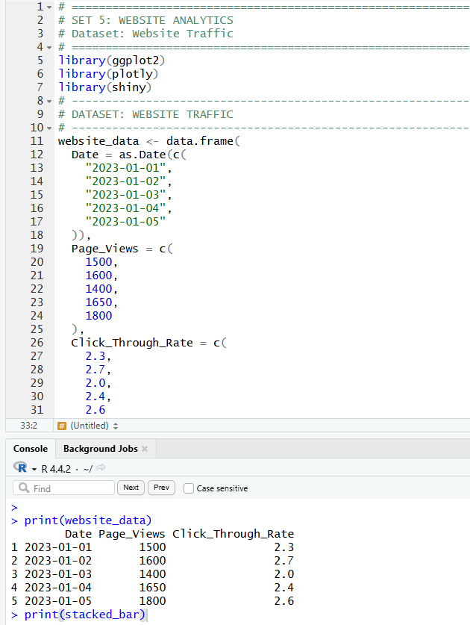

1. Create a line chart to visualize the trend in daily page views over time. Label the axes and title the chart.
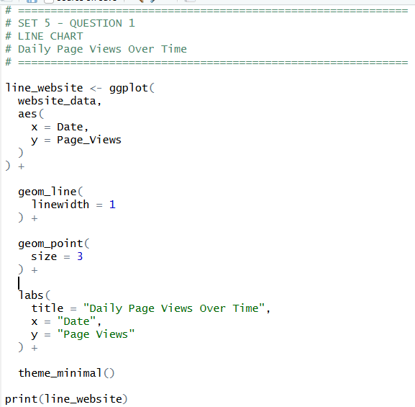
OUTPUT:
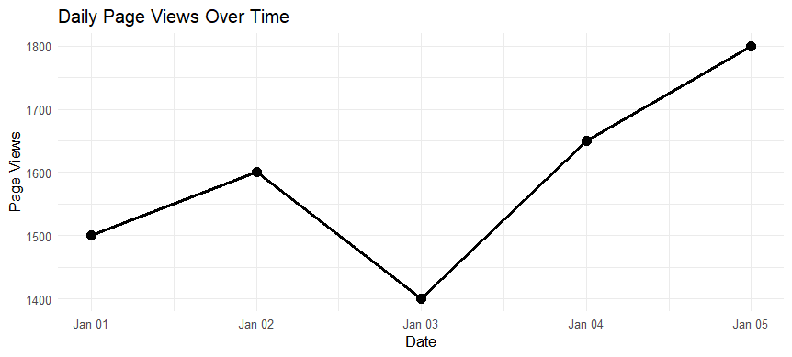

2. Generate a bar chart showing the top N days with the highest click-through rates. Label the chart elements.
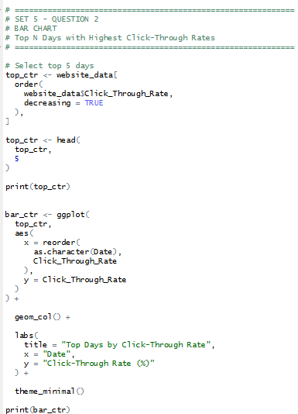
OUTPUT:
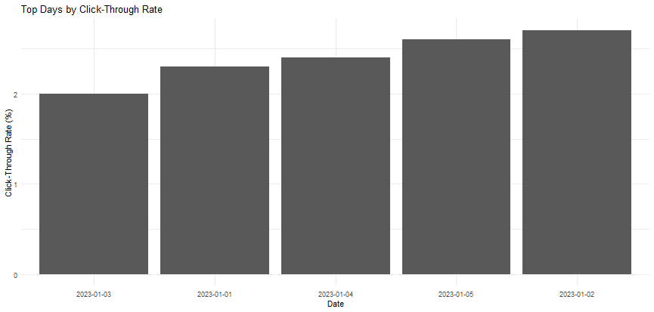

3. Develop a stacked area chart to display the distribution of user interactions (likes, shares, comments) on a website.
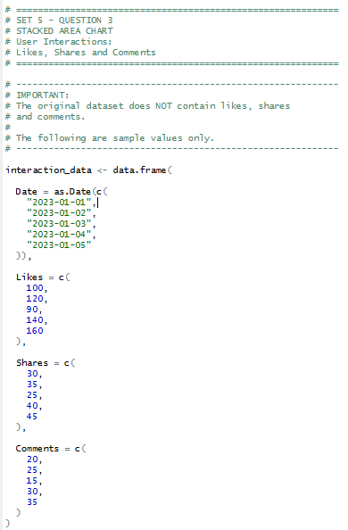
OUTPUT:
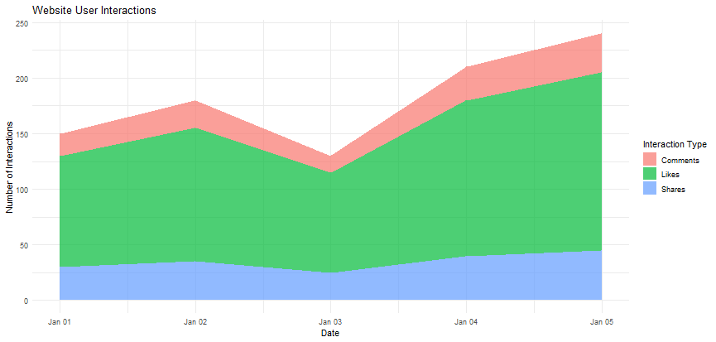

4. Build a Tableau dashboard with the line chart and bar chart for interactive exploration of website traffic data.
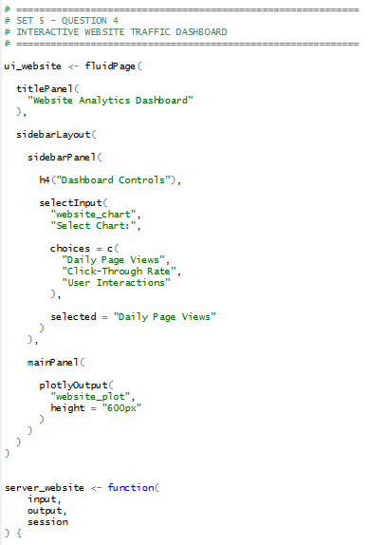
OUTPUT:
