SIMATS ENGINEERING
SAVEETHA INSTITUTE OF MEDICAL AND TECHNICAL SCIENCES
NAME: Y. Veerendar Reddy
DATE:01/10/2026
LAB EXP: 6
Reg Mo: 192325102
Course Code/ Name: DSA0601 / Data Handling and Visualization
Set 6: Product Sales Analysis
Dataset: Monthly Product Sales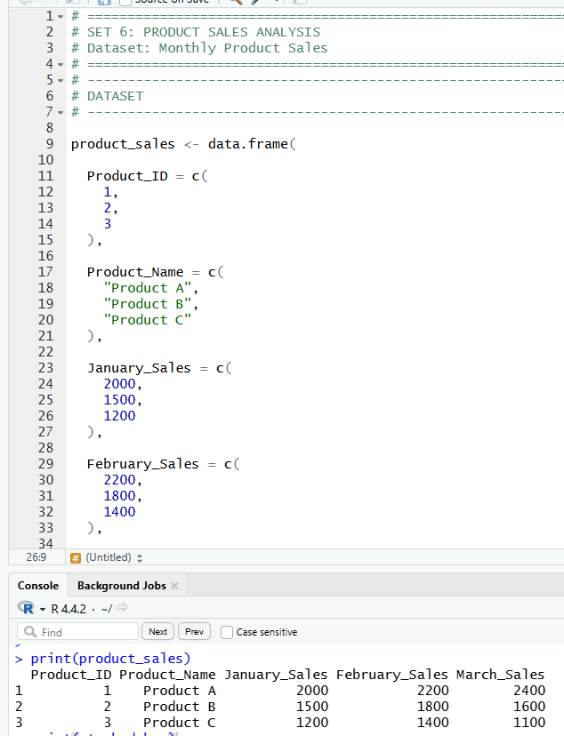
1. Create a grouped bar chart to visualize the sales of each product for the first quarter. Label the chart elements.
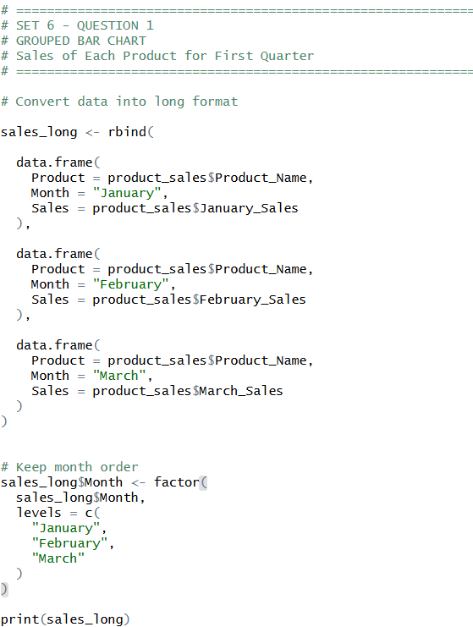
OUTPUT:
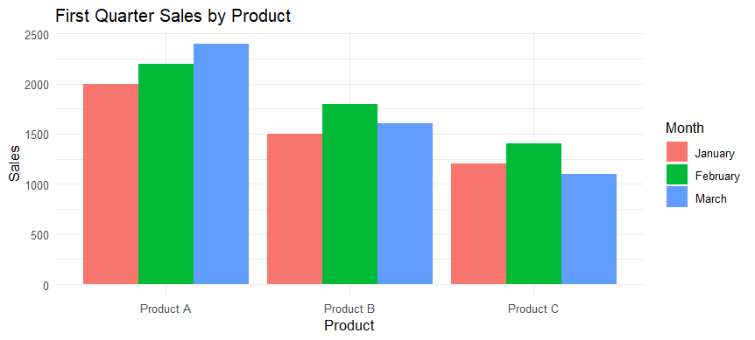
2. Generate a stacked area chart to represent the overall sales trend for all products over the three months.
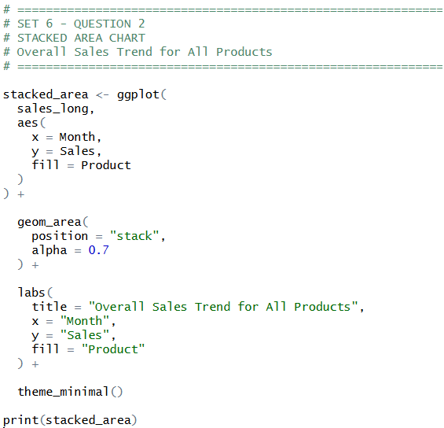
OUTPUT:
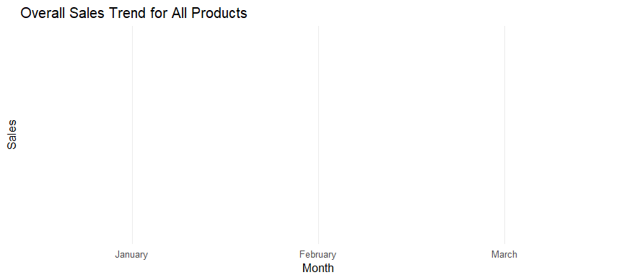

3. Build a table to show the monthly sales data for each product. Label the table elements.
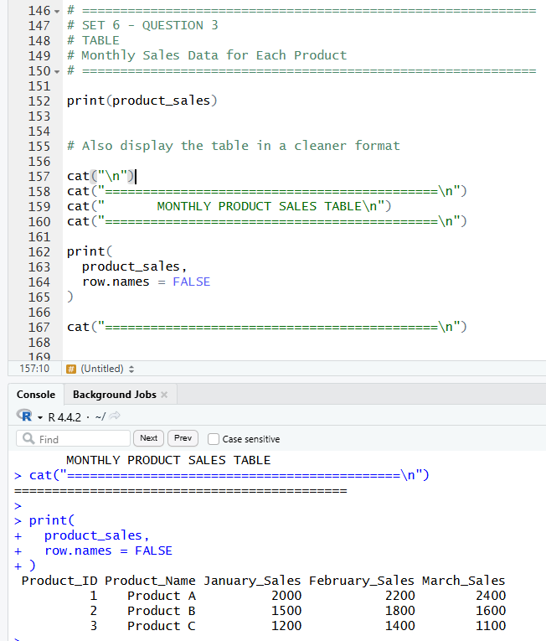

4. Develop a Tableau dashboard combining the grouped bar chart, stacked area chart, and the table for interactive exploration of sales data.
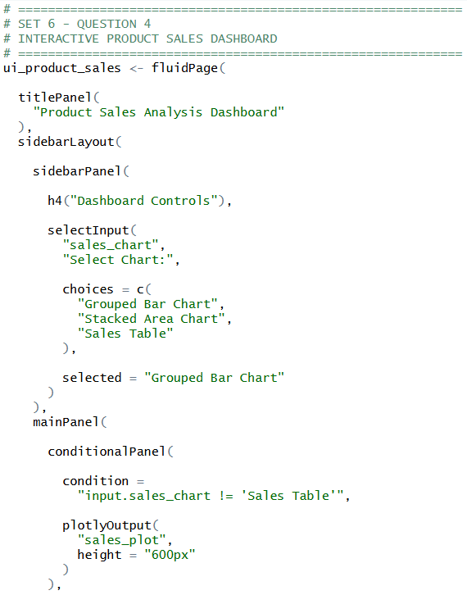
OUTPUT:
