SIMATS ENGINEERING
SAVEETHA INSTITUTE OF MEDICAL AND TECHNICAL SCIENCES
NAME: Y. Veerendar Reddy
DATE:03/10/2026
LAB EXP: 8
Reg Mo: 192325102
Course Code/ Name: DSA0601 / Data Handling and Visualization
Set 8 Employee Performance Analysis
Dataset: Employee Performance
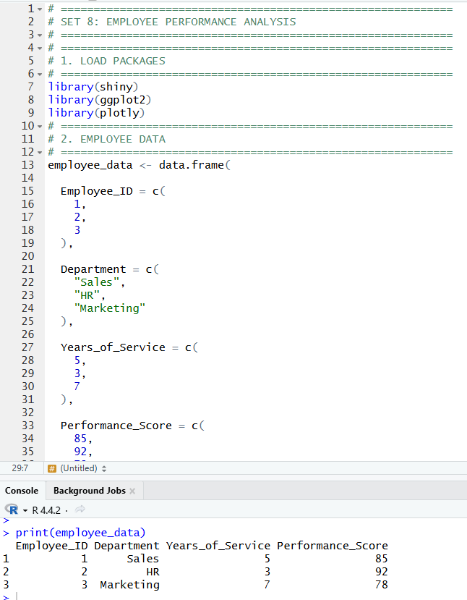

1. Create a line chart to visualize the performance trend of employees over time. Label the axes and title the chart.
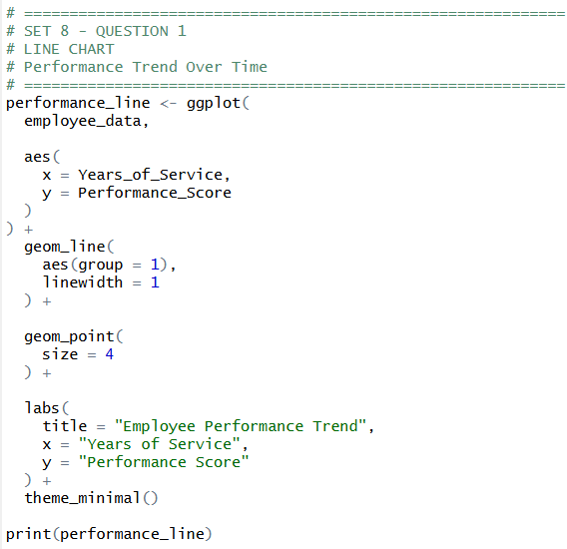
OUTPUT:
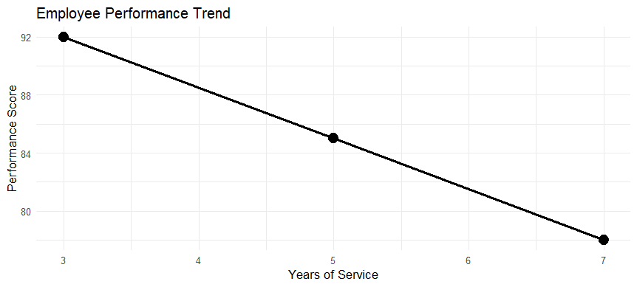

2. Generate a bar chart showing the distribution of employees across different departments. Label the chart elements.
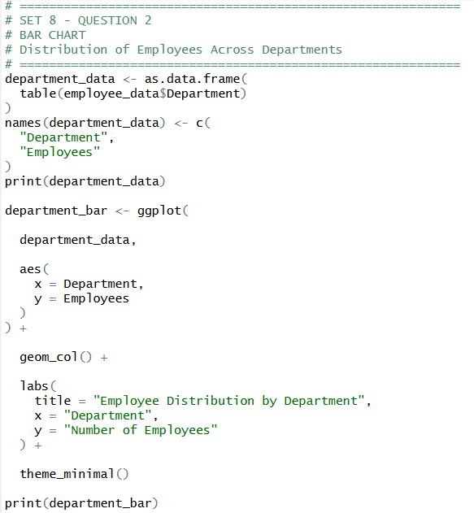
OUTPUT:
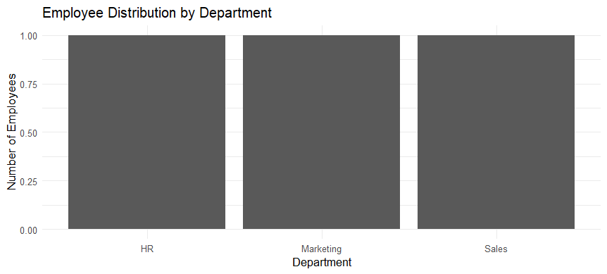

3. Build a table to display the performance data for each employee. Label the table elements.
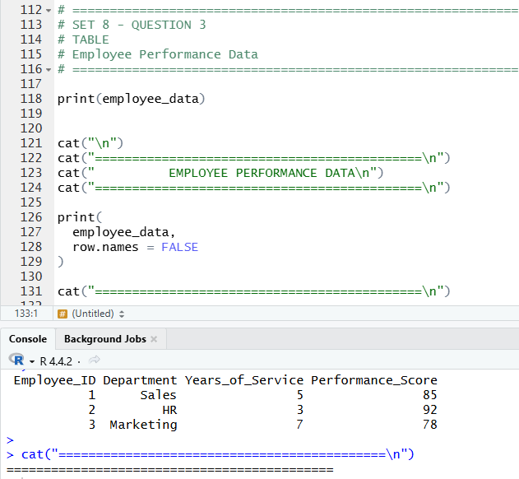

4. Develop a Tableau dashboard combining the line chart, bar chart, and the table for interactive exploration of employee performance data.
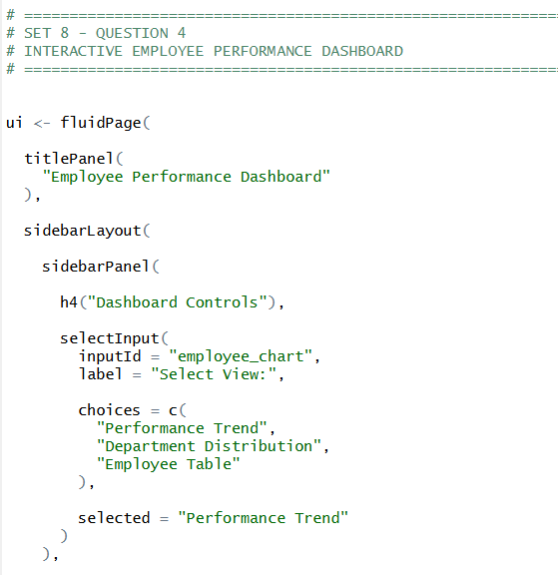
OUTPUT:
