SIMATS ENGINEERING
SAVEETHA INSTITUTE OF MEDICAL AND TECHNICAL SCIENCES
NAME: Y. Veerendar Reddy
DATE:10/10/2026
LAB EXP: 16
Reg Mo: 192325102
Course Code/ Name: DSA0601 / Data Handling and Visualization
Set 16: Customer Demographics Analysis
Dataset: Customer Demographics
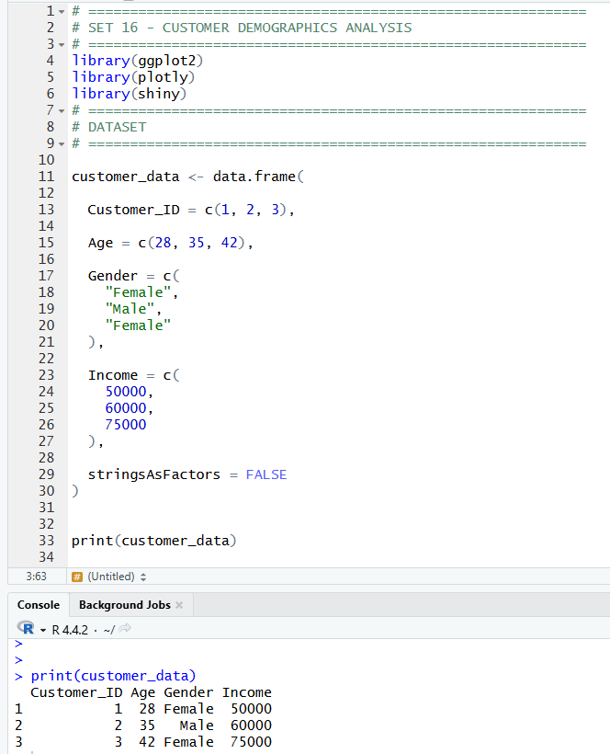
1. Create a bar chart to visualize the distribution of customer ages. Label the axes and title the chart.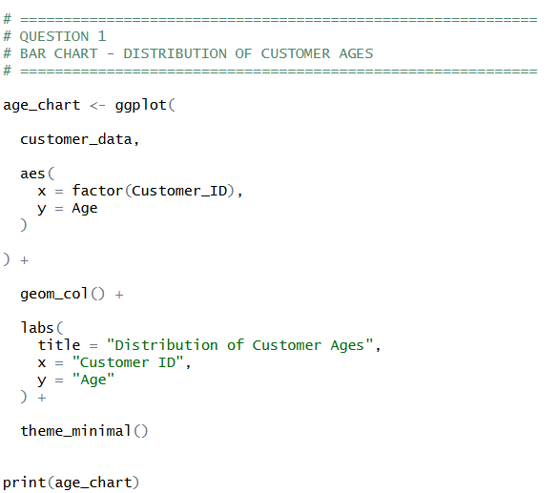
OUTPUT:
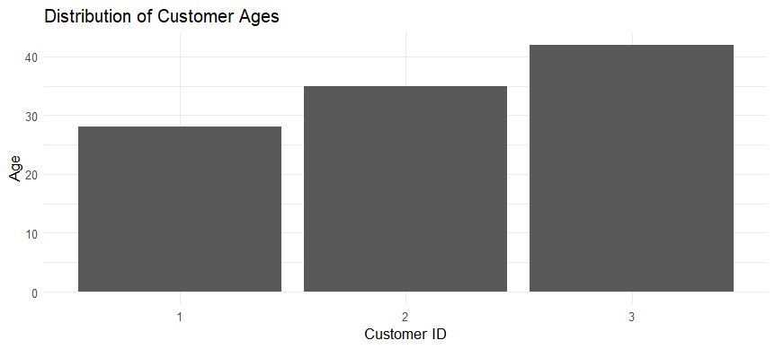

2. Generate a pie chart to represent the distribution of customers by gender.
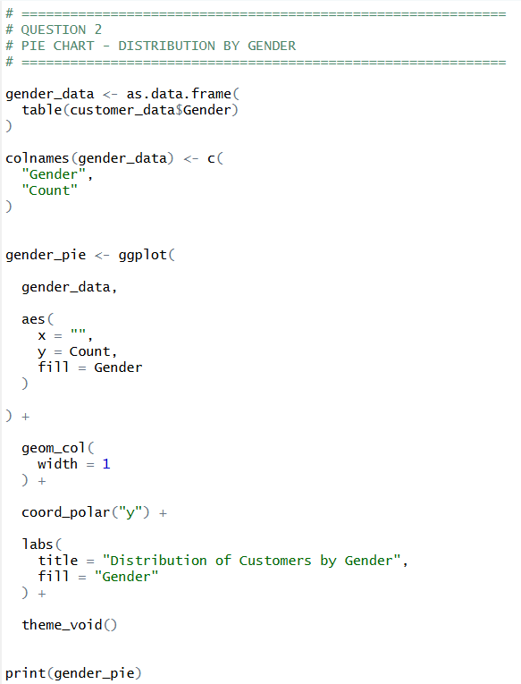
OUTPUT:
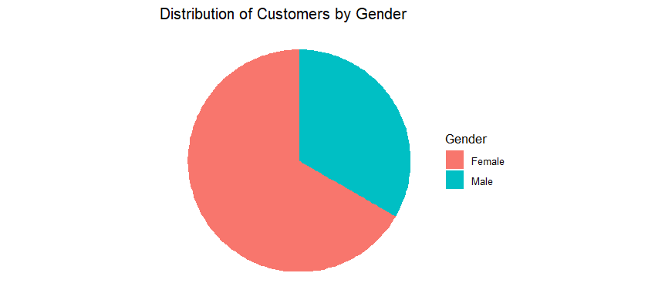
3. Build a table to show the demographic information for each customer. Label the table elements.
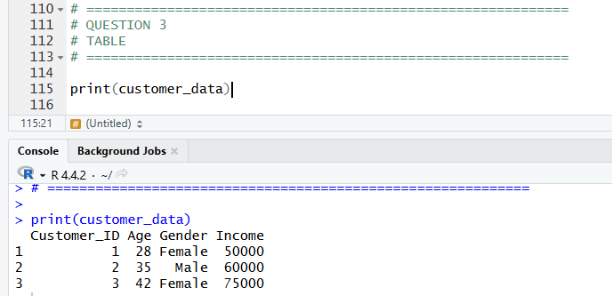

4. Develop a Tableau dashboard combining the bar chart, pie chart, and the table for interactive exploration of customer demographics.
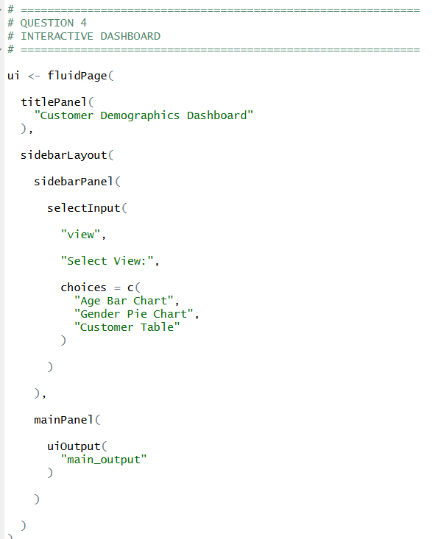
OUTPUT:
