SIMATS ENGINEERING
SAVEETHA INSTITUTE OF MEDICAL AND TECHNICAL SCIENCES
NAME: Y. Veerendar Reddy
DATE:10/10/2026
LAB EXP: 18
Reg Mo: 192325102
Course Code/ Name: DSA0601 / Data Handling and Visualization
Set 18: Product Inventory Management
Dataset: Product Inventory
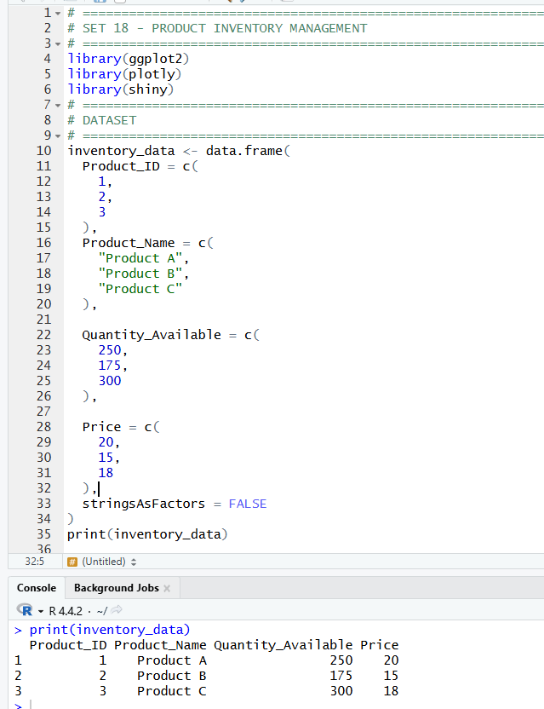
1. Create a bar chart to visualize the quantity of each product in the inventory. Label the axes and title the chart.
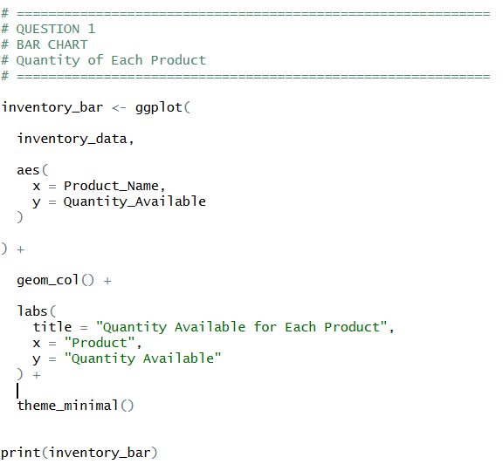
OUTPUT:
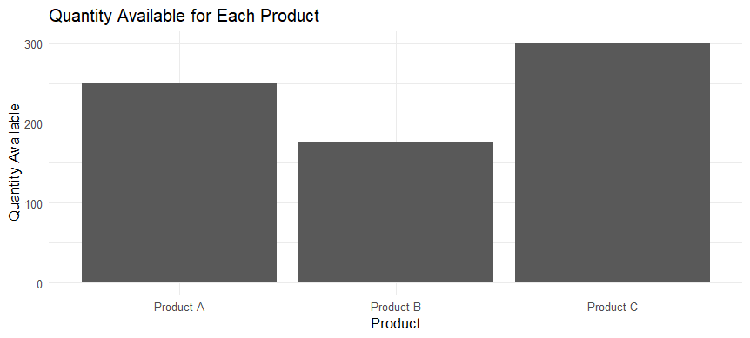

2. Generate a stacked bar chart to show the quantity of each product within different product categories.
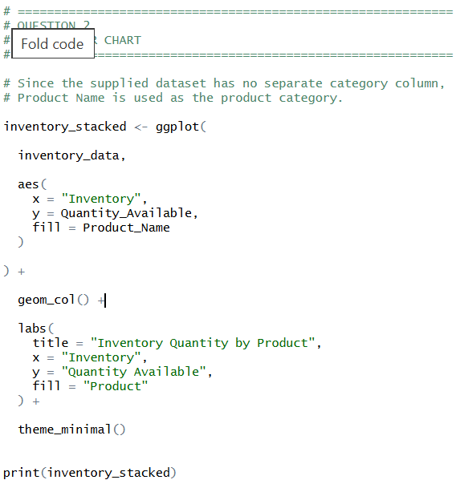
OUTPUT:
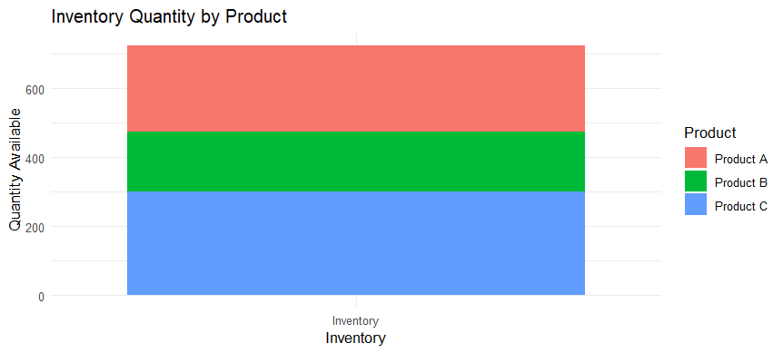

3. Build a table to show the inventory data for each product. Label the table elements.
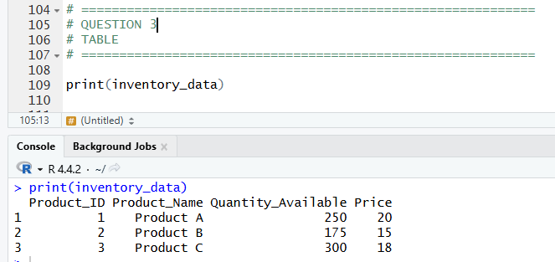

4. Develop a Tableau dashboard combining the bar chart, stacked bar chart, and the table for interactive exploration of inventory data.
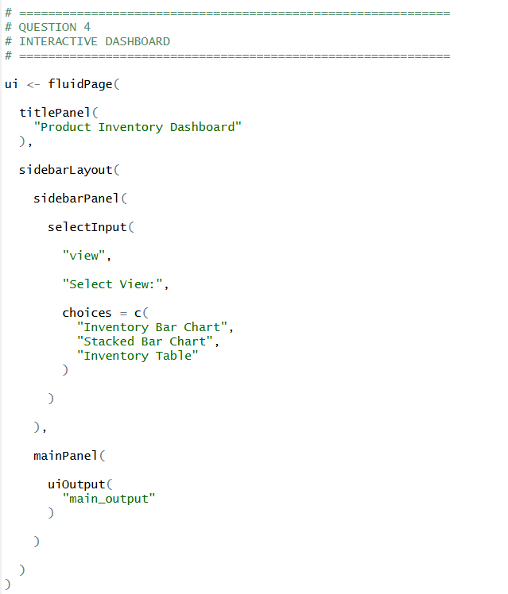
OUTPUT:
