SIMATS ENGINEERING
SAVEETHA INSTITUTE OF MEDICAL AND TECHNICAL SCIENCES
NAME: Y. Veerendar Reddy
DATE:22/10/2026
LAB EXP: 28
Reg Mo: 192325102
Course Code/ Name: DSA0601 / Data Handling and Visualization
SET 28
Dataset: Vehicle Performance Analysis
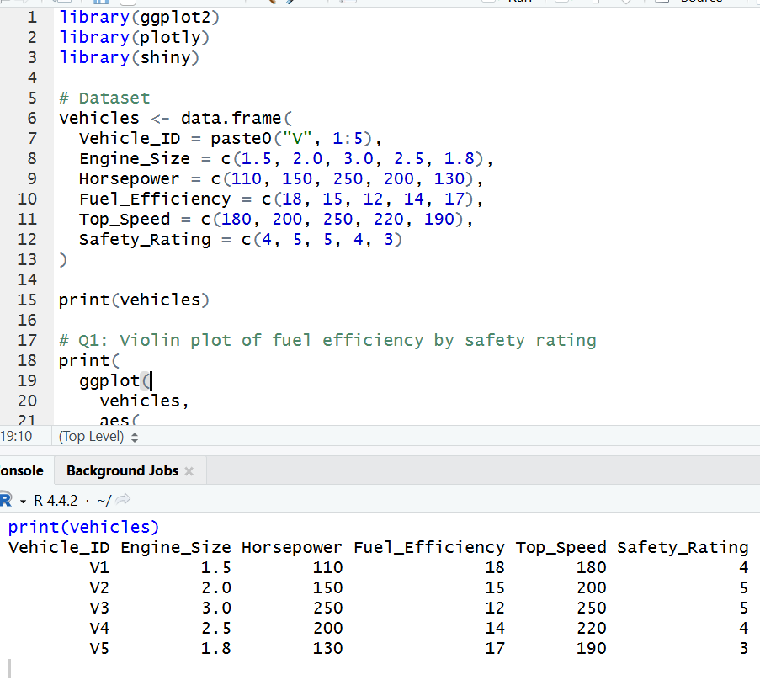
1. Using R, develop a violin plot to compare the distribution of Fuel_Efficiency across different Safety_Rating categories. Examine the spread, central tendency, and variability within each group, and interpret what this indicates about efficiency patterns.
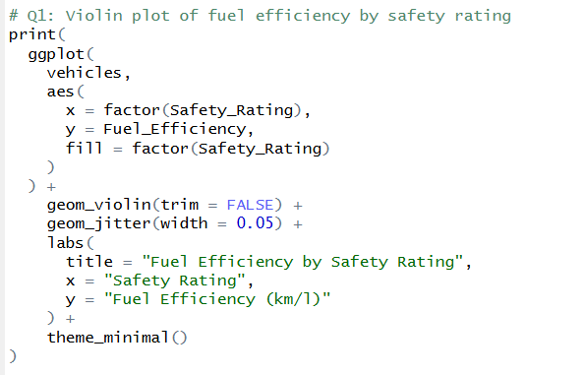
OUTPUT:
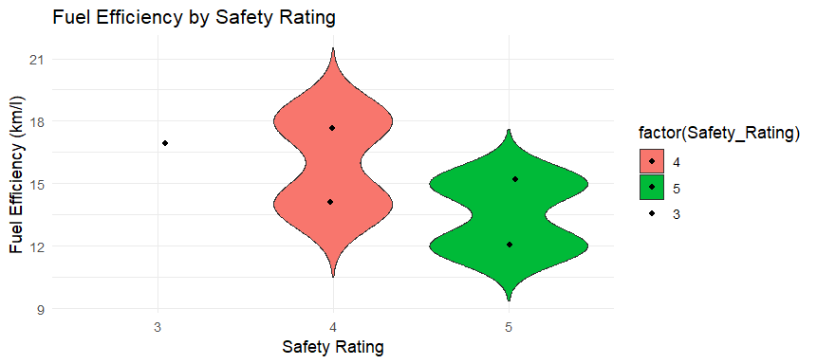

2. Using R, construct a scatter plot to explore the relationship between Horsepower and Top_Speed, applying color differentiation based on Engine_Size. Analyze the strength and direction of correlation and find observable performance trends.
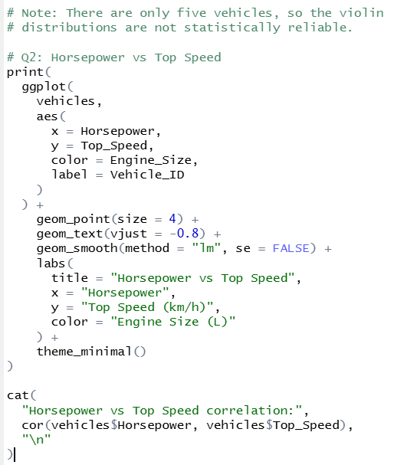
OUTPUT:
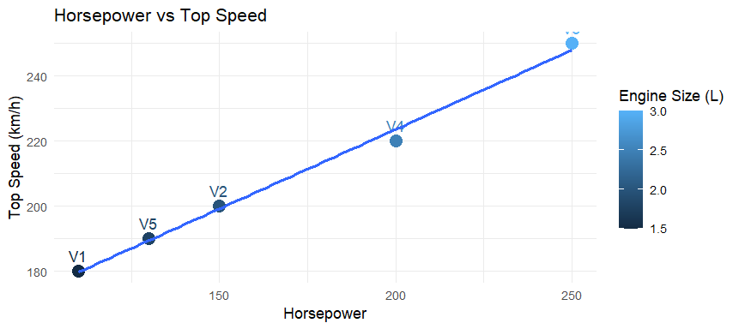

3. Using R, create a correlation heatmap for all numerical variables in the dataset. Identify the variables most strongly associated with Top_Speed and their influence on overall vehicle performance.
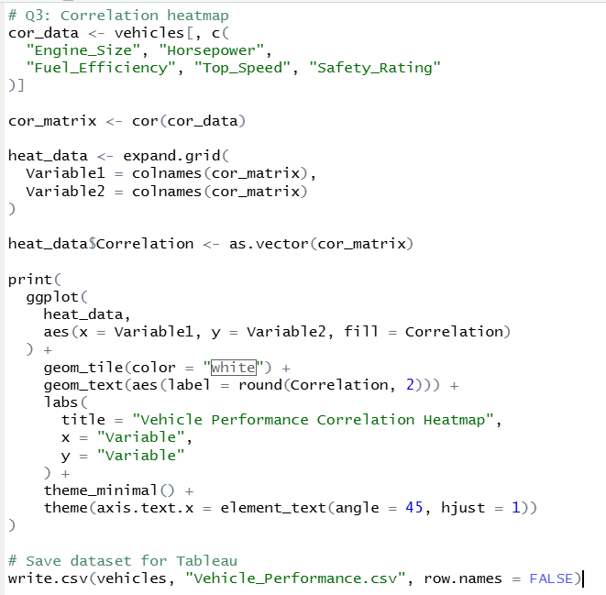
OUTPUT:
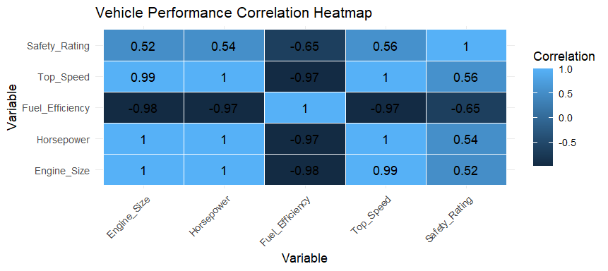
4. In Tableau, design an interactive dashboard incorporating bar charts and scatter plots, along with filters for Engine_Size and Safety_Rating, to highlight vehicles that balance fuel efficiency and high performance. Provide analytical interpretation of the insights derived from the dashboard.
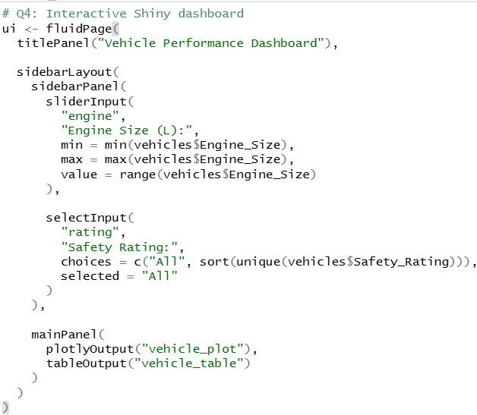
OUTPUT:
