SIMATS ENGINEERING
SAVEETHA INSTITUTE OF MEDICAL AND TECHNICAL SCIENCES
NAME: Y. Veerendar Reddy
DATE:22/10/2026
LAB EXP: 29
Reg Mo: 192325102
Course Code/ Name: DSA0601 / Data Handling and Visualization
SET 29
Dataset: Student Academic Performance
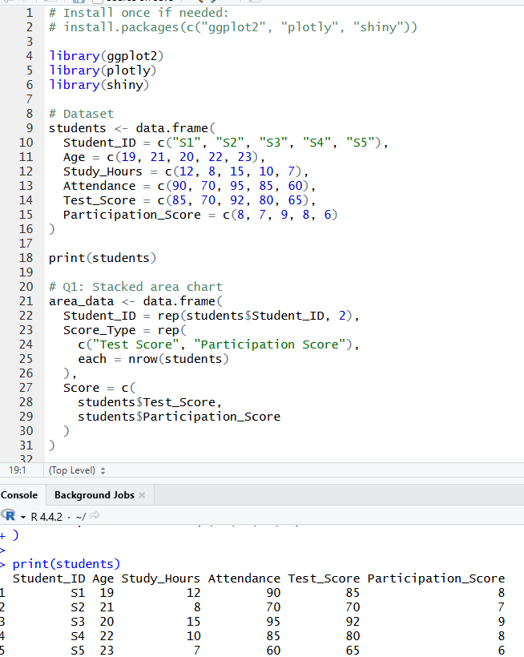
1. Using R, create a stacked area chart showing Test_Score and Participation_Score across students. Analyze trends.
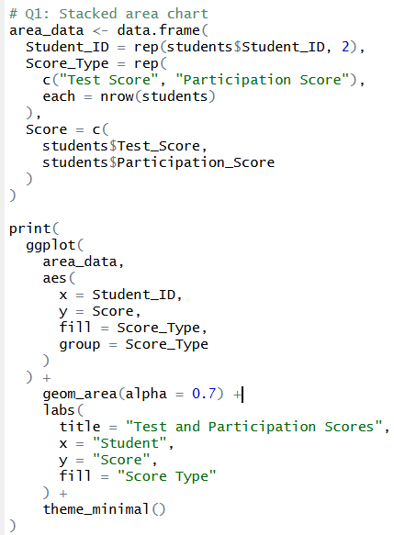
OUTPUT:
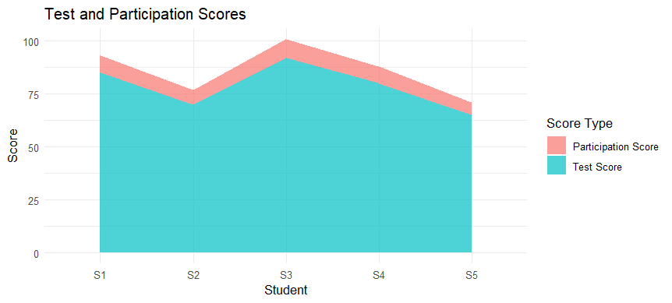

2. Using R, generate a boxplot of Study_Hours grouped by Attendance quartiles. Inter prepatterns. Include axis labels, title, and colors for each quartile. Analyze the boxplot to identify median and interquartile range of study hours per attendance quartile and any outliers in study hours.
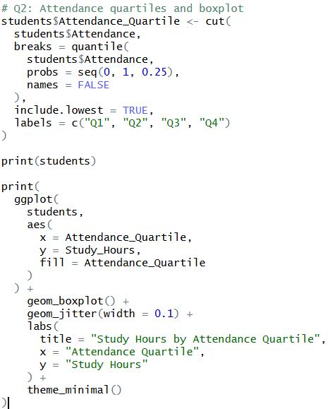
OUTPUT:
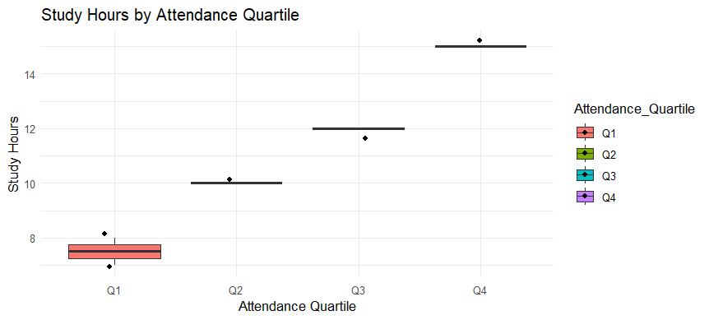

3. Using R, construct a density plot for Test Score to evaluate score distribution and outliers.
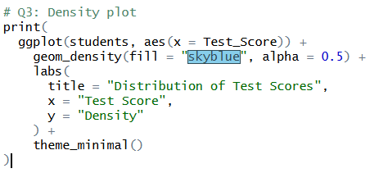
OUTPUT:
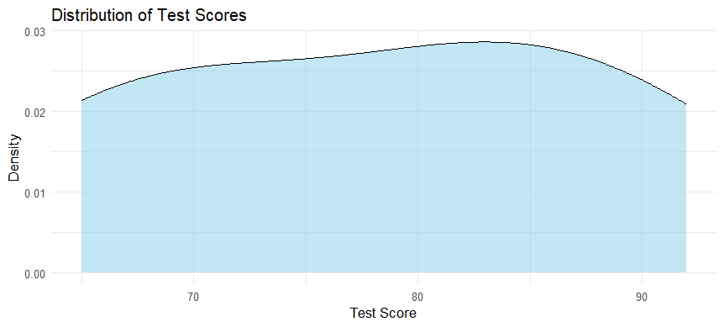

4. In Tableau, design an interactive scatterplot with Study_Hours on X-axis, Test_Score on Y-axis, colored by Participation_Score. Include filters for Age.
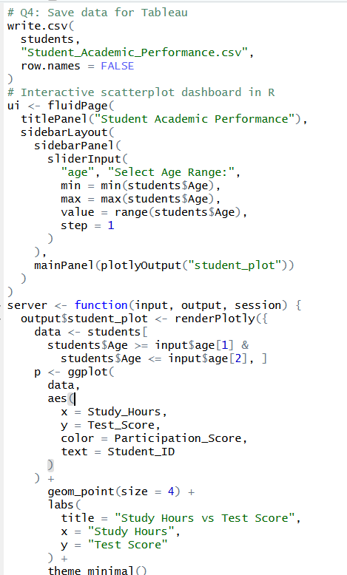
OUTPUT:
