SIMATS ENGINEERING
SAVEETHA INSTITUTE OF MEDICAL AND TECHNICAL SCIENCES
NAME: Y. Veerendar Reddy
DATE:22/10/2026
LAB EXP: 30
Reg Mo: 192325102
Course Code/ Name: DSA0601 / Data Handling and Visualization
SET 30
Dataset: Mobile_App_Usage.csv
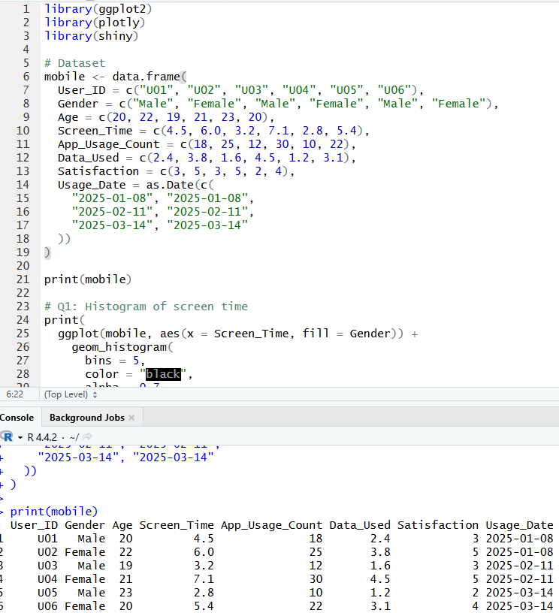
1. Import the dataset in R. Plot a histogram and density plot for Screen_Time. Add suitable colors and labels. Interpret the screen-time distribution.
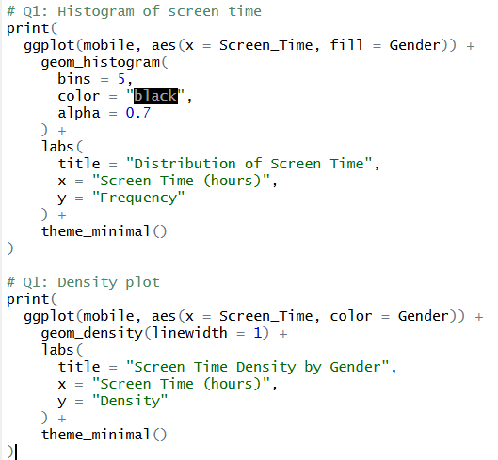
OUTPUT:
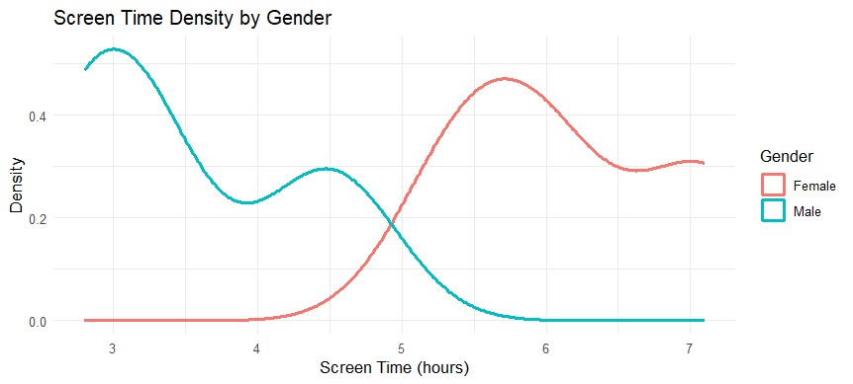

2. Create a scatter plot using R programming between Data_Used and Screen_Time. Calculate the correlation between them. Add a trend line. Explain the relationship.
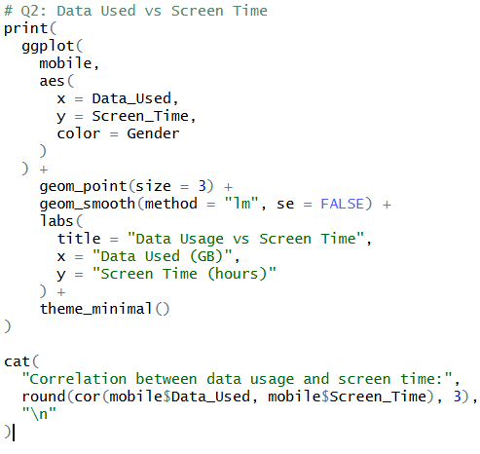
OUTPUT:
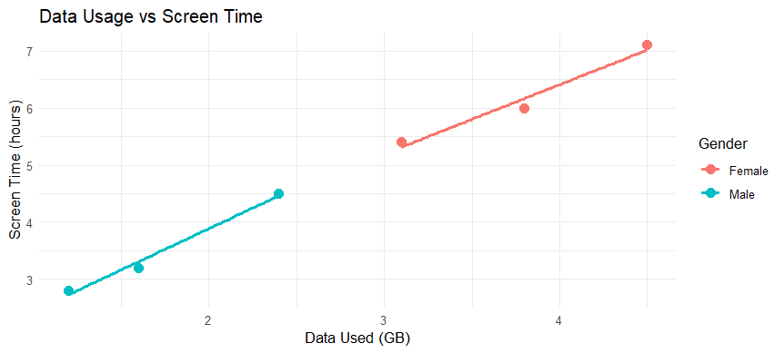

3. Using R, find the average Satisfaction score for each Gender. Create a bar chart for the averages. Add value labels. Interpret user satisfaction patterns.
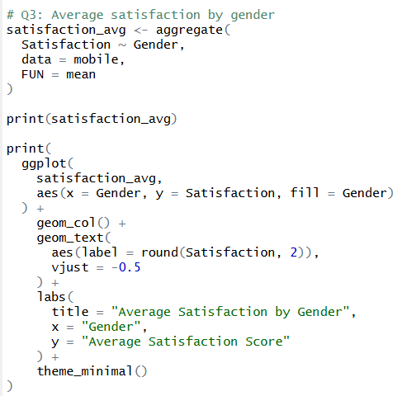
OUTPUT:
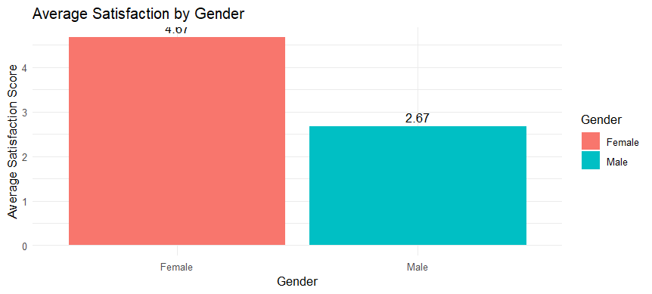

4. Import Mobile_App_Usage.csv into Tableau. Create a bubble chart (Screen Time vs Data Used). Use color for Gender and size for App Usage Count. Create a line chart for usage trends. Add filters for Gender and Usage_Date. Design a mini dashboard.
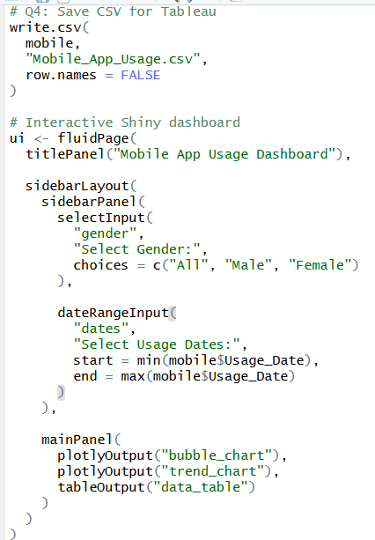
OUTPUT:
