ASSESSMENT TOOL 1 - PART 1
Code 1

# Markov Decision Process Demonstration

grid_size <- 4

start <- c(1,1)
goal <- c(4,4)

state <- start

path <- matrix("",grid_size,grid_size)

path[start[1],start[2]] <- "S"
path[goal[1],goal[2]] <- "G"

print("Initial Grid")
print(path)

step <- 1

cat("\nStarting Simulation\n\n")

while(!(all(state==goal))){

row <- state[1]
col <- state[2]

possible <- list()

if(row>1)
possible$Up <- c(row-1,col)

if(row<grid_size)
possible$Down <- c(row+1,col)

if(col>1)
possible$Left <- c(row,col-1)

if(col<grid_size)
possible$Right <- c(row,col+1)

best_action <- NULL
best_distance <- 100

for(a in names(possible)){

next_state <- possible[[a]]

distance <- abs(goal[1]-next_state[1]) +
abs(goal[2]-next_state[2])

if(distance < best_distance){

best_distance <- distance
best_action <- a
state_next <- next_state

}

}

reward <- -1

if(all(state_next==goal))
reward <- 100

cat("Step:",step,"\n")

cat("Current State :",state,"\n")
cat("Action Taken :",best_action,"\n")
cat("Next State :",state_next,"\n")
cat("Reward :",reward,"\n\n")

state <- state_next

step <- step+1

}

OUTPUT:

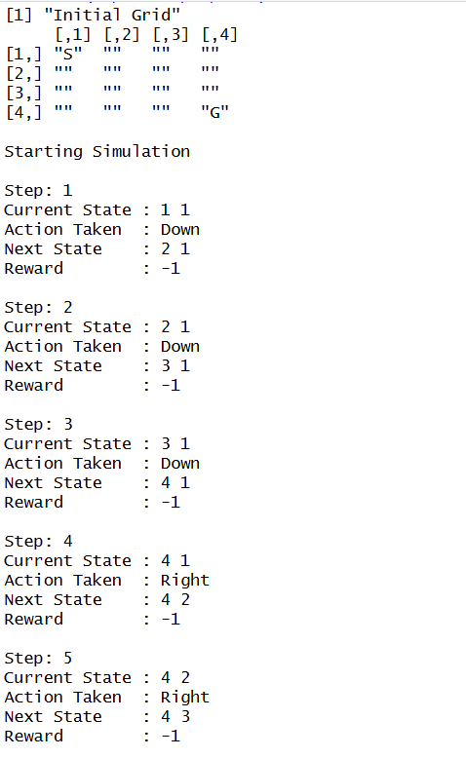

Code 2:

# R Program to Visualize an Agent's Path in a 4×4 Grid World

grid_size <- 4

x <- c(1,1,2,3,4,4,4)
y <- c(1,2,2,2,2,3,4)

plot(
1:grid_size,
1:grid_size,
type = "n",
xlim = c(1,4),
ylim = c(4,1),
xlab = "Column",
ylab = "Row",
main = "Agent Path in Grid World"
)

abline(v = 1:4, col = "gray")
abline(h = 1:4, col = "gray")

text(1,1,"S",cex=2,col="blue")
text(4,4,"G",cex=2,col="red")

lines(y,x,lwd=3)
points(y,x,pch=19,cex=1.5)

OUTPUT:

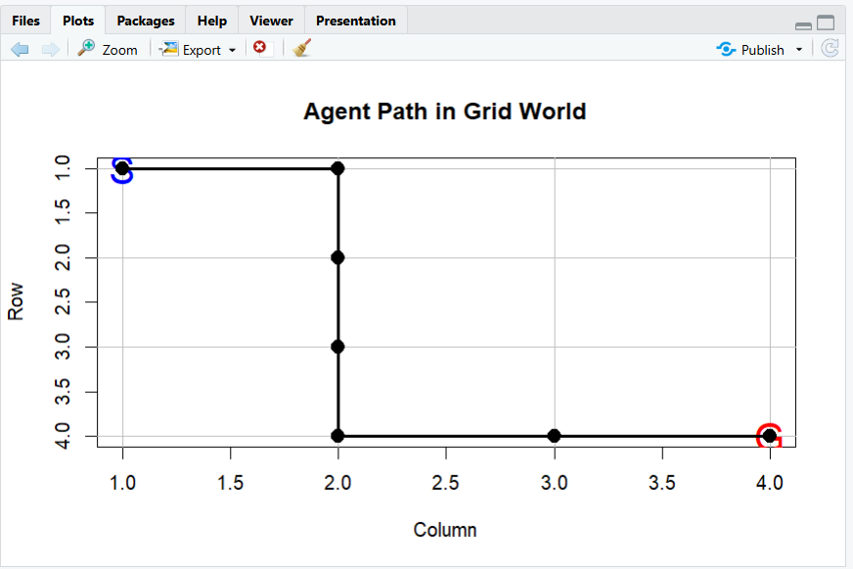

Code 3:

#R Program to Visualize the Markov Decision Process (MDP) Workflow Using DiagrammeR

library(DiagrammeR)

grViz("
digraph MDP {

graph [
layout = dot,
rankdir = TB,
bgcolor = '#FDFEFE',
pad = 0.5,
nodesep = 0.5,
ranksep = 1.0,
splines = ortho
]

node [
shape = box,
style = 'rounded,filled',
fontname = 'Times New Roman',
fontsize = 32,
penwidth = 4,
color = '#2C3E50',
width = 3,
height = 0.8
]

edge [
color = '#5D6D7E',
penwidth = 2,
arrowsize = 0.9
]

A [label='Markov Decision Process', fillcolor='#1ABC9C', fontcolor='white']

B [label='State Space\n(S)', fillcolor='#5DADE2']
C [label='Action Space\n(A)', fillcolor='#F5B041']

D [label='Transition\nProbability', fillcolor='#58D68D']
E [label='Reward\nFunction', fillcolor='#EC7063']

F [label='Initialize\nPolicy', fillcolor='#AF7AC5']

G [label='Policy\nEvaluation', fillcolor='#85C1E9']
H [label='Policy\nImprovement', fillcolor='#F7DC6F']

I [label='Optimal\nPolicy', fillcolor='#2ECC71', fontcolor='white']

J [label='Decision\nMaking', fillcolor='#F1948A']

K [label='Performance\nEvaluation', fillcolor='#BB8FCE']

L [label='Final\nOutput', fillcolor='#95A5A6', fontcolor='white']

A -> B
A -> C

B -> D
C -> D

D -> E

E -> F

F -> G

G -> H

H -> G [label='No', color='red', fontcolor='red']

H -> I [label='Yes', color='darkgreen', fontcolor='darkgreen']

I -> J

J -> K

K -> L

}
")

OUTPUT :

