1. Post application is up and running
2. Open post man, verify weather admin service is running or not
3. Graphical user interface, text, application, email

   Description automatically generated
4. Verify data persisted in the DB

Verify the able to get the user details or not

Update user

Delete user

Retrieving the user data set by passing the Id

**Sign-in validation by passing username and pwd**

-ve case provide the correct e-mail and pwd is wrong

Email id not exit and try to sign-in

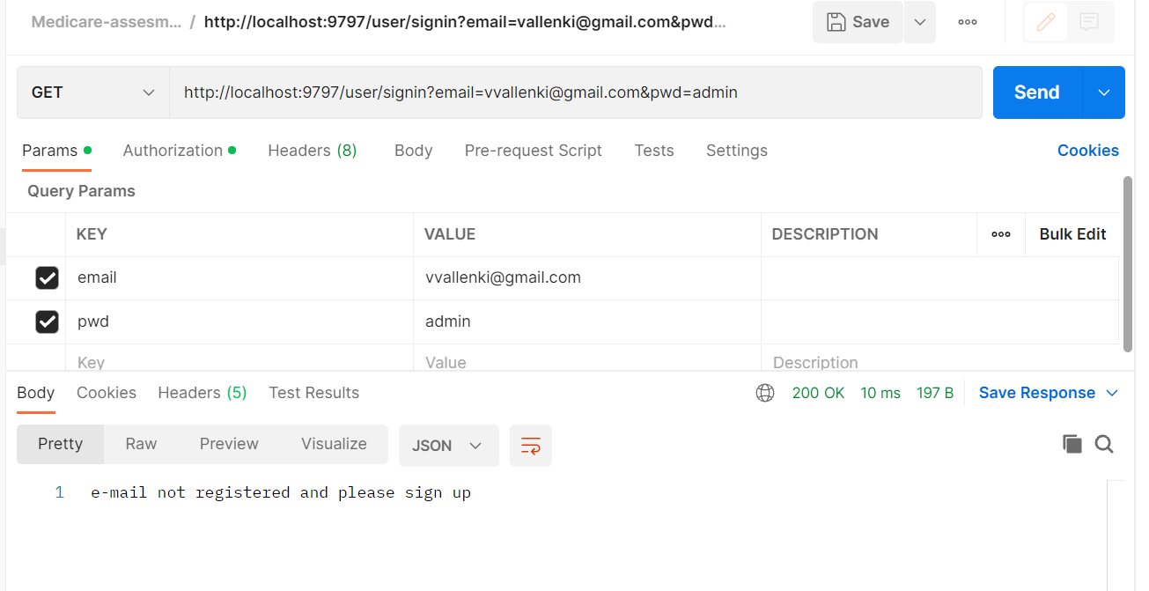

Extract Medicine by Id

Configure Medicine

Update Medicine

Delete Medicine by Id

Search by medicine name

Without providing the input name- that means full search

Medicine does not exist

**UI Validations/Test cases**

**Login Validation – Admin with correct user credentials validated through back end**

Post submit button the below page appears – Admin roles for users

**Admin login with valid user name and not the correct password**

**New User try to login - it will show message for registration**

**New User registration**

**Admin main page list users**

**Updating the user**

**Delete user**

**Medicines page for Admin**

**Update Medicine**

**Configure Medicine**

