**Introduction:**

Welcome to Wound Detox, a groundbreaking mobile application poised to revolutionize the way we handle injuries in emergency situations. Wound Detox empowers users with an intelligent assistance system that provides swift and effective management for wounds of all types and severity levels.

At the core of Wound Detox is its innovative image recognition technology, meticulously trained to identify and categorize various types of wounds, including abrasions, bruises, cuts, lacerations, and stab wounds. Users can simply upload an image of the injury, and Wound Detox instantly analyzes the wound, offering detailed information and personalized treatment recommendations.

For minor wounds, Wound Detox provides users with comprehensive treatment details and prescriptions, ensuring prompt and effective care even for those without medical expertise. This feature is invaluable in empowering individuals to confidently address minor injuries on their own, minimizing the risk of complications and promoting faster healing.

In situations where injuries are more severe or require professional attention, Wound Detox goes the extra mile. For moderate-level injuries, the app not only offers treatment recommendations but also locates nearby hospitals equipped to handle the specific type of injury. This seamless integration of medical resources ensures that users can access the appropriate care without delay, improving outcomes and reducing the burden on emergency services.

However, Wound Detox doesn't stop there. Recognizing the critical importance of timely intervention in emergency situations, the app includes a built-in emergency response feature. With just one click, users can summon an ambulance to their precise location, ensuring that help arrives swiftly when every second counts.

Wound Detox represents a significant advancement in emergency wound management, harnessing the power of technology to provide users with intelligent assistance and seamless access to medical resources. By combining advanced image recognition capabilities with real-time access to treatment recommendations and emergency services, Wound Detox is poised to transform the way we approach wound care in emergency situations.

**Area and Problem Statement**

**Area:**

The area of focus for the Wound Detox project lies within the intersection of healthcare and technology, specifically in the domain of emergency wound management. This encompasses the development of a mobile application equipped with advanced image recognition capabilities and seamless integration with medical resources and emergency services.

**Problem Statement:**

Despite the prevalence of accidents and injuries, many individuals lack the necessary knowledge and resources to effectively manage wounds in emergency situations. This can lead to delayed treatment, improper care, and potentially serious complications. Additionally, accessing appropriate medical care quickly can be challenging, particularly in situations where injuries are severe or require specialized treatment.

**The problem statement for Wound Detox is two-fold:**

Lack of Immediate Guidance: In the event of an injury, individuals may not have access to immediate medical guidance or may lack the expertise to assess and treat wounds effectively. This can result in suboptimal care and delayed healing, exacerbating the risk of complications.

Difficulty Accessing Medical Care: Finding nearby hospitals equipped to handle specific types of injuries or accessing emergency medical services promptly can be challenging, especially in critical situations where time is of the essence. This can lead to delays in receiving appropriate care, potentially worsening outcomes for the injured individual.

By addressing these challenges through the development of Wound Detox, the project aims to empower individuals with the knowledge and resources they need to respond effectively to injuries in emergency situations. Additionally, by integrating seamless access to medical resources and emergency services, the project seeks to streamline the process of accessing appropriate care, ultimately improving outcomes for individuals in need of immediate medical attention.

**Objective**

**Develop Advanced Image Recognition System:** Create a robust image recognition system capable of accurately identifying and categorizing various types of wounds, including abrasions, bruises, cuts, lacerations, and stab wounds. Train the system using a diverse dataset to ensure high levels of accuracy and reliability.

**Design User-Friendly Mobile Application**: Develop a user-friendly mobile application interface that allows individuals to easily upload images of wounds and receive instant feedback and treatment recommendations. Ensure intuitive navigation and accessibility for users of all levels of technological proficiency.

**Provide Personalized Treatment Recommendations**: Utilize the image recognition system to generate personalized treatment recommendations based on the type and severity of the identified wound. Offer comprehensive guidance on wound care techniques, medication administration, and follow-up procedures.

**Integrate Real-Time Medical Resource Locator**: Implement a feature within the app that locates nearby hospitals and medical facilities equipped to handle specific types of injuries. Provide users with relevant information such as facility ratings, distance, and available services to facilitate informed decision-making.

**Incorporate Emergency Response Functionality**: Integrate emergency response functionality into the app, allowing users to summon an ambulance to their precise location with a single click in critical situations. Ensure seamless communication between the app and emergency services to expedite response times and improve outcomes.

**Ensure Data Privacy and Security:** Implement robust data privacy and security measures to safeguard users' personal information and medical data. Adhere to industry standards and regulations to ensure compliance with privacy laws and protect user confidentiality.

**Conduct User Testing and Feedback Iteration:** Conduct extensive user testing to gather feedback on the app's functionality, usability, and effectiveness. Iterate on the design and features based on user input to continually improve the app's performance and user satisfaction.

**Promote Awareness and Adoption:** Develop a comprehensive marketing and outreach strategy to promote awareness of the Wound Detox app and encourage adoption among target user groups. Collaborate with healthcare professionals, first responders, and community organizations to reach a wide audience and maximize impact.

**Difference between existing system and proposed system**

**Technology Integration:**

**Existing System**: The current approach to wound management may rely primarily on human assessment and basic first aid knowledge. There may be limited technological integration for immediate wound assessment and treatment guidance.

**Proposed System (Wound Detox):** The Wound Detox system integrates advanced image recognition technology, allowing users to upload images of wounds for instant analysis and personalized treatment recommendations. This technology-enhanced approach provides users with immediate, accurate guidance on wound management.

**Access to Medical Resources:**

**Existing System:** Individuals may struggle to locate nearby hospitals or medical facilities equipped to handle specific types of injuries, especially in emergency situations.

**Proposed System (Wound Detox):** Wound Detox includes a real-time medical resource locator that identifies nearby hospitals and medical facilities based on the type and severity of the identified wound. This feature enables users to quickly access appropriate medical care, improving response times and outcomes.

**Emergency Response Functionality:**

**Existing System:** In emergency situations, individuals may rely on traditional methods, such as calling emergency services or seeking assistance from bystanders, which can lead to delays in accessing medical help.

**Proposed System (Wound Detox):** Wound Detox includes built-in emergency response functionality, allowing users to summon an ambulance to their precise location with a single click. This seamless integration with emergency services expedites response times, ensuring timely medical assistance in critical situations.

**Personalized Treatment Recommendations:**

**Existing System:** Treatment recommendations for wounds may be generalized and may not take into account the specific type and severity of the injury.

**Proposed System (Wound Detox):** Wound Detox provides personalized treatment recommendations based on the type and severity of the identified wound. This tailored guidance ensures that users receive appropriate care suited to their individual needs, minimizing the risk of complications and promoting faster healing.

**User Interface and Experience:**

**Existing System:** The user interface and experience of existing approaches to wound management may vary widely and may not always be intuitive or user-friendly.

**Proposed System (Wound Detox):** Wound Detox is designed with a user-friendly mobile application interface, ensuring intuitive navigation and accessibility for users of all levels of technological proficiency. This streamlined user experience enhances usability and encourages widespread adoption of the system.

Overall, the proposed Wound Detox system represents a significant advancement over existing approaches to wound management by leveraging technology to provide users with immediate, personalized guidance, seamless access to medical resources, and integrated emergency response functionality.

**Functional Requirements:**

**User Registration and Authentication:**

Users should be able to create accounts and log in securely.

The system should verify user credentials and authenticate users for access.

**Wound Image Upload and Analysis:**

Users should be able to upload images of wounds from their mobile devices.

The system should analyze the uploaded images using image recognition technology to identify the type and severity of the wound.

**Personalized Treatment Recommendations:**

Based on the analysis of the wound image, the system should provide personalized treatment recommendations, including wound care techniques and medication suggestions.

**Real-Time Medical Resource Locator:**

The system should locate nearby hospitals and medical facilities equipped to handle the specific type of injury identified in the wound image.

Users should be able to view relevant information about these facilities, such as ratings, distance, and available services.

**Emergency Response Integration:**

Users should have the option to initiate an emergency response directly from the app.

The system should interface with emergency response services to dispatch ambulances to the user's location in critical situations.

**Non-Functional Requirements:**

**Security:**

The system should employ robust security measures to protect user data and ensure confidentiality.

User authentication should be secure to prevent unauthorized access to sensitive information.

**Reliability:**

The system should be reliable and available 24/7 to assist users in emergency situations.

It should have backup mechanisms in place to ensure data integrity and system continuity.

**Performance:**

The system should be responsive and able to handle a large number of concurrent users without significant latency.

Image analysis and treatment recommendation generation should be performed swiftly to provide timely assistance to users.

**Scalability:**

The system should be designed to scale horizontally to accommodate increasing user demand and growing data volume.

It should be able to handle spikes in traffic during emergencies without degradation in performance.

**Usability:**

The user interface should be intuitive and easy to navigate, catering to users of all levels of technological proficiency.

Clear instructions and prompts should guide users through the process of uploading images and accessing treatment recommendations.

**Compliance:**

The system should comply with relevant regulations and standards for healthcare data privacy and security.

It should adhere to legal requirements for emergency response services and medical facility accreditation.

By fulfilling these functional and non-functional requirements, the Wound Detox system can provide users with a reliable, secure, and user-friendly platform for managing wounds in emergency situations effectively.

**System Architecture**

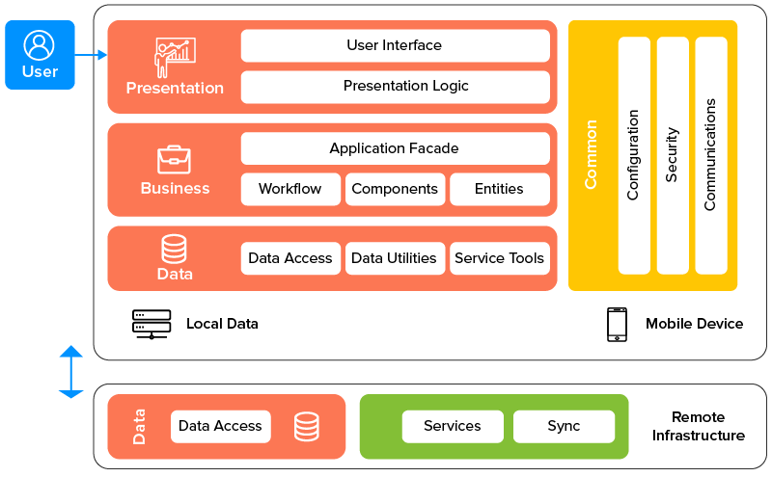

**Data Flow Diagram**

**Level 1**

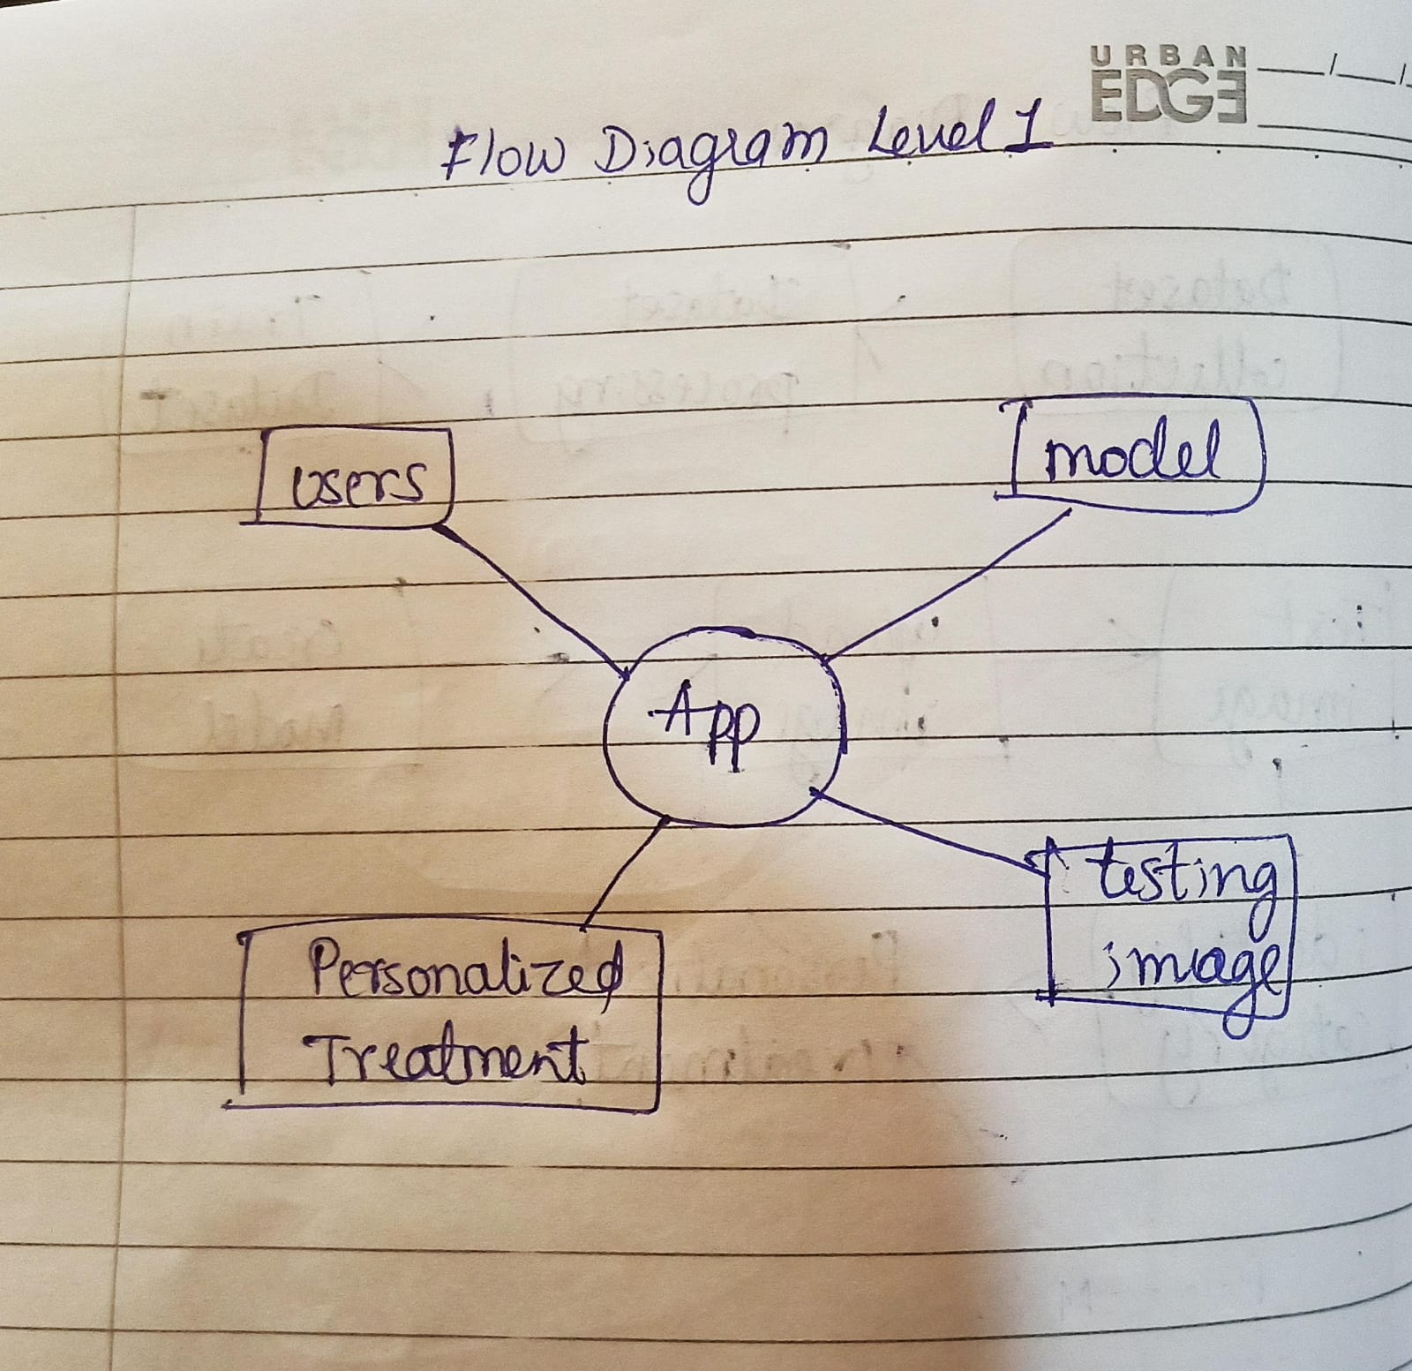

**Level 2**

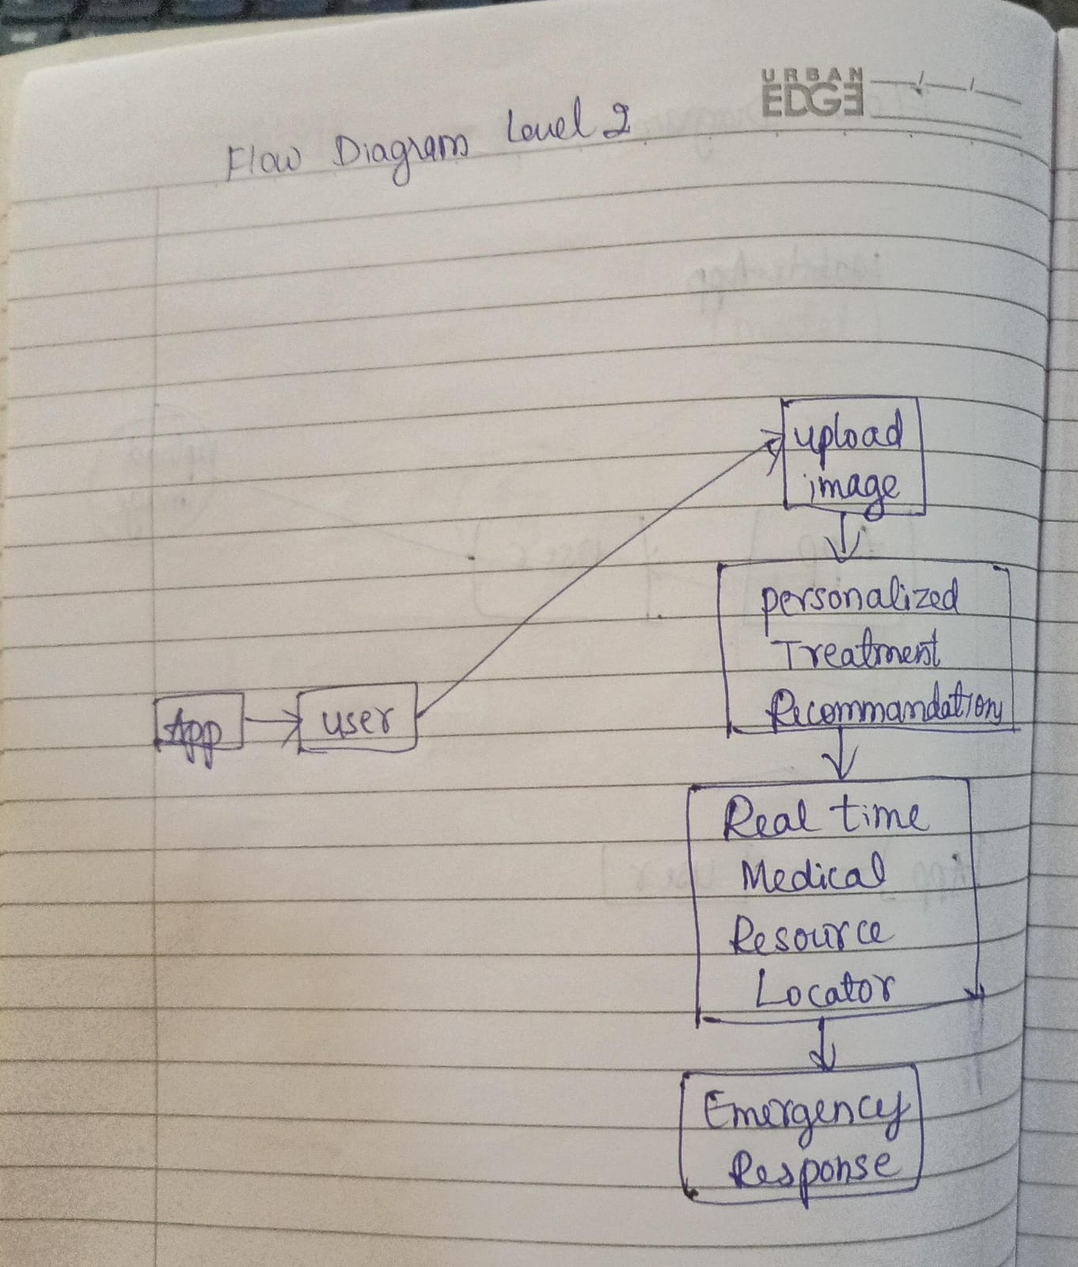

**Expected Results**

**Improved Wound Management**: Users will have access to accurate and timely wound analysis, leading to improved management of injuries. The personalized treatment recommendations provided by the system will help users administer appropriate care, reducing the risk of complications and promoting faster healing.

**Enhanced Access to Medical Care**: The real-time medical resource locator feature will enable users to quickly locate nearby hospitals and medical facilities equipped to handle their specific injuries. This will streamline the process of accessing medical care, reducing delays and ensuring that users receive timely and appropriate treatment.

**Efficient Emergency Response**: The integration of emergency response functionality will enable users to quickly summon assistance in critical situations. By initiating ambulance requests directly from the app, users can reduce response times and receive prompt medical attention when every second counts.

**Increased User Confidence:** Users will feel more confident in their ability to manage wounds effectively, even in emergency situations. The guidance provided by the Wound Detox system will empower users with the knowledge and resources they need to take immediate action and respond appropriately to injuries.

**Positive User Experience**: The user-friendly interface and seamless functionality of the Wound Detox app will contribute to a positive user experience. Clear instructions, intuitive navigation, and responsive design will make it easy for users to access the system's features and receive assistance when needed.

**Enhanced Healthcare Ecosystem:** By providing users with access to personalized wound management and facilitating efficient access to medical care, Wound Detox will contribute to an overall improvement in the healthcare ecosystem. Reduced strain on emergency services, fewer complications from untreated injuries, and increased user empowerment will all contribute to a healthier and safer community.

Overall, the implementation of the Wound Detox system is expected to result in improved outcomes for individuals in need of emergency wound management, ultimately saving lives and reducing the burden on healthcare systems.

**Conclusion**

In conclusion, the development and implementation of the Wound Detox system represent a significant step forward in emergency wound management. By leveraging advanced image recognition technology, real-time medical resource location services, and seamless emergency response integration, Wound Detox aims to empower individuals with the knowledge, resources, and tools they need to effectively respond to injuries in critical situations.

Through personalized treatment recommendations, quick access to nearby medical facilities, and efficient ambulance dispatch, Wound Detox has the potential to improve outcomes for individuals in need of immediate medical assistance. By reducing delays in accessing care, minimizing the risk of complications, and promoting faster healing, Wound Detox can make a tangible difference in the lives of those facing emergencies.

Furthermore, Wound Detox contributes to a broader goal of enhancing the healthcare ecosystem by alleviating strain on emergency services, promoting user empowerment, and fostering a culture of proactive injury management. By promoting awareness, adoption, and continued refinement based on user feedback, Wound Detox has the potential to become an indispensable tool for both individuals and healthcare professionals alike.

In essence, Wound Detox represents a transformative approach to emergency wound management, harnessing the power of technology to save lives, improve outcomes, and make a positive impact on the well-being of individuals and communities.

**References**

1. <https://www.ncbi.nlm.nih.gov/pmc/articles/PMC7951490/>
2. <https://www.ncbi.nlm.nih.gov/pmc/articles/PMC2696775/>
3. <https://pubs.acs.org/doi/10.1021/acsptsci.3c00030>
4. <https://www.researchgate.net/publication/363577851_Water_for_wound_cleansing>
5. <https://academic.oup.com/jac/article/71/11/3026/2462051>
6. <https://www.researchgate.net/publication/363283154_How_to_cleanse_a_wound>
7. <https://emedicine.medscape.com/article/1895071-overview?form=fpf>