To run project install python 3.7.2 version and then install all packages given in requirement.txt file and then double click on run.bat file to get below page
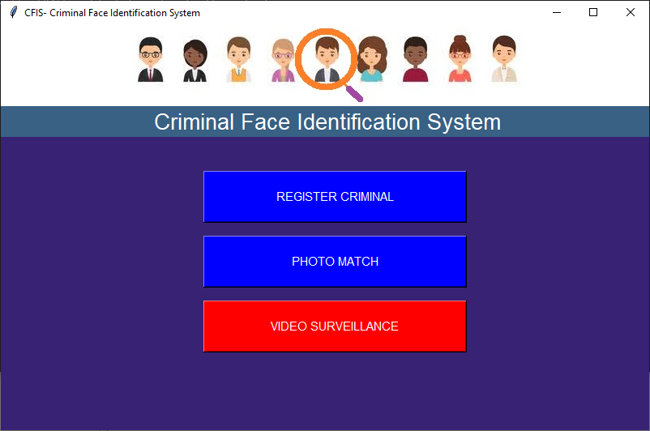
In above screen click on ‘Register Criminal’ button to get below page
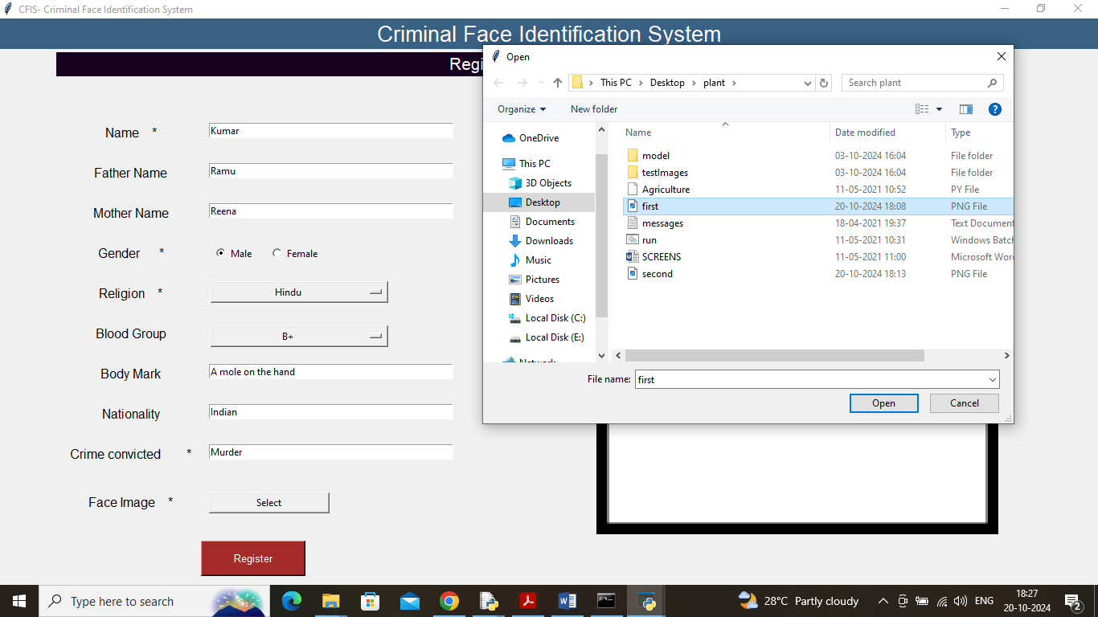
In above screen adding registration details and then upload image and then click on ‘Register’ button to get below page
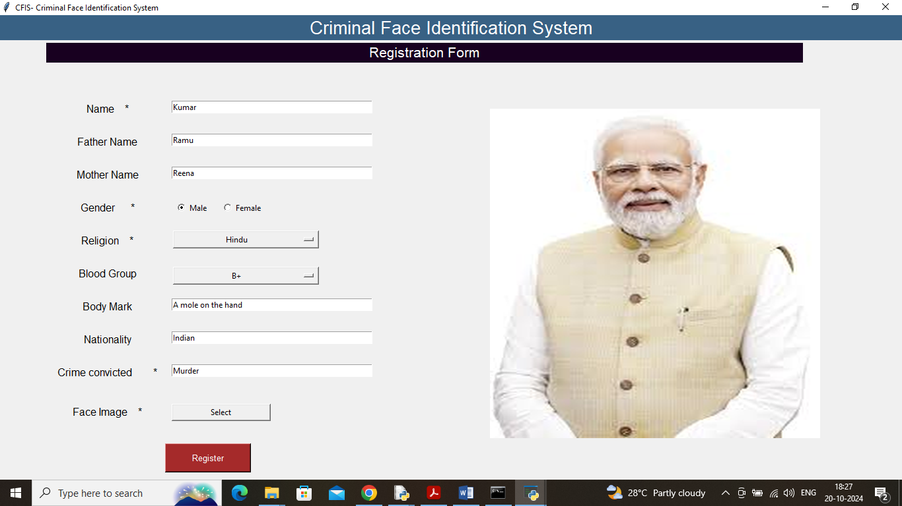
In above screen image is loaded and now click on ‘Register’ button to get below page
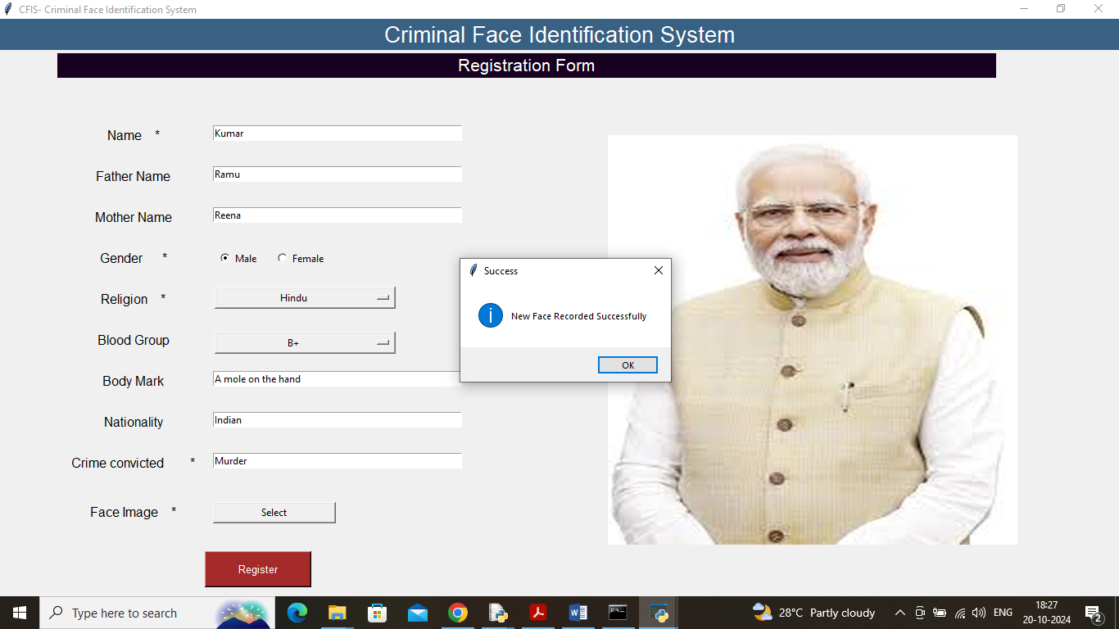
In above screen new face registered and now click on ‘photo match” button to get below page
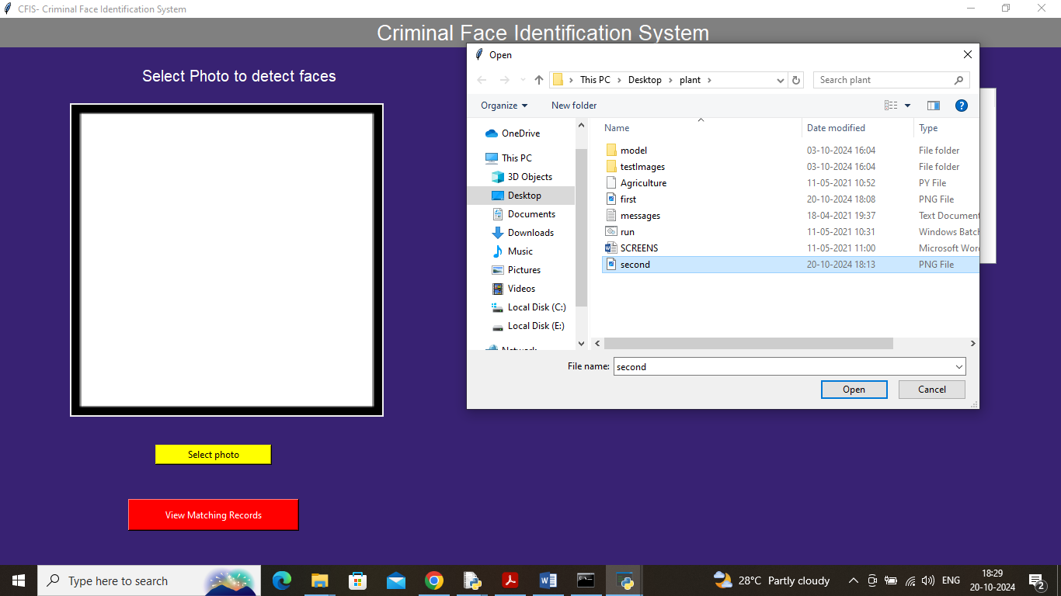
In above screen for matching I am browsing and selecting another image and then click on ‘Open’ button to get below page
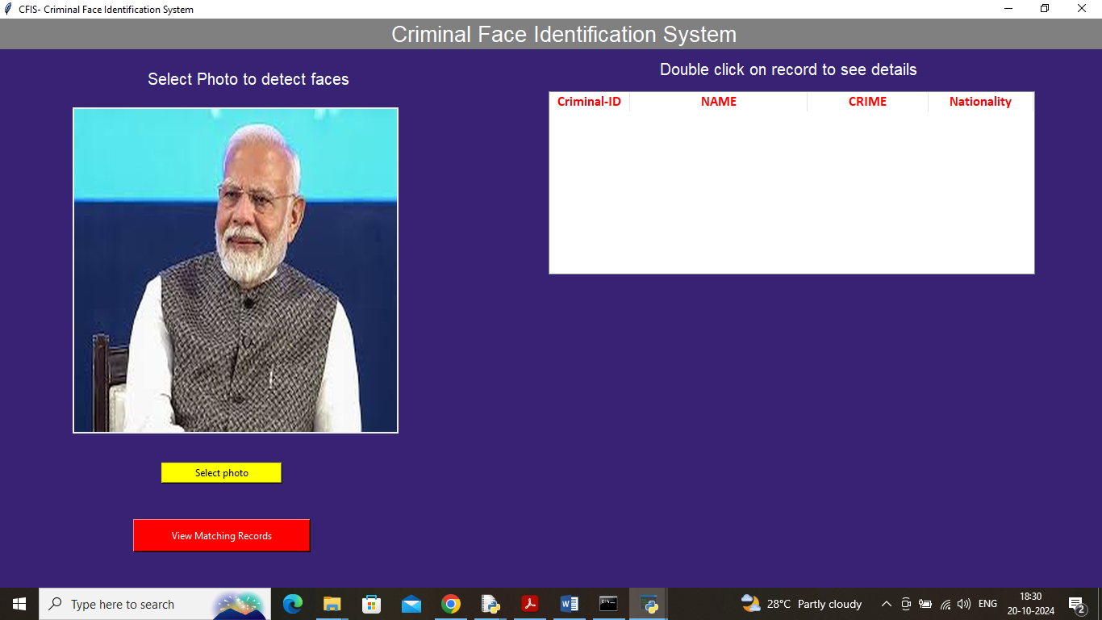
In above screen for same person face I uploaded another image and then click on ‘View Matching’ button to get below page
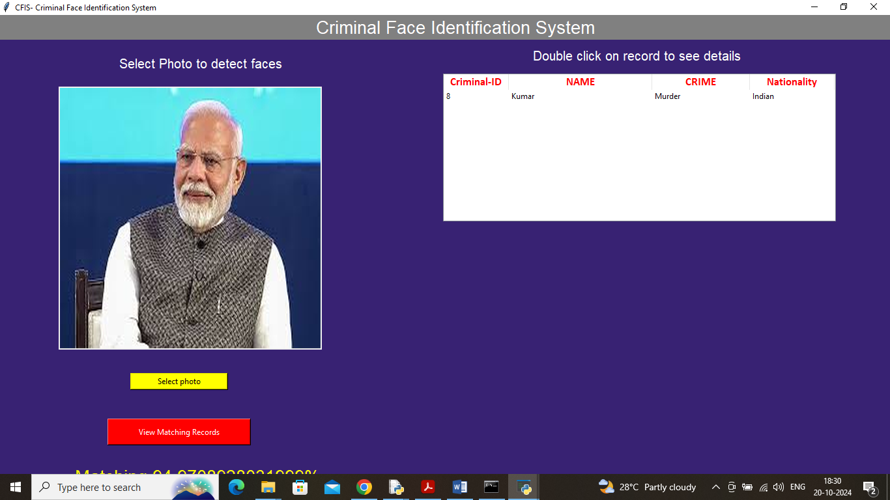
In above screen I got the matching score with same person for which I registered and now double click on that row in table to get below details
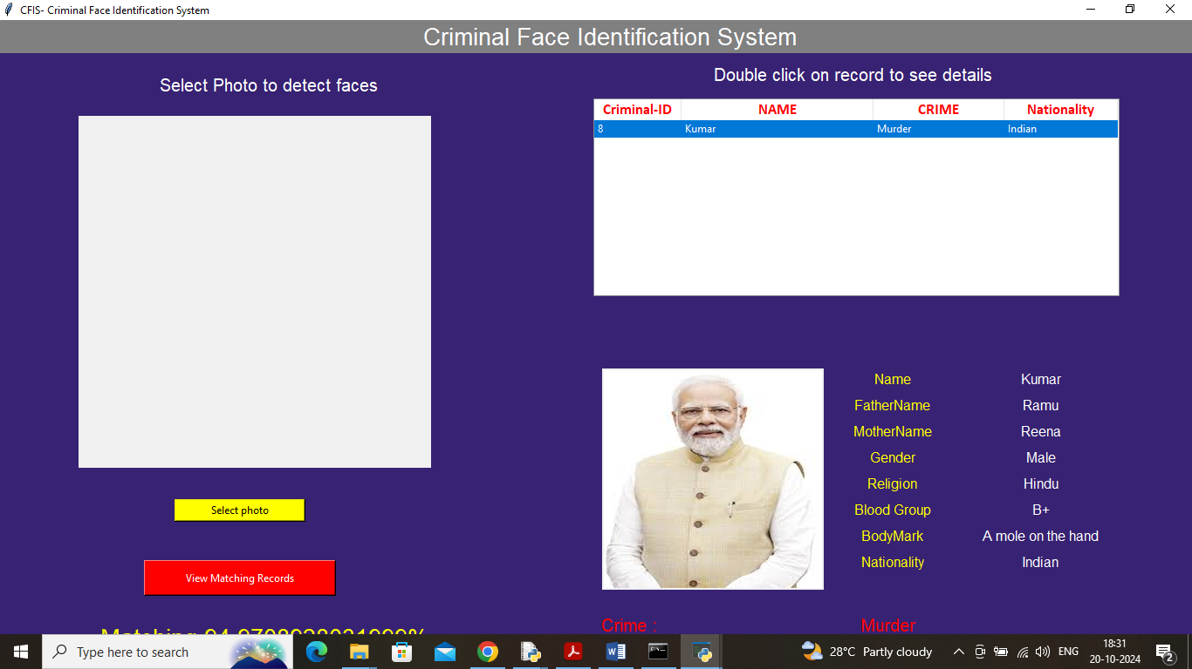
In above screen can see full details of that person and now click on ‘Video Surveillance’ button to get below page
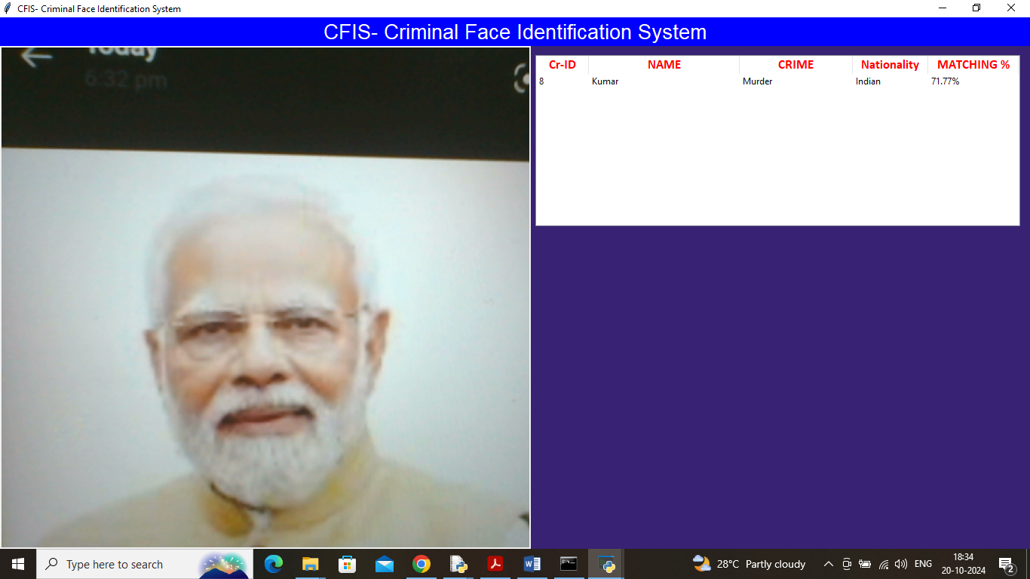
In video surveillance also person recognized as Kumar.
In same way you can execute code.
Don’t add your images manually to ‘images’ folder as images will be added to that folder programmatically.

