**JavaScript**

**Prerequisite:**

***Sublime Text:*** *the most popular web editor at the time of this writing. Lightweight and highly customizable, especially if you use its 3rd Party package manager. It’s free, but you will receive regular notifications asking you to pay $60 USD for a license.* [*https://www.sublimetext.com/*](https://www.sublimetext.com/)

***Visual Studio Code:*** *a completely free editor from Microsoft. Very similar to Sublime Text but contains a few other features such as a built-in terminal and Git integration. Also has a 3rd Party package manager.* [*https://code.visualstudio.com/*](https://l.facebook.com/l.php?u=https%3A%2F%2Fcode.visualstudio.com%2F&h=ATPzDNJanZbSrqLfIoRzst-cIWuVSTjFIw24Tum1msyHo_5vqX2WIUjiF1818AePGVUlJDzX-LFPP3Urg059UsQdg8U7xWTkfgDzhWWPpUsXqmy-3kBmb4DIUNiK2VCFivcBaShzDtT_)

***Brackets:*** *a completely free editor from Adobe. It’s codebase is open source, so lots of features are added to it regularly. Some of these features are added to Adobe’s premium web editor, Dreamweaver. Not as feature-rich as Sublime Text and Visual Studio code, but still a great web editor.* [*http://brackets.io/*](https://l.facebook.com/l.php?u=http%3A%2F%2Fbrackets.io%2F&h=ATP1dEBRP2uNi4_zBJ5JH9SyqiGPj7Ko6TcVt53JP4q-jHS3nqTCIarbsEMCWHpWbe9EF-3QkIVI5DMsCQKNesYYDpyH7sXbH4FuGGpDwl6w52XR4Z66PxiObtXNharjskAITRC_NSEd)

***Atom:*** *a completely free editor from GitHub that is also open source, and highly customizable. Can be extended with its package manager, which is internal and not 3rd party.* [*https://atom.io/*](https://atom.io/)

***Notepad++:*** *a completely free, Windows-only editor. It was one of the first barebones web editors to be released. Definitely not as feature-rich as the other editors but still great for writing basic code.* [*https://notepad-plus-plus.org/*](https://l.facebook.com/l.php?u=https%3A%2F%2Fnotepad-plus-plus.org%2F&h=ATMh3QkOvNaXLpZM1-_UM5fr8oZ_B2KRpcDS411em1xUaV5zRytcNZXVX_dpKBBt6GxsuYJqMQRuN0lXh_kGOeuqDxAMzWW2U-n9kbvAnR80V55RAJV8y8NOCDDwU2wrDwIp8TviYiPd)

***Dreamweaver:*** *a premium web editor from Adobe. Lots of features, lots of 3rd party extensions available for it and a great visual editor that’s WYSIWYG (What You See Is What You Get). Since its not open source, it doesn’t add new features as rapidly as some of the other editors. It also is not free, costing you $19.99 a month through Adobe Creative Cloud. But it remains one of the best premium web editors, if not the best.* [*http://www.adobe.com/products/dream...*](http://www.adobe.com/products/dreamweaver.html)

***Webstorm:*** *a premium web editor that’s more modern than Dreamweaver. Lots more modern features, most of which are based around JavaScript...strong support for Angular, React, Karma, etc. If you buy a monthly subscription, it’s a little less expensive than Dreamweaver at $12.99 a month.* [*https://www.jetbrains.com/webstorm/*](https://www.jetbrains.com/webstorm/)

***Netbeans:*** *a completely free web editor that you can use to edit HTML, CSS JavaScript, but is more well-known for its Java integration. It offers several different versions for download so you may want to download the one based around HTML5. Like Notepad++, it’s not as feature-rich as the other editors but still great for writing basic code.* [*https://netbeans.org/*](https://l.facebook.com/l.php?u=https%3A%2F%2Fnetbeans.org%2F&h=ATNZPERUOfWrqdjGa_Ch2bQNtN_qRq_Q8b-jWa9PQat5G_XjycC-Mtnm1jKmp-ypshh7NvLCTC3v2pphCFyzSF7c1CzA7yTKK7zeCmvuE4LinvYbSd9b5tIJYznDWJjWQhRKdtH7TQV-)

***IntelliJ IDEA:*** *a premium web editor that you can use to edit HTML, CSS JavaScript, but is also more well-known for its Java integration. Much more feature-rich than Netbeans and it does offer a free version, but lacks lots a features when compared to the free editors.* [*https://www.jetbrains.com/idea/*](https://l.facebook.com/l.php?u=https%3A%2F%2Fwww.jetbrains.com%2Fidea%2F&h=ATPnEzxE3or4AQPDDW7GsMmPL9-jM2-hzdFSswxrlX6moyV2metab_WwVG8oM9nYUHmFU3bvLmMBAoG8pEVem8bBbAP0C-VTXfGnpThf0BCIah5upu5B4qJPbhyiX3CJ9Bjmip3-x6kE)

*List of free online HTML/CSS/JS editors:*

* *Mozilla Thimble:*[*thimble.mozilla.org*](http://thimble.mozilla.org/)
* *Plunker: [Plunker](http://plnkr.co/" \t "_blank)*
* *JSBIN:*[*JS Bin*](http://jsbin.com/)
* *CodePen: [CodePen](http://codepen.io/" \t "_blank)*
* *jsfiddle:*[*Create a new fiddle*](http://jsfiddle.net/)
* *codemagic:*[*codemagic.gr*](http://codemagic.gr/)
* *liveweave:*[*HTML5, CSS3 & JavaScript playground for web designers & developers*](http://liveweave.com/)
* dabblet: [dabblet.com](http://dabblet.com/)
* cssdeck: [HTML5, CSS3, JS Demos, Creations and Experiments](http://cssdeck.com/)

**Tasks Outline:**

When solving the day to day tasks/assignments, strive to create not just code that works, but code that is stylish and concise. Try to write small code which perform just a single task, and then combine those smaller pieces to create more complete design.

**Task1:**

Write a JavaScript Program which changes the content?

**a.**

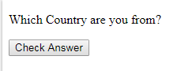

When user clicks on check answer it should able to display answer.

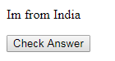

**b.**

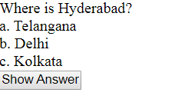

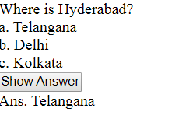

**Task2:**

Apply CSS for JavaScript “Change font-size of “Hello Teammm!”” upon button click.

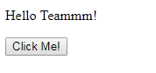

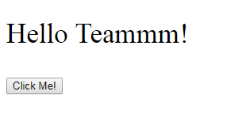

**Task3:**

* Write a function called squareNumber that will take one argument (a number), square that number, and return the result. It should also log a string like "The result of squaring the number 3 is 9."
* Write a JavaScript program for Addition and Multiplication of two Numbers?

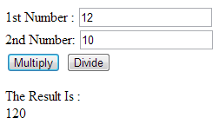

* Write a JavaScript program to calculate the area of square

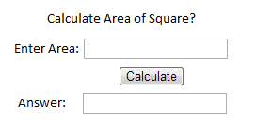

* Design Basic Arithmetic Operations:

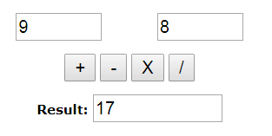

**Task4:**

Use Input fields for all JavaScript programs below and try to

* Write a JavaScript program to get current date in different formats?
* mm-dd-yyyy, mm/dd/yyyy or dd-mm-yyyy, dd/mm/yyyy
* Write a JavaScript function to get difference between two dates in days
* Write a JavaScript function to get the last day of a month.
* Write a JavaScript function to calculate 'yesterday day'.
* Write a JavaScript program to calculate age?
* Write a JavaScript function to check whether a string is blank or not.
* Write a JavaScript function to add Months to a date in input field?

**Task5:**

Design Simple radio buttons with yes and No, when clicked on yes display 3 fields and when clicked on “No” Display one field.

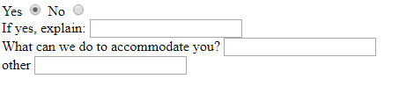

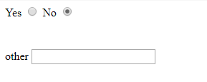

**Task6:**

Design a webpage with a dropdown list with colors inside and change background color upon dropdown list color chosen? Ex: colors- White, Aqua, Pink, Silver

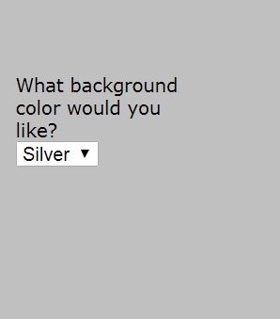

Create three radio buttons upon chosen color display color in square?

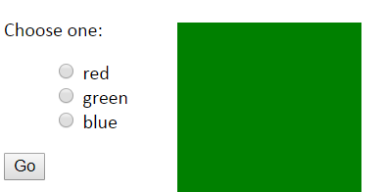

**Task 7:**

Generate a random password using JavaScript function?

**Task 8:**

Apply colors even and odd numbers upon click events?

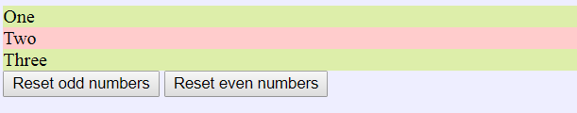

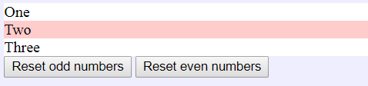

**Task 9:**

When clicked on Checkboxes display’s checkboxes and when chosen radio buttons display Some Content show and hide?

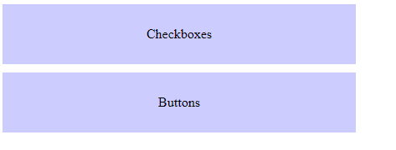

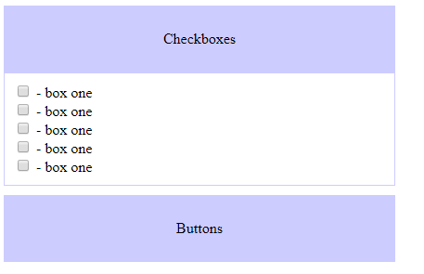

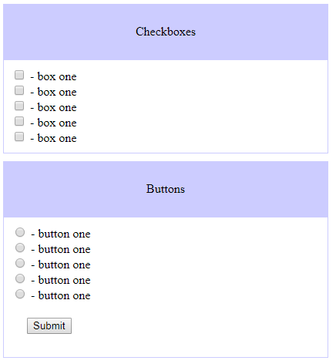

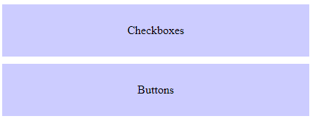

**Task 10:**

Create a webpage with four hyperlinks, when clicked on third hyperlink navigate it third paragraph i.e. change background color or apply border for it.

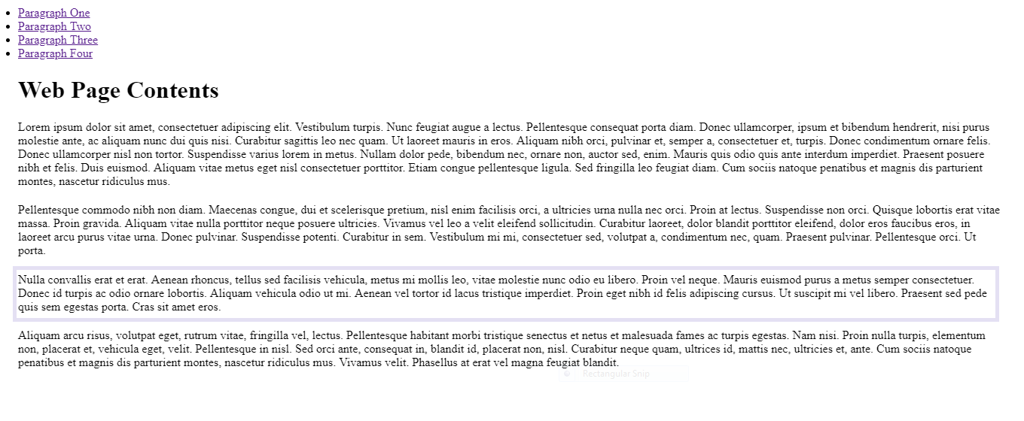

**Task 11:**

When clicked on square display alert with properties of it.

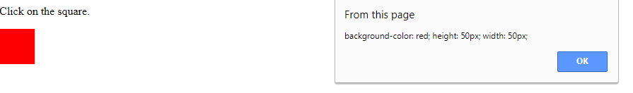

Increase counter upon image clicked using javascript?



**Task 12:**

Form validations:

When clicked on username it should accept 7 letters or characters and display error message below to it:

a)

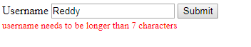

b)

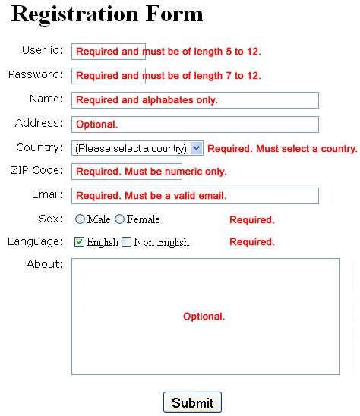

c)

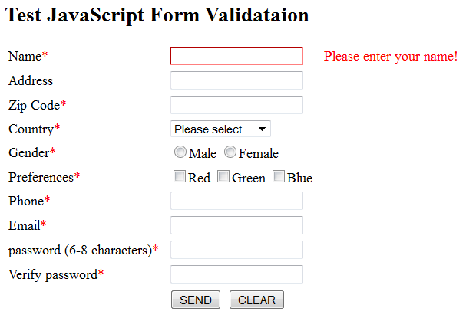

**Task 13:**

Design input fields when clicked on add language add input fields below to It., when clicked on remove the fields.

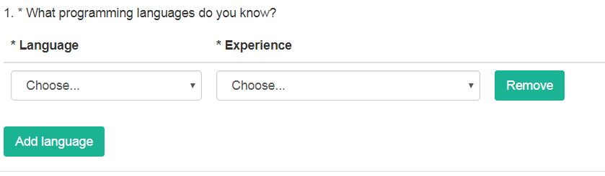

b) Based on Months selected display boxes using javascript

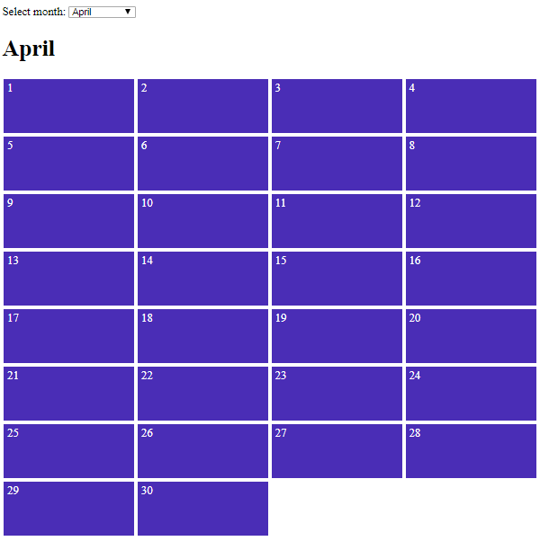

c)

Based on dropdown selected display message as below:

Sunny: It is nice and sunny outside today. Wear shorts! Go to the beach, or the park, and get an ice cream.

Rainy: Rain is falling outside; take a rain coat and a brolly, and don't stay out for too long.

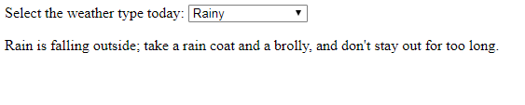

d) Based on location selected display sub locations:

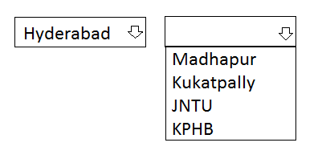

**Task 14:**

Create a category of items, display sub category of items and price, Quantity(editable), remove items.

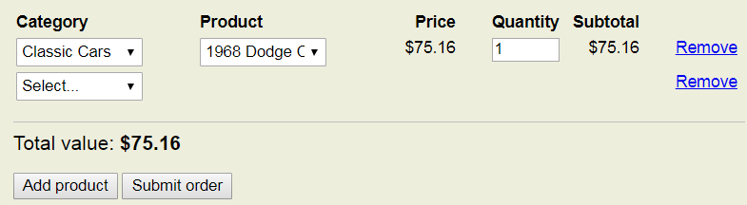

b) Create an input field to add an item and display items below after adding, delete the items.

