Minikube installation

Create an instance with ubuntu OS and t2.medium

* apt-get update –y
* apt-get install curl wget apt-transport-https –y
* curl -fsSL https://get.docker.com -o get-docker.sh

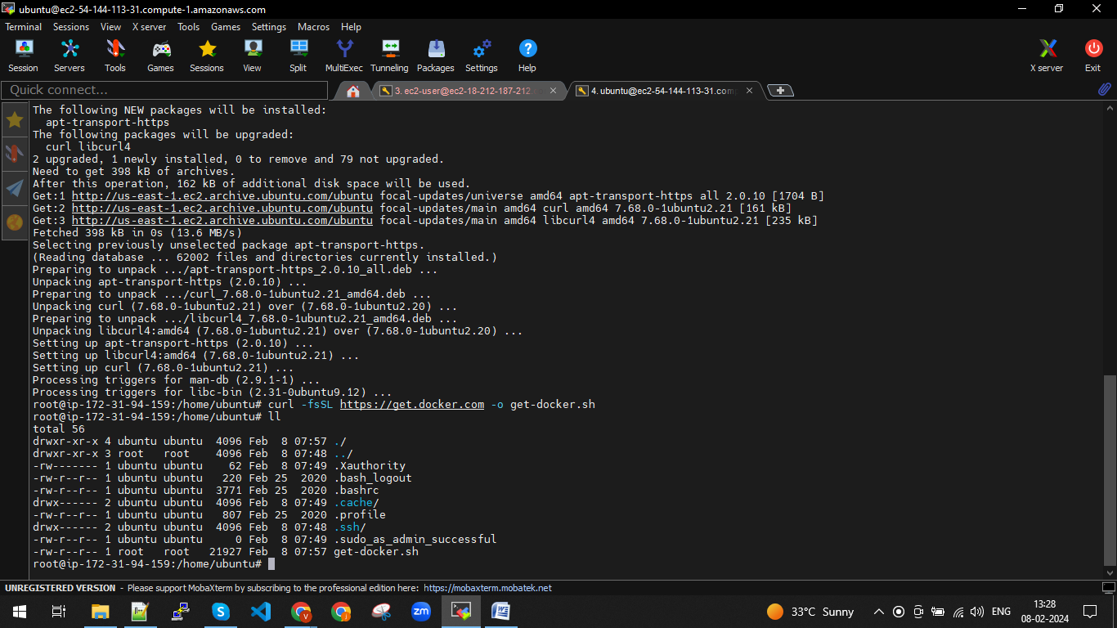

* sh get-docker.sh
* install minikube

curl -LO <https://storage.googleapis.com/minikube/releases/latest/minikube-linux-amd64>

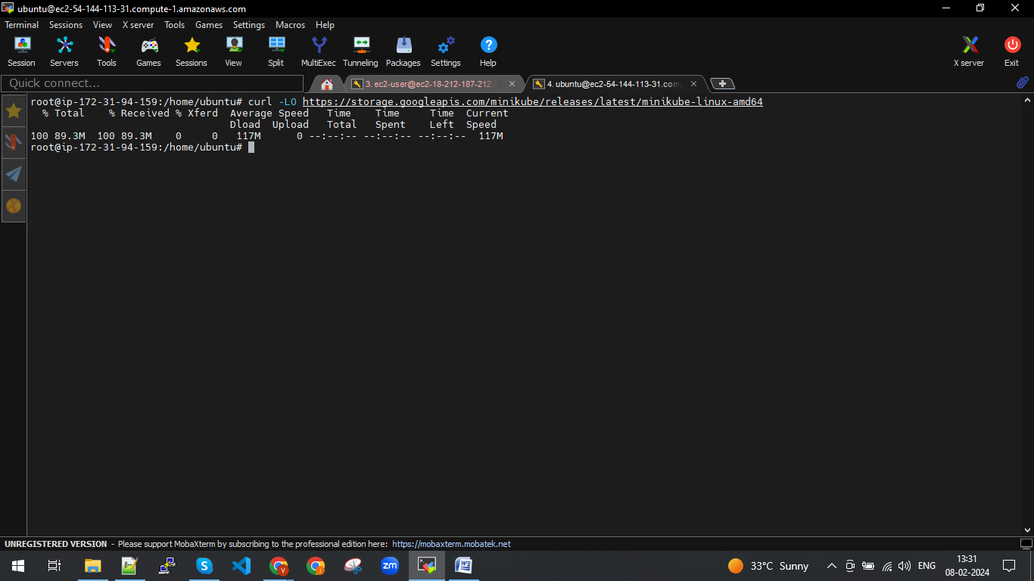

* 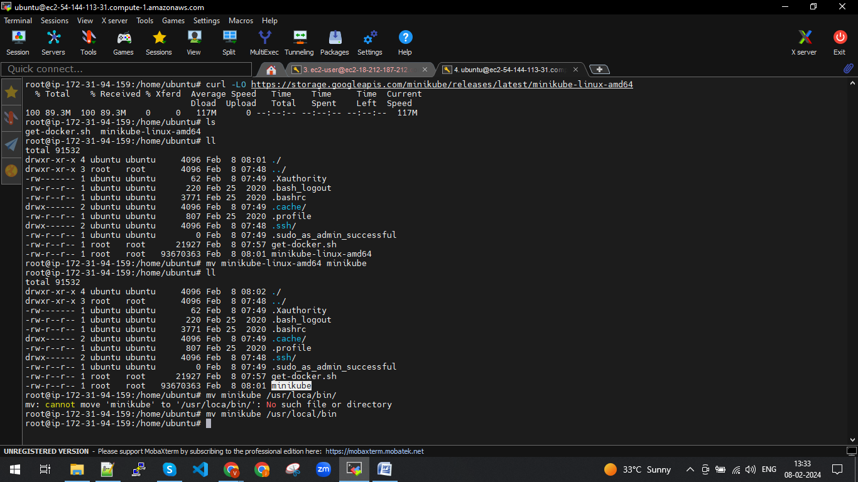
* chmod +x /usr/local/bin/minikube

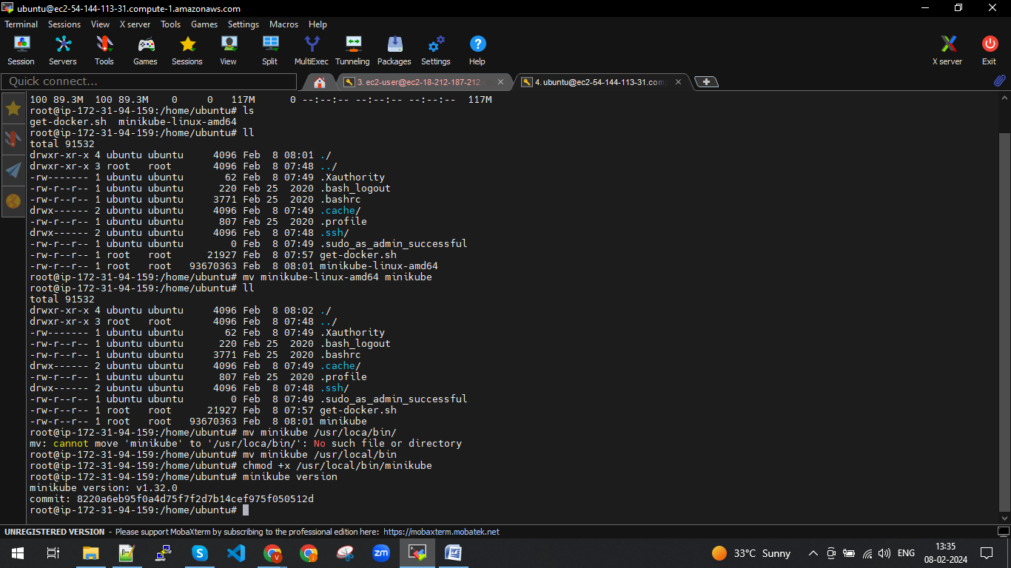

* install kubectl by using below link

<https://kubernetes.io/docs/tasks/tools/install-kubectl-linux/>

curl -LO [https://dl.k8s.io/release/**$(**curl -L -s https://dl.k8s.io/release/stable.txt**)**/bin/linux/amd64/kubectl](https://dl.k8s.io/release/$(curl%20-L%20-s%20https://dl.k8s.io/release/stable.txt)/bin/linux/amd64/kubectl)

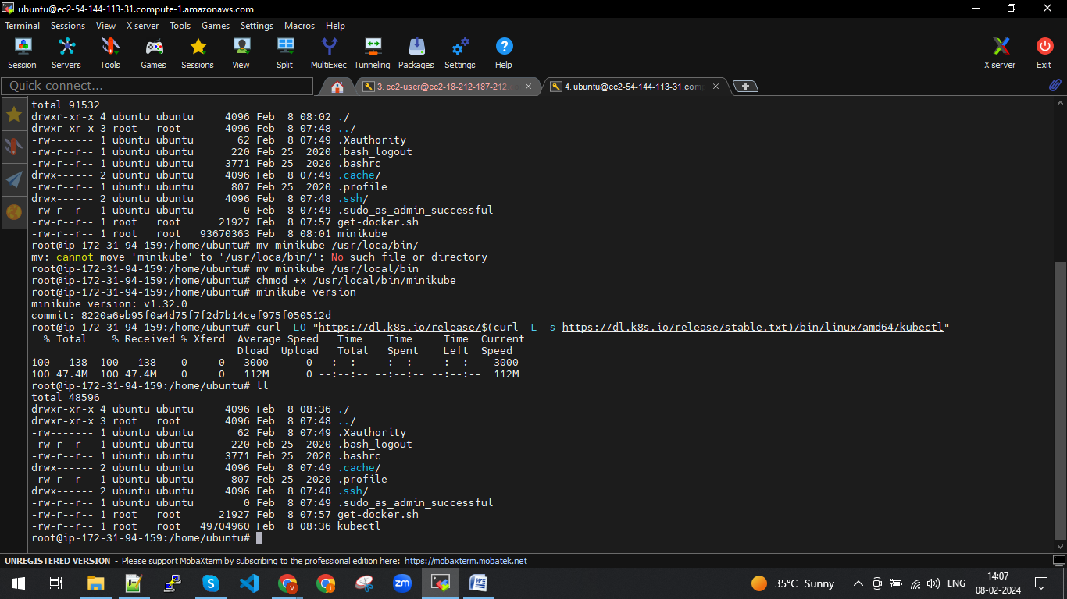

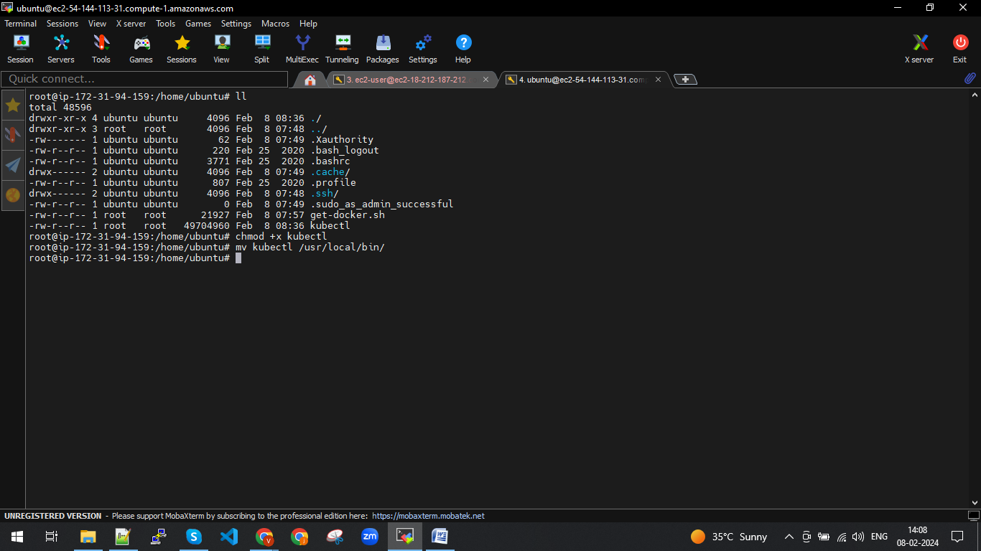

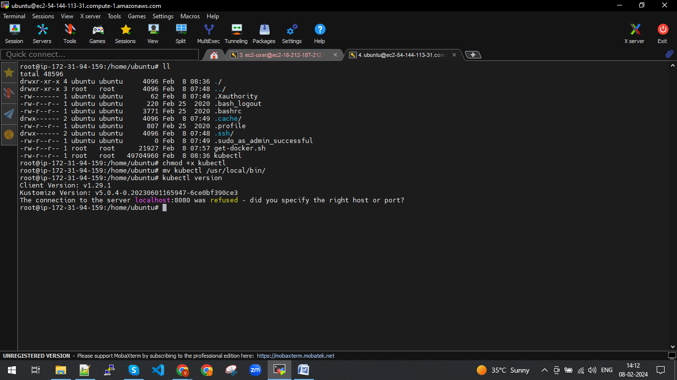

Minikube start –dreiver=docker –force

