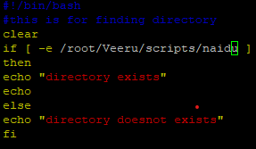

1) Create on Bash script to check if a directory is available or not.

Out put



2) Create a bash script which will create multiple files.

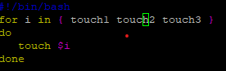

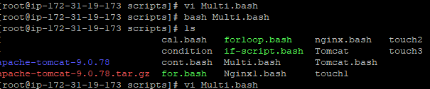

3) Create a bash script to take backup of a directory.

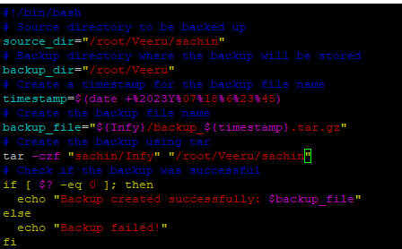

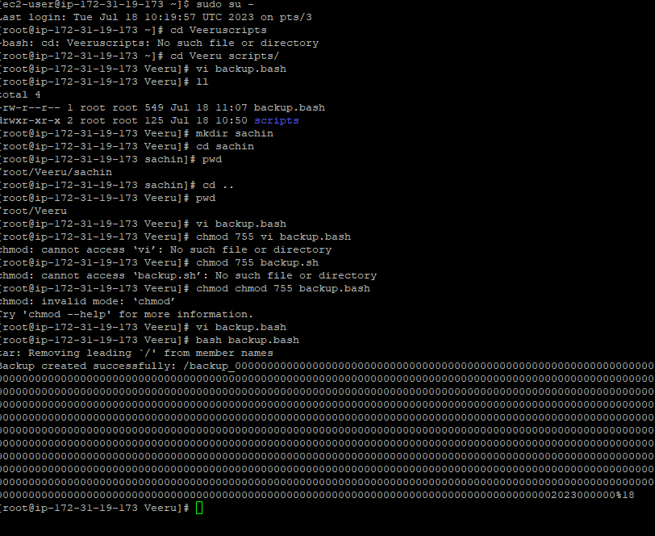

4) Create a bash script to install nginx in ec2 server.

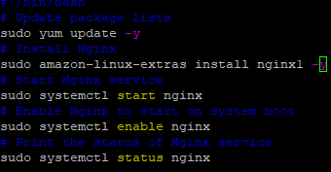

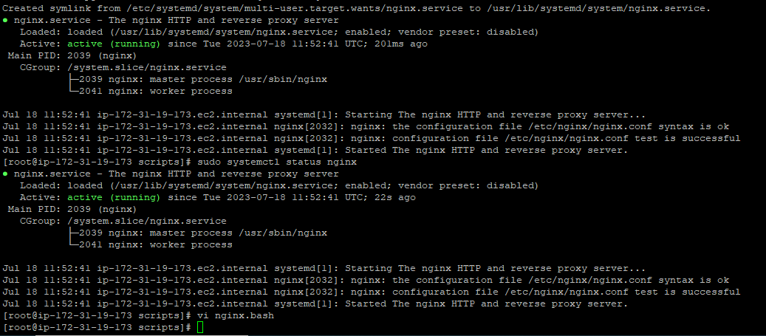

5) Create a bash script to install ApacheTomcat in ec2 server.

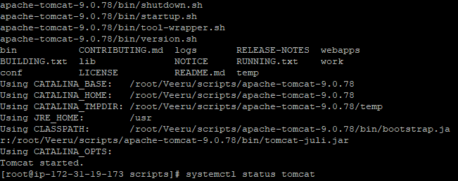

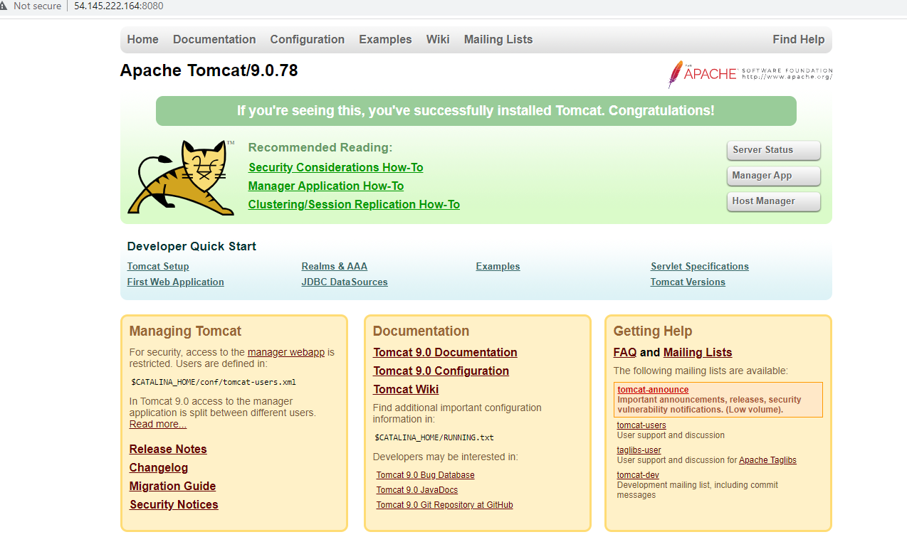

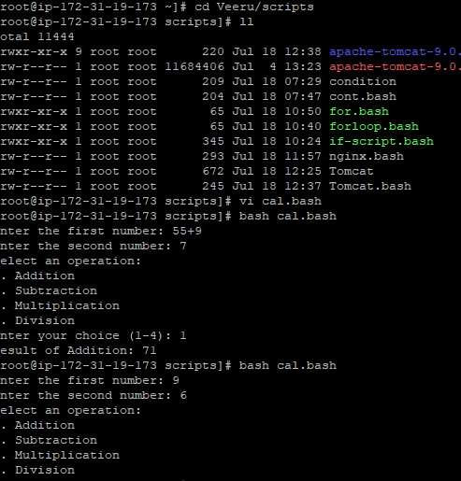

7) Create a bash script for calculator.

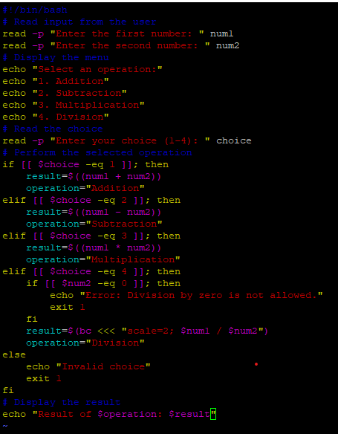

6) Create a bash script to check list if nginx service is running or not,if not running

then script should start the service.

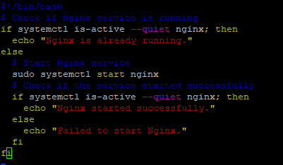

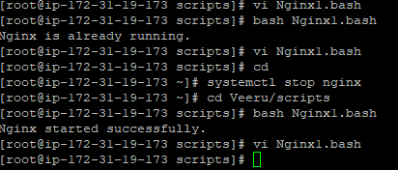

8) Create a bash script to check if directory is avaialble or not,if not then create a directory.

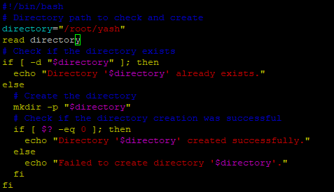

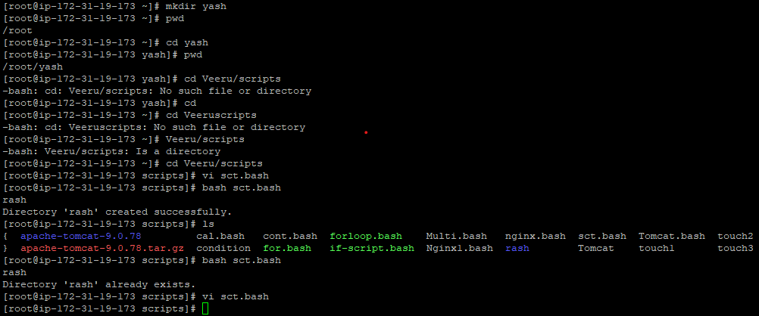

9) Create bash script to delete last 3 lines for a file.

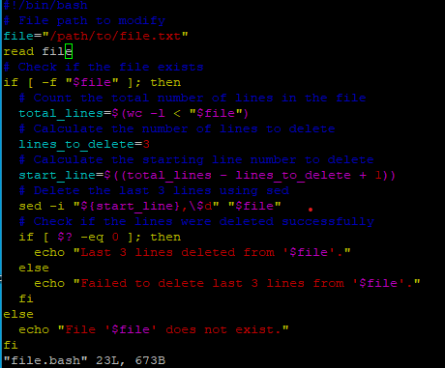

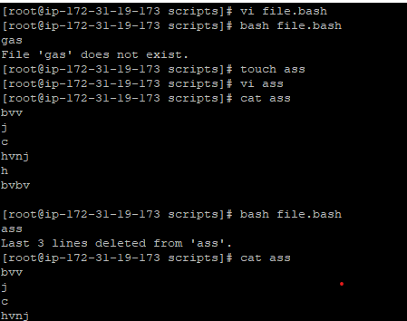

1) April 5th Midnight





2) 5 th of Every November,Jan,June if it is a Thursday.

3) At 05 and 27th minutes of 9,10,11 hours everyday.



4) 15th second of 34 min. of 9th hour on 15th Aug



5.Every midnigh



6.Every Weekend ( Saturday night 11.59 )



7) After every reboot

@reboot /path/to/my_script.sh