CS 4040/5040
Milestone 1
Author: Viraj Parmar
Date: November 1, 2025
Runtime Table
n | k | Median Time (ms)
10 | 10 | 0.002
10 | n | 0.002
10 | n² | 0.005
100 | 10 | 0.018
100 | n | 0.009
100 | n² | 0.339
1000 | 10 | 0.073
1000 | n | 0.143
1000 | n² | 47.065
2000 | 10 | 0.144
2000 | n | 0.238
2000 | n² | 47.503
5000 | 10 | 0.381
5000 | n | 0.597
5000 | n² | 48.275
10000 | 10 | 0.798
10000 | n | 1.283
10000 | n² | 51.138
20000 | 10 | 1.451
20000 | n | 2.717
20000 | n² | 53.899

Runtime Plot
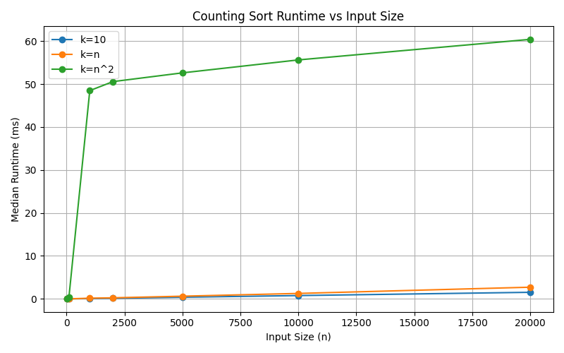
Observations
- When k = 10 or k = n, runtime grows linearly with n, showing O(n + k) behavior.
- When k = n², runtime increases sharply because the count array becomes very large, increasing both memory and computation time.
- The results align well with the expected linear-time behavior for small k.

Comparison with Milestone 1
Algorithm | Typical Complexity | Runtime Growth | Suitability
Insertion Sort | O(n²) | Very steep; skipped for large n (≥ 10,000) | Small n (< 5,000)
Quick Sort (Randomized) | O(n log n) | Smooth, scalable | Large n (≤ 20,000)
Counting Sort | O(n + k) | Linear for small k, slows for huge k | Integer arrays with small range

