Game Design Document
Fill up the Following document

- Write the title of your project.
COVID RUNNER

- What is the goal of the game?
Endless runner game based on the pandemic

- Write a brief story of your game?

There will be a main character running and avoiding obstacles like corona in the air, people without masks and people sneezing.

- Which are the playing characters of this game?
- Playing characters are the ones which respond to the user based on the input from the user
- Cars, monkeys, dinos, wizards etc, are the playing characters in the game.
Number | Character Name | What can this character do?
1 | Covid_runner | It runs, jumps and can use power ups.
2 | Sanitizer_powerUp | When the runner touches this he is Immune to the virus for 15 seconds.
3 | Sneezing_person | Person sneezes and the runner has to dodge the bacteria or use a shield to avoid it.
4
5
6
7
8

- Which are the Non Playing Characters of this game?
- Non Playing characters are the ones which don't have an action or a behaviour when the user interacts with the game.
- Hurdles, stones, bananas, coins, etc are non playing characters in the game.
Number | Character Name | What can this character do?
1 | coins | Give u coins using which you can buy powerups.
2 | noMaskPerson | If the player touches this, he loses.
3
4
5
6
7
8

Draw your imagination of this game. What does this game look like?
- Draw the game either on your computer or on paper,
- Add images of scenes of the game to show each of the playing and non-playing characters at least once.

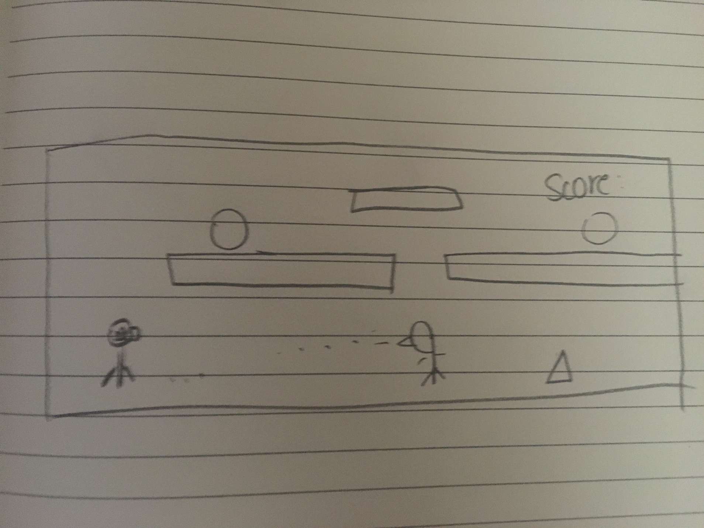

How do you plan to make your game engaging?
By adding good graphics and likeable characters. It will be a fast paced game so that the player doesn’t get bored.

