OS :

Why do we need computer ? or purpose of computer

The purpose of the computer is to generate the information

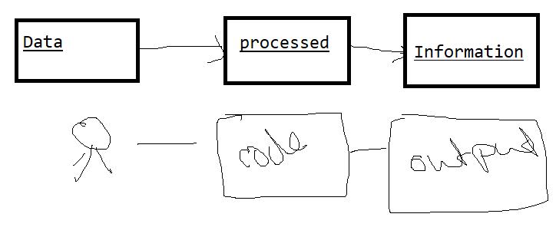

What are the different type of the information we have got

Operational information

Managerial information

DSS : decision support system

Definition : of computer is a device which execute instruction

Computer has got

Hardware : tangible

Software : in tangible

3 type of software

System software controllers the hardware

Application software: *use by user*

Utility software : used by multiple people for

Firmware : both hardware and software

different purpose : GitLab, git, bitbucket

Software configuration management SCM

Version control system

Repository

Repository:

1. Central repository
2. Local repository
3. Folder

Central repository will have integrated code

Local repository will have individual developer code

Folder where the developer will code

Central --🡪 local🡪 folder

Create project -🡪 clone/ or pull the project 🡪 develop

Folder --🡪 local -🡪 central

Commit push

Config

--global

-m

Push

Origin

Commit

Clone

Add .

Add readme.fl

Branching

Master branch (final code )

Dev branch (code at development )

Assignment Find

What is git conflict

how do solve git conflict