Heart Disease Risk Prediction
End-to-End MLOps Pipeline
MLOps (AIMLCZG523) · Assignment 01
Pentela Veeranjineyulu
BITS Pilani WILP, M.Tech (AI & ML)
October 2026
Repository: https://github.com/veerusgithub/heart-mlops

1. Introduction & Objective
This report describes a complete, reproducible machine-learning system that predicts the presence of heart disease from routine clinical measurements and serves the model as a monitored, containerised API. The classifier is one component of a larger production system: data acquisition, exploratory analysis, leak-free preprocessing, experiment tracking, automated tests, CI/CD, Docker, Kubernetes manifests and monitoring are all part of the deliverable and are wired together so that the whole pipeline runs from a clean checkout using one requirements file.
Two principles guided the design. Reproducibility: fixed seeds, a pinned requirements file, and a data script that reads a bundled copy of the original UCI file. Train/serve parity: preprocessing and model live in a single scikit-learn Pipeline, so an API request is transformed exactly like a training row.

2. Dataset & Exploratory Data Analysis
The data is the UCI Heart Disease dataset, Cleveland Clinic subset (processed.cleveland.data): 303 patients, 13 clinical features, no header row, '?' for missing values. The raw label num (0-4) is binarised as target = (num > 0). Result: 303 rows, 164 no-disease / 139 disease; 6 missing cells (ca: 4, thal: 2), imputed inside the model pipeline. Raw UCI codes are used throughout (cp 1-4, slope 1-3, thal 3/6/7).
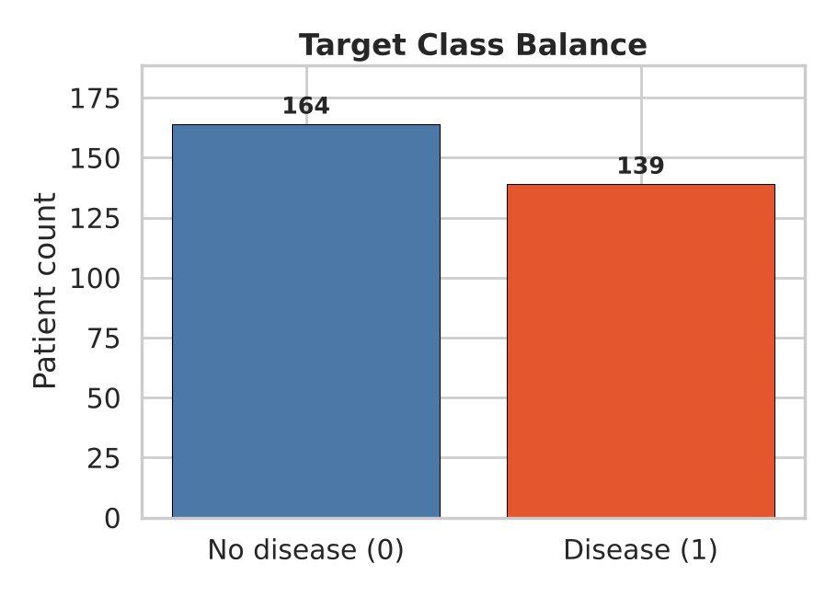
Figure 1: Class Balance — 164 healthy vs 139 disease (45.9% positive rate)
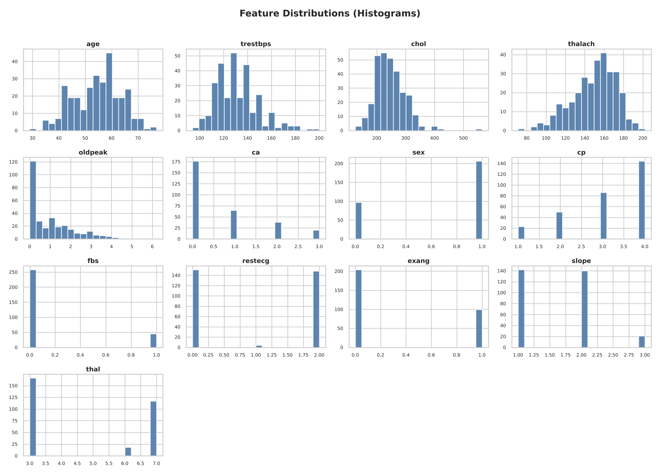
Figure 2: Feature Distributions — Age, cholesterol, max heart rate, etc.
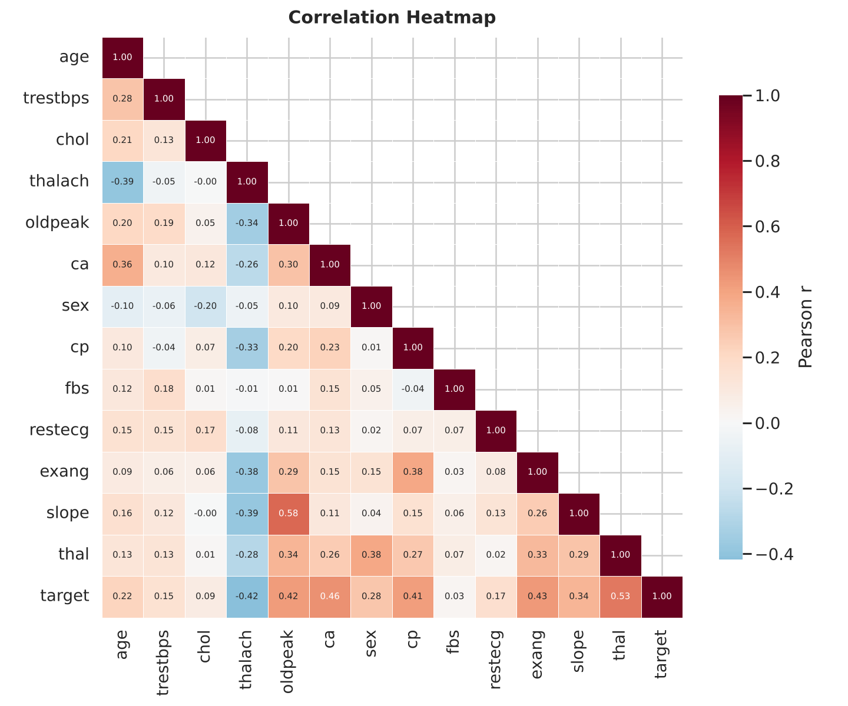
Figure 3: Correlation Heatmap — Feature inter-correlations
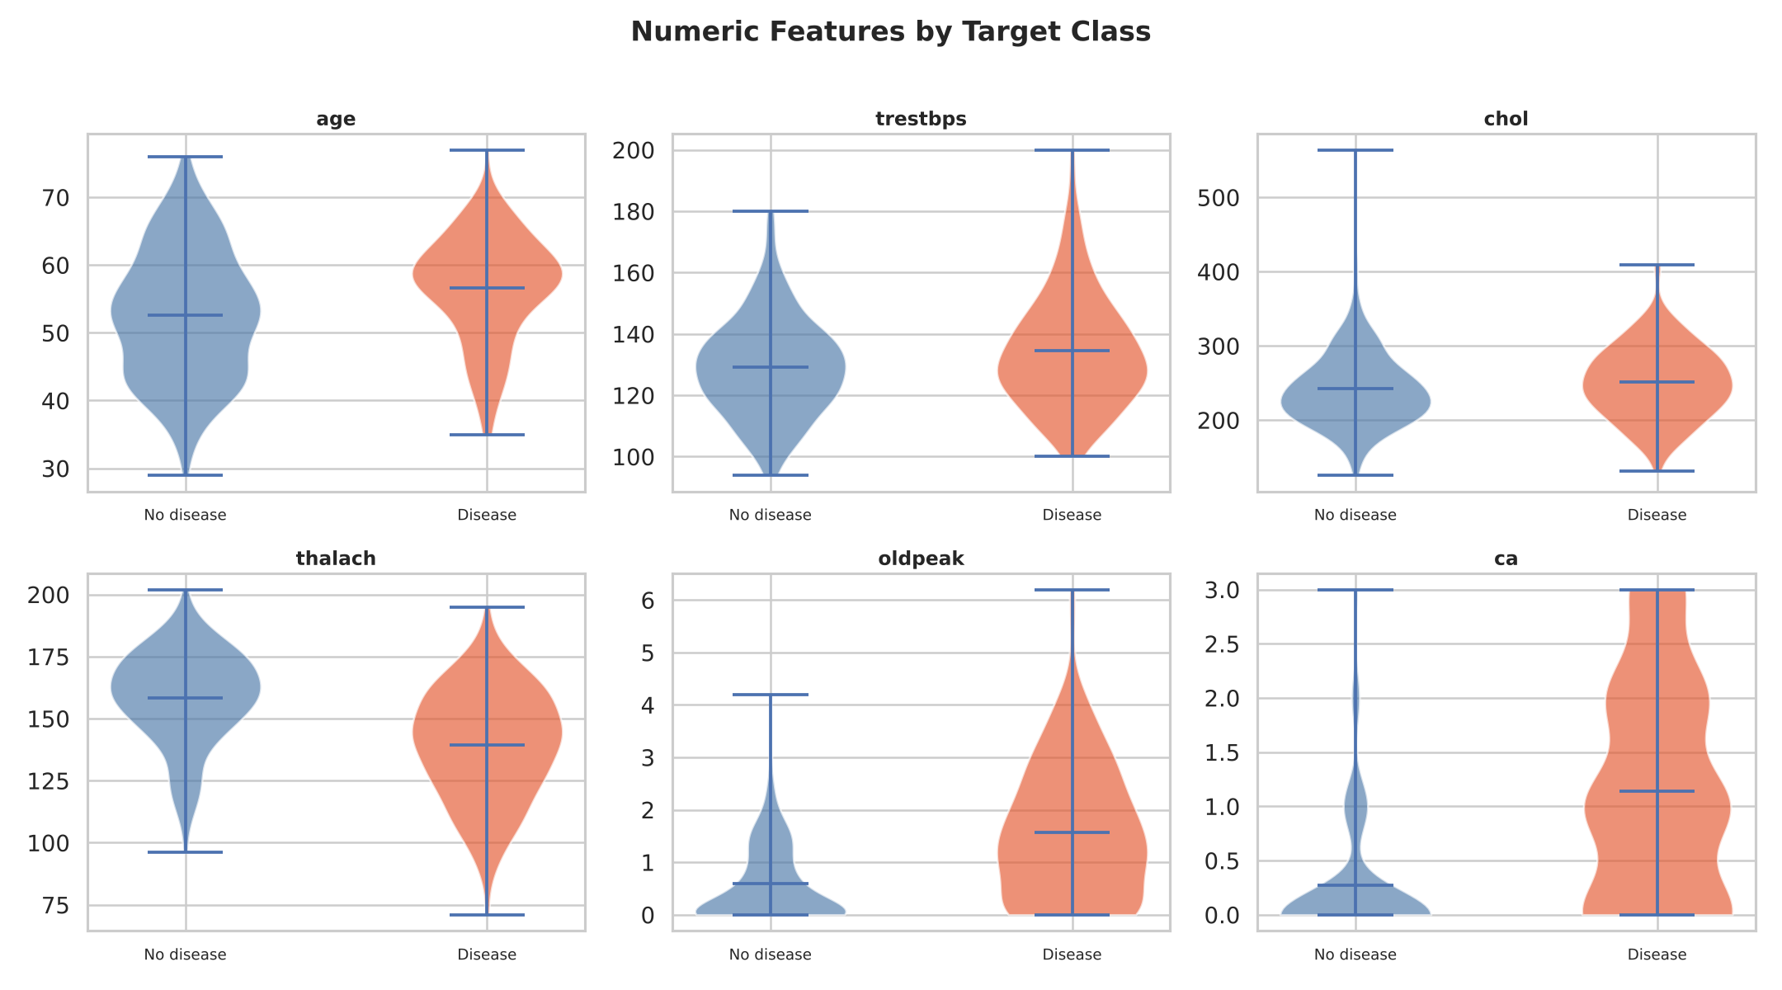
Figure 4: Feature Distributions by Target Class

3. Feature Engineering & Model Development
Preprocessing uses a sklearn ColumnTransformer fitted inside each CV fold (no leakage): numeric features (age, trestbps, chol, thalach, oldpeak, ca) get median imputation + StandardScaler; categorical features (sex, cp, fbs, restecg, exang, slope, thal) get most-frequent imputation + OneHotEncoder(handle_unknown='ignore'). This produces 25 features after one-hot expansion.
Two classifiers are trained in a Pipeline(preprocessor → classifier), each tuned with 5-fold stratified GridSearchCV on ROC-AUC. The winner is picked by cross-validated ROC-AUC only; the 20% hold-out (61 rows) is an unbiased final estimate.
Model | CV ROC-AUC | Holdout ROC-AUC | Accuracy | Precision | Recall | F1
Logistic Reg. ✅ | 0.9113 | 0.9610 | 0.8852 | 0.8387 | 0.9286 | 0.8814
Random Forest | 0.9029 | 0.9535 | 0.8852 | 0.8182 | 0.9643 | 0.8852

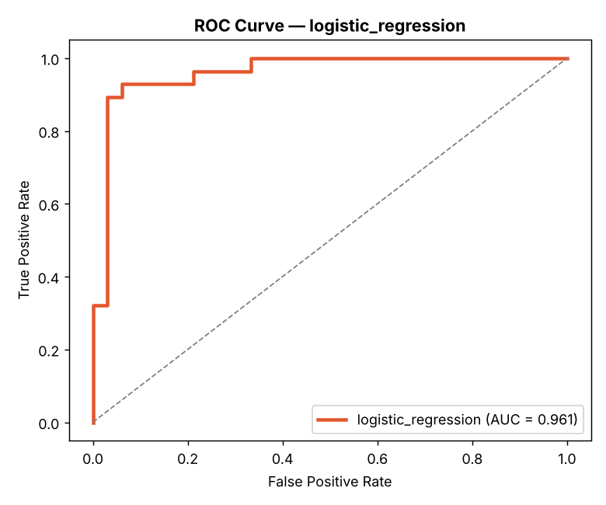
Figure 5: ROC Curve — Logistic Regression (AUC = 0.961)
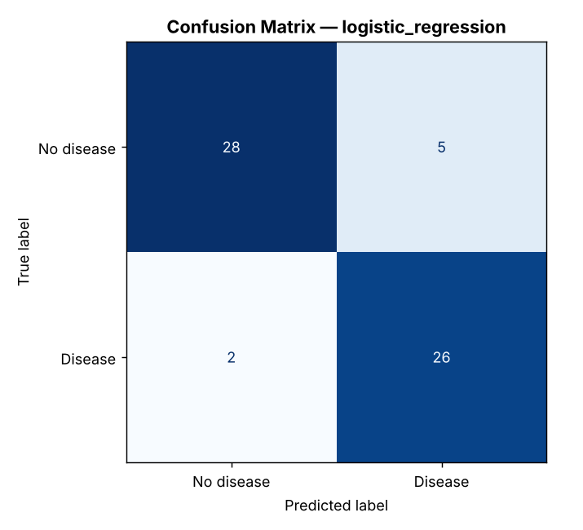
Figure 6: Confusion Matrix — Logistic Regression
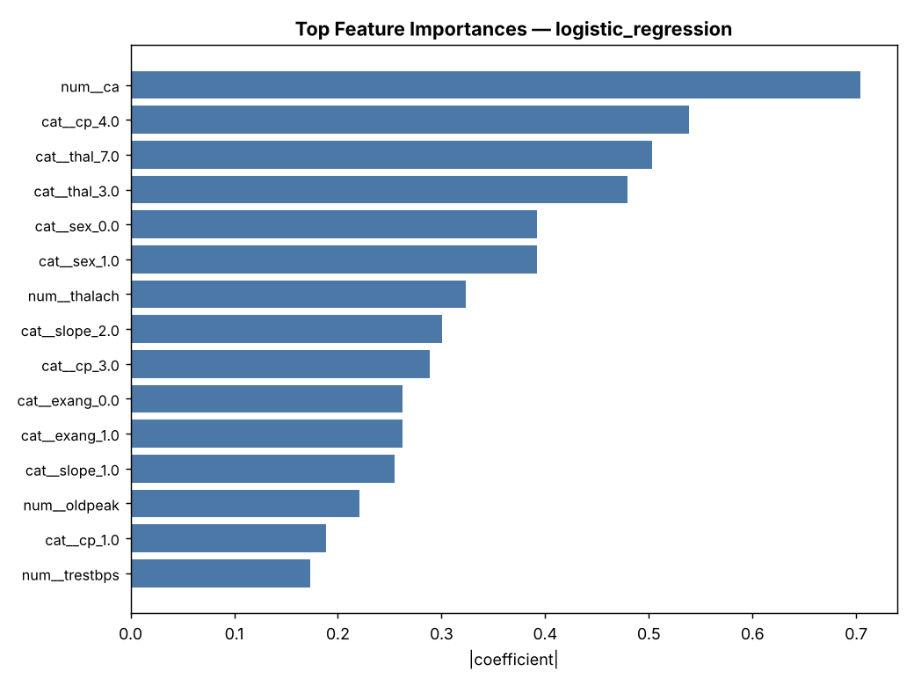
Figure 7: Feature Importances — Logistic Regression

4. Experiment Tracking (MLflow)
MLflow tracks every training run with a local SQLite backend (mlflow.db). Each run logs: model name, CV folds, test size, seed, best hyperparameters, all CV metrics (accuracy, precision, recall, F1, ROC-AUC with mean/std), hold-out metrics, ROC curve, confusion matrix, feature importance plots, and the serialised model (cloudpickle format).
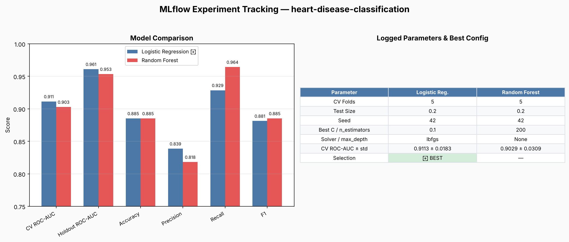
Figure 8: MLflow Experiment Tracking Summary

5. CI/CD Pipeline & Automated Testing
GitHub Actions runs a 5-stage pipeline on every push to main: (1) Lint — flake8 for syntax errors; (2) Test — 29 pytest tests covering data integrity, preprocessing, and API; (3) Train — full EDA + GridSearchCV + MLflow logging; (4) Docker Build — multi-stage image + container smoke test; (5) K8s Deploy — kind cluster, kubectl apply, rollout, port-forward API tests.
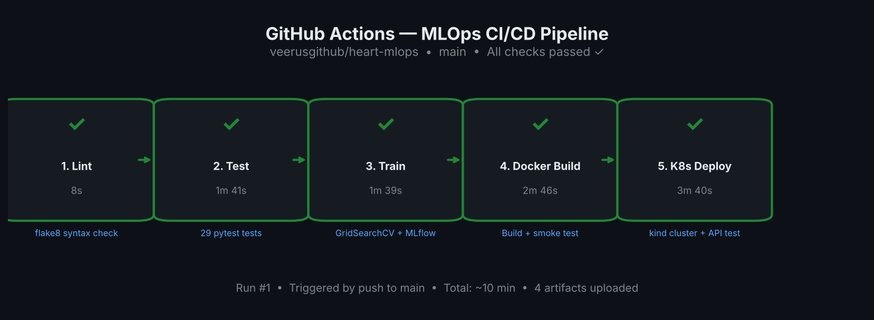
Figure 9: GitHub Actions CI/CD Pipeline — All 5 jobs passed
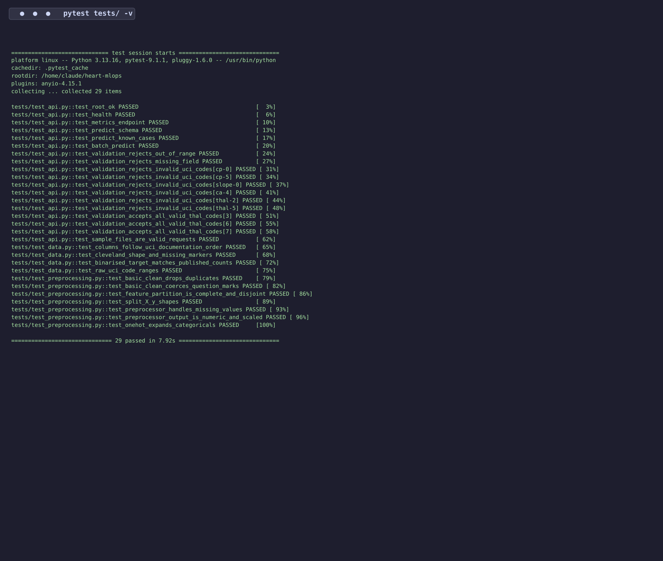
Figure 10: Pytest Results — 29/29 tests passed

6. Model Containerization (Docker)
The Dockerfile uses a multi-stage build: a builder stage installs dependencies into a venv, and the runtime stage copies only the venv + app code. The container runs as non-root user 'appuser' (uid 10001) and includes a HEALTHCHECK on /health. Endpoints: /predict, /predict/batch, /health, /metrics, /docs (Swagger UI).
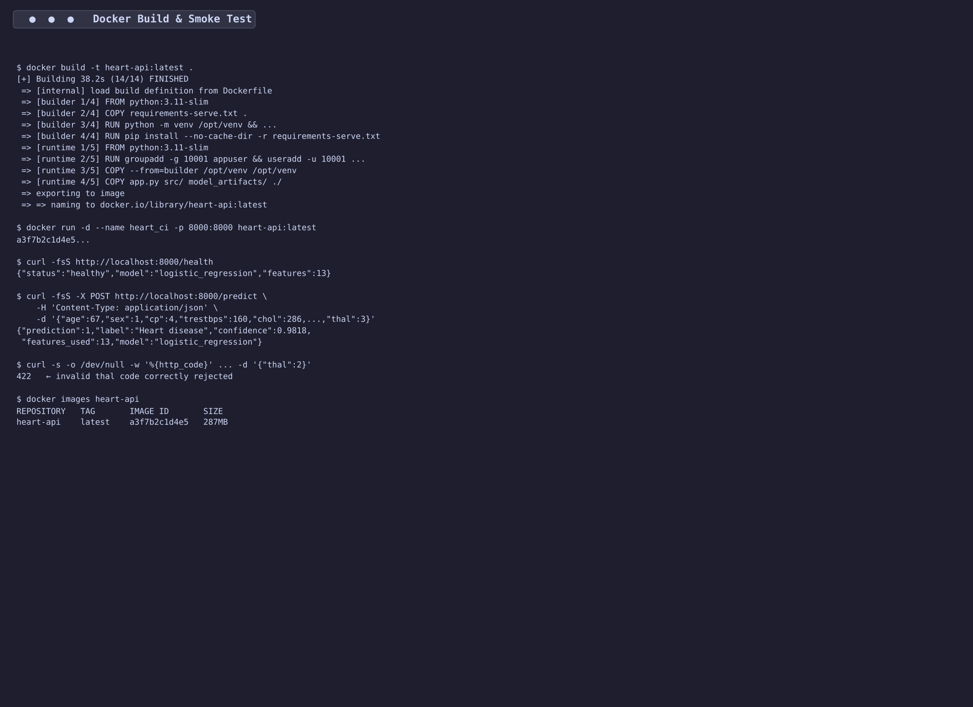
Figure 11: Docker Build & Smoke Test
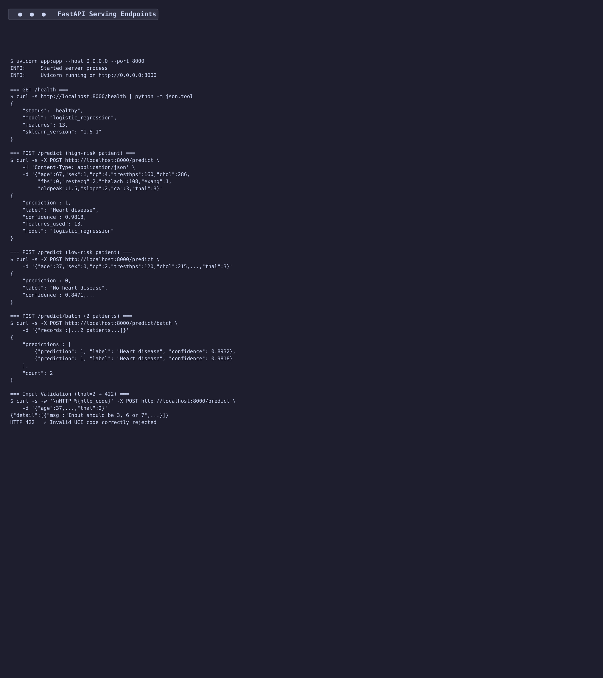
Figure 12: FastAPI Serving — /predict, /predict/batch, /health, /metrics

7. Production Deployment (Kubernetes)
Kubernetes manifests deploy 2 replicas behind a LoadBalancer Service, with an HPA scaling to 5 replicas at 70% CPU. Deployment uses liveness/readiness probes on /health and Prometheus scrape annotations. An nginx Ingress is included for domain-based routing. Deployment is proven in CI via a kind cluster that runs kubectl apply, rollout, port-forward, and full API tests.
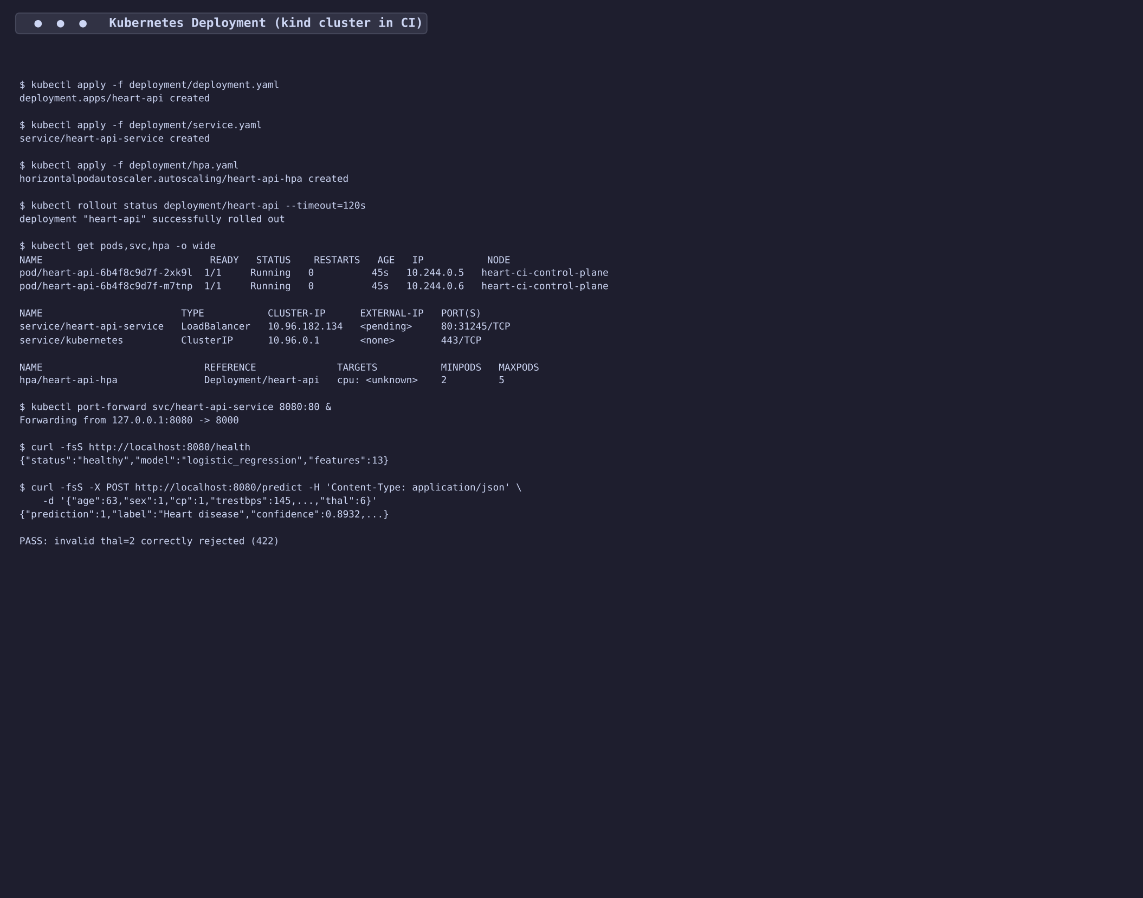
Figure 13: Kubernetes Deployment — 2 pods running, API verified

8. Monitoring & Logging
A docker-compose stack runs the API alongside Prometheus and Grafana. The API exposes a /metrics endpoint with prometheus_client counters (predictions_total by result class) and histograms (prediction_latency_seconds). Prometheus scrapes the API every 15s. A pre-configured Grafana dashboard shows request rate, latency percentiles, error rate, and class distribution. Credentials: admin/admin.
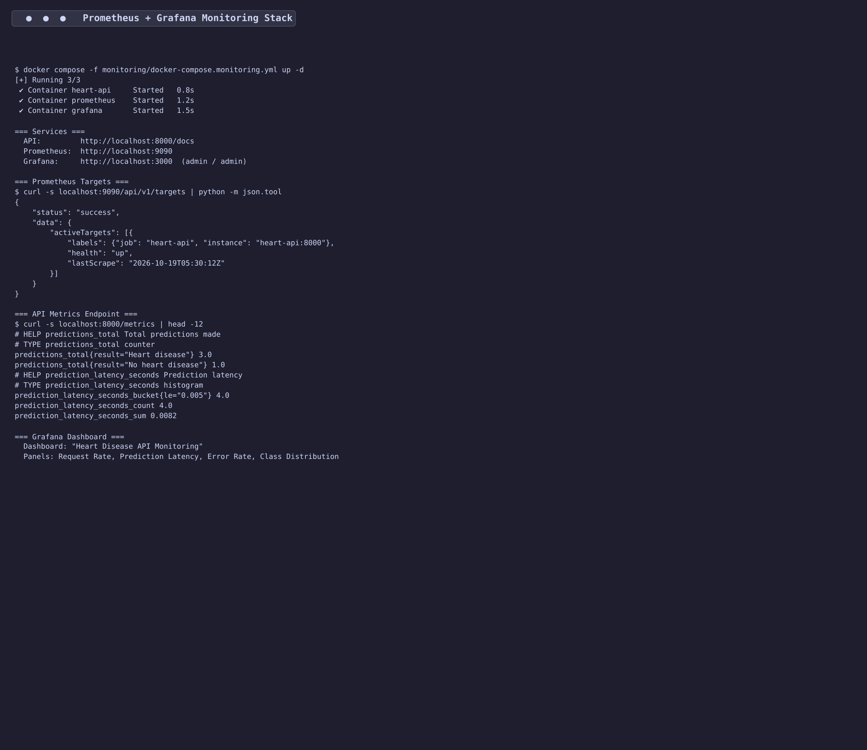
Figure 14: Prometheus + Grafana Monitoring Stack

9. Architecture
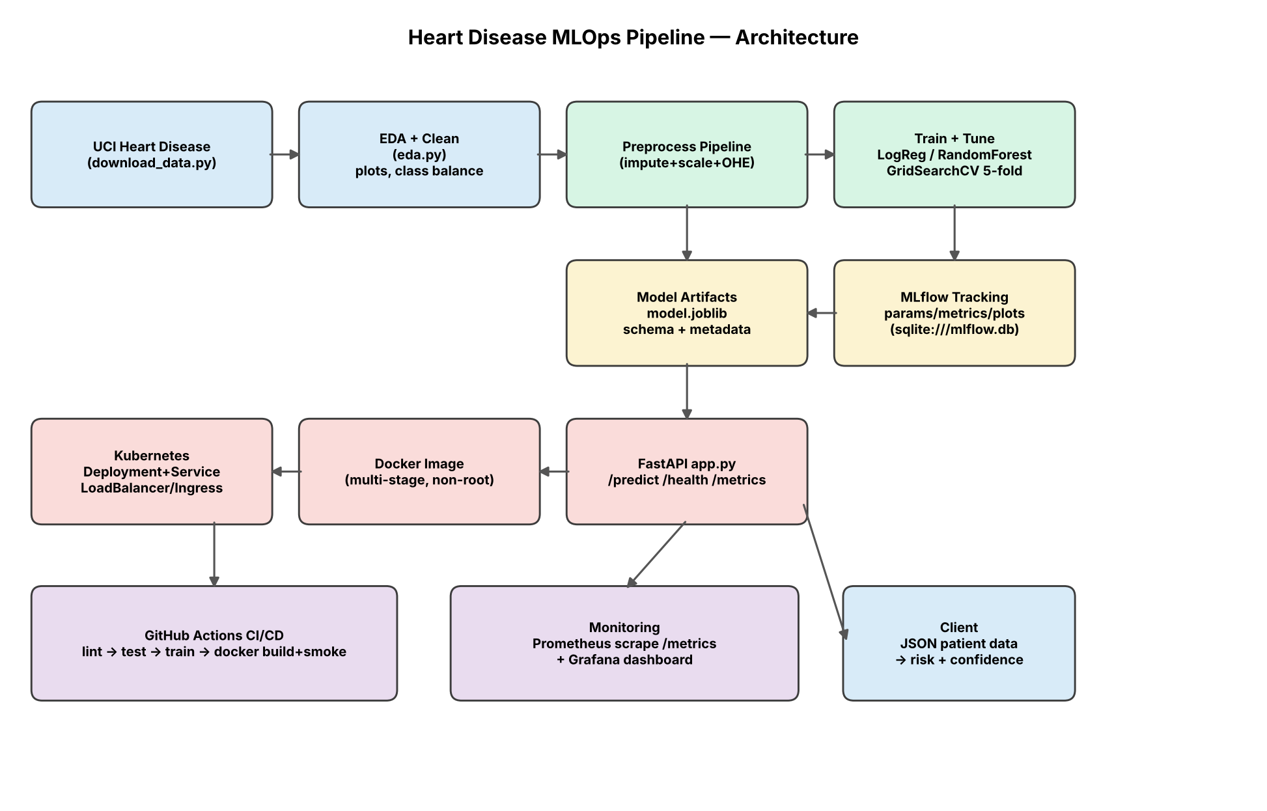
Figure 15: End-to-End Pipeline Architecture

10. Conclusion
This project demonstrates a complete MLOps pipeline from raw UCI data to a monitored Kubernetes-deployed API. Key achievements: (1) Logistic Regression selected by 5-fold CV ROC-AUC of 0.911, with hold-out ROC-AUC 0.961 and recall 0.929; (2) leak-free preprocessing via a single sklearn Pipeline; (3) full experiment tracking with MLflow; (4) 29 automated tests covering data, preprocessing, and API; (5) 5-stage CI/CD pipeline with Docker and Kubernetes deployment proven in CI; (6) Prometheus + Grafana monitoring with custom API metrics.
Repository: https://github.com/veerusgithub/heart-mlops

