Python Programs — Output Screenshots
Console-style screenshots generated by running the 10 uploaded Python programs with their provided sample data.

1. Academic Progression Audit
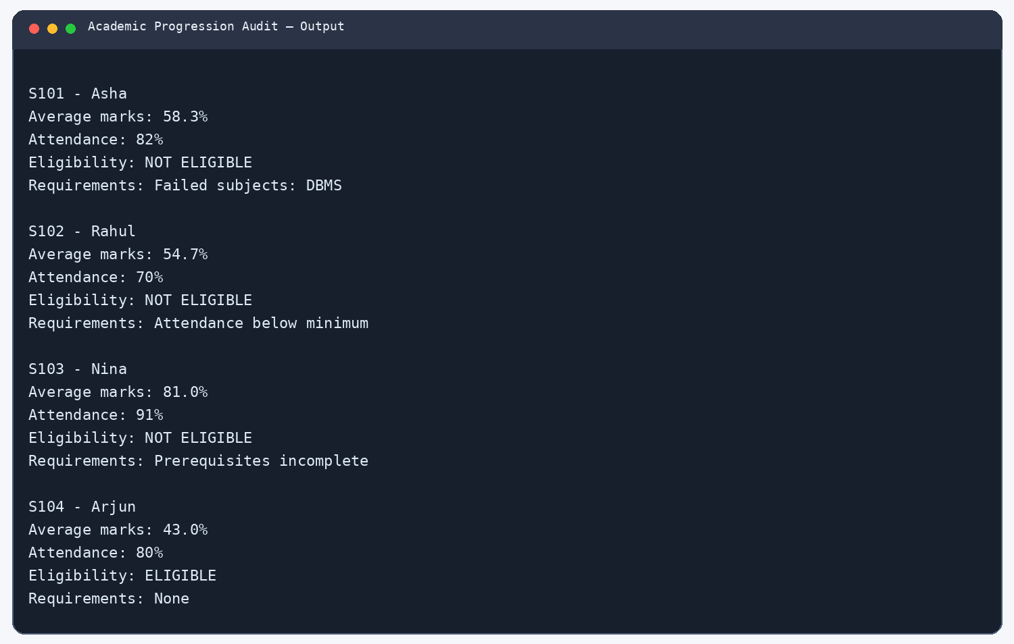

2. Advanced String-Based Registration Record Analyzer
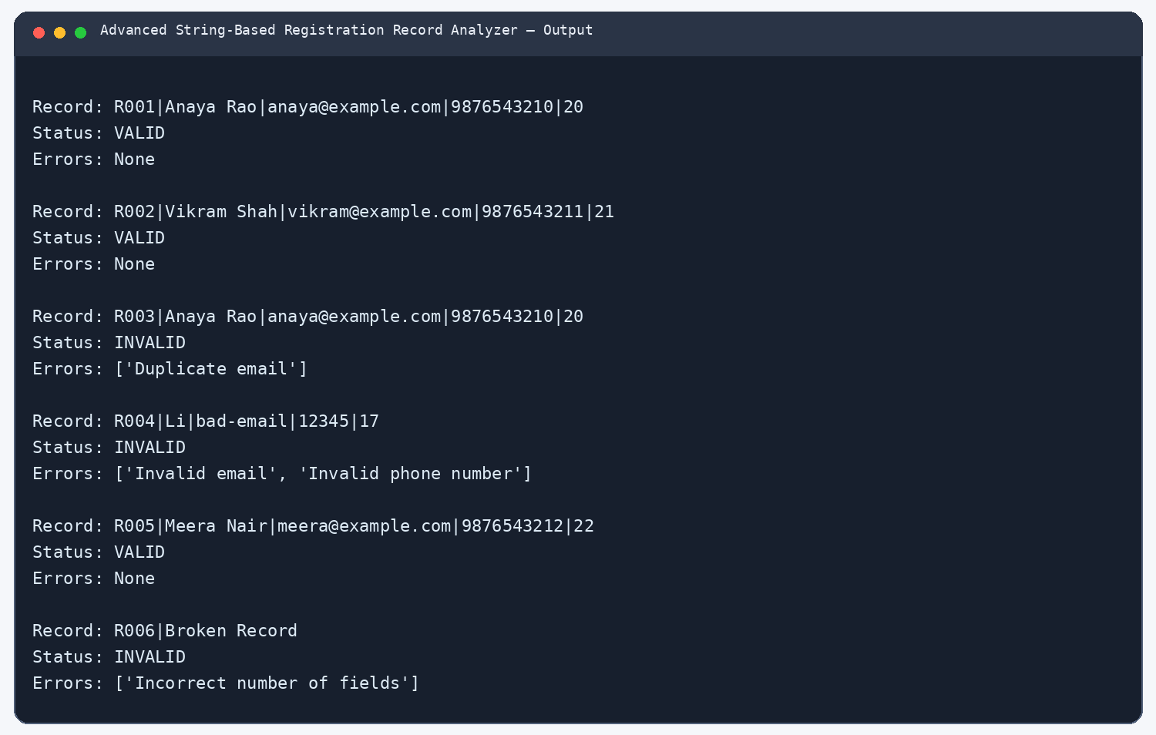

3. Campus Incident Prioritization
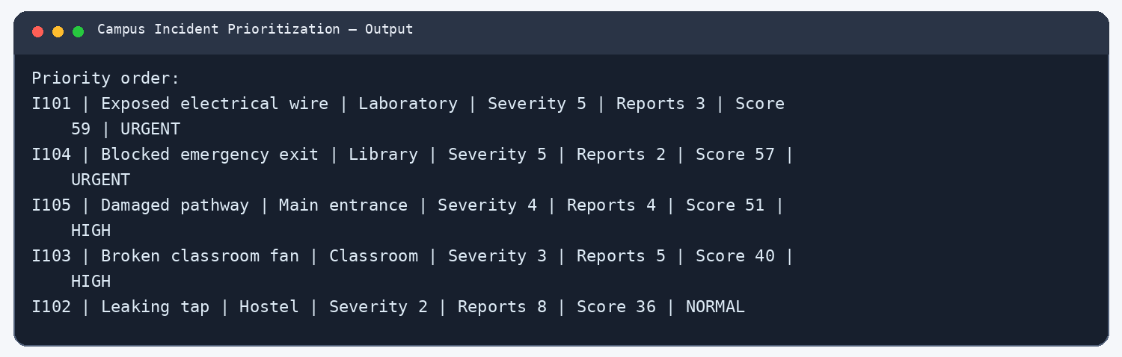

4. Disaster Relief Supply Allocation
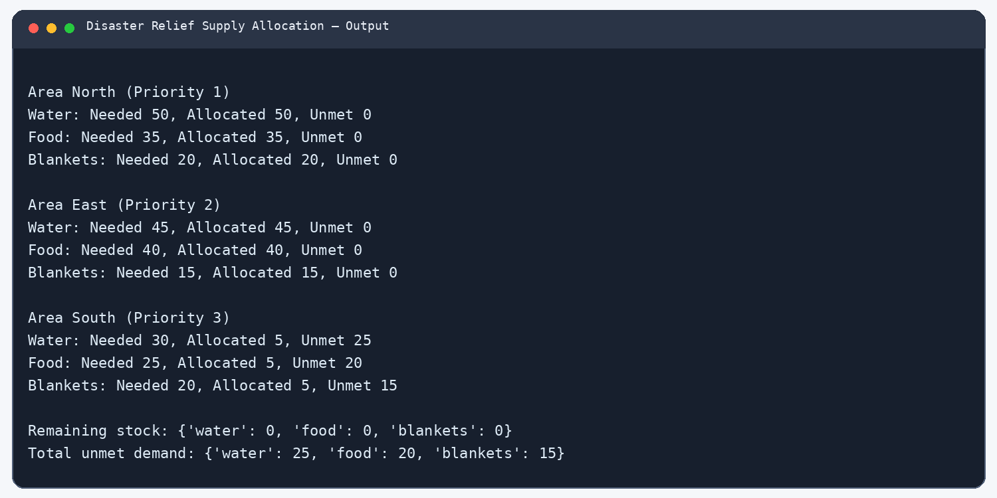

5. E-Commerce Order Reconciliation
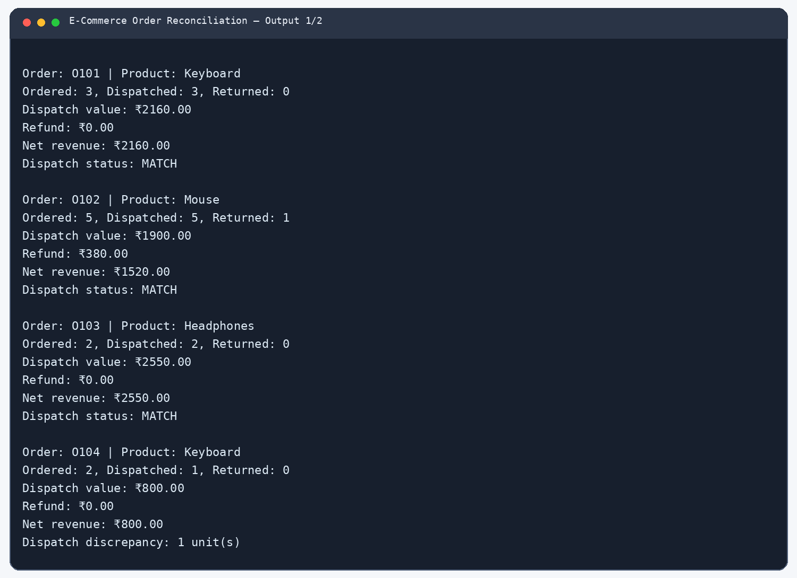
Output screenshot 1 of 2
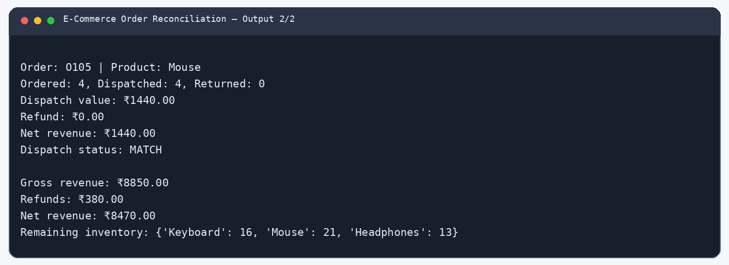
Output screenshot 2 of 2

6. Library Resource Distribution
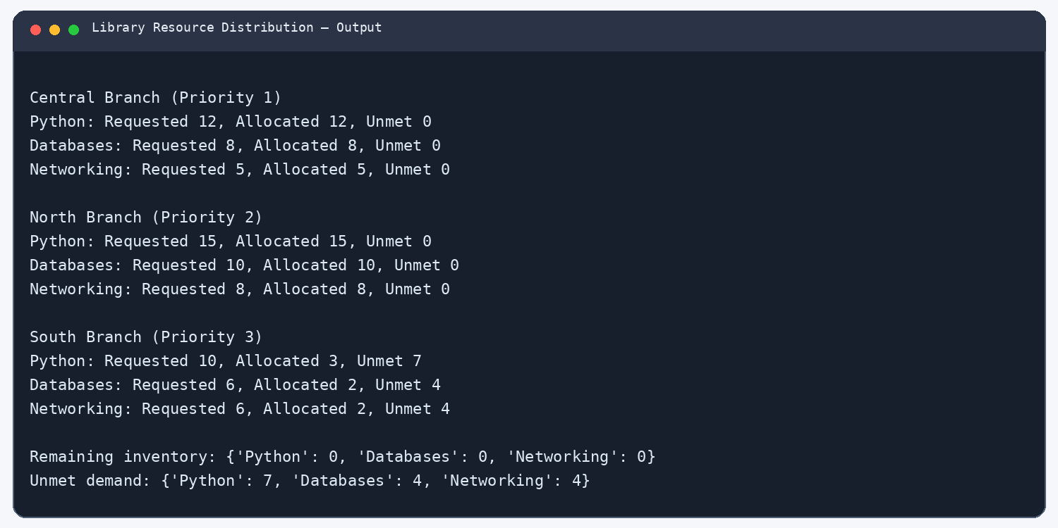

7. Manufacturing Production Planner
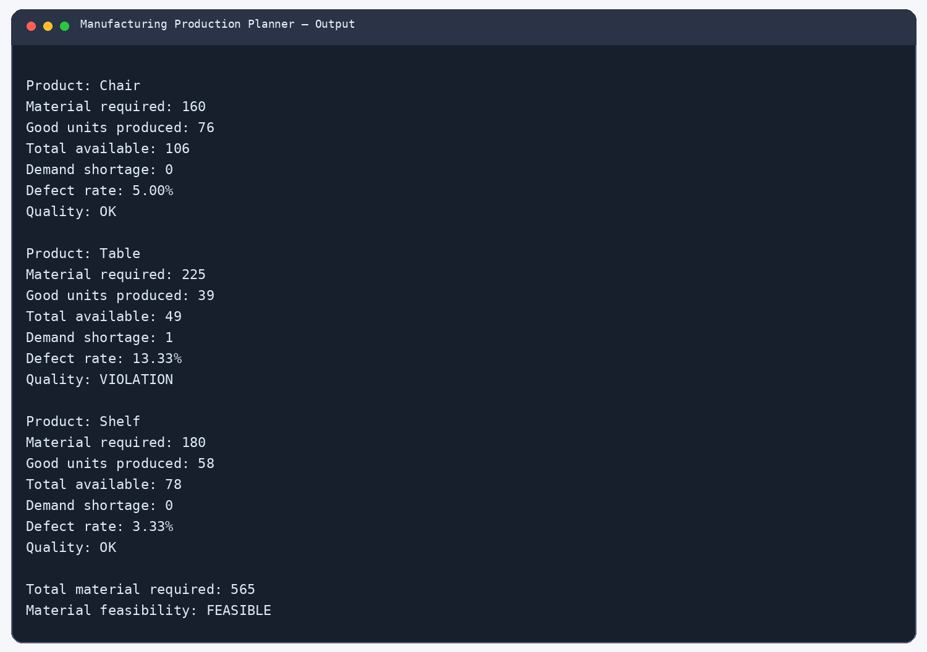

8. Public Transport Fare Reconciliation
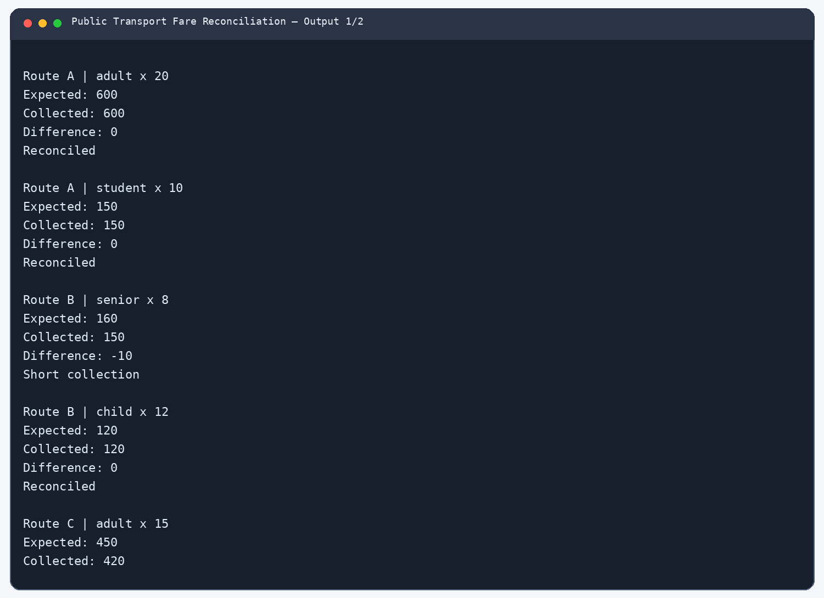
Output screenshot 1 of 2
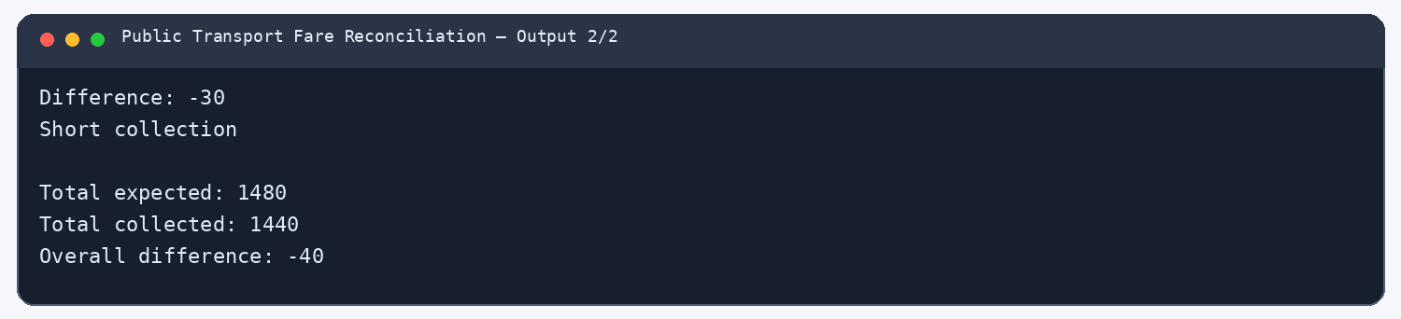
Output screenshot 2 of 2

9. Smart Campus Management System
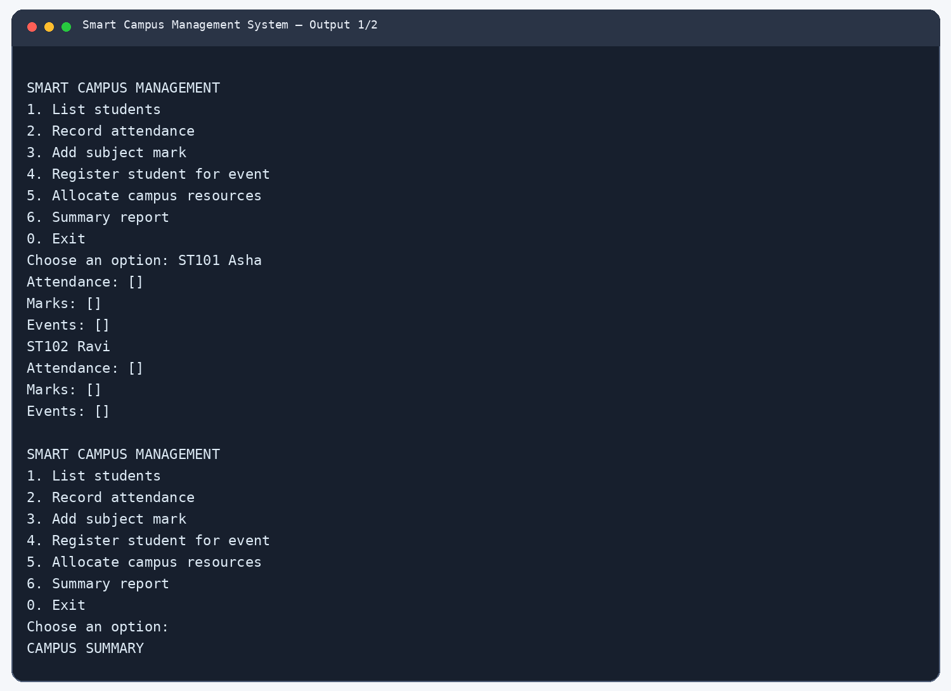
Output screenshot 1 of 2
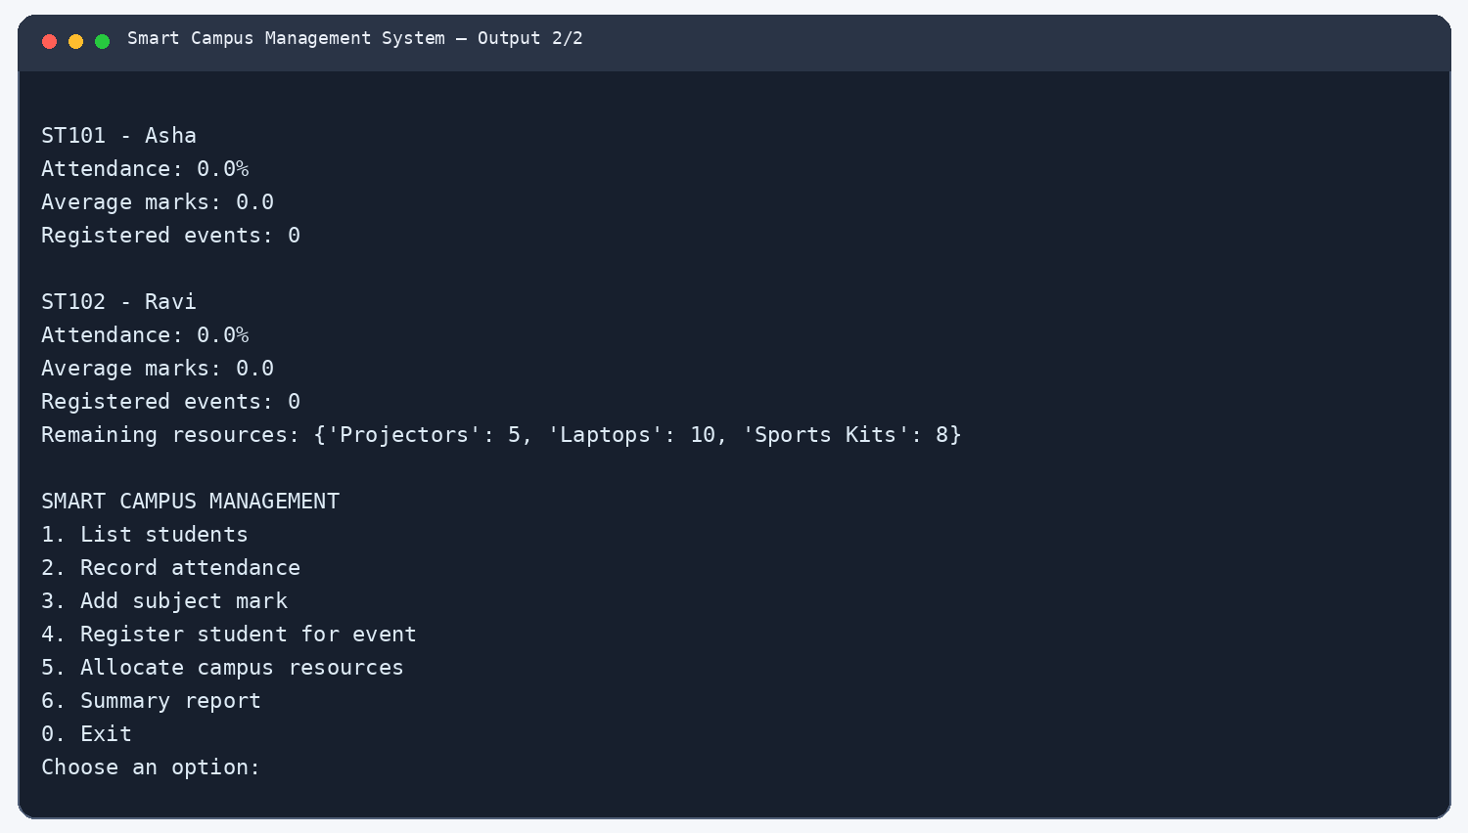
Output screenshot 2 of 2

10. Sports Scheduling and Scoring
