10 Simple Python Programs
with Output Screenshots
Beginner-friendly examples for first-year B.Tech students
Note: The output screenshots below show sample runs using the example inputs provided. Your output may differ when you enter different values.

1. Progressive Electricity Billing
Python Program
units = int(input("Enter electricity units: "))
if units <= 100:
bill = units * 2
elif units <= 200:
bill = 100 * 2 + (units - 100) * 3
else:
bill = 100 * 2 + 100 * 3 + (units - 200) * 5
print("Electricity Bill =", bill)
Output Screenshot:
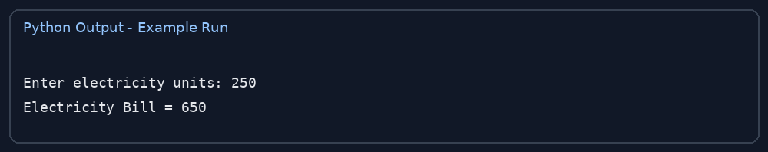

2. Hospital Billing and Patient Classification
Python Program
days = int(input("Enter number of hospital days: "))
room = int(input("Enter room charge per day: "))
medicine = float(input("Enter medicine charges: "))
bill = days * room + medicine
if bill >= 20000:
patient = "High Cost"
else:
patient = "Normal Cost"
print("Total Hospital Bill =", bill)
print("Patient Classification =", patient)
Output Screenshot:
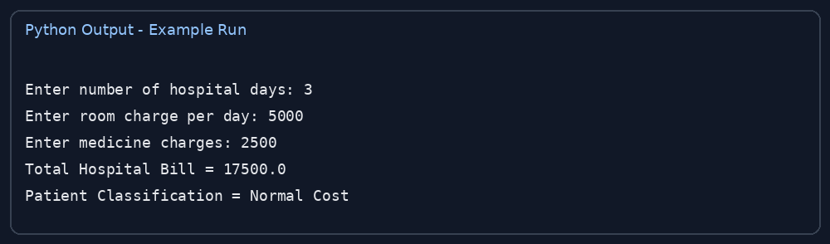

3. Employee Payroll and Deduction Analysis
Python Program
salary = float(input("Enter basic salary: "))
hra = salary * 0.10
da = salary * 0.05
deduction = salary * 0.08
gross = salary + hra + da
net = gross - deduction
print("Gross Salary =", gross)
print("Deduction =", deduction)
print("Net Salary =", net)
Output Screenshot:
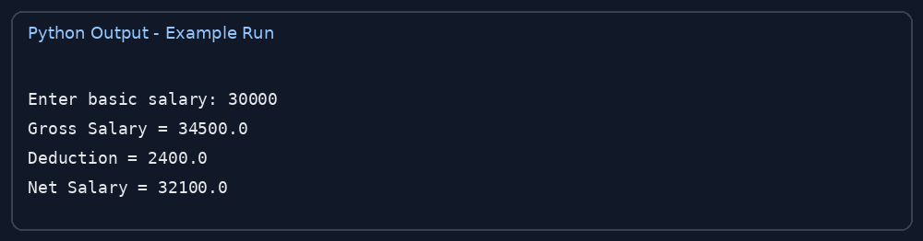

4. Retail Billing with Multiple Discount Rules
Python Program
amount = float(input("Enter total purchase amount: "))
if amount >= 5000:
discount = amount * 0.20
elif amount >= 2000:
discount = amount * 0.10
else:
discount = amount * 0.05
final_bill = amount - discount
print("Discount =", discount)
print("Final Bill =", final_bill)
Output Screenshot:
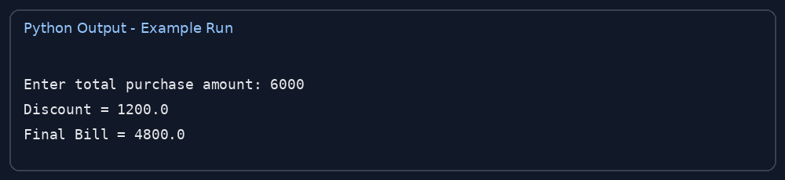

5. Manufacturing Cost and Profitability Analysis
Python Program
quantity = int(input("Enter quantity produced: "))
cost = float(input("Enter cost per item: "))
price = float(input("Enter selling price per item: "))
total_cost = quantity * cost
revenue = quantity * price
profit = revenue - total_cost
print("Total Cost =", total_cost)
print("Revenue =", revenue)
print("Profit =", profit)
if profit > 0:
print("Result: Profit")
elif profit < 0:
print("Result: Loss")
else:
print("Result: No Profit, No Loss")
Output Screenshot:
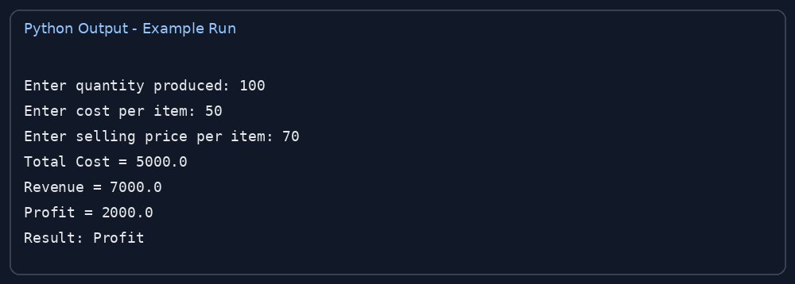

6. Multi-Currency Travel Budget Analysis
Python Program
rupees = float(input("Enter budget in INR: "))
rate = float(input("Enter exchange rate (1 foreign unit in INR): "))
foreign_money = rupees / rate
print("Budget in foreign currency =", round(foreign_money, 2))
Output Screenshot:
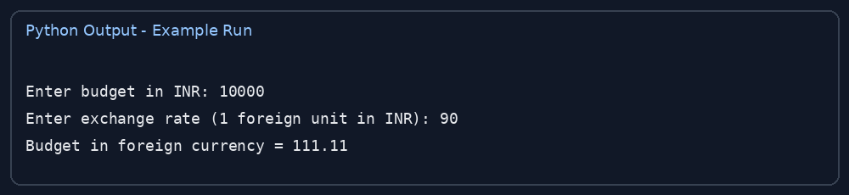

7. Campus Event Financial Planning
Python Program
students = int(input("Enter number of students: "))
fee = float(input("Enter fee per student: "))
expenses = float(input("Enter total event expenses: "))
income = students * fee
balance = income - expenses
print("Total Income =", income)
print("Total Expenses =", expenses)
print("Remaining Balance =", balance)
if balance >= 0:
print("Event is within budget")
else:
print("Event is over budget")
Output Screenshot:
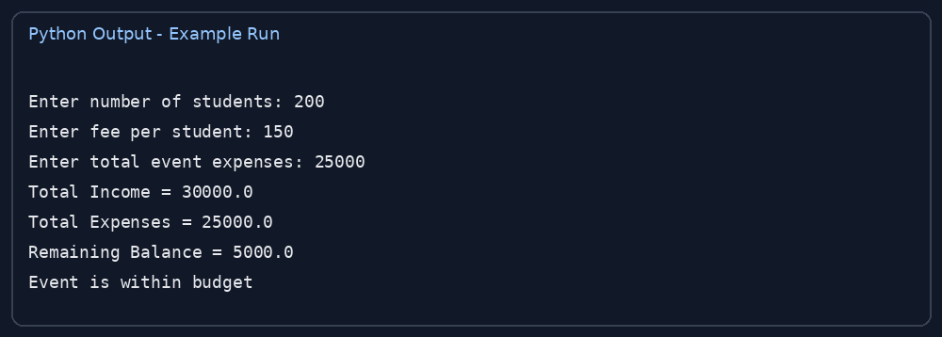

8. Examination Result and Grace-Mark Validation
Python Program
marks = int(input("Enter marks out of 100: "))
if marks >= 35:
print("Result: Pass")
elif marks >= 30:
grace = 35 - marks
print("Grace Marks Required =", grace)
print("Result: Eligible for grace marks (if permitted)")
else:
print("Result: Fail")
Output Screenshot:
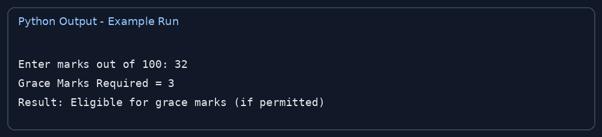

9. Attendance Recovery Computation
Python Program
total = int(input("Enter total classes: "))
attended = int(input("Enter classes attended: "))
percentage = (attended / total) * 100
print("Attendance Percentage =", round(percentage, 2), "%")
if percentage >= 75:
print("Attendance is sufficient")
else:
required = (0.75 * total - attended) / 0.25
print("More classes to attend =", max(0, int(required) + 1))
Output Screenshot:
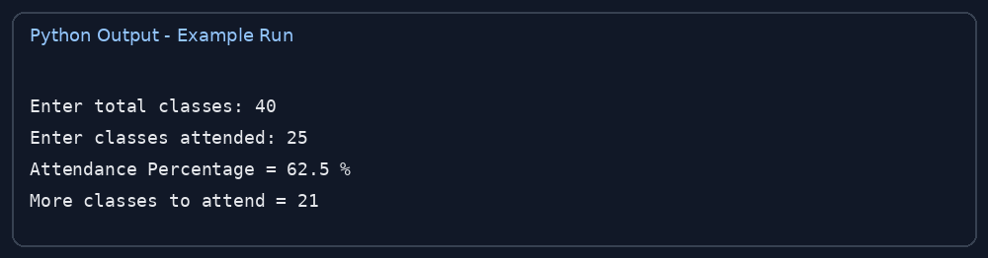

10. ATM Transaction Sequence Simulation
Python Program
balance = 5000
while True:
print("\n1. Check Balance")
print("2. Deposit")
print("3. Withdraw")
print("4. Exit")
choice = int(input("Enter your choice: "))
if choice == 1:
print("Balance =", balance)
elif choice == 2:
amount = float(input("Enter deposit amount: "))
if amount > 0:
balance += amount
print("Deposit successful")
else:
print("Invalid amount")
elif choice == 3:
amount = float(input("Enter withdrawal amount: "))
if amount > 0 and amount <= balance:
balance -= amount
print("Withdrawal successful")
else:
print("Invalid amount or insufficient balance")
elif choice == 4:
print("Thank you for using ATM")
break
else:
print("Invalid choice")
Output Screenshot:


