PYTHON ACTIVITY-BASED LEARNING
10 CASE STUDIES
Complete documentation: problem statement, objectives, assumptions, algorithm, flowchart, pseudocode, source code, test cases, output screenshots, and conclusion

General Instructions
Run each Python program in Python 3 (for example, in VS Code). The screenshots show sample runs using the listed inputs. Use the sample assumptions stated in each case; actual institutional or commercial rules may differ.
Suggested GitHub repository name: Python-Activity-Based-Learning

1. Progressive Electricity Billing

1. Problem Statement
Calculate an electricity bill using progressive rates: first 100 units at ₹2 per unit, next 100 units at ₹3 per unit, and units above 200 at ₹5 per unit.

2. Objectives
- Read electricity units from the user.
- Apply progressive slab rates using if/elif/else.
- Display the total bill.

3. Assumptions
- Units are whole numbers and cannot be negative.
- The rates are sample rates for this case study, not official tariff rates.

4. Algorithm
1. Start.
2. Input units.
3. If units ≤ 100, bill = units × 2.
4. Else if units ≤ 200, bill = 200 + (units − 100) × 3.
5. Otherwise, bill = 400 + (units − 200) × 5.
6. Display bill and stop.

5. Flowchart
Start → Input units → Check units ≤ 100? → Calculate using the matching slab → Display bill → End
Flowchart sequence shown in text form; arrows indicate the flow between steps.

6. Pseudocode
INPUT units
IF units <= 100: bill = units * 2
ELSE IF units <= 200: bill = 200 + (units - 100) * 3
ELSE: bill = 400 + (units - 200) * 5
PRINT bill

7. Python Source Code
units = int(input("Enter electricity units: "))
if units < 0:
print("Invalid units")
elif units <= 100:
bill = units * 2
elif units <= 200:
bill = 100 * 2 + (units - 100) * 3
else:
bill = 100 * 2 + 100 * 3 + (units - 200) * 5
# Units above 200 are charged at ₹5 each.
if units >= 0:
print("Electricity Bill =", bill)

8. Test Cases
Input | Expected result
50 | ₹100
150 | ₹350
250 | ₹650

9. Output Screenshot
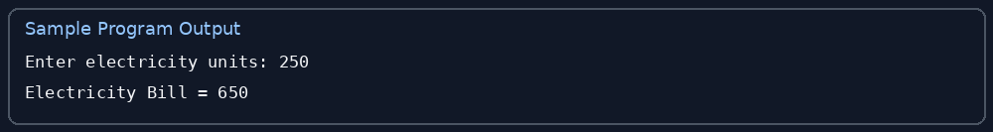

10. Conclusion
The program calculates the bill according to the progressive unit slabs.

2. Hospital Billing and Patient Classification

1. Problem Statement
Calculate a patient's hospital bill from the number of days, daily room charge, and medicine charges. Classify bills of ₹20,000 or more as High Cost.

2. Objectives
- Accept patient billing details.
- Calculate the total hospital bill.
- Classify the bill based on a threshold.

3. Assumptions
- Inputs are non-negative.
- ₹20,000 is a sample classification threshold, not a medical or hospital policy.

4. Algorithm
1. Start.
2. Input days, daily room charge, and medicine charges.
3. Calculate bill = days × room charge + medicine charges.
4. If bill ≥ 20,000, classify as High Cost; otherwise Normal Cost.
5. Display bill and classification.
6. Stop.

5. Flowchart
Start → Input billing details → Calculate total → Bill ≥ ₹20,000? → Display classification → End
Flowchart sequence shown in text form; arrows indicate the flow between steps.

6. Pseudocode
INPUT days, room_charge, medicine
bill = days * room_charge + medicine
IF bill >= 20000: category = High Cost
ELSE: category = Normal Cost
PRINT bill, category

7. Python Source Code
days = int(input("Enter number of hospital days: "))
room = float(input("Enter room charge per day: "))
medicine = float(input("Enter medicine charges: "))
bill = days * room + medicine
print("Total Hospital Bill =", bill)
if bill >= 20000:
print("Patient Classification = High Cost")
else:
print("Patient Classification = Normal Cost")

8. Test Cases
Input | Expected result
2 days, ₹3000/day, ₹1000 medicine | ₹7,000; Normal Cost
3 days, ₹6000/day, ₹2500 medicine | ₹20,500; High Cost

9. Output Screenshot
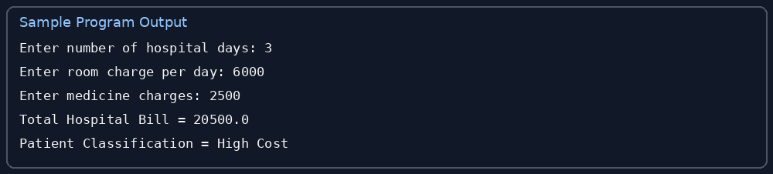

10. Conclusion
The program adds room and medicine charges and classifies the total using a threshold.

3. Employee Payroll and Deduction Analysis

1. Problem Statement
Calculate gross and net salary using a basic salary, HRA of 10%, DA of 5%, and a deduction of 8% of basic salary.

2. Objectives
- Read basic salary.
- Calculate allowances and deduction.
- Display gross and net salary.

3. Assumptions
- Basic salary is non-negative.
- Rates are sample classroom assumptions; real payroll rules may differ.

4. Algorithm
1. Start.
2. Input basic salary.
3. Calculate HRA = 10% of basic and DA = 5% of basic.
4. Calculate gross = basic + HRA + DA.
5. Calculate deduction = 8% of basic; net = gross − deduction.
6. Display results and stop.

5. Flowchart
Start → Input basic salary → Calculate allowances → Calculate gross and deduction → Calculate net → Display → End
Flowchart sequence shown in text form; arrows indicate the flow between steps.

6. Pseudocode
INPUT basic
hra = basic * 0.10
da = basic * 0.05
gross = basic + hra + da
deduction = basic * 0.08
net = gross - deduction
PRINT gross, deduction, net

7. Python Source Code
basic = float(input("Enter basic salary: "))
hra = basic * 0.10
da = basic * 0.05
deduction = basic * 0.08
gross = basic + hra + da
net = gross - deduction
print("Gross Salary =", gross)
print("Deduction =", deduction)
print("Net Salary =", net)

8. Test Cases
Input | Expected result
₹30,000 | Gross ₹34,500; deduction ₹2,400; net ₹32,100
₹20,000 | Gross ₹23,000; deduction ₹1,600; net ₹21,400

9. Output Screenshot
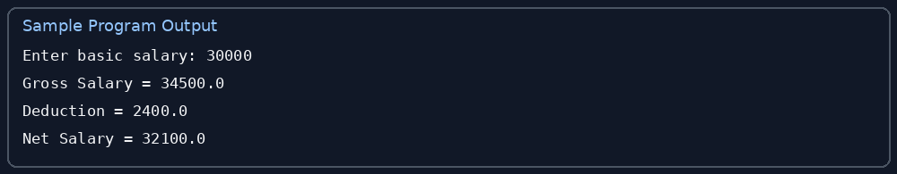

10. Conclusion
The program calculates salary components and the resulting net salary.

4. Retail Billing with Multiple Discount Rules

1. Problem Statement
Calculate a retail bill with discounts: 20% for purchases of ₹5,000 or more, 10% for ₹2,000–₹4,999.99, and 5% for purchases below ₹2,000.

2. Objectives
- Accept the purchase amount.
- Select the correct discount tier.
- Display discount and final amount.

3. Assumptions
- Purchase amount is non-negative.
- Discounts are sample rules for this exercise.

4. Algorithm
1. Start.
2. Input purchase amount.
3. If amount ≥ 5000, discount = 20%.
4. Else if amount ≥ 2000, discount = 10%; otherwise discount = 5%.
5. Calculate final bill = amount − discount.
6. Display values and stop.

5. Flowchart
Start → Input amount → Select discount tier → Calculate discount and final bill → Display → End
Flowchart sequence shown in text form; arrows indicate the flow between steps.

6. Pseudocode
INPUT amount
IF amount >= 5000: rate = 0.20
ELSE IF amount >= 2000: rate = 0.10
ELSE: rate = 0.05
discount = amount * rate
PRINT discount, amount - discount

7. Python Source Code
amount = float(input("Enter total purchase amount: "))
if amount < 0:
print("Invalid amount")
else:
if amount >= 5000:
rate = 0.20
elif amount >= 2000:
rate = 0.10
else:
rate = 0.05
discount = amount * rate
print("Discount =", discount)
print("Final Bill =", amount - discount)

8. Test Cases
Input | Expected result
₹6,000 | 20% discount = ₹1,200; final ₹4,800
₹3,000 | 10% discount = ₹300; final ₹2,700
₹1,000 | 5% discount = ₹50; final ₹950

9. Output Screenshot
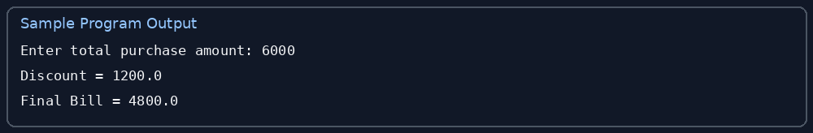

10. Conclusion
The program applies different discount percentages based on the purchase amount.

5. Manufacturing Cost and Profitability Analysis

1. Problem Statement
Calculate production cost, sales revenue, and profit or loss from quantity produced, cost per item, and selling price per item.

2. Objectives
- Read production and price details.
- Calculate total cost and revenue.
- Identify profit, loss, or break-even.

3. Assumptions
- Quantity is a non-negative integer.
- Unit cost and selling price are non-negative.

4. Algorithm
1. Start.
2. Input quantity, cost per item, and selling price.
3. Calculate total cost = quantity × cost.
4. Calculate revenue = quantity × selling price.
5. Calculate profit = revenue − total cost.
6. Print cost, revenue, and profit/loss result.
7. Stop.

5. Flowchart
Start → Input quantity and prices → Calculate cost and revenue → Calculate profit → Profit positive/negative/zero? → Display → End
Flowchart sequence shown in text form; arrows indicate the flow between steps.

6. Pseudocode
INPUT quantity, cost, price
total_cost = quantity * cost
revenue = quantity * price
profit = revenue - total_cost
PRINT total_cost, revenue, profit
IF profit > 0: PRINT Profit; ELSE IF profit < 0: PRINT Loss; ELSE: PRINT Break-even

7. Python Source Code
quantity = int(input("Enter quantity produced: "))
cost = float(input("Enter cost per item: "))
price = float(input("Enter selling price per item: "))
total_cost = quantity * cost
revenue = quantity * price
profit = revenue - total_cost
print("Total Cost =", total_cost)
print("Revenue =", revenue)
print("Profit =", profit)
if profit > 0:
print("Result: Profit")
elif profit < 0:
print("Result: Loss")
else:
print("Result: No Profit, No Loss")

8. Test Cases
Input | Expected result
100 items, cost ₹50, selling price ₹70 | Cost ₹5,000; revenue ₹7,000; profit ₹2,000
10 items, cost ₹80, selling price ₹60 | Loss ₹200

9. Output Screenshot
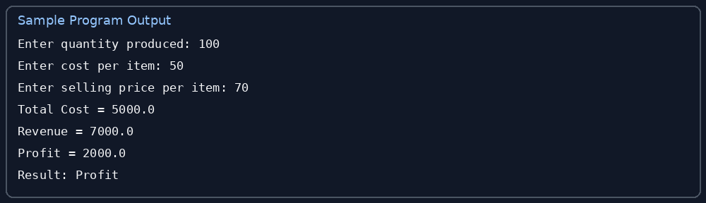

10. Conclusion
The program determines whether production results in profit, loss, or break-even.

6. Multi-Currency Travel Budget Analysis

1. Problem Statement
Convert a travel budget in Indian rupees into a foreign currency using an exchange rate supplied by the user.

2. Objectives
- Accept the budget in INR.
- Accept the INR value of one foreign currency unit.
- Calculate and display the converted budget.

3. Assumptions
- Budget and exchange rate must be positive or zero for budget, and strictly positive for rate.
- The rate is entered by the user and is not a live exchange rate.

4. Algorithm
1. Start.
2. Input INR budget and exchange rate.
3. If rate ≤ 0, display invalid rate.
4. Otherwise calculate foreign amount = INR budget ÷ rate.
5. Display result rounded to two decimal places.
6. Stop.

5. Flowchart
Start → Input INR budget and rate → Is rate positive? → Convert budget → Display result → End
Flowchart sequence shown in text form; arrows indicate the flow between steps.

6. Pseudocode
INPUT rupees, rate
IF rate <= 0: PRINT Invalid exchange rate
ELSE: foreign_money = rupees / rate; PRINT round(foreign_money, 2)

7. Python Source Code
rupees = float(input("Enter budget in INR: "))
rate = float(input("Enter INR value of 1 foreign unit: "))
if rupees < 0 or rate <= 0:
print("Invalid budget or exchange rate")
else:
foreign_money = rupees / rate
print("Budget in foreign currency =", round(foreign_money, 2))

8. Test Cases
Input | Expected result
₹10,000; rate ₹90 per foreign unit | 111.11 foreign units
₹4,500; rate ₹90 | 50.00 foreign units

9. Output Screenshot
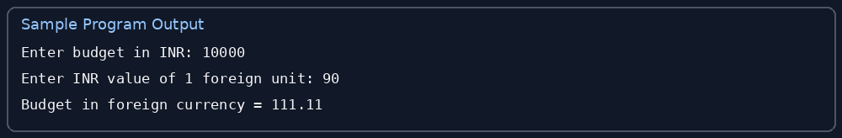

10. Conclusion
The program converts a budget using a user-provided exchange rate.

7. Campus Event Financial Planning

1. Problem Statement
Calculate event income from student contributions, compare it with expenses, and determine the remaining balance or deficit.

2. Objectives
- Read number of students, fee per student, and expenses.
- Calculate income and balance.
- Report whether the event is within budget.

3. Assumptions
- All inputs are non-negative.
- Each student pays the same fee.

4. Algorithm
1. Start.
2. Input students, fee, and expenses.
3. Income = students × fee.
4. Balance = income − expenses.
5. If balance ≥ 0, event is within budget; otherwise over budget.
6. Display results and stop.

5. Flowchart
Start → Input event details → Calculate income → Subtract expenses → Balance ≥ 0? → Display status → End
Flowchart sequence shown in text form; arrows indicate the flow between steps.

6. Pseudocode
INPUT students, fee, expenses
income = students * fee
balance = income - expenses
PRINT income, expenses, balance
IF balance >= 0: PRINT Within budget; ELSE: PRINT Over budget

7. Python Source Code
students = int(input("Enter number of students: "))
fee = float(input("Enter fee per student: "))
expenses = float(input("Enter total event expenses: "))
income = students * fee
balance = income - expenses
print("Total Income =", income)
print("Total Expenses =", expenses)
print("Remaining Balance =", balance)
if balance >= 0:
print("Event is within budget")
else:
print("Event is over budget")

8. Test Cases
Input | Expected result
200 students, ₹150 fee, ₹25,000 expenses | Income ₹30,000; balance ₹5,000; within budget
100 students, ₹100 fee, ₹12,000 expenses | Deficit ₹2,000; over budget

9. Output Screenshot
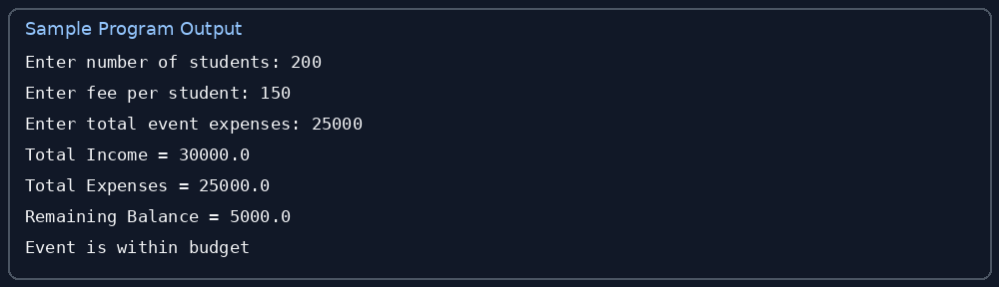

10. Conclusion
The program supports basic financial planning for a campus event.

8. Examination Result and Grace-Mark Validation

1. Problem Statement
Classify marks out of 100: 35 or more is Pass, 30–34 may be eligible for grace marks, and below 30 is Fail.

2. Objectives
- Accept marks.
- Apply pass/fail thresholds.
- Calculate the grace marks needed to reach 35 when applicable.

3. Assumptions
- Marks are from 0 to 100.
- Grace marks are shown as a possible calculation only; actual eligibility depends on institutional rules.

4. Algorithm
1. Start.
2. Input marks.
3. If marks are outside 0–100, display invalid marks.
4. Else if marks ≥ 35, display Pass.
5. Else if marks ≥ 30, calculate grace = 35 − marks and display possible eligibility.
6. Otherwise display Fail.
7. Stop.

5. Flowchart
Start → Input marks → Validate range → Check pass threshold → Check grace range → Display result → End
Flowchart sequence shown in text form; arrows indicate the flow between steps.

6. Pseudocode
INPUT marks
IF marks < 0 OR marks > 100: PRINT Invalid marks
ELSE IF marks >= 35: PRINT Pass
ELSE IF marks >= 30: PRINT grace = 35 - marks; PRINT possible grace eligibility
ELSE: PRINT Fail

7. Python Source Code
marks = int(input("Enter marks out of 100: "))
if marks < 0 or marks > 100:
print("Invalid marks")
elif marks >= 35:
print("Result: Pass")
elif marks >= 30:
print("Grace Marks Required =", 35 - marks)
print("Possible grace eligibility (check college rules)")
else:
print("Result: Fail")

8. Test Cases
Input | Expected result
72 | Pass
32 | 3 grace marks needed; check rules
20 | Fail

9. Output Screenshot
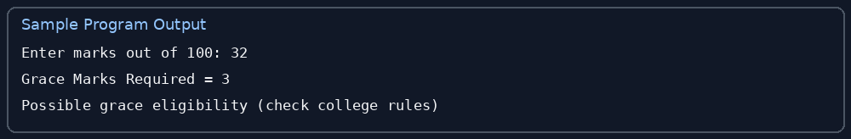

10. Conclusion
The program validates marks and displays a result based on sample thresholds.

9. Attendance Recovery Computation

1. Problem Statement
Calculate attendance percentage and estimate how many additional classes a student must attend consecutively, without missing classes, to reach 75% attendance.

2. Objectives
- Read total and attended classes.
- Calculate attendance percentage.
- Estimate extra classes needed to reach 75%.

3. Assumptions
- Total classes must be greater than zero.
- Attended classes must be between zero and total classes.
- The calculation assumes each future class is attended and total classes increase too.

4. Algorithm
1. Start.
2. Input total classes and attended classes.
3. Validate the values.
4. Calculate percentage = attended ÷ total × 100.
5. If percentage ≥ 75, report sufficient attendance.
6. Otherwise increase the number of attended and total classes until attendance reaches 75%.
7. Display extra classes needed and stop.

5. Flowchart
Start → Input class counts → Validate → Calculate percentage → Is percentage ≥ 75%? → If no, estimate extra attended classes → Display → End
Flowchart sequence shown in text form; arrows indicate the flow between steps.

6. Pseudocode
INPUT total, attended
VALIDATE total > 0 AND 0 <= attended <= total
percentage = attended / total * 100
IF percentage >= 75: PRINT sufficient
ELSE: extra = 0; WHILE (attended + extra) / (total + extra) < 0.75: extra = extra + 1
PRINT percentage, extra

7. Python Source Code
total = int(input("Enter total classes: "))
attended = int(input("Enter classes attended: "))
if total <= 0 or attended < 0 or attended > total:
print("Invalid class counts")
else:
percentage = attended / total * 100
print("Attendance Percentage =", round(percentage, 2), "%")
if percentage >= 75:
print("Attendance is sufficient")
else:
extra = 0
while (attended + extra) / (total + extra) < 0.75:
extra += 1
print("More consecutive classes to attend =", extra)

8. Test Cases
Input | Expected result
40 total, 25 attended | 62.5%; attend 20 more consecutive classes
40 total, 32 attended | 80%; attendance sufficient

9. Output Screenshot
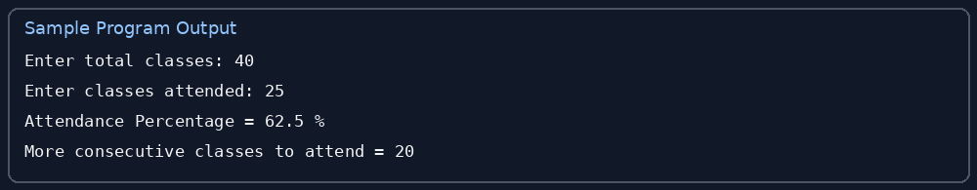

10. Conclusion
The program calculates attendance and estimates the additional consecutive classes required.

10. ATM Transaction Sequence Simulation

1. Problem Statement
Simulate an ATM menu that allows balance checking, depositing, withdrawing, and exiting.

2. Objectives
- Display a transaction menu.
- Update the balance after valid deposits and withdrawals.
- Reject invalid amounts and insufficient funds.

3. Assumptions
- The starting balance is ₹5,000.
- This is a classroom simulation and does not connect to a real bank.
- Transactions must be positive.

4. Algorithm
1. Start with balance = 5000.
2. Display menu: check, deposit, withdraw, exit.
3. Read choice.
4. For check, display balance.
5. For deposit, add a positive amount.
6. For withdrawal, subtract a positive amount only if balance is sufficient.
7. For exit, display thank-you message and stop; otherwise repeat.

5. Flowchart
Start → Set balance → Show menu → Read choice → Perform selected transaction → Update/display balance → Exit? → If no, repeat; if yes, End
Flowchart sequence shown in text form; arrows indicate the flow between steps.

6. Pseudocode
balance = 5000
REPEAT: DISPLAY menu; INPUT choice
IF choice = 1: PRINT balance
ELSE IF choice = 2: INPUT amount; IF amount > 0: balance += amount
ELSE IF choice = 3: INPUT amount; IF 0 < amount <= balance: balance -= amount
ELSE IF choice = 4: PRINT Thank you; STOP
ELSE: PRINT Invalid choice

7. Python Source Code
balance = 5000
while True:
print("\\n1. Check Balance")
print("2. Deposit")
print("3. Withdraw")
print("4. Exit")
choice = int(input("Enter your choice: "))
if choice == 1:
print("Balance =", balance)
elif choice == 2:
amount = float(input("Enter deposit amount: "))
if amount > 0:
balance += amount
print("Deposit successful")
else:
print("Invalid amount")
elif choice == 3:
amount = float(input("Enter withdrawal amount: "))
if 0 < amount <= balance:
balance -= amount
print("Withdrawal successful")
else:
print("Invalid amount or insufficient balance")
elif choice == 4:
print("Thank you for using ATM")
break
else:
print("Invalid choice")

8. Test Cases
Input | Expected result
Choice 1 | Balance = ₹5,000
Deposit ₹1,000 then check | Balance = ₹6,000
Withdraw ₹7,000 | Invalid amount or insufficient balance

9. Output Screenshot
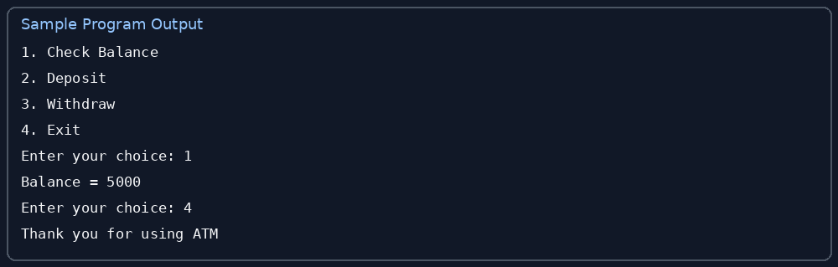

10. Conclusion
The program simulates basic ATM transactions and validates deposits and withdrawals.

Submission Checklist
- Problem statement included for all 10 case studies.
- Objectives and assumptions included for all 10 case studies.
- Algorithm and flowchart included for all 10 case studies.
- Pseudocode and Python source code included for all 10 case studies.
- Test cases and sample output screenshots included for all 10 case studies.
- Conclusion included for all 10 case studies.
- Upload this document and any required source files to your own GitHub repository named Python-Activity-Based-Learning.
- Submit the GitHub repository link after uploading.

