**Young Researchers Retreat** 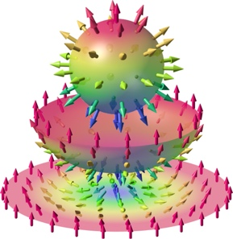

**12 - 15 September 2022, Annweiler am Trifels**

**SPP2137 Skyrmionics**

**Topological Spin Phenomena in Real-Space for Applications**

**REGISTRATION**

**There is NO registration fee. Full board accommodation is included.**

**Please return to Lisa Seitz (sekretariat-e51@ph.tum.de)**

Name:

Email address:

Position: 🞎 student 🞎 postdoc 🞎 junior group leader

Affiliation:

Gender (for the purpose of allocating accommodation only):

**♣** We would like to hear about your research! It is integral to the retreat that everyone presents their work, regardless of its development stage (even if preliminary), either as a poster or an oral presentation.

Title of contribution:

Type: 🞎 poster

🞎 oral. Please provide a short description here [less than 100 words.]

**♣** [Optional] What do you expect from the retreat?

Your answer:

**♣** Do you have any allergies or dietary restrictions?

Your answer:

Child care services may be arranged upon request.

Accessible accommodation may be arranged upon request.