**Young Researchers’ Retreat 2024** 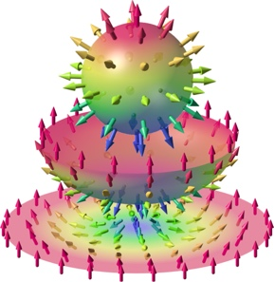

**21- 25 April 2024, Dietmannsried**

**SPP2137 Skyrmionics**

**Topological Spin Phenomena in Real-Space for Applications**

**Registration**

**Please return to Alessandro Pignedoli**

**(alessandro.pignedoli@uni-due.de)**

**Name:**

**E-mail address:**

**Affiliation:**

**Date of Arrival**:

**Date of Departure:**

**Dietary request**

vegetarian  vegan  other, please specify:

I wish to give an **oral** presentation

Title of contribution:

I wish to give a **poster** presentation

Title of contribution: