**Retreat- & Networking-Meeting** 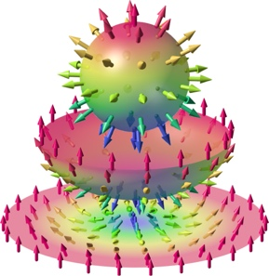

**13 - 15 September 2023, Hamburg**

**SPP2137 Skyrmionics**

**Topological Spin Phenomena in Real-Space for Applications**

**Registration**

**Please return to Christian Pfleiderer**

**(christian.pfleiderer@ph.tum.de)**

Name:

E-mail address:

Affiliation:

**** I wish to participate **personally**

Date of Arrival:

Date of Departure:

**** I wish to give an **oral** presentation

Title of contribution:

**** I wish to give a **poster** presentation

Title of contribution: