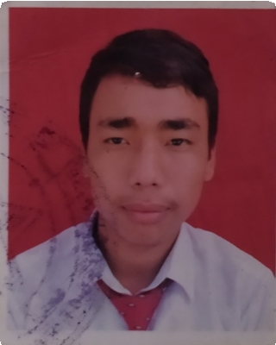Bishal Magar

E-mail :

[magarbeeshal6@gmail.com](mailto:magarbeeshal6@gmail.com)

Phone :

9803841568

# Objective

Address:

Gaushala, Mahottari, Nepal

Seeking a position where extensive experience will be further developed and utilized. To work in a challenging environment using all my skills and efforts to explore. Extensive experience to the credit.

# Work experience

## Western Computers & Multi Trade Link Pvt. Ltd

### Support Manager

2019 — Present

Troubleshoot problems with PCs, server, software, communications device, Provide end user desktop as well as networking support with this technician, Maintain desktop, laptops, printers, CCTV, biometric device peripherals software, Updates on the progress of ongoing requests,

Provide technical support for hardware, software and networking as per customer demand or problems.

## Awal Toner Suppliers 2018 — 2019

### Support Manager

Troubleshoot problems with PCs, server, software, communications device, Maintain printers and troubleshoot problems with any kind of printers, Provide end user desktop as well as networking support with this technician,

Maintain desktop, laptops, printers, CCTV, biometric device peripherals software.

# Qualifications

Certified Hardware and Networking Certified Printer Troubleshooting

# Education

## SLC 2011 — 2012

### Nepal Government

Interests

Music

Troubleshooting Technical Problems Exploring new Places

Getting together with friends

# References

Nibesh Awal Managing Director Awal Toner Suppliers 9841884136

Bisham Tandukar Chairman

Western Computers and multi trade link 9851153237