**SYNOPSIS**  
  
**PROJECT TITLE**  
  
**TOUR AND TRAVAL MANAGEMENT SYSTEM**   
  
**OBJECTIVE**

|  |
| --- |
| Main Objective of this system is to provide Online Registration, Tour Package |
| Information, Ticket Booking, Online Payment and Searching Facility for |
| Customer and also Generate Different types of Report. |

**EXISTING SYSTEM**All Work are done Manually.

In Manual Booking System Customer has to go to the Travelling office.

Ask Inquiry for Travelling then Book ticket Finally Pay Payment & Collect Receipt.

Difficult To Maintain the Customer Details of Package and Payment Receipt in Register.

They Register Tour Package in the notebook.

Add advertisement in Local newspaper or Local Market.

Use Travelling Facility For the Limited Area or Person.

**NEED FOR NEW SYSTEM**

To Create User Friendly Web site for Customer To Destination Information for Customer.To Generate Different Types of Reports.To Provide the Option of Book your Own Trip For Customer.To Provide package Details. **PROPOSED SYSTEM:**

The proposed system is a web based application and maintains a centralized repository of all related information. The system allows one to easily access the relevant information and make necessary travel arrangements. Users can decide about places they want to visit and make bookings online for travel and accommodation.

**SERVICES PROVIDED BY TOUR SYSTEM**

To See Best Value Tour

To see Desination Information

To Book own Tour

View Package

Search Package  
Booking

**MODULES:**

**ADMIN:**Admin can manage the user and receive package from traveler & package management.  
**TRAVELER:**Traveler create the package and give to admin. **CUSTOMER:**Customer can view package and booking. **VISITOR:**Visitor view side and give feedback. **1)ADMINISTRATOR MODULE:**

This module provides administrator related functionality. Administrator manages all information and has access rights to add, delete, edit and view the data related to places, travels, routes, bookings, etc.  
  
-Registration(Login)  
-Manage User  
-Manage Tour-package

- Manage Ticket Booking

-View Cancellation

-View feedback

**2)TRAVELS MODULE:**

This module provides the details of various travel agencies. A user can select the appropriate agency depending on convenience and accessibility.  
  
  
-Registration  
-Login  
-Manage Tour  
-Manage Tour Package Cost  
-Manage Bus(Travels)

3**)CUSTOMER:**This module helps to customer.  
 -View Package

-Search Package  
-Booking  
-Give Feedback

**4)VISITOR:**View Site  
Visitor view side and give feedback.

**ADVANTAGES**

The tours & travel websites have made it possible to book Your Own Trip

It is easy to use, robust, secured Website

Ease to maintain both System as well as Database.

Many selection and filter tools allows customer to comparison shop.

**E-R DIAGRAM**

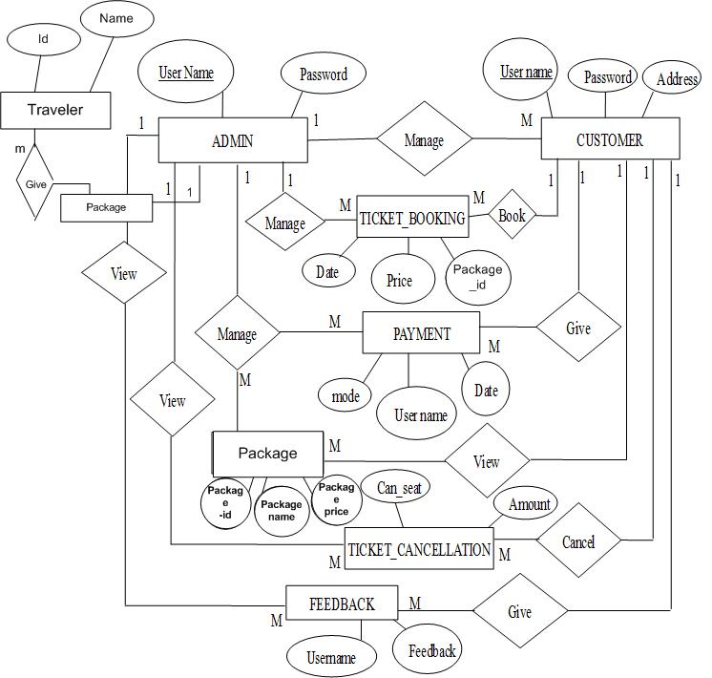

**DATA TABLES:**

1. **Table Name:** Login_mst

**Description:** To store the admin, customer, Traveler Login Details  
 **Primary Key:** User Name

|  |  |  |  |  |
| --- | --- | --- | --- | --- |
| **Sr.** | **Name** | **DataType** | **Constraint** | **Description** |
| **no** |  |  |  |  |
|  |  |  |  |  |
| 1 | Username | Varchar(10) | Primary Key | To store the |
|  |  |  |  | username |
|  |  |  |  |  |
| 2 | User_Type | Varchar(10) | Not null | To store user type |
|  |  |  |  | like admin, |
|  |  |  |  | customer,traveler |
|  |  |  |  | etc. |
|  |  |  |  |  |
| 3 | Password | nvarchar(10) | Not null | To store the |
|  |  |  |  | password |
|  |  |  |  |  |

1. **Table Name:** AgeRegistration_mst

**Description:** To store Agent Personal Information.

**Primary Key:** Company_name

|  |  |  |  |  |
| --- | --- | --- | --- | --- |
| **Sr.** | **Field Name** | **Data Type** | **Constraint** | **Description** |
| **no** |  |  |  |  |
|  |  |  |  |  |
| 1 | Name | Varchar(50) | Not null | To store the Name of |
|  |  |  |  | agent. |
|  |  |  |  |  |
| 2 | Company_Name | Varchar(50) | Primary Key | To store Company Name. |
|  |  |  |  |  |
| 3 | Address | Varchar(50) | Not null | To store address. |
|  |  |  |  |  |
| 4 | City | Varchar(50) | Not null | To store city. |
|  |  |  |  |  |
| 5 | Zip_code | Numeric(18,0) | Not null | To store Agent zip code. |
|  |  |  |  |  |
| 6 | Country | Varchar(50) | Not null | To store country. |
|  |  |  |  |  |

|  |  |  |  |  |
| --- | --- | --- | --- | --- |
| 7 | Mobile no | Numeric(18,0) | Not null | To store mobile number. |
|  |  |  |  |  |
| 8 | Email_id | Nvarchar(30) | Not null | To store the Email id. |
|  |  |  |  |  |
| 9 | Comment | Varchar(50) | Not null | To store Comment. |
|  |  |  |  |  |

1. **Table Name:** AgePackage_Management

**Description:** To store Agent Package Detail.

**Primary Key:** Tour_id

|  |  |  |  |  |
| --- | --- | --- | --- | --- |
| **Sr .** | **Field Name** | **Data Type** | **Constraint** | **Description** |
| **no** |  |  |  |  |
|  |  |  |  |  |
| 1 | Agent_Name | Varchar(50) | Not Null | To Store Agent Name. |
|  |  |  |  |  |
| 2 | Agent_mobile | Numeric(18,0) | Not Null | To Store Mobile |
|  |  |  |  | number. |
|  |  |  |  |  |
| 3 | Company_Name | Varchar(50) | Not Null | To Store company |
|  |  |  |  | Name. |
|  |  |  |  |  |
| 4 | Tour_id | Numeric(18,0) | Primary | To Store Tour id. |
|  |  |  | Key |  |
|  |  |  |  |  |
| 5 | Package_type | Varchar(50) | Not null | To store Package type |
|  |  |  |  | like royal, Holiday. |
|  |  |  |  |  |

|  |  |  |  |  |
| --- | --- | --- | --- | --- |
| **Sr .** | **Field Name** | **Data Type** | **Constraint** | **Description** |
| **no** |  |  |  |  |
|  |  |  |  |  |
| 6 | Category | Varchar(50) | Not null | To store tour Catrgory. |
|  |  |  |  |  |
| 7 | Tour_place | Varchar(50) | Not null | To store the tour place. |
|  |  |  |  |  |
| 8 | Days | Numeric(18,0) | Not null | To store tour days. |
|  |  |  |  |  |
| 9 | Amount | Numeric(18,0) | Not null | To store tour amount. |
|  |  |  |  |  |

1. **Table Name:** Booking_mst

**Description:** it can store Booking Detail.

**Primary Key:** Booking_id

|  |  |  |  |  |
| --- | --- | --- | --- | --- |
| **Sr .** | **Field Name** | **Data Type** | **Constraint** | **Description** |
| **no** |  |  |  |  |
|  |  |  |  |  |
| 1 | Booking_id | Integer | Primary Key | To Store Booking id |

|  |  |  |  |  |
| --- | --- | --- | --- | --- |
| 2 | Traveler_ name | Varchar (50) | Not null | To store Booking |
|  |  |  |  | traveler name |
|  |  |  |  |  |
| 3 | Package_id | Integer | Not null | To Store Package id |
|  |  |  |  |  |
| 4 | Package_name | Varchar(20) | Not null | To store package |
|  |  |  |  | name. |

|  |  |  |  |  |
| --- | --- | --- | --- | --- |
| 5 | Create Date | Date Time | Not null | Create date of record. |

|  |  |  |  |  |
| --- | --- | --- | --- | --- |
| 6 | Update Date | Date Time | Not null | Update date of record. |

1. **Table Name:** category_master

**Description:** To store travels category Detail.

**Primary Key:** c_id

|  |  |  |  |  |
| --- | --- | --- | --- | --- |
| **Sr .** | **Field Name** | **Data Type** | **Constraint** | **Description** |
| **no** |  |  |  |  |
|  |  |  |  |  |
| 1 | C_id | Integer | Primary key | To store category id. |
|  |  |  |  |  |
| 2 | Package_type | Varchar(10) | Not null | To store the package |
|  |  |  |  | type. Like holiday |
|  |  |  |  |  |
| 3 | category | Varchar(20) | Not null | To store category like |
|  |  |  |  | royal, delux etc. |
|  |  |  |  |  |

1. **Table Name:** country_master

**Description:** To store country Detail.

**Primary Key:** country_id

|  |  |  |  |  |
| --- | --- | --- | --- | --- |
| **Sr .** | **Field Name** | **Data Type** | **Constraint** | **Description** |
| **no** |  |  |  |  |
|  |  |  |  |  |
| 1 | Country_id | Integer | Primary Key | To store the country id. |
|  |  |  |  |  |
| 2 | country | Varchar(10) | Not null | To store the country name. |
|  |  |  |  |  |

1. **Table Name:** AdmPackage_management

**description:** it store the Package Detail Like type, days, amount etc.

**Primary Key:** id

|  |  |  |  |  |
| --- | --- | --- | --- | --- |
| **Sr.no** | **Field Name** | **Data Type** | **constraint** | **Description** |
|  |  |  |  |  |
| 1 | Id | Numeric(18,0) | Primary Key | To store Package id. |
|  |  |  |  |  |
| 2 | Package Type | Varchar(30) | Not null | To store Package Type like |
|  |  |  |  | Holiday, Royal etc. |
|  |  |  |  |  |
| 3 | Category | Varchar(15) | Not null | To store Package Category |
|  |  |  |  | like Group tour, adventure |
|  |  |  |  | tour etc. |
|  |  |  |  |  |
| 4 | Tour_Place | Varchar(15) | Not null | To store Tour Place name. |
|  |  |  |  |  |

|  |  |  |  |  |
| --- | --- | --- | --- | --- |
| 5 | Days | Nchar (10) | Not null | To store tour package |
|  |  |  |  | Days. |
|  |  |  |  |  |
| 6 | Amount | Varchar(20) | Not null | To store Amount of Tour |
|  |  |  |  | Packages. |
|  |  |  |  |  |

**8.Table Name:** Feedback

**Description:** to store the feedback details.

|  |  |  |  |  |
| --- | --- | --- | --- | --- |
| **Sr.** | **Field Name** | **Data Type** | **Constraint** | **Description** |
| **No** |  |  |  |  |
|  |  |  |  |  |
| 1 | Name | Integer | Not null | To store name. |
|  |  |  |  |  |
| 2 | Emailid | Varchar(30) | Not null | To store email id. |
|  |  |  |  |  |
| 3 | Contact_no | Numeric(10) | Not null | To store contact no. |
|  |  |  |  |  |
| 4 | Feedback | Varchar(30) | Not null | To store feedback status. |
|  |  |  |  |  |