Classifying COVID Briefing Political Bias from Red and Blue State Governors

Vikki Fiore

**Abstract**

The following research discusses the topic of identifying potential differences in COVID-19 news briefings from governors across the United States. Machine learning techniques were used in an attempt to classify these briefings according to the governor’s political ideology. Much of this classification was done at the phrase level, with certain aspects also making use of document level analysis. Feature extraction was done via Python libraries, the machine learning software Weka, and the text analysis website Voyant Tools. In all, the trained classifiers performed above baseline.

**1 Introduction**

In March of 2020, life as many knew it came to a halt as the United states braced to face an unpresented global pandemic. Despite the fact that science and statistics are nonpartisan, it did not take long for COVID-19 to become the center of the political world. All governors across the country made efforts to communicate and relay information about the crisis to their constituents through frequent press briefings. Almost all news sources have either a liberal or conservative bias to some degree, and the media often interpreted these briefings differently according to the network’s political leaning. However, it remains unclear the degree of bias that might be included in the governors’ briefings and word choice. All people possess inherent bias on certain topics, and politicians are certainly no exception. This paper attempts to measure and classify the linguistic differences that may exist in briefings based on the governor’s political ideology.

Previous research on bias detection has been done at the phrase or sentence level as opposed to the word level, with some research even making use of the document level in analysis. Machine learning techniques such as neural networks have also been frequently utilized.

**1.1 Related Work**

Opinions and biases are expected in media, news, and other such information sources. Even writing which claims to come from a neutral, non-politically-affiliated source will be prone to some type of bias simply based on its writer’s word choice and opinion. In their 2014 paper, Iyyer, Enns, Boyd-Graber, and Resnik from University of Maryland denoted that, “Many of the issues discussed by politicians and the media are so nuanced that even word choice entails choosing an ideological position” (p. 1). In the case of this research, a sentence was said to show ideological bias and opinion if the writer’s political ideology was evident from the text.

Recasens, Danescu-Niculescu-Mizil, and Jurafsky of Stanford University followed a similar approach. These researchers looked at the before and after versions of articles that had been revised to eliminate bias. In this case, the context of a word was defined as a 5-gram, which is similar to other research that analyzed at the phrase level. Lemmatization was also incorporated (p. 6).

The Facebook Artificial Intelligence team also published a paper that included work on bias and disinformation detection. This paper noted that while traditional methods of text analysis such as TF/IDF are useful, self-supervised training methods tend to be more robust (Halevy, et.al, 2020). The research done by this team used self-supervised models.

**2 Method**

**2.1 Data Collection**

The website Rev was used to obtain annotated transcripts of COVID briefings given by governors across the country. 46 briefings given by Republican governors were collected and 46 briefings given by Democrat governors were collected, for 92 total briefings total. Briefings ranged from ten minutes to over an hour in length. Effort was made to stratify the briefings across various parts of the country as to not have regional dialects or events be an unintended variable. Additional efforts were made to make sure both the Republican and Democrat briefing sets included at least some briefings from female governors. Data was much more prevalent from governors with greater name recognition and governors of larger states, meaning certain states may be slightly overrepresented. However, I also attempted to stratify these factors as much as possible to avoid unwanted confounding variables. NLTK and simple Python scripts were used to strip special or unwanted characters from the transcripts, and they were then rewritten into basic .txt files for analysis.

This set of briefings were given in March and April of 2020, early on in the pandemic. A second set was also obtained in the same way of briefings given in November and December. The intent here was to compare classification rates at different times in the pandemic. However, data was much more limited for the November and December months. Most of this seemed due to governors giving fewer briefings during this time. Because of the limited amount of data and the potential drawbacks that could create, these briefings were only used for a small portion of the research.

**2.2 Feature extraction**

Voyant Tools was used to collect data from the briefings regarding lexical richness such as number of words, number of types, type-token ratio, and average words per sentence. Voyant Tools was also used to create word graphics.

The Python library Text2Emotion was used to extract emotion features from the text. This library quantifies the presence of 5 basic emotions. These include happiness, anger, sadness, surprise, and fear. The numbers corresponding to these emotions were then graphed using Python.

NLTK was used to extract the most frequent phrases from each set of briefings, since previous researchers seemed in agreement that using phrase, or sentence level analysis increased classification performance over word-level analysis. I decided on 4-grams, 5-grams, and 6-grams for this research. A total of 60 phrases were extracted, 30 from the set of Republican briefings and 30 from the set of Democrat briefings.

**3 Results**

**3.1 Analysis and Visualization of Text**

The Python library Emotion2Text was used to extract numeric values representing five emotions from both the Democrat and Republican corpus of briefings. The results were as follows:

Emotions from the Republican governor corpus:

-Happy: 0.06

-Angry: 0.12

-Surprise: 0.24

-Sad: 0.24

-Fear: 0.35

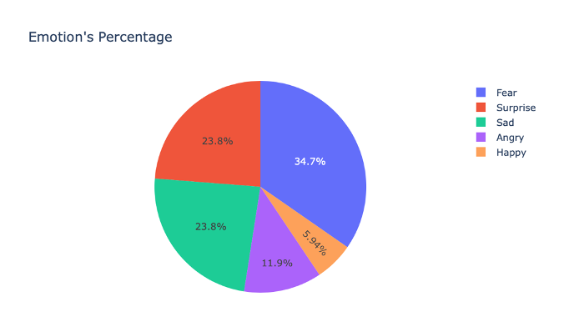

Emotions from the Democrat governor corpus:

-Happy: 0.15

-Angry: 0

-Surprise: 0

-Sad: 0.62

-Fear: 0.23

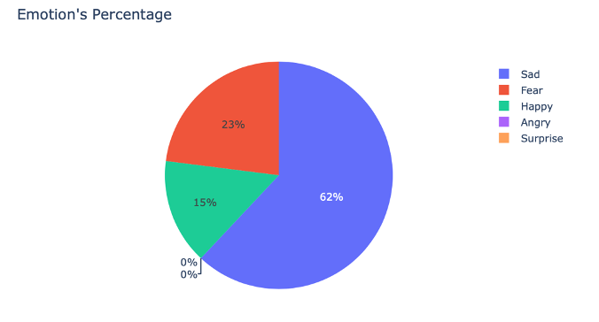

The most notable differences were in surprise and sadness. The value for surprise was significantly higher in the corpus of briefings from Republican governors while the value for sadness was significantly higher in the corpus of briefings from Democrat governors.

**3.2 Machine Learning**

**3.2.1 Document Level Classification**

The document level emotion and lexical richness features were analyzed in Weka. The best classification results were obtained using a Naïve Bayes classification algorithm and 10-fold cross validation. 68.5% of instances were classified correctly, compared to a baseline of 50%. A more detailed analysis of the results can be seen in the table below.

|  |  |  |  |  |  |
| --- | --- | --- | --- | --- | --- |
|  | TP Rate | FP Rate | Precision | Recall | F-Measure |
| Democrat | 0.72 | 0.35 | 0.67 | 0.72 | 0.37 |
| Republican | 0.65 | 0.28 | 0.70 | 0.65 | 0.37 |
| Weighted Avg. | 0.69 | 0.32 | 0.69 | 0.69 | 0.37 |

**3.2.2 Document Level Clustering**

The Classes to Clusters Weka filter was used in order to ignore the class attribute and generate clustering. During the test phase Weka then assigns classes to the clusters based on the majority value of the class attribute within each cluster. In this case, the class attribute was the point of view of the transcript. This yielded a rate of incorrectly clustered instances of 39.1%. This technique is an unsupervised one and was done in order to ensure other supervised techniques that require pre-labeling the data based on the governor’s point of view were not creating unwanted bias.

3.2.3 N-gram Sentiment Analysis

The phrases extracted from the initial set of briefings were put into a .arff file using Python and were analyzed in Weka using the Word to Vec algorithm. This algorithm uses a technique for learning vector representations of words called “word embeddings”. A Naïve Bayes classification was then performed using a 66/33 split. This yielded a 77% correct classification rate, much improved compared to the baseline of 50%.

This was repeated using the set of phrases extracted from briefings giving in November and December. This classification attempt gave a 85% correct classification rate, also compared to a 50% baseline.

**4 Discussion and Future Directions**

Above baseline classification results can very well be indicative of bias and differences in the speeches given by Republican and Democrat governors, and the higher classification rate in the N-gram analysis of briefings from November and December could be indicative of a higher amount of polarization in these briefings. However, the limited data must be taken into account, as must other potential confounding variables. It would be helpful in future to redo this classification with a larger data set, potentially obtained by annotating YouTube videos of briefings rather than relying on a third party site such as Rev.

There are interesting differences in the extracted emotions between briefing sets, and this is something that could be looked at more in depth in future research. The software LIWC extracts many more emotions from text than the Python library uses, and could be used in a future expansion of this research.

**5 References**

Halevy, A., Ferrer, C. C., Ma, H., Ozertem, U., Pantel, P., Saeidi, M., & Stoyanov, V.

(2020). Preserving integrity in online social networks. *arXiv preprint*

*arXiv:2009.10311*.

Iyyer, M., Enns, P., Boyd-Graber, J., & Resnik, P. (2014). Political Ideology Detection

Recasens, M., Danescu-Niculescu-Mizil, C., & Jurafsky, D. (2013). Linguistic Models   
 for Analyzing and Detecting Biased Language. Retrieved from   
 http://www.aclweb.org/anthology/P13-1162