### **Title:** The user cannot remove an item from the cart via the "REMOVE" button on the inventory page

**Bug Report ID: BR_001**

**Linked Test Case ID: TC_CART_002**

**Reported By:** Ivana Stamenkovic

**Date:** 20/02/2025

**Status:** New

**Environment:**

* **Device:** HP 250 G8 Notebook PC
* **OS:** Windows 11 Home 24H2
* **Browser:** Google Chrome - Version 133.0.6943.127 (Official Build) (64-bit)

**Preconditions:** The user is logged in to https://www.saucedemo.com/v1/index.html and Sauce Labs Backpack is in the cart.

**Steps to Reproduce:**

1. Click the "REMOVE" button next to Sauce Labs Backpack.
2. Click on the cart icon.
3. Verify that the Sauce Labs Backpack is no longer in the cart.

**Test Data:**

* **Username:** problem_user
* **Password:** secret_sauce

**Expected Result:**

1. The "REMOVE" button changes back to "ADD TO CART" and the cart icon updates - the white number 1 in the red circle disappears.
2. The user is redirected to the cart page.
3. The Sauce Labs Backpack is no longer visible in the cart.

**Actual Result:** When logged in as problem_user, the user is able to click on the "REMOVE" button, but it does not update to "ADD TO CART" and the cart icon does not update either. The Sauce Labs Backpack is also still visible in the cart.

**Attachment (video/photo):** <https://go.screenpal.com/watch/cTnr6FnhsqX>

**Comment:** The same issue is reproducible with Sauce Labs Bike Light and Sauce Labs Onesie.

**Reproducibility:** Always (100%)

**Severity**: Minor (affects user experience but does not completely block functionality)

### **Title:** The user cannot change the quantity of an item directly on the cart page

**Bug Report ID: BR_002**

**Linked Test Case ID: TC_CART_QTY_006**

**Reported By:** Ivana Stamenkovic

**Date:** 20/02/2025

**Status:** New

**Environment:**

* **Device:** HP 250 G8 Notebook PC
* **OS:** Windows 11 Home 24H2
* **Browser:** Google Chrome - Version 133.0.6943.127 (Official Build) (64-bit)

**Preconditions:** The user is logged in to https://www.saucedemo.com/v1/index.html as standard_user (password: secret_sauce).

**Steps to Reproduce:**

1. Click the "ADD TO CART" button next to an item on the inventory page.
2. Click on the cart icon.
3. Click on the quantity input field next to an item in the cart.
4. Enter a new number.

**Test Data:**

* **Item:** Sauce Labs Backpack
* **Updated Quantity:** 2

**Expected Result:**

1. The cart icon updates - a white number 1 in a red circle appears in the upper-right corner of the cart icon.
2. The user is redirected to the cart page.
3. The user is able to click on the quantity input field and the cursor changes from pointer to the shape of an I-beam.
4. Entered number is now displayed as the item quantity.

**Actual Result:** Once redirected to the cart page, the user is able to click on the quantity input field and the cursor changes from pointer to the shape of an I-beam. However, after updating the quantity, the number in the quantity input field remains the same and the entered number is not displayed.

**Attachment (video/photo):** <https://go.screenpal.com/watch/cTnr6Enhs0R>

**Reproducibility:** Always (100%)

**Severity**: Major (the cart is the only place where the users can see the quantity of the items in the cart and they should be able to update it)

### **Title:** The user is not redirected to the correct Sauce Labs page after clicking the "About" button in the burger menu

**Bug Report ID: BR_003**

**Linked Test Case ID: TC_ABOUT_001**

**Reported By:** Ivana Stamenkovic

**Date:** 20/02/2025

**Status:** New

**Environment:**

* **Device:** HP 250 G8 Notebook PC
* **OS:** Windows 11 Home 24H2
* **Browser:** Google Chrome - Version 133.0.6943.127 (Official Build) (64-bit)

**Preconditions:** The user is logged in to https://www.saucedemo.com/v1/index.html

**Steps to Reproduce:**

1. Click on the burger menu on the top left corner of the screen.
2. Click on the "About" button.

**Test Data:**

* **Username:** problem_user
* **Password:** secret_sauce

**Expected Result:**

1. The burger menu opens on the left side of the screen.
2. The user is redirected to https://saucelabs.com/ and the screen looks as shown on the screenshot - <https://prnt.sc/7fLNkDpR1o-6>

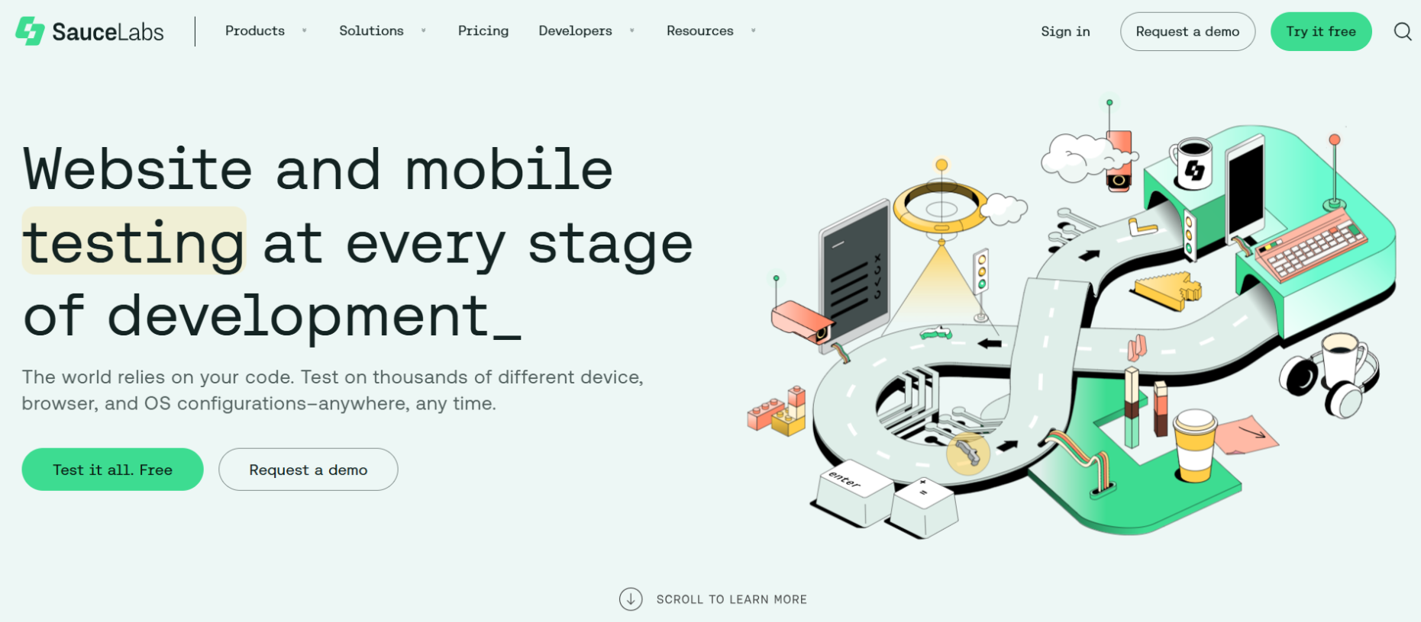

**Actual Result:** When logged in as problem_user, the burger menu opens on the left side of the screen, but after clicking on the “About” button, the user is redirected to a page that does not exist (404 Not Found message is displayed).

**Attachment (video/photo):** <https://go.screenpal.com/watch/cTnrXwnhswW> & <https://prnt.sc/rnxB4mw-Khw0>

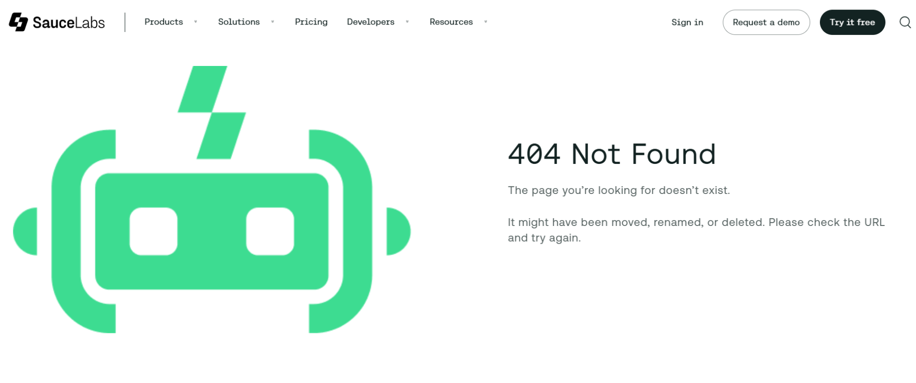

**Reproducibility:** Always (100%)

**Severity**: Minor (it affects navigation and creates poor user experience, but it does not impact core functionality, and the user can still manually type the address or Google it)

### **Title:** The user is not redirected to the correct product display page after clicking on the inventory item

**Bug Report ID: BR_004**

**Linked Test Case ID: TC_INVENTORY_001**

**Reported By:** Ivana Stamenkovic

**Date:** 21/02/2025

**Status:** New

**Environment:**

* **Device:** HP 250 G8 Notebook PC
* **OS:** Windows 11 Home 24H2
* **Browser:** Google Chrome - Version 133.0.6943.127 (Official Build) (64-bit)

**Preconditions:** The user is logged in to https://www.saucedemo.com/v1/index.html

**Steps to Reproduce:**

1. Click on the image or the title of an inventory item.
2. Verify that the product display page corresponds to the selected inventory item.

**Test Data:**

* **Username:** problem_user
* **Password:** secret_sauce
* **Item:** Sauce Labs Backpack

**Expected Result:**

1. The user is able to click on the image or the title of the selected inventory item and is redirected to its product display page.
2. The product display page corresponds to the selected inventory item (image, title, product description and price on PDP match the ones on the inventory page).

**Actual Result:** The user is redirected to the PDP but it belongs to another item.

**Attachment (video/photo):** <https://go.screenpal.com/watch/cTnrX8nhszr>

**Comment:** The same issue is reproducible with all of the items (Sauce Labs Fleece Jacket leads to a PDP which does not belong to any of the available items - and PDP for Sauce Labs Bike Light is missing - check BR_005).

**Reproducibility:** Always (100%)

**Severity**: Major (it directly affects product selection and navigation and it significantly impacts usability and trust in the system)

### **Title:** Product display page for Sauce Labs Bike Light is missing

**Bug Report ID: BR_005**

**Linked Test Case ID: TC_INVENTORY_001**

**Reported By:** Ivana Stamenkovic

**Date:** 21/02/2025

**Status:** New

**Environment:**

* **Device:** HP 250 G8 Notebook PC
* **OS:** Windows 11 Home 24H2
* **Browser:** Google Chrome - Version 133.0.6943.127 (Official Build) (64-bit)

**Preconditions:** The user is logged in to https://www.saucedemo.com/v1/index.html

**Steps to Reproduce:**

1. Click on the image or the title of an inventory item.
2. Verify that the product display page corresponds to the selected inventory item.

**Test Data:**

* **Username:** problem_user
* **Password:** secret_sauce
* **Item:** all of them

**Expected Result:**

1. The user is able to click on the image or the title of the selected inventory item and is redirected to its product display page.
2. The product display page corresponds to the selected inventory item (image, title, product description and price on PDP match the ones on the inventory page).

**Actual Result:** The user is redirected to the PDP but it belongs to another item.

**Attachment (video/photo):** <https://go.screenpal.com/watch/cTnrl1nhsBx>

**Comment:** After checking all of the items on the inventory page, it is notable that all of the PDP are there (just not linked to the correct items - check BR_004), except for the Sauce Demo Bike Light PDP which is missing. Pay attention to the PDP linked to Sauce Labs Fleece Jacket.

Sauce Labs Backpack redirects to Sauce Labs Fleece Jacket

Sauce Labs Bike Light redirects to Sauce Labs Bolt T-Shirt

Sauce Labs Bolt T-Shirt redirects to Sauce Labs Onesie

Sauce Labs Fleece Jacket redirects to missing PDP (item not found)

Sauce Labs Onesie redirects to Test.allTheThings() T-Shirt (Red)

Test.allTheThings() T-Shirt (Red) redirects to Sauce Labs Backpack

**Reproducibility:** Always (100%)

**Severity**: Major (the user cannot view details or purchase this item)

### **Title:** “REMOVE” button does not change back to “ADD TO CART” after clicking on the “Reset App State” in the menu

**Bug Report ID: BR_006**

**Linked Test Case ID: TC_RESET_001**

**Reported By:** Ivana Stamenkovic

**Date:** 21/02/2025

**Status:** New

**Environment:**

* **Device:** HP 250 G8 Notebook PC
* **OS:** Windows 11 Home 24H2
* **Browser:** Google Chrome - Version 133.0.6943.127 (Official Build) (64-bit)

**Preconditions:** The user is logged in to https://www.saucedemo.com/v1/index.html and there is an item in the cart.

**Steps to Reproduce:**

1. Click on the dropdown menu on the top left corner of the screen.
2. Click on the "Reset App State" button.

**Test Data:**

* **Username:** standard_user
* **Password:** secret_sauce
* **Item:** Sauce Labs Backpack

**Expected Result:**

1. The menu opens on the left side of the screen.
2. The “REMOVE” button next to the item changes back to “ADD TO CART” and the cart icon updates - a white number in the red circle disappears.

**Actual Result:** The cart icon updates - a white number in the red circle disappears, but the “REMOVE” button next to the item does not change back to “ADD TO CART”.

**Attachment (video/photo):** <https://go.screenpal.com/watch/cTnrD7nhMxB>

**Comment:** The issue is reproducible with any other item and on the PDP, as well.

**Reproducibility:** Always (100%)

**Severity**: Minor (affects user experience but does not completely block functionality)

**Additional Bugs to Be Reported:**

**ABR_001**

**Area:** Inventory Page

**Current:** Product images are not visible when logged in as problem_user (password: secret_sauce).

**Requested:** Ensure product images load correctly for all users.

**Reason:** Missing images affect usability and product visibility, potentially leading to a poor user experience.

**ABR_002**

**Area:** Inventory Page / Cart (Add & Remove)

**Current:** The Sauce Labs Bolt T-Shirt cannot be added to the cart from the inventory page when logged in as problem_user (password: secret_sauce). The same issue occurs with Sauce Labs Fleece Jacket and Test.allTheThings() T-Shirt (Red).

**Requested:** Ensure that all products can be added to the cart successfully for all users.

**Reason:** Users are unable to purchase specific items, which impacts functionality and user experience.

**ABR_003**

**Area:** Inventory Page

**Current:** Items on the inventory page are not sorted according to the selected criteria when logged in as problem_user (password: secret_sauce). The issue occurs with all sorting options (Name A to Z, Name Z to A, Price low to high, Price high to low).

**Requested:** Ensure that the sorting functionality works correctly for all users.

**Reason:** Incorrect sorting affects usability and makes it difficult for users to find products in the desired order.

**ABR_004**

**Area:** Checkout

**Current:** The user is able to proceed to checkout with no items in the cart.

**Requested:** Implement a validation check to prevent users from accessing the checkout page if their cart is empty.

**Reason:** Users should not be able to complete a purchase without adding items, as this is incorrect behavior and could lead to confusion or errors in order processing.

**ABR_005**

**Area:** Checkout

**Current:** The checkout form accepts empty space as a valid input for all required fields (First Name, Last Name, and Postal Code).

**Requested:** Implement input validation to ensure that fields cannot contain only spaces and must have valid characters.

**Reason:** Allowing empty spaces bypasses required field validation, which can lead to incorrect or incomplete user data.

**Suggestions for Improvement:**

**SI_001**

**Area:** Login Page

**Current:** The password input field masks the entered characters, and there is no option to reveal them.

**Requested:** Add a "Show Password" option (eye icon) to allow users to view their entered password.

**Reason:** This improves user experience by reducing login errors due to mistyped passwords.

**SI_002**

**Area:** Login Page

**Current:** When the user attempts to log in without entering any credentials, an error message "Epic sadface: Username is required" is displayed, even though the password is also required.

**Requested:** Display a single combined error message when both fields are empty - "Epic sadface: Username and Password are required”.

**Reason:** This improves user experience by providing clear and immediate feedback, preventing unnecessary extra steps.

**SI_003**

**Area:** Inventory Page & Product Display Page (PDP)

**Current:** When a user adds an item to the cart, only the cart icon updates, but no confirmation message is displayed.

**Requested:** Display a success message (e.g., "Item added to cart!") when an item is successfully added.

**Reason:** Providing immediate feedback enhances user experience and ensures the user is aware that the action was successful.

**SI_004**

**Area:** Inventory Page, PDP, and Cart (Add & Remove)

**Current:** When a user clicks the "REMOVE" button, the item is immediately removed from the cart without confirmation.

**Requested:** Display a confirmation prompt (e.g., "Are you sure you want to remove this item from your cart? Yes / No") before removing the item.

**Reason:** Prevents accidental removal of items and gives users a chance to cancel the action if it was unintentional.

**SI_005**

**Area:** Inventory Page, PDP, and Cart (Add & Remove)

**Current:** When a user removes an item from the cart, the only indication is the cart icon update, but no confirmation message is displayed.

**Requested:** Display a confirmation message (e.g., "Item removed from cart!") when an item is successfully removed.

**Reason:** Providing immediate feedback enhances user experience and ensures the user is aware that the action was successful.

**SI_006**

**Area:** Main Menu

**Current:** When hovering over a menu item, there is no noticeable visual change.

**Requested:** Enhance the hover state by changing the link color and/or background color to provide clear visual feedback.

**Reason:** Improves user experience by making it evident which menu item is being interacted with, enhancing accessibility and usability.

**SI_007**

**Area:** Checkout

**Current:** When the user attempts to checkout without entering any credentials, an error message "Error: First Name is required" is displayed, even though the last name and zip/postal code are also required.

**Requested:** Display a single combined error message when both fields are empty - "Error: First Name, Last Name, and Zip/Postal Code are required”.

**Reason:** This improves user experience by providing clear and immediate feedback, preventing unnecessary extra steps.