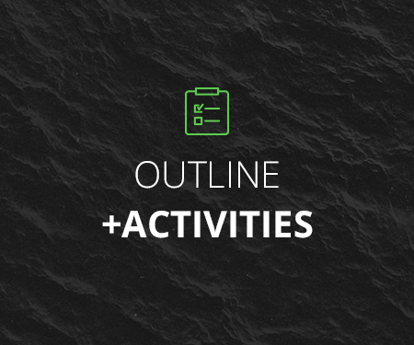
Section Name | Lecture Name | Lecture Format | Lecture Description | Practice Activity
1. Introduction to the Course | 1. Welcome to the Course! | Video: Talking Head | Welcome to the course!  I was once new to using the Command Line to Manage MySQL Databases and I learned to do it with ease. You can, too!  This course is structured to walk you through mastering basic management of MySQL databases through the command line. I’ll give you a quick overview of the course so you know what to expect.  I’m excited to teach you and I hope you are as excited to learn! Let’s get started. | Gather your credentials for accessing the MySQL server
2. The Basic Database Management Tasks You Will Need to Know | 2. Sign in to the MySQL server | Video: Screencast | Before you can accomplish any of the tasks in this section, you must first sign in to the MySQL Server. It’s a snap to do!
 | 3. Create the MySQL Database | Video: Screencast | You could probably almost guess the command you have to use just by looking at the title of this lecture! You’ll be right on your way in no time.
 | 4. Create a User | Video: Screencast | Be careful that you follow the structure of the command closely. Many people make some small mistakes that create big problems.
 | 5. Manage the User Privileges | Video: Screencast | You must make sure that you grant the necessary privileges to the specific User you have created. Make sure that you specify the User in the exact same way you created it.
 | 6. Practice creating a Database and a User | Video: Assignment via a Talking Head / Answer sheet via a PDF Resource | Create a Database, a User and assign Privileges as specified in the lecture | Hands-on Activity in the terminal
3. Database Backup and Recovery | 7. Create a Database backup | Video: Screencast | The most precious asset on any site is its data. You need to know how to create database backups. Remember, if it’s not backed up, it doesn’t exist!
 | 8. Restore a Database | Video: Screencast | A database backup doesn’t do you any good if you can’t back it up.
 | 9. Practice backing up and restoring a Database | Video: Assignment via a Talking Head | We are going to have to cheat a bit here. I’ve provided a resource for you to download to create the database initially. I’ll give you the command to use to create the database. You’ll notice the similarity to the command for restoring a backup :) | Hands-on Activity in the terminal
4. Optional advanced command line database-fu | 10. Reset a User’s password | Video: Screencast | Most likely the database credentials will be used within an application and not by a human being. But, in the event that they are being used by a human being who forgot the password or if there is some other reason you need to change the password, this lesson will show you how.
 | 11. Add an index to a table | Video: Screencast | You may find that certain queries you are running could benefit from being able to access a table more efficiently. Adding an index can save a lot of CPU cycles when selecting data from a table
 | 12. Clever uses of mysql -exec | Video: Screencast | Prepare to be amazed as I show you some clever techniques to harvest information from your database
 | 13. Quiz: Test your DB-fu | Text: Quiz questions / PDF answer sheet | See how well you can explain what the commands accomplish. Then check your responses against the answer sheet | Self-assessment
5. Conclusion | 14. Thanks for taking this course! | Video: Talking Head | I hope that you found this course absolutely delightful! I’d be absolutely delighted if you would provide me some feedback. If you want some structured prompts, check the resources attached to this lecture.

