Chessgame database statistics

# Task

Lorem ipsum dolor sit amet, consectetur adipiscing elit.   
 In porta metus vel odio eleifend, non volutpat velit sollicitudin. Curabitur dapibus   
 mollis sem placerat lobortis. Praesent in accumsan erat. Cras eget massa quis lectus   
 dapibus hendrerit ut quis odio. Nullam non porta mauris, vitae pharetra mauris. Nulla  
 quis massa ex. Integer elementum massa quis tortor fermentum molestie. Nulla imperdiet   
 nisl nisi, ac vehicula justo pharetra non. Cras laoreet neque et lobortis sodales.

# Tables

Table regarding number of games won, lost and remis by stockfish

|  |  |  |
| --- | --- | --- |
| Won | Lost | Remis |
| 992 | 8 | 1599 |

Table regarding number of games won by stockfish with white or black

|  |  |
| --- | --- |
| Won with white | Won with black |
| 698 | 300 |

# Plots

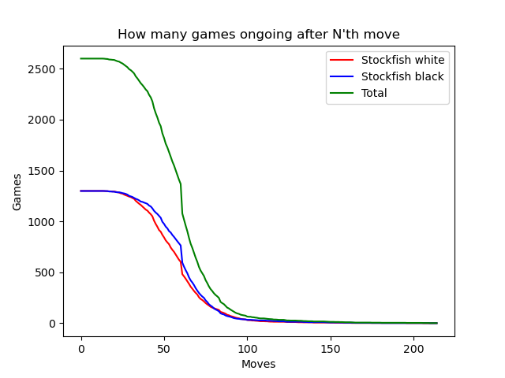

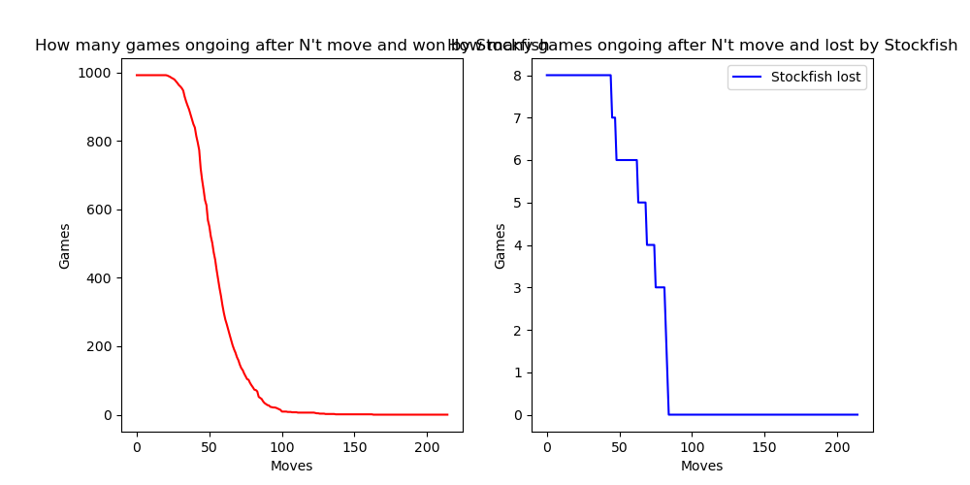

# Tables statistics

Table regarding mean of the number of moves in a game

|  |  |
| --- | --- |
| Mean of: | Mean |
| All the games in total | 60.321 |
| Games where stockfish was white | 58.762 |
| Games where stockfish was white | 61.881 |
| Games where stockfish won | 55.078 |
| Games where stockfish lost | 68.625 |

Table regarding standard of the number of moves in a game

|  |  |
| --- | --- |
| Standard deviation of: | Standard deviation |
| All the games in total | 19.586 |
| Games where stockfish was white | 19.78 |
| Games where stockfish was white | 19.272 |
| Games where stockfish won | 16.673 |
| Games where stockfish lost | 15.482 |

Table regarding different openings played by stockfish and if they were won or lost

|  |  |  |  |
| --- | --- | --- | --- |
| Opening | Won | Lost | Remis |
| Nimzo-Indian | 22 | 13 | 43 |
| Sicilian | 151 | 89 | 342 |
| QGA | 7 | 3 | 20 |
| QGD | 28 | 9 | 83 |
| Budapest | 9 | 0 | 17 |
| Queen's pawn game | 17 | 8 | 44 |
| French | 42 | 11 | 77 |
| Ruy Lopez | 47 | 15 | 102 |
| English opening | 20 | 12 | 56 |
| Gruenfeld | 8 | 4 | 28 |
| Reti opening | 12 | 4 | 26 |
| Caro-Kann | 36 | 11 | 75 |
| English | 43 | 17 | 93 |
| Queen's Indian | 26 | 10 | 66 |
| QGD semi-Slav | 18 | 8 | 50 |
| Petrov | 8 | 0 | 19 |
| King's Indian | 31 | 7 | 47 |
| Catalan | 10 | 0 | 20 |
| Sicilian defence | 13 | 2 | 19 |
| Reti | 9 | 8 | 21 |
| Robatsch (modern) defence | 7 | 8 | 8 |
| QGD Slav | 12 | 4 | 36 |