ASSORTED (unorganized) and INCOMPLETE VS DESIGN NOTES (scribblings, musings, etc.)

Last modified October 26th, 2007

NOT FOR PUBLIC DISTRIBUTION
(at least until it’s sufficiently done to be presentable, intelligible, etc. – that, and it’ll be full of spoilers :-/ )

"Icarus descended upon the coldest sea, foundering inheritance rimward of Eden."

(titles in chronological order)

A list of titles and highlights

Icarus Descended: ( ~2684 ? )
  - Pre-SPEC Expansion in the Diamond Dust
  - Founding of the major human powers
  - Origins of the Merchant’s Guild
  - Devolvement of fallen colonies into piracy, etc.
The Stars Are Also Pyres:
  - Fraternal War
  - Origins of the Confederation of Inhabited Worlds
Upon the Coldest Sea: ( 3276 )
  - Aeran War
  - Maturation of “Grandchildren”
  - Andolian powershifts
Black Paralysis:
  - Exploration/exploitation of Jump Network
  - FTL maturation, discovery of “locked” gates
  - Changes in Human-Rlaan relations
  - Final death throws of Aeran Ascendency
  - Origins of “marked” Aeran co-operators
Foundering Inheritence: ( ~3663 ? )
  - Further exploration of locked gates
  - Revelations on the Ancients’ libraries
  - Opening of gates
  - Launching of the Fleet of 10,000
  - Invasion of Rlaan space from beyond locked gate
  - Decline of Rlaan assembly
    - Near extinction of Saahasayaay
    - Devestation of Rlaan population
  - Evidence of TWHON stirring
  - Revelations on the intended role of the Nano-Plague
The 10,000:
  - Travels and struggles of the stranded fleet
  - Origins of the Pen-Ul and Pen-Pen
Rimward of Eden: ( ~11007 ? )
  - A young marked Aera struggles to claim his people’s birthright and escape from human imposed bondage on a world never truly recovered from an interstellar cataclysm, the cause of which has been lost in time and strife to the inhabitants of his world. Old relics lead him to seek the help of a “demon”.

TIMELINE INFO

TWHON Era: ??? to ???
- According to what evidence exists in the recovered records of the Ancients A and Ancients B species, Those Who Have Only Names were a group predating the Ancients, with some degree of interaction or legacy involvement with all Ancient species.

Ancient Era ??? to ~2 Million BCE
- Several Million Years BCE
Ancients A, B expand throughout this region of the galaxy, interact with at least 4-6 other groups of similar developmental level
- ~2 Million Years BCE
Widespread cataclysms:
Abandonment of Ancient research labs on Uln homeworld
Evidence of interspecies warfare among Ancients
Slag worlds and planetary debris fields formed
Evidence suggesting that all Ancient species were rendered defunct over a very short period of time

Inheritor Era ~2 Million BCE to present (3276 CE at beginning of "Upon the Coldest Sea")
- ~960,000 to ~830,000 BCE
Alphan/Betan sublight expansion
Conflict between Alphan and Betan species leads to development of FTL technology
Both Alphan and Betan species rendered extinct due to conflict with Nano-Plague
- ~100,000 BCE
Rlaan Workers and Defenders speciate
- ~13,000-11,000 BCE
Humans develop agriculture
- 9783 BCE
Rlaan writing system formalized across entire planet
Rlaan Assembly formed

"Icarus Age" begins (11th Century BCE)
- 11th Century BCE
Rlaan begin sublight expansion
- 1st Century BCE
Aera begin clearing forests to create agricultural land
- 3rd Century CE
Rlaan research into FTL re-activates Nano-Plague
Rlaan expansion halted as Rlaan recover from Nano-Plague
- 5th Century CE
Uln reach Sul-Gatwa High Castle
Gatwa dynasty cements Ulnish supremacy
- 15th Century CE
Rlaan finish consolidating post Nano-Plague recovery, reintegrating surviving colony worlds back into the Rlaan Assembly
Rlaan encounter the Saahasayaay homeworld
New Rlaan Assembly expansion policies instituted, including stringent requirements for core-system development before expansion
- 18th Century CE
Uln begin sublight expansion
Negative Rlaan experiences with Saahasayaay lead them to concentrate on the construction of designer species from pre-sapients, including the Lmpl and Nuhln, rather than relying on encountering useful sapients.
- 23rd Century CE
Death-throws of the nation-states on Earth
Increasingly cemented meme-groups
Humans begin sublight expansion
Origins of the Forsaken
- 25th Century CE
Second generation colonies launched (Human space)
Massive construction projects common (Human space)
Cherryh station
Hephaestus
FIXME MORE EXAMPLES TO COME LATER
- 26th Century CE
Humans begin forays into jump technology, in particular, the Unadorned and Andolians
- 27th-28th Century CE
Nano-Plague activates in Human space
Collapse of nanite-based technologies in Human space
Human societies stabilize, having adapted or failed.
"Interstellar Church of True Form's Return" founded
"Icarus Age" ENDS

"Diamond Dust Age" begins (28th Century CE)
- "Reconstruction period" begins
Beginnings of human interstellar economy.
Initial formation of Merchant Cartels
Displacement of Forsaken by FTL claim-jumpers begins.
- 29th Century CE
SPEC drive invented by Emilio Sofono
Displacement of Forsaken accelerates.
"Reconstruction period" ends
- "Exploration period" begins
- 30th Century CE
First Contact (for humans): Unadorned discover Mishtali
Joint Shaper/Light-Bearer venture discovers ancestors of Dgn and Shmrn in system dubbed "Beckett's Murky Venture".
Light-Bearers discover Ktah
Light-Bearers occupy Ktah
Andolians discover Ktah
First human interstellar conflict (later dubbed "The Fraternal War") begins
Hoshino uprising, Light-Bearer presence on Ktah neutralized, nuclear retaliation kills over 1 billion Klk'k.
Andolians liberate Ktah system
"Ktah restoration project" begins
Andolians reveal Light-Bearers' Space-Born project, muting Light-Bearer support from other factions
Widespread ramp up of space-based military assets begins (Human space)
Andolians systematically debilitate Light-Bearer faction, liberating Space-Born and Shmrn. Andolians now responsible for more human deaths than any other group in human history.
- 30th-31st Century CE
Surviving Light-Bearers turned over to Klk'k, Space-Born, and Shmrn custody.
Light-Bearer meme-group rendered defunct
Andolians cede control of several former Light-Bearer colonies to other factions, primarily Shapers as compensation for lost investements.
Independent Shmrn colonization effort begins.
"Andolian Protectorate" established as entity in control of Andolian and Klk'k affairs
Diplomatic talks concerning the formation of "Confederation of Inhabited Worlds" begin
League of Independent Human Worlds (LIHW) formed
"Exploration period" ends
"Diamond Dust Age" ENDS

"Confederation Age" begins (31st Century CE)
- "Paranoid Avarice period" begins (Human space)
Independent human meme-groups aggressively absorbed by larger meme-groups.
Andolians discover Purth, begin redesigning them
Aera encounter Bzbr, become increasingly worried about potentially abundant sentient species
- "Confederation of Inhabited Worlds" formed
Internal conflicts abate. Military buildups continue due to increased assessments of risk from potential alien sapients.
- (MORE PRECISE TIME-GOES-HERE)
Rlaan encounter Uln
- (MORE PRECISE TIME-GOES-HERE)
Humans (specifically Shapers) encounter Rlaan
- (MORE PRECISE TIME-GOES-HERE)
Aera encounter Uln
- (MORE PRECISE TIME-GOES-HERE)
Aera/Humans/Rlaan/Uln expand to each others' borders
- (MORE PRECISE TIME-GOES-HERE)
Aera colony passage negotiations fail
- (MORE PRECISE TIME-GOES-HERE)
Aera attempt to sneak convoy through Rlaan space
Aeran convoy destroys Rlaan civilian vessels
- (MORE PRECISE TIME-GOES-HERE)
Aera-Rlaan war
- (MORE PRECISE TIME-GOES-HERE)
Aera-Rlaan cease-fire
- 3276 CE
Aera invade Forsaken space
Confederation grudgingly mobilizes to support Forsaken
Aera/Confederation enter into a state of war

A conversation (edited):

rimward of where the THWON have returned to
in the madness that remains of them
back to where old memories took them

but the stories are all quite far apart in time
the one I want to attach to "Rimward of Eden" takes place several thousand years after "Upon the coldest sea"
indeed, several thousand years after "Foundering Inheritance"
which takes place hundreds of years after Upon the Coldest Sea

there was a struggle between the Ancients and their creators, TWHON
think Gods and Titans, only with a different outcome
The Ancients lost their lives, the TWHON lost its/their (it's hard to choose the better term) sanity, among other things
there were, of course, many different types of Ancient
diverse playthings crafted while the mind of TWHON was itself more diverse
many of the varied and bizarre devastations visited upon former Ancient worlds occurred after the struggle proper, after the residents were themselves all or mostly dead
and what was left of the TWHON was far from sane, far, even, from a semblance of intelligible thought
torn apart by a civil war among different aspects of a single mind
shredded utterly bashing itself against the small but sharp holdouts of the Ancients
TWHON is an appropriate name for them, for the aspects were not so much named as _the name_. Embodied aspects of thoughts, principles, ambition
But what is left is no longer a mind

D: don't suppose you've got history for what they were before and how they became that mind?
T: not really - that predates even their own knowledge, to some extent
it happened a _long_ time ago
the Ancients certainly didn't know the details
part of the reason their libraries (some of which continue operation in the void between stars) are interested in watching groups such as the Andolians
pondering how a life form evolves from muck to Godhead
D: cool
T: but for an approximate date, let's say that the ancestors of the TWHON became the sole owners of the entire galaxy at least 1 billion years ago
what may or may not have co-existed prior to this is unknown
how many species they initially represented is unknown
what they became was very well known to the Ancients, and not really much at all known to the younger species
I've tried to keep details about the TWHON out of wide public distribution
D: which you've done very well ;-)
T: a developers-only section would be nice... neh, whatever
Some things are best not served until thoroughly cooked
D: hehehe, indeed
T: but, I'm happy you think it a worthwhile yarn that I'm spinning
D: ya, it sounds sweet :-)
T: how's the plot for Black Paralysis coming these days, btw?
D: the plot is just about as murky as it's every been ;-)
T: ok, well, I was jotting down some things in the timeline, and that may be of use/interest to you at some point
D: that may well be a very good idea :-)
T: so, basically, I see Black Paralysis as potentially being a really good setup piece for all the glory, suffering, and devastation that comes in Foundering Inheritance
with the title being an apt reference to our inability to move quickly outside of the jump network, which, by the time it takes place, is pretty well hemming everyone in (the Aera were just unlucky enough to be in a corner and find it out sooner than most others)
D: hey! that's like one of the many meanings I actually thought of :-)
T: namely, the discovery of the "on-ramps" out of our section of the galaxy
and out of our section of the jump network
which.... seem to be blocked off
this, of course, is of profound interest to the remnants of the resisting Aera
and sparks some turning points in Human-Rlaan relations
amid some power shifts internal to the Rlaan between anthro-philic and anthro-phobic elements
mostly opaque to the casual human observer
an opacity not to our benefit
D: okay, you've just summed up basically everything I had worked out so far (and then some) ... neato :-)
T: but ultimately not to theirs (but not until Foundering Inheritance)
Foundering Inheritance will feature the launching of the fleet of 10,000, the joint expeditionary force, a grand symbol of of unity, progress, and optimism
it will also feature the near destruction of the entire Rlaan species
both of them ;-)
D: hehehe, howso?
T: there are multiple on-ramps
they have to be opened from both sides
the expeditionary fleet was sent into one
but the Rlaan had their own plans for one they didn't bother telling anyone about
unfortunately, while the expeditionary fleet went through something unlocked due to ages of neglect
the Rlaan opened something unlocked because the other side was waiting, and hoping for someone to unlock the far side
oops
D: heh, unlucky
T: insufficient precaution, in many ways
over-trust of their own
relative to the efforts at the joint gate

where cooperation bred sufficient mistrust
D: that doesn't stike me as an overly rlaan trait though (overtrust)
T: but of whom?
they trusted themselves
they were betrayed by themselves
unwittingly
hubris
D: trust in teh benign unknown then
they seem to have always approached new contact with caution
T: they didn't know they were making contact :)
D: ya, but surely they would have thought of the possibility?
T: oh, yes, they did
but that wasn't what screwed them
they didn't know they were making contact _while they were making contact_
D: oh
T: they didn't think far enough outside the box to understand what happened before it was rather late in the game - a somewhat more Rlaan trait
D: ya
T: but yes, bad luck as much as anything else
had it been the joint venture going there, it would have been disastrous, but less likely cataclysmic
they got greedy and paid for it dearly
as did most everyone else
pay for it dearly, that is
could have been even worse
except that it got worse ;-)
but in a way that helped those further away
D: very cryptic :-P
T: That which was overtaking the Rlaan attracted the notice of the remnants of TWHON
not that it knew what they were
not that the Rlaan really understood what it was when it came through
but the nano-plague remembered
it remembered very clearly
for the first time in a very long time
it fulfilled its intended purpose
D: ooooh, nice :-)
T: now, the conclusion of this part will intentionally leave a few loose ends, but make clear what groups are still around
it will therefore be somewhat surprising to view the situation at the beginning of Rimward of Eden
(if one has been following events)
because, in the long interim between the two, much seems to have been both gained and lost
the protagonist in Rimward of Eden is actually an Aeran youth
on a planet of subjugated Aera ruled over by humans, themselves clearly fallen from some greater height
upon further inspection it will become apparent that interstellar travel no longer appears to be occurring
D: interesting
T: As the protagonist struggles for his own survival in a landscape of standing buildings and collapsed societies, powerful artifacts and abject poverty, he will end up seeking the aid of an ancient "demon"
(of course, nothing of the sort, but what do they know?)
whose aid will end up transporting them and others met along the way on a trip that opens their eyes (and ours) to what has become of our stretch of stars
filling in some of the pieces in-between, will be the story of the fleet of 10,000 which ends up stranded (relative to where it launched from) by the events concluding Foundering Inheritance
but this story takes place a long way away, and is a story of what happens in our neck of the woods only though inference, and the story of what happened somewhere else, a long time ago
D: :-)
if this were a set of novels, I would so own the series :-)
T: as a set of games, I don't envision all of them being well suited to being flight-sims, or at least not in any traditional sense
D: it seems to be most of them won't be
T: well, Icarus Descended would be best served Elite-like
moreso even than Upon the Coldest Sea, in that it _is_ an often lawless, expanding frontier
much more "western"-esque
makes all the "space-is-for-libertarians" crowd happier... until they remember what it all turned into in VS - freedom begat monopolies, totalitarian states, fascist intrusions, and religious extremism as well as democracies, progress, and personal growth
There's also the story of the Fraternal War (aka. the war between the Andolians and Lightbearers) that I think has some good stories in it. From a Klk'k perspective, I'd go with "The Stars are also Pyres" as a good proto-title
that could play reasonably well as a mission-based flight sim
although, there are some ground elements that are more interesting
although it perhaps makes more sense to just experience them, rather than influence them
And then there's always the best fodder for an FPS - "Simon says die"
about the Simons
D: hehehe
T: did I tell you about the Simons?
D: nope :-)
T: think simon wiesenthal meets "the punisher"
From a Klk'k perspective
D: neat idea :-)
T: anywho, so those are the broadest outlines of where I see story points of interest in a ~9000 year spread of time in the VS future history
D: ya, it sounds really cool :-) you've certainly put a hell of a lot of thought into it :-)
T: well, I wish I'd put as many hours of writing into it ;-)
at least gaim archives conversations, so I can point and grunt when people ask again ;-)
D: lol
T: I think Rimward of Eden would be best as an adventure game of sorts
whatever the interface, that's the genre it seems most part of
even if the mechanics involve a first person perspective
I think, especially in a first person perspective, it might be interesting to be an Aera
D: definitely :-)
foundering inheritance doesn't really fit anywhere though in terms of comp games ... it'd be a great novel, but there's so much that just couldn't be conveyed in just one tyupe of game
T: well, maybe it doesn't make sense to just make it one game then :)
D: touche
T: but... given how long its taking us (admittedly at very-much-part-time-pace)
to do one installment, I'll worry about getting the universe in shape first
and then how we're going to present it
because there _are_ several key points that do map to tangible genres
the other thing, is to look at one of the things I really want to do with VS:utcs
which is, to have a very flexible progression of "little story" in the scope of a much less flexible "big story"
which the character doesn't so much influence, as live in (the big story, that is)
Note that Deucalion is not the linchpin for 9000 years of VS history
D: course not :-)
utcs is just part of the story from his perspective
T: well, given that he hadn't been created yet, it'd be hard for him to be much influence on Icarus Descended ;-)
D: hehehe
T: and, unbeknownst to him, he did play some role, though through little fault of his own, in the timing of some events in utcs ;-)
which is to say, the role he played occurs befor utcs proper
and hence can't be screwed up by the player - then again, it'd be pretty hard to do, as the only required action is (more or less) his existing at all
Deucalion is a remarkable being, in that he's actually an apology
Deucalion is a library's way of apologizing for killing an exploration crew some decades prior
His role in the timing of things entirely being an issue of getting the AI quorum pondering what built him, how, and why
and the effect that such ruminations had upon the rollout time for the "grandchildren"
sometimes, it is enough to know something is possible
that alone can make a difference, even if the particulars are beyond reach
a nudge, a narrowing of search, a path otherwise not taken, that leads to a slight speedup in something else, itself long in the making, long before Deucalion
D: cool :-)
On the Fall of the Ancients and TWHON (NOT COMMON KNOWLEDGE)

There were, as you assumed, more than two species of Ancients - in fact, I'm fairly sure it is mentioned somewhere (although I can't recall where, and if I can't, then... ) that there is evidence of interactions with at least six other groups of Ancients. The two in question were just the locals, and their domain was demarcated by the locked gates, an imposition of the TWHON. The TWHON, whether the Ancient group in question arose more or less naturally to a meaningful existence, or was created entirely from scratch by TWHON whimsy, were the creators of all of the Ancient groups in that the molded them and shaped them to their own designs and for their own reasons. Had their era not passed, there would have come a time when, whether directly or by Ancient proxy, the TWHON would almost certainly have manipulated Humans, Rlaan, and Aera alike for whatever motivation struck them at the time - and, if by odd chance we had remained sufficiently insignificant to escape the notice of the TWHON, the local Ancients would almost certainly have had their own games to play, more likely than not at our eventual expense. There were, to distill the essence of relevant groups, only the Ancients and the TWHON, as no other groups were given license to develop.
The downfall of both groups was to come from a great indecision within the mind of the TWHON. As the Ancients progressed into an early post-technological stage of development, certain aspects of the TWHON mind no longer saw it proper to use them as playthings and experimental subjects (both of the former as groups, not individuals - the TWHON didn't do "alien abductions" they just started massive interstellar wars, conducted xenocides, created plagues, monsters, new Ancients, challenges, rewards both equitable and not... standard god-like-being stuff). To keep things brief, and use metaphor and analogy (though it leads to an incomplete description), one can picture this all culminating in an eventual Ancient revolt, assisted by elements of the TWHON mind that, rather than being squashed, instead set off a "civil war" within the TWHON mind, spilling over into the TWHON bodies. The defensive assistance rendered by the pro-Ancient TWHON lines of thought against their urges toward continued usage of the Ancients as inconsequential entities, would eventually become very well known to the extant species (and cause many later species to cease to be extant) as the "nano-plague." A majority of the Ancient groups joined the revolt, though some continued to fight by proxy for their masters.
One decisive battle would prove to be the beginning of the end for the era of TWHON and Ancient alike. On one of the two research planets in what is now the Uln home system, indeed, on the planet that is now a noticeable debris field in the Uln home system, research was frantically being conducted on how to reinforce the allied lines of TWHON thought at the expense of antagonistic patterns withing the TWHON mind. The future Uln homeworld was evacuated and the proto-Uln abandoned. Fleets of moon-sized Ancient craft, a fragment of one such eventually becoming the Sul-Gatwa high-castle, and numerous TWHON bodies gathered in the system to defend and participate in the ongoing research. An armada of TWHON bodies attacked the system, and prototype device were activated. The battle unleashed enormous devastation upon both fleets, but the TWHON-mind-altering devices were to prove far more lasting in the devastation they were to unleash. In addition to cognitive dissonance increasing within the TWHON mind from the operations of the mind-altering devices, the battle was sufficiently fierce that TWHON ideas, and thus Names, were dying along with TWHON bodies. These deaths echoed, and then reverberated, and then fed back and amplified on the devices, burning themselves into, and by turn burning out the TWHON mind. As the battle proper neared physical resolution, the forces allied on the side of the Ancients' liberation looking to have gotten the better of the engagement, though the victory would likely have already been Pyrrhic in the longer term, the TWHON mind sank below the threshold of sanity, all Names becoming muddled and losing sufficiency of form (the TWHON mind already having been many times weakened by prior TWHON-TWHON engagements). What moments ago were their supporting deities now turned on the Ancients in the TWHON slide from supremacy and, along with the remains of the invading TWHON bodies, themselves equally deranged, slaughtered every Ancient in the system and destroyed, too late, the planet on which their downfall was birthed. The Uln homeworld was spared a more sterile fate only for the hurry with which what remained of the TWHON mind wished to distance itself from a place of suffering.
What had before been a war, if a galaxy-devastating one, became a cataclysmic spectacle of heretofore unrivaled savagery, devoid of rhyme or reason. As the TWHON mind degenerated, the Names of Rage, Confusion, and Suffering fared better than many, and were allowed to greatly influence the actions now being undertaken by the TWHON bodies throughout the galaxy as they began to purge every system of Ancients of every kind, revolutionaries and loyalists both. It was in this period, not during the war proper, that the slag worlds were created; the great overkill measures of boiled atmospheres, muted suns, melted crusts, and shattered worlds left to re-coalesce into the not infrequent debris clouds seen in UTCS era systems were not the actions taken by victorious armies upon their foes, but by a great singular mad mind, fragmented and devolving, lashing out in sometimes self-annihilating fashion (see: worlds rendered uninhabitable by what would appear to be prolonged bombardment by large impactors) at anything that could be detected by its increasingly twisted perception. Every living Ancient in every system on the jump network was exterminated. Every gathering of Ancients in systems off of the jump network was obliterated. What was once TWHON hunted the Ancients, and in finding and annihilating them, found the occasional glimmering shred of purpose to its new existence. All that remained of the Ancients were arks and tombs, drifting alone in the relative safety of the void between stars. When it could no longer find anything to hunt, the TWHON bodies wandered, some disassociating, some taking to slumber, some few wandering beyond the edge of our galaxy, to slowly plough the deepest of voids toward ambiguous end, and a great many retreated to the warm embrace of the old and dying stars far coreward of our portion of this galaxy.
Events in “Foundering Inheritance” Time Period (HASN’T HAPPENED YET)

One of the key points about the Foundering Inheritance era mentioned in the conversation concerning the overall VS universe timeline is that the Rlaan do not realize they are encountering a new alien entity. The destructive force that renders the domain of the Rlaan Assembly broken and the Saahasayaay nearly extinct is first encountered as the local variant of the nano-plague on the other side of the locked gate (the expidition of the 10,000 finds no local nano-plague, as the Ancients in that region had been supporters of the status quo) in the Saahasayaay home system. As the variation between observed nano-plague entities in locals space was greater than that between the two spaces, seeing more of the ubiquitous nano-plague on the other side of the locked gate was seen as mildly interesting, but generally unremarkable. It may have even been somewhat unremarkable, save for the other-side nano-plague recognizing the symbiotes in the Saahasayaay (see wiki description of Saahasayaay life cycle) and activating in a decidedly organized fashion. It is no coincidence that the habitable worlds of the jump network are disproportionately suited to oxygen breathers, and it is no coincidence that near the Saahasayaay system there are several other chlorine worlds, and near the Rlaan homeworld, several methane-ammonia systems, and another locked gate. These areas were provided for neighboring Ancient groups, resident across the locked-gate boundaries. The symbiote in the Saahasayaay was a tool of one such neighbor, and the other-side nano-plague, another tool, recognized its kin, even in its kin's damaged state. The other-side nano-plage effected changes to fix the symbiotes, allowing the other-side nano-plague (hereafter OSNP for brevity) to use the Saahasayaay as a conduit for information, and then for dissemination of the symbiote fixes back to the Saahasayaay homeworld. The eventual goal of both OSNP and symbiote was simple, if vain and likely futile: to prepare the way for a return of their long-dead Ancient creators, existing currently only as dormant information. While the OSNP increased its activity, building progressively larger colonies, the colonies macrostructures, and the macrostructures becoming macroscopic machines themselves, it remained resource limited - the immediate region of several star systems was quite barren, strip-mined in its hey-day during the Ancient-TWHON war, and then ravaged in the aftermath, and it would be some time before the OSNP would be able to produce drone ships either as an end product or to transport goods from richer systems. Neither could the OSNP act directly in our region, as our own nano-plague would react negatively to it if it were to try to expand. Instead, the erstwhile-Saahasayaay (not truly Saahasayaay anymore, but merely avatars for their finally flourishing symbiotes) staged a revolt, taking numerous Rlaan civilians as hostages, knowing this would delay the Rlaan response long enough for their ships, now crossing freely into the other-side to be upgraded by the OSNP - if not yet to anything resembling Ancient standards, then enough to be a great surprise to the Rlaan when the time for combat was to finally come.

Bargaining, in a very uncharacteristic way for Saahasayaay (this itself already greatly disturbing the Rlaan), for the safety of the Saahasayaay outside of the home system with the lives of the Rlaan Workers, the ex-Saahasayaay gained both more crucial time and powerful weapon: the Rlaan Workers were themselves modified by the OSNP to have an innate desire to sabotage, kill, and disrupt - while the Rlaan would check them for bio-weapons and such, the Rlaan mindset precludes consideration of Workers as themselves being instruments of violence, and so clean bills of health and belongings would see them released back into Rlaan society. In a move reminiscent of the battle of Puebla, the Rlaan forces charged directly through the jump-gate and the inevitable fixed defenses, rather than flanking with SPEC. The Rlaan suppression fleet met with horrendous casualties at the hands of the upgraded Saahasayaay vessels, and, the first glimmer that more than just a Saahasayaay ploy to escape Rlaan rule via the lock-gate was underway, upgraded vessels of remnants of the Rlaan expeditionary force itself (there having been some resistance in the Saahasayaay overtaking of the expeditionary force). Though unsuccessful in retaking the system, the attempt had bought the Rlaan valuable time, though they did not then know this, for the OSNP ramp-up would be significantly slowed by the damage to many of the already quite small number of vessels at the command of the OSNP and ex-Saahasayaay. Nonetheless, while the Rlaan re-inforced and re-grouped, planning to send an even larger force through, this time via SPEC, this remained a "local" issue, with news of the Saahasayaay rebellion being an event not shared with the human powers. However, when, shortly after returning to Rlaan space, the modified Rlaan Workers set about their assigned terrorist tasks, the entirety of Rlaan space was overtaken with hysteria and paranoia - Workers committing violent acts of terror, even if the actual damage was so small as to be trifling, and most of the Workers in question perished in the execution of their tasks, was so antithetical to the Rlaan worldview of the possible that it threw their entire society into gridlocked turmoil. This was to prove fatal for long term Rlaan aspirations, and to be a saving grace for all other species in the region, as it was a disaster now too large to keep quiet. Fleet movements that could have all directed themselves in a bloody, but likely ultimately successful assault on the OSNP beachhead, were curtailed, as the Rlaan, in paranoid meltdown, saw threats everywhere that the released Workers could still be, and held back significant fleet resources for use with the Rlaan Enforcers to retrace the paths and hunt down every one of the "abominations."

When the second attempt to retake the Saahasaay homeworld and the lock-gate failed (even more poorly than the first, thanks to new waves of ships of unknown design), the fact that the situation was exceptionally dangerous became increasingly apparent to all parties. Joint efforts were undertaken to organize an interspecies response. As these efforts began, the first counter-attacks began to issue forth from the lock-gate. As time wore on, the enemy ships improved in design rapidly, if only slowly in number. Analysis of probable causes leads to the the gate in (formerly) Forsaken space from which the fleet of 10,000 left being locked from both sides, isolating both fleet and research colony from the rest of known space. Strikes are radiating further and further out from the lock-gate, battles are slowly worsening in per-ship losses, and the combined forces of the extant species are being repeatedly forced to withdraw to keep from being overrun. The situation is grim,especially as it is obvious that time is not on the side of the newer species. It is only by becoming much grimmer that the situation will improve.

As the first wave of nearly-Ancient quality drone craft is completed and larger craft construction commences and continues, it is launched en-masse in a series of attacks against the Rlaan, both fleets and worlds, carving a vast barren region into the Rlaan Assembly's territory. However, this coordinated use of Ancient tech stirs TWHON fragments slumbering in the other-side, and the resolution of this conflict is set in motion. A single small TWHON fragment plows straight through into our region, bypassing the unprepared OSNP, and engages the drone craft. Though the fragment is destroyed, the drone craft are decimated in number and universally damaged. All OSNP and ex-Saahasayaay forces retreat to an expanded beachhead area in the systems near the lock-gate, the drones being recalled for repair and re-deployment against the stirring TWHON fragments in the OSNP's own region. Meanwhile, the presence of a TWHON fragment in our own region fully activates our own nano-plague (it already having a many hundreds of years head-start on the OSNP due to our own FTL travelling). Nano-plague factories begin defensive preparations against subsequent TWHON incursion. Reconnaissance of the beachhead proves difficult, and recon through the lock-gate, nearly impossible. However, it becomes clear that the preparations being made at the beach-head are for an OSNP/ex-Saahasayaay escape from their region, and no longer directly a pacification of ours - the OSNP are losing. Though drone-craft from our region have begun to appear in number, they do not cross over into the next region to assist - they still obey the long meaningless borders between their long dead masters.

With the evidence of a distinct drop in craft from the beach-head area signalling a likely imminent collapse, the joint Human, Grandchild, Klk'k, Rlaan, Aera forces embark upon a massive suicide mission of genocide - having realized that the OSNP cannot operate freely in our region except through the ex-Saahasayaay, and that they could not hope to defeat the OSNP forces in direct engagement, they instead chose to exterminate the Saahasayaay hosts to the Ancient-designed symbiotes and as much of any construction infrastructure as they could manage. The strike was well-timed, and the tactic not one the ex-Saahasayaay had weighted with high probability, having been too colored in their view by lingering effects of their time in Rlaan service. The Saahasayaay homeworld was carpeted by anti-matter bombs even as the fleet delivering them was being savaged by OSNP drones. It was unclear exactly how successful the mission had been - very few craft returned, and there were too many unknowns as to other potential bootstrapping sources for the OSNP. However, only days after the raid, TWHON fragments broke through the locked gate, signalling the totality of the OSNP demise in their own region, and the entire Saahasayaay home system, when it was next visited, was found to be slagged. Whether through previous TWHON attrition, or superior preparation, our own dones were faring somewhat better against the TWHON fragments. Also remarkable was that our nano-plague took to using jump-point deactivation as a time-gaining tactic in fighting the TWHON fragments, which either could not or would not be bothered to reactivate the jump points and instead would travel through some more advanced SPEC-like manner directly between stars in the absence of jump points. Though the TWHON-nano-plague fight raged, the priority of the extant species remained the re-locking of the locked gate. The expedition charged with doing so was assembled as quickly as possible given the extreme losses all parties had already endured, and expected to endure again.

Upon reaching the, now disconnected from the jump network, former Saahasayaay home system, they found no fleet waiting for them, instead, they found a single, small TWHON fragment body and a series of slagged worlds. Much to their surprise, the TWHON body completely ignored them as long as they remained distant from the lock-gate. When local drones engaged the TWHON fragment and it chased the drones out of the system, the expedition set up to lock the gate and retreated.

Though the few TWHON fragments that entered our region were eventually defeated (the long-active nano-plague prevented local procurement of re-inforcements, that being the true key point of the nano-plague, the drones being entirely secondary, as Ancient fleets were assumed to exist at the nano-plague's creation) the TWHON-drone conflict made the area around the lock-gate unfit for habitation both through further destruction of worlds and severing of jump-links.

At incident's end, the Rlaan were no longer the power they were, with many worlds destroyed, many more damaged, their fleet broken, and the breach of trust that started the incident a sticking point that would be quite well remembered in the coming period of rebuilding - one they would pay dearly for in control over their future, and one which would lead the Rlaan-Briin to societal dominance with the support of the Post-Human powers. Moreover, there was now a great pallor over the futures of all of the extant species, as it became clear that this could not be a lasting defeat of the TWHON - rather, the very stirring of our nano-plague, it's true purposes at last revealed, would undoubtedly bring more suffering in the future. The sword of Damocles would now rest over all of their heads, and it would clock-like sound each hour to pass of doom creeping forward while salvation remains nebulous.

…

d: simply that the 'cleaning up' of the whole mess seemed "easy"
(22:28:20) d: as in, besides the space fleets, the only real losers from the whole lot were the rlaan and the s*
(22:29:01) d: which didn't quite match what I thought led to teh later timeline you talked about
(22:30:07) d: but I get now that it was the long term events set in motion (ie the activation of the local nano plague) are what sets ruin to teh current crop of spacefaring races
(22:30:42) d: but don't let that comment mislead you, melikes :-)
(23:06:05) t: yeah, the Post-Human powers didn't get their turf destroyed
(23:06:13) t: but their fleets were shredded
(23:06:19) t: I should make that more explicit
(23:06:44) t: most of the ships involved in the late action, even defending the Rlaan, weren't Rlaan anymore
(23:07:05) t: there just weren't many of them left
(23:08:23) t: The sweep made by the OSNP drone craft was a bit understated
(23:10:00) t: We're talking, Rlaan needing to ask for help to clean up all the dead Rlaan bodies understated
(23:11:02) t: And the suicide run.... would be the largest congregation of extant species ships seen in a long time
(23:14:03) t: especially with a hyper-active nano-plague playing serious hell with production (bad tendency to eat some high-quality materials) although that would die down soon enough
(23:14:39) d: cooly, that's some better sense of proportion ;-)
(23:17:23) t: that, and they weren't able to confirm that they killed all of the ex-Saahasayaay
(23:17:42) t: minor potential problem, that, over the next few thousand years
(23:18:02) d: as in, point for focus of paranoid delusions?
(23:18:24) t: that, and just because you're paranoid doesn't mean they aren't out to get you
(23:18:27) t: :)
(23:18:37) d: :-)
(23:18:41) t: closing the gate was intentionally anti-climactic
(23:21:23) t: it deprives the survivors of the solace of accomplishment, false or otherwise
(23:21:55) t: forcing them to face the unsettling reality that, at most, they've only delayed the inevitable
(23:22:22) d: point
(23:22:45) t: which, I think, is a nice note to end that chapter on :)
(23:22:59) t: condensed in form as it may be

One of the things that I should have mentioned more explicitly is that the above was only a description of what was going on in Rlaan space during this period. The events in Human/Post-Human/former-Aeran space are fairly important too, and brought all the more to a head because of the fall of the Rlaan - it is worth remembering that a key reason that warfare was fought in a "restricted" i.e. non-genocidal/collateral-damage-minimizing fashion in the UTCS era was the Rlaan intolerance for civilian body counts (so if you were going to butcher planetary populations, you had to keep it on the serious down-low). With the Rlaan gone, there's nothing but human conscience to prevent atrocity (which is not a historically viable solution). Add to this the tensions between human (Basically Purists and allied factions - the Forsaken still remaining distant from the affairs of the Confederation worlds) and post-human (The Andolian Protectorate (having expanded (via negotiated annexation) by this point to include the former Unadorned, Mechanist, and Shaper polities) and the Grandchildren) political groupings in what has become of the Confederation and the destruction of the vast majority of the Confederation and its constituents' military forces (worth noting that the majority of the ships on the "suicide run" on the Saahasayaay home system were civilian vessels hastily armed as cannon fodder due to a lack of remaining military forces), and you have a recipe for violent unrest, even if the human worlds themselves were not ravaged. Likewise, even before the actual destruction of the fleets, there was significant political maneuvering occurring within Human/Post-Human space concerning both the fleet of 10,000/other expansionst projects and scheming by various groups to position themselves to profit from what was initially seen as a minor mishap in Rlaan space.

To briefly summarize where things go from here:
Sensing imminent Protectorate weakness, the Shapers plot and execute a revolt. With internal stress between the post-human and human elements of the Confederation already near boiling, the Shapers hope to ignite a civil war with their revolt, believing that they will come out on top when all the dust has settled and no other group remains to stand against them.

Preliminary movements of the Shaper revolt involve prodigious use of bio-weapons, including morphologic virus packages aimed at Purist, LIHW and other traditional human populations in Confederation space. The Forsaken, the bulk of their population now in former Aeran space, are not targeted due to extremely low population density. Chief among these virus packages are ones that overwrite the germ-line DNA, causing erstwhile human parents to either run sterile or produce offspring with Shaper-designed genomes. Viral packages for the Klk’k populations are more simply plague oriented, and, as with the human packages, are designed for stealth and long incubation periods. The Shapers have also been producing modified fungal strains that act as factories for “Quickships,” extremely fragile but extremely cheap in-system pilotless craft. The Quickships require engines and weaponry, but are otherwise selfcontained. As they are considered totally expendable, great liberties are taken with the safety, reliability, and sustainability of the weapons and engines produced for the Quickships – Quickships would invariably die from radiation and heat stresses in prolonged service, even if they were not engaged in combat.

As their bio-weapons begin to activate, the Shapers actively revolt, laying a surprise siege to Kubernan. However, their intelligence gathering proves mortally flawed when their attack on Hephaestus is insufficient to halt production of Grandchildren. The blockade of Kubernan greatly reduces the flow of resources into Hephaestus, but the failure of the Shapers to break the Grandchildren’s homeworld means that they cannot readily press home their intended beheading of the Andolian Protectorate.

The Andolian-led response of the Protectorate is swift and brutal. Having actually made some preparations for a Shaper attack back during the cold-near-war period prior to the Aeran war and the unfurling of the Grandchildren, the signal is given to activate a number of deep-space asteroid bases set up a few week’s SPEC from each of the core Shaper worlds. These bases will spend the next several days accelerating at maximum thrust before activating their SPEC drives and proceeding on a collision course.

Meanwhile, plague and the creatures dubbed “murder-babies” for their habit of consuming their mothers just prior to expected birth, the latter turning out to be an extremely rapid-growth form of Shaper Hulk, inflict terror upon the human populations of the Confederation. The Andolians, in their sterile compounds, and many Mechanists, devoid of the necessary pathways for infection, are not directly affected, although there are riots and violence in the off-worlder sections of Andolian holdings, and the Unadorned will find themselves devastated by the Shaper plagues. The Shapers embark on a widespread propaganda campaign, and use the promise of cures and vaccines as leverage to gain support from the human governments. Several capitulate outright, and many more are overthrown by their own populations, most, at this point, having long preferred to side with the Shapers over the Andolian led Protectorate and their emblematically non-human Grandchildren. The Shaper revolt is now a full-fledged civil war.

After six centuries of existence, the Confederation is now dead in name as well as fact. The Rlaan are powerless to do more than watch in horror, and the Forsaken and Marked-Aera are hard pressed enough as it is just trying to keep any potential plague-bearers out of their space. The Uln bide their time, preferring to wait until one side is closer to victory before considering any benefits possible from backing one side or the other or pursuing territorial ambitions in the resultant power vacuum.

With the bulk of human space-naval forces already having been destroyed in efforts against the ex-Saahasayaay, the engagements seen are quite different from those during the Aeran war. The Confederation Joint fleet has completely disintegrated, with individual ships falling to one side or another of the conflict, or simply returning to the crew’s system of origin. Small numbers of ships, many of them conscripted civilian craft, or Regional Guard forces are often deciding factors in individual battles. Capital engagements are only seen around key worlds, and ground engagements are frequently fought between small forces among swarms of ambiguously allied civilians. Neither side engages in significant restraint, and the toll in collateral damage is staggering.

While the Shaper assault on Andolian space gains little headway, and the blockade on Kubernan is broken, the retreat of Protectorate forces to defend their own territory has left the Shapers and their “allies” a fairly free hand to attack and consolidate power in the rest of the former Confederation. In a move that signifies to all with sufficient understanding that the Shapers no longer consider mainline humans to be members of the same species as themselves, the Shapers deploy mind-altering parasites to ensure the submission of both willing and protesting conquest alike. Throwing the resources, both material and population, of their vassals into the fray as cannon fodder, the Shapers are able to keep Kubernan and Hephaestus under constant threat of attack, forcing the Grandchildren to be deployed defensively rather than be allowed to engage in strikes against their own forces. With the fall of Sol, Bantam, and New Camelot, the core region of humanity’s oldest colonies is almost entirely in Shaper hands, with the Purists, ISMG, and High Born polities in collapse.

Attacking through space ostensibly controlled by the crippled Rlaan, but in truth barely patrolled, the Shapers attempt to plague-bomb the Shmrn worlds, releasing a virus package designed to turn future Shmrn generations into Dgn. Given the widespread panic in the wake of the war, countermeasures are in place, and the effect, as intended, is more psychological than military. This act, however, pushes the neighboring Uln to believe that neutrality would, in the end, be no armor against a victorious Shaper entity, and the Uln throw in their (small) lot with the Protectorate.

This would be the peak of Shaper aspirations for dominance. Coinciding with the impact of the asteroid-base kinetic weapons on nearly four-dozen Shaper homeworlds, the Protectorate launched a counterattack spraying forth from Kubernan, spearheaded by a fresh crop of Grandchildren produced at Hephaestus. The Protectorate strike force handily defeated the vassal-ships surrounding the recent Shaper conquests. However, they neither charged toward the Shaper worlds nor attempted to liberate the conquered human populations. Instead, the Protectorate had come to the conclusion that any world already conquered by the Shapers was too polluted by Shaper bio-weapons, traps, and incubators (human hosts being used to produce new Shapers), and was safer cleansed than liberated. Using what would eventually be revealed as a set of bio-weapons of Rlaan origin, the Protectorate fleet embarked on their scorched earth & flesh campaign, destroying every extraplanetary structure found, raining down orbital bombardments upon every exposed spaceport and industrial area, and leaving behind a cloud of extremely voracious organisms capable of rapidly degrading planetary human populations to “manageable levels” – especially given the Shaper efforts on every conquered world to make sure their own bio-agents could have mass effect.

Certain that they could easily best the Shapers in direct engagements, the Protectorate sought out existing and potential hosts within Shaper reach and exterminated them with extreme prejudice. Both Shaper and Protectorate sides had known from the beginning that there would be no negotiated end to this conflict – the vast populations of the Purist and LIHW holdings, however, had never anticipated this war, and yet were the ones doing the bulk of the dying, being killed by the 10s and eventually 100s of billions. The last contribution of the Unadorned before succumbing entirely as a political and cultural entity, having been devastated by the Shaper plagues, would ironically feature heavily in accelerating the demise of mainstream humanity. Following on from the Ancient library research that had led to knowledge about the locking and unlocking of the far-gates, the Unadorned had discerned how to temporarily disrupt normal jump points. The Culling fleet, as it would come to be known, used this new ability both to delay Shaper reinforcements and to protect their own rear. While the disruptions lasted only a day or two, that was frequently more than enough time for the fleet to crush the Shaper presence in a system. The support of their vassals pulled out from under them, and a third of their own planets now without an inhabitable surface due to the impacts, the outcome of the war had been determined, and only the shape of things to come remained to be decided.

The human population of the old Confederation no longer a potential threat-in-the-making, Protectorate forces throughout the entirety of their space rushed out from their defensive deployments and began attacking relentlessly. The rush came from the perceived threat of the Shapers fleeing out of the jump network, slinking off to where they may not be found for centuries, an everpresent ghost of a menace, leaving all the bloodshed for, in the end, naught in terms of safety. However, owing to some degree of confidence in their eventual victory, the cultural unity of the Andolians, and, perhaps moreso even than the other two, to not having the AI Quorum cease its infiltration of Shaper computing systems when the Shapers joined the Protectorate, the Protectorate had a much better informed covert operations presence in Shaper space than the Shapers in the Protectorate.

The Shapers had not begun work on their escape efforts until after the Culling fleet’s offensive began. Though the preparations were still ongoing, the distributed nature of the Shaper efforts made it unlikely that sabotage would sufficiently slow the progress to allow Protectorate forces to reach all systems before an exodus could occur. Rather, the Protectorate’s covert operatives were employed in gathering information as to the destinations of the Shaper vessels. The seed fleets were allowed to leave, but would either find themselves ambused when they came out of SPEC to resupply (the key point being that, absent fuel, they would no longer be threats to meaningfully flee the ambush), or, for the sublight “drifter” fleets, chased down and exterminated. What few Shapers slipped through the Protectorate’s net would no longer constitute a people, a culture, or anything other than stray scattered individuals, living out the rest of their lives in exile. Historians would say of the war that, despite the Shapers’ superior intellects, which had led them on what should have been more successful strategies, it was the superior Andolian knowledge of the situation at hand that determined the outcome of the war. A combination of ignorance and mild hubris (belief, not that just that they could win, but that they deserved to, for being “better” than their Andolian competitors) proved fatal for the Shapers.

However, before their demise played out, the Shapers did leave a few more marks. The punitive plague-raid on the Uln (a simple killing virus) was far superior in efficacy to that on the Shmrn, and the Uln would prove notably cowed by the experience in their later negotiations with the First Empire. Realizing that the bio-weapon used by the Protectorate was of Rlaan origin, the Shapers incorrectly concluded that the Rlaan had collaborated with the Protectorate in engineering the Shaper demise, and likewise sent the Rlaan a “farewell present” targeting their civilian population – less perhaps a parting shot than a warning that the Rlaan would not be immune from the Shapers’ intended return. However, even in their shattered state, the Rlaan were adept at producing counter-viral agents, and the plague bombing was perceived more as an incomprehensible act of deranged malice than an action of war. This act by the Shapers was to prove fundamental to supporting the Protectorate arguments to the Rlaan, utterly aghast, nauseated, and made profoundly uneasy by the Protectorate tactics of the Culling fleet, that the Shapers were so deranged as to leave euthanizing them as the only option. Indeed, this act was so fundamental to the Protectorate arguments that there is much speculation as to whether Protectorate operatives may have played a role in convincing the Shapers to attack the Rlaan.

The Shapers sufficiently defeated, the Protectorate turned now to salvaging, rather than slaughtering the human survivors of the post-human war. Quarantine centers were organized on marginal, devastated worlds long abandoned by the Forsaken during the events of the Aeran war. There were so few survivors, that the operation, even given the ravaged nature of the Protectorate fleet and economy, was feasible. Actual Shaper worlds, rather than briefly conquered worlds, were not landed on for centuries, instead being dusted with radioactive materials, bombarded with asteroids and anti-matter bombs, seeded with counter-terraforming machines, and kept under constant vigilance and quarantine until no signs of life were visible. They would remain under quarantine even after this point until ground crews, only now visiting the planets, could verify no residual “gifts” lingering on. Where intransigent Shaper bio-forms were still found, they were rooted out until the planets were deemed sanitized, sterilized, and untainted, only then becoming eligible for re-terraforming. Rlaan, specifically Rlaan-Briin, were brought in to help clean up the bio-weapon mess that was the former human inhabited region of space. Compensation for this assistance, along with the new political and military realities, was to make the Rlaan-Briin, as an anthrophilic force within the Rlaan, the dominant group in Rlaan politics.

On a sad aside, the Dgn died along with their masters. Indeed, the only Dgn to survive the war would be those Dgn babies inflicted upon the Shmrn by the Shaper terror attack.

While many former human worlds were deemed too dangerous for human habitation, they were a fine environment for a new generation of Grandchildren to settle, for the first time moving out of their Andolian cradle. Backed by these new colonies of Grandchildren, the Protectorate would eventually become a different entity – the First Empire, expanding to include Shmrn, Uln, and eventually Rlaan space under a single sovereignty. This expansion would be one of implied, rather than exercised force, and would be performed through a series of peacefully negotiated annexations.

Under the Empire, there would be a distinct split between those populations merging into the increasingly collective population of Andolian origin and those relegating themselves to an increasingly zoo-like status, preserved as the Ur-Human, Ur-Aeran, Ur-Rlaan, etc. on worlds both garrisoned under and protected by Grandchildren. The Grandchildren themselves would change as well, the garrison forces becoming increasingly detached from the path of the Empire, while the Grandchildren who became settlers of the former human worlds would become vital participants in all aspects of the Empire. As millennia passed, these divisions would come to have names, the Legion, the Ur-, the Firstborn, and the Inheritors, respectively. There also arose another class, beings constructed to bridge generational gaps within the Legion, who, due to their indefinite lifespans, were known as Methusalans. Though a very small portion of the total population, their role in monitoring and mitigating the negative effects of cultural drift would give them important positions within the Empire.

The Pax Legion would last for many generations before interruption by ex-Saahasayaay forces that had regrouped outside the jump network for some millennia. While the war was brutal, it was decisively won with knowledge gleamed from study of Ancient library information. However, evidence mounted that the aggression between the two sides both using vaguely Ancient derived technology had served to further rouse TWHON enitities. The majority of the Legions would end up heading off in a mass exodus to dwell around the deep-space devices responsible for maintaining the jump-network, as these would provide cover for further investigations into Ancient derived technology and limit the danger to the Ur. The Inheritors would remain behind to pursue their own ends absent the Legions’ supervision, with maintenance of contact and mitigation of drift falling to the Methusalas as the go-betweens.

This arrangement would last only for a few centuries before, in a series of tragic confusions, the return of the descendants of the 10,000 would once more break the peace.

Relevant Species of the UTCS timeperiod
Humanity
Uplifts/Client Species  - Dgn  - Mishtali  - Purth  - Super Cetaceans (SuCets)  - Super Simians (SuSims) | Subspecies  - Homo Sapiens Sapiens  - Homo Sapiens Superioris  - Homo Sapiens Pluralis  - Homo Sapiens Cyberis  - Homo Sapiens Suprahomo  - Homo Sapiens Cosmonatalis

Rlaan
Uplifts/Client Species  - Lmpl  - Nuhln  - Saahasayaay | Subspecies  - Rlaan Defender  - Rlaan Worker  - Rlaan Hybrid
Aera
Uplifts/Client Species
- Bzbr
Ancients
Uplifts/Client Species  - Unknown | Constituent Species  - Ancients (Species A)  - Ancients (Species B)  - Ancients (other)
Those who have only names (TWHON)

Klk'k

Shmrn

Uln

Hoffman's blobs

Humans

Subspecies
- Homo Sapiens Sapiens (Faction with highest population percentage: Purists)
- Homo Sapiens Superioris (Faction with highest population percentage: Shapers)
- Homo Sapiens Cyberis (Faction with highest population percentage: Mechanists)
- Homo Sapiens Pluralis (Faction with highest population percentage: Andolians)
- Homo Sapiens Suprahomo (defunct)
- Homo Sapiens Cosmonatalis (Faction with highest population percentage: Spaceborn)

Physical characteristics

Homo Sapiens Sapiens
Although small changes have occurred over the millenia, a great percentage of the human population remains without intentional genetic or physical modification, and thus remains not too far removed from the humans of more ancient history. Whether through simple lack of resources, lack of desire, or rejection of change, Homo Sapiens Sapiens, unmodified except for the genetic drifts incurred over centuries of colonization, remains the most populous of the human subspecies.

Homo Sapiens Superioris
Many eugenics programs have been launched in human history, but none have been so successful. The path of self-affected evolution via active genetic redesign has lead to a strain of humanity stronger, more durable, more resistant to disease and injury, of higher average intelligence, enjoying longer life-spans, and possessing keener senses.
Assuming that the universally ink-black UV-resistant skin and complete lack of any hair other than the signature blue-white eye-brows is not disconcerting, any Superioris is almost certain to be considered physically beautiful, but it takes some experience to discern one Superioris from another. However, these benefits come at the cost of much higher sustanence requirements, and a tremendous narrowing of diversity.

Homo Sapiens Cyberis
Having replaced many of their body parts with mechanical equivalents, or having forgone any pretense of human form, these cyborgs cover a diverse and vibrant set of body types. Those with total body replacement can usually pass anything short of close inspection if they're willing to deal with maintenance of a synthetic flesh exterior. If the goal is, as is often the case, to adapt the body to the demands of work or habitat, anything from mining attachments to full strength-enhancing endoskeletons could be an integral part of the form. Locomotion seen to date ranges from bipedal to poly-pedal, tracked, wheeled, or even sets of thrusters. In addition, this sort of technical enhancement may provide the ability to extend one's lifespan indefinitely if the base neurological systems have already been altered to be non-senescent (provided one has access to regular maintenance service). However, no matter how modified they may be, at the least, portions of their brains and nervous systems remain.
While communities of such modified humans exist on the worlds of many factions, the Mechanist faction is the only full-fledged meme-group centered upon the post-flesh goals of Homo Sapiens Cyberis.

Homo Sapiens Pluralis
While various communities have arisen that rely upon linked existences, none save the Andolians have sufficiently differentiated themselves en masse from the rest of humanity to be a discernable grouping. Implanted at birth with hardware that allows data-net access and an array of almost constantly transmitting sensors, a permanently linked existence has rendered this strain of humanity notably different in culture and mentality from all other strains.
While every Pluralis retains its individuality, each is awash in a similarly accessible sea of information. Culling from the group of those not capable of entering into such an existence combined with a willingness to engage in limited crafting of offspring has also lead to small but noticeable genetic drift over the past 800 years. Implantation is universal, and the use of synthetic or mechanically enhanced body modifications is not uncommon, but the desire for total body replacement present in the Cyberis strain is absent.
The linked existence and general cultural proclivities of the Andolians have brought them to near unity on their religious doctrine. While an Andolian would refer to his/herself as a devout skeptic existing in the absence of proof of the metaphysical, many others find it simpler to call them Atheists.
While not overly concerned with improving the physical form, health-related genetic traits deemed undesireable have been recorded and then excised from the gene pool. When isolated for long periods of time from any data-net, Pluralis individuals often experience pronounced withdrawal symptoms, earning them the nickname "Link-Junkies".

Homo Sapiens Suprahomo (Lightbearers)
(Nearly Extinct)
One of the earlier factions to aggressively expand outward in the FTL era were the Lightbearers, a meme-group built around the development of a supra-human race. Believing the human form to be the sacred forefront of evolution in the entire galaxy, they sought to claim the place of their distilled and purified strain at the throne of all sentients.

Homo Sapiens Cosmonatalis
Crafted as a slave race by the now defunct Light-Bearer faction, the Spaceborn, as they are commonly referred, remain frail and over-specialized, incapable of surviving in planetary environments. Instead, as they were designed, they spend their entire lives in micro-gravity. The Spaceborn have a unique cardiovascular system superbly tuned to life outside of a gravity well.
Their bone structure, however, is a less cheery affair, and the Spaceborn, though not suffering the degenerative effects of planetborn entities in prolonged micro-gravity, never had much durability in the first place and are weaker and more easily injured. They are almost universally tall, lanky, and flexible, and all are possessed of a rather pallid complexion tending toward a slight reddishness. Spaceborn frequently begin developing severe medical problems between the age of 60-80 Earth years, giving them a somewhat shorter life expectancy than that of the other subspecies.
Almost all Spaceborn live in habitats situated in Andolian Protectorate space, having relocated from Light-Bearer space after liberation from that faction.

Habitat
Originating on the third world of the Sol system, all variants of humanity, even Homo Sapiens Cyberis, are most comfortable in Oxygen-Nitrogen atmospheres, and temperatures not overly distant from 294 Kelvin.

Culture
Listed below are links to noteworthy human Meme-groups, organizations, and governments:
FIXME

Religion
Among the most mixed and varied in the known galaxy, running the gamut from atheists to zealots. Refer to the individual groups for more information.

Number scheme
Base 10.

Dgn

The Dgn, like their brethren the Shmrn, are the descendants of a joint Shaper and Lightbearer uplifting program begun with dextrous, tool using, but pre-civilized saltwater marsh dwellers. The Dgn are the branch cultivated by the Shapers and remain an integrated servant class in Shaper society.

Physical characteristics
See below pictures:
See Also: Shmrn

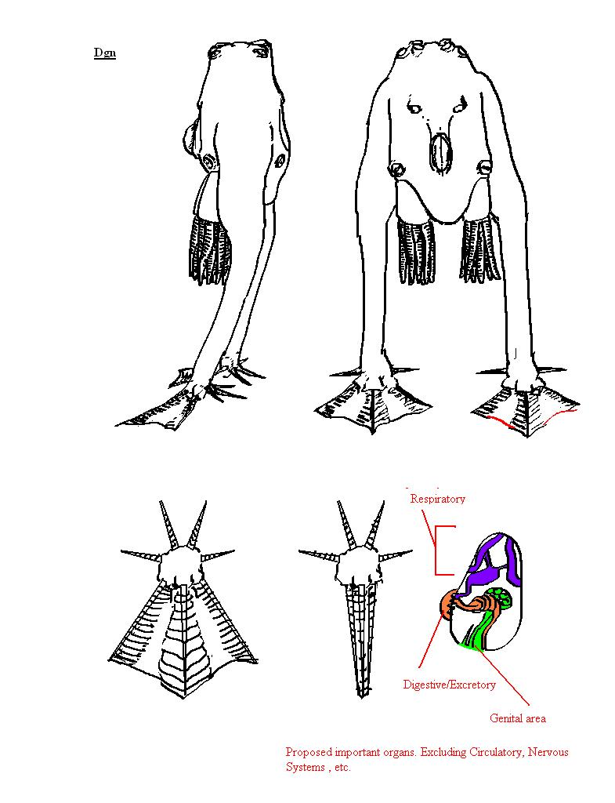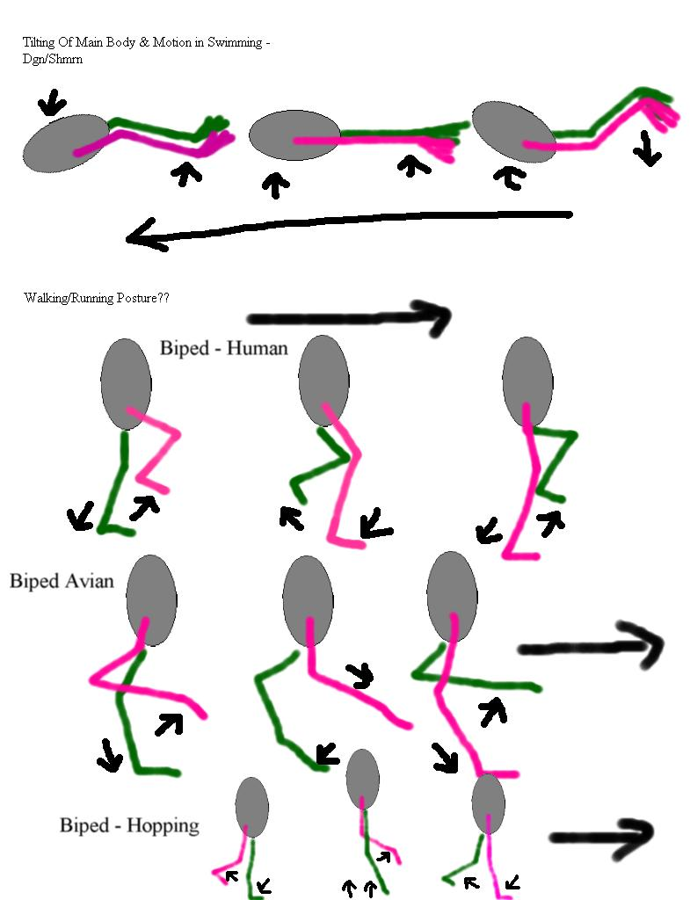

Through genetic engineering their life expectancy has been extended to over 50 years.

Habitat
The Dgn can breathe in both atmospheric and aquatic conditions, provided that there is sufficient oxygen dissolved in the water. They do, however, require either a humid land environment, or frequent re-wetting to keep both their skin and breathing orifices from drying out. The native Dgn habitat ranged from coastal saltwater marsh-land to tidal flats and into the coastal shallows themselves.

Culture
What native culture existed among the pre-modified Dgn has been greatly altered. Bred for servitude, the Dgn are not greatly renowned for intellectual achievements. The Dgn exist as a servant race for the Shapers, working on nearly all Shaper aquatic projects, and filling other unwanted roles in society. The one noted exception to this rule is the use of Dgn as medical assistants in Shaper hospitals, where their dexterity has proved them faster than humans at prepping the injured for surgery. While the rights of the Dgn are well defined by the Shapers, and abuse is not at all tolerated, their rights are not the same as those of the Shapers, and if the Dgn are to be considered citizens of the Shaper political body, then they are, at best, second class citizens. The Shapers have built them to not be overly concerned about this (the Shapers having had a different vision of what they desired from their uplift than the Lightbearers, who were more concerned with continued evidencing of their believed and beloved superiority over lesser species). One cannot say that the Dgn are entirely pleased with their position, but neither can one say that there is fertile ground for revolt, as the Dgn do not seem to possess within them a particular desire to be forced to decide their own destinies. As the Dgn do not complain and the Shapers do not overtly or actively seek to mistreat the Dgn, their freedom is something sought after by activist groups rather than brought about by an armed foreign entity.

Religion
Whatever glimmerings of disorganized religous beliefs they may have had as more simple creatures have been lost. Currently prohibited from engaging in organized religious activities due to historic fostering of undesired solidarity.

Number scheme
Dgn use Human numbers.

Mishtali

The Mishtali were the first intelligent life forms Humanity came in contact with, and at the time were enjoying a prolonged and happy bronze age. Perhaps fortunately for them, the Unadorned were the discovering faction, governing the Mishtali with a benign neglect. The Mishtali managed the jump from a nomadic existence to being spaceport baggage handlers quite well, all things considered, only eating a fairly small number of colonists and tourists in the process.

Physical characteristics
FIXME
See below pictures:

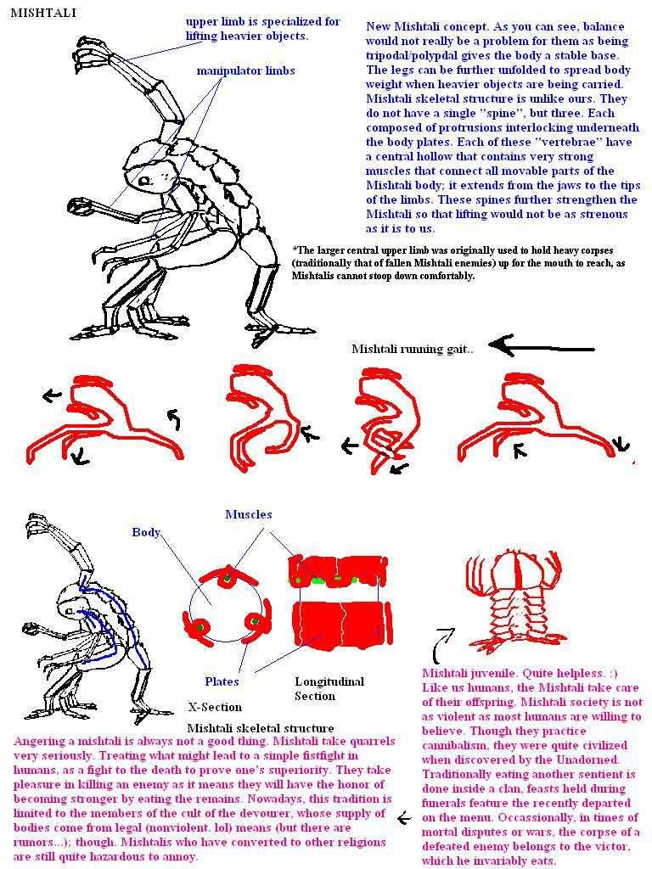

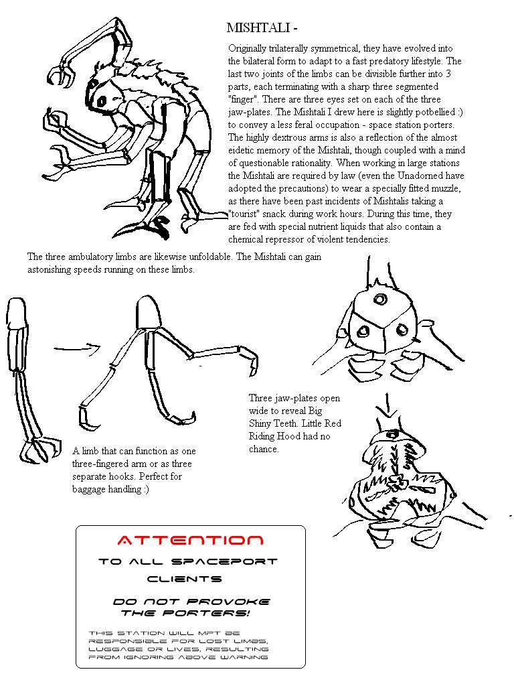

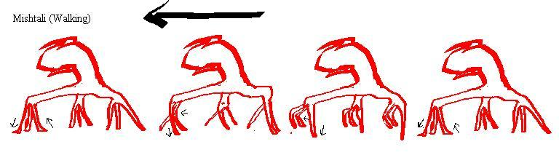

Habitat
Oxygen-Nitrogen FIXME

Culture
Given the cultural oddities of both the Unadorned, who come close to religious reverence in their views on computers, and the Mishtali, known for being the source of the Cult of the Devourer wherein the religious rituals are accompanied by the consumption of the remains of both Mishtali and alien sentients, it is believed by many to be just as well that the Unadorned, as their discoverers, are responsible for shepherding them.

Religion
The Mishtali practice a number of religions, both native and foreign. Chief among the native religions in, albeit infamous, notariety, is the Cult of the devourer. The Cult of the Devourer centers on the belief that success in life is directly tied with what one eats, and that the more powerful the being that was eaten, the better one's life can be. Thus, eating the remains of sentient beings is as good as it gets. This, obviously, raises a few issues among many groups, but there are enough humans and Dgn willing to be paid for the eventual consumption of their corpse that the churches of the Cult of the Devourer tend not to lack for sustenance. These churches are, as a rule, very festive and pleasant places to visit, provided one is not turned off by the cuisine. The Mishtali have been very willing to convert to just about anything, so the Mishtali also tend to have the largest alien populations of most obscure human religions.

Number scheme
Base e.
This is what happens when math types (of admitedly questionable initial sanity) decide to bring civilization to an undeveloped species that doesn't understand exactly what is meant by "optimal".

Purth

The Purth are an uplifted client species of the Andolians. In large part an experiment in synthesis of work done by the Unadorned and the Mechanists, the Purth are cybernetic beings, with assistive AI and built in networking capacity. It is only through these upgrades that a Purth achieves something much like sentience.
Although they sometimes operate autonomously from their Andolian patrons, Purth never do so alone. Only by networking their minds together will a group of Purth be confident enough to venture off without guidance.FIXME

Physical characteristics
The Purth were chosen primarily because of their very hardy constitution, and have proved themselves invaluable in high gravity applications. Each individual Purth is quite large, comparable to a small motor vehicles, and covered in a skin heavily composed of silicones. The silicones are at their most present on the footpads, which allow the Purth to walk across still-cooling lava flows and traverse boiling mineral springs.FIXME

Habitat
FIXME

Culture
FIXME

Religion
The Purth were pre-sentient before the Andolians altered them, and are universally predisposed to ignore religious issues entirely.

Number scheme
Purth use binary, due to their number processing being heavily computer assisted.

Super Cetaceans (SuCets)

Super Cetaceans (SuCets) are the result of what some consider the first truly profound endeavours of Humanity in combining the fields of genetics and cybernetics. While there are still SuCets around, they are generally considered a "failed" experiment, never thinking in a sufficiently compatible manner to become either useful tools or partners, and requiring cybernetic additions that were too costly, post nano-plague, for novelty value. Small communities of SuCets exist on some of the more affluent and metropolitan oceanic worlds, and their largest community, though quite small, remains on Earth.

Physical characteristics
The bulk of their genetic code derived from a potpourri of whales and porpoises, they are oxygen breathing swimmers of immediately recognizeable cetacean form, overcoming their lack of manipulator limbs via integrated mechanical prosthesis.

Habitat
The shallower seas of the continental shelves and the vast waters of oceans and oceanic worlds with oxygen-nitrogen atmospheres.

Super Simians (SuSims)

Super Simians (SuSims) and SuSim Cyborgs have been one of the more stunting trends for "true" AIs, arising from the advances in the fields of genetics and integrated cybernetics. For physically manifested tasks considered too menial, too dangerous, or too monotonous for Humans, the SuSims and SuSimCys proved cheaper, more reliable, and, through advancements in genetics, easier to dominate than AI alternatives.
As a client race they are quite prevalent in High-Born space as servants. In other societies, however, the use of SuSims is seen as inhumane or otherwise frowned upon.

Physical characteristics
The SuSims were constructed from augmented blends of Terran primates, and many discernable features of their Chimpanzee and Bonobo ancestors are immediately recognizeable. They remain hairy, not for practical purposes, as much as to help convince their masters that the lines between pet, tool, and slave have not been crossed in an era when some "Humans" may be further distant genetically than the SuSims are from Homo Sapiens Sapiens.

Habitat
They are capable of breathing an oxygen-nitrogen atmosphere.

Rlaan

Ammonia-blooded, methane breathers from a cool world distantly orbiting a hot star, the Rlaan are a collection of oddities. Unique among the known space-faring groups, the Rlaan are actually two separate species, the defenders and workers speciating some hundred thousand or so years ago.

Physical characteristics (Defender, Workers & Hybrids)
Rlaan are radialy symmetric beings with a base four split. Their workers stand about one meter high at the prime knee, and are nearly one meter in diameter. Members of their warrior caste tend towards being 50% larger in both dimensions. Rlaan natively breathe a methane-based atmosphere, and must wear special breathing apparatus to negotiate oxygen-nitrogen environments. Their skeletal structure, being an exoskeletal carapace supported internally by millions of reinforcing struts, is best suited to lower gravity worlds, and leads to the use of mechanical assistance on larger or denser rocky bodies.
Both species are similar in appearance, with the primary differences being size, the degree of fine control in the manipulator appendages (workers have better fine control), and the structural integrity of the skeleton (defenders are less fragile than workers).
The defenders tend towards darker shades of red and purple, whereas the workers are somewhat pale. Though the offspring of worker-defender matings are sterile, these hybrids exist as nearly 4% of the population, and have come to play important social roles, especially in the realm of politics.
Rlaan are radially symmetric with four equivalent segments. Each of these segments contains one compound eye composed of four segments, one ambulatory appendage, one mouth with four mandibles, one manipulator appendage, various local organs, and portions of the central organs. The Rlaan skeleton is a supported exoskeleton, that is to say, the exoskeleton is supported internally by a network of millions of small extensions of the skeleton, which together form a sort of highly porous lattice that the soft internals reside in. A defender stands about 1.5 meters high at the top of its carapace, and 2 meters high at its knee joint. The central body is around one meter in diameter, and a third of a meter in thickness. Out of this central body come the four abulatory limbs, going up and out from the body to the knee joint, and then proceeding down where they terminate in a four-splayed gripping foot. Suspended below the central body is the "head" portion of the Rlaan, about half a meter in diameter and also about a third of a meter in thickness, with its bottom covered in a particularly thick extrusion of the exoskeleton. The manipulator appendages sprout from the region connecting the head with the main body, and end in four radially arranged fingerlike structures. A worker’s dimensions are about 70% that of a defender.
Concept art for a Rlaan Worker and Rlaan Defender (Defender not to scale)
(the front and the back legs are cut away for better visibility)
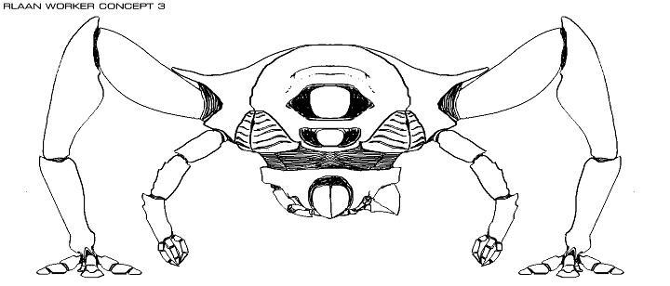

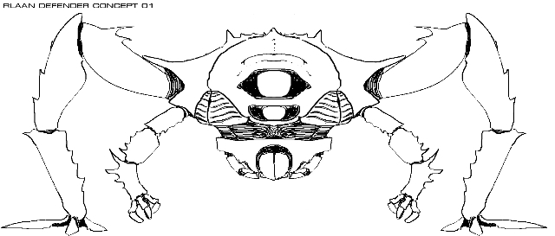

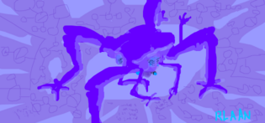

Habitat
With equatorial temperatures peaking near 230 K, seas of ammonia, and a methane atmosphere, the Rlaan homeworld is not what most species would consider a prime vacation spot. Life on this planet progresses at a rather slower pace than that on water worlds, but proceeds nonetheless. From the point of view of ammonia-methane life, the Rlaan planet is actually quite toasty.

Culture
Rlaan lifespans tend to be between 250-350 years. This is believed to be a large factor in their cultural homogeneity and the methodical nature of their advances, both through space and as a culture. Rlaan culture itself is a very dry affair, with social dynamics primarily involved around expository investigations of philosophical debates that have yet to be satisfactorily translated into the language of any other species.

Music
Their music, if it can be called such, has been compared to "the set of frequencies one would expect to register if a Myztherian Octpanther were let loose in a campanile". On a more disturbing note, the Rlaan central archives possess the largest collection of data concerning Jerry Lewis and Yoko Ono outside of Human space. The Rlaan are, however, regarded by many of the other space faring races as much more intelligent than their culture’s taste in art would suggest.

Writing
Rlaan written language appears as a sequence of characters consisting of one to four radial slashes in each of four quadrants formed by a pair of crossed lines. It is read in a counterclockwise spiral out from a blank central region that is reserved for the signature glyphs of the author. The Rlaan have vast stores of written documents going back thousands of years, but attempts to decipher most of them have met with limited success, as the concepts often being discussed seem to have no corollaries in the languages of any other species.

Science
Rlaan science is more advanced in the fields of chemistry and genetic manipulation than any of the other space-faring races. The Rlaan are also quite knowledgeable about materials science and the advances in the latter are often related to the former. Aside from these noted cases though, Rlaan science has advanced more slowly than that of the Humans or the Aera, and the extent of its advances is more a measure of the age of Rlaan investigations into science than any particular brilliance on the part of the Rlaan. Though not truly uncreative, the Rlaan seem hard pressed in the department of inventive spontaneity. In particular, the Rlaan are rather behind humanity in their exploration of both artificial intelligence and tightly integrated biomechanical systems, having sufficed with loosely coupled designer organisms.

Politics
The Rlaan are governed by a body whose name translates to The Rlaan Assembly it appears to be some form of representative democracy, but the exact methods of choosing one’s representative seem complex and arcane beyond the tolerance of most observers to bother attempting to figure out. This body then churns out laws and regulations at a breakneck pace, the enforcement of which is then delegated to the complex Rlaan Bureaucracy. Attempts to understand the inner workings of the Rlaan Bureaucracy have met only with confusion for all parties involved. Strangely, the members of the Assembly are disproportionately sterile hybrids, believed by the Rlaan to be more levelheaded than either the aggressive defenders or the timid workers. One thing that did translate clearly, however, was the Rlaan differentiation between civilian and non-civilian. Given their biological distinction between these two, it is easy to see why the Rlaan have such firm views upon how civilians should be treated.

Notable Rlaan Factions and Organizational Entities
- The Rlaan Assembly
- Rlaan Briin
- Rlaan Merchants
- Rlaan Hunters
- Rlaan Enforcers

Religion
Most Rlaan are adherents of Rlaanbzztkrlbzeentkaan. What this means is very difficult to say, as, though it is a text based religion, the text is under constant revision. Indeed, the Rlaan Assembly regularly submits changes and additions to the holy text. Contradictory edicts abound, and scores of companion volumes are included with every copy that debate the relative merits of breaking one set of edicts over another. Edicts contradicting each other,however, are the least of a reader's worries, as the universe is created 37 times in 17 entirely distinct fashions, by a grand total of 4301 entities, albeit 4210 of these were all in one creation story. History, morality, ethics, and the fundamental nature of reality itself are all presented in so many different forms in the text, that it defies rational understanding as to how the Rlaan consider the book canonical and relevant. However, they do. And they gather together at one of the 73 specified intervals of worship, for those that interpret worship as being allowed, to engage in whatever activity is currently believed to be both correct and legal by the group that has thus met. Rlaan places of worship are thus remarkably like most Rlaan art: constantly changing in nature but composed of themes that are themselves mind-numbingly repetitive, and constantly possessed of an aesthetic that runs counter to common human tastes.

Number scheme
Depending on your viewpoint, either base 4 or base 256. Namely, every Rlaan character is composed of 4 subcharacters, so, going by the subcharacters, it's base 4, but there are 256 distinct numerals per character read. Rlaan numbers are distinguishable from the characters in the rest of the Rlaan script in that the center of each subcharacter is marked with a dot. As far as the Rlaan are concerned, it's base 256.

Lmpl

Physical characteristics
See pictures below:
FIXME

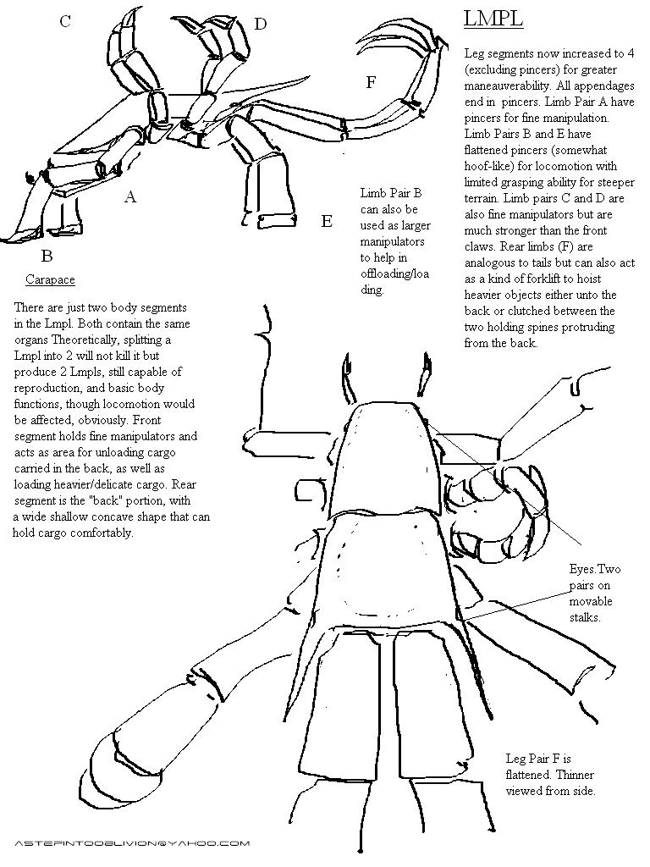
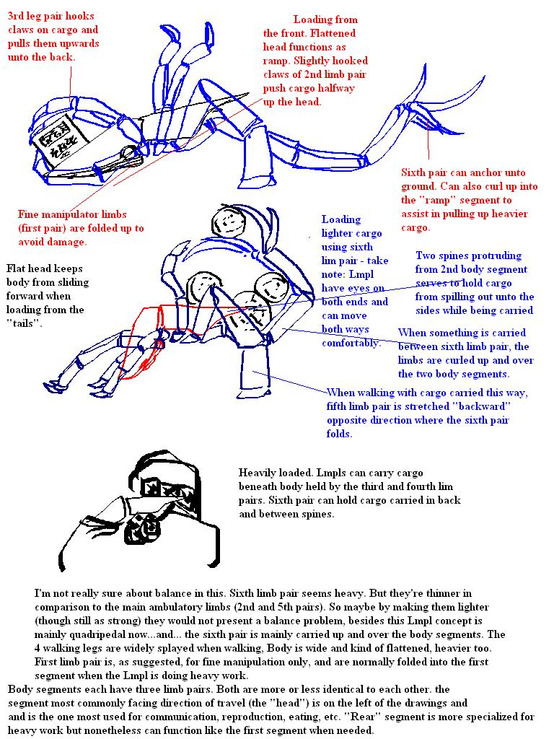

Habitat
Oxygen-Nitrogen

Culture
Like the Nuhln, the Lmpl were a sub-sentient species that the Rlaan selected for uplifting. The Lmpl were a project in adapting a lifeform to an envioronment inhospitable to Rlaan workers. The Lmpl are intelligent, but remarkably, and sometimes to a fault, single-minded, though such is in keeping with their technical workforce mission. The second of the two major uplift projects, the Lmpl are considered a solid success, and enjoy their own niche role in Rlaan society. Admittedly, as they are Oxygen-Nitrogen breathers, they spend very little time actually in Rlaan society proper.

Religion
All Lmpl are adherents of Rlaanbzztkrlbzeentkaan (see Rlaan->Religion).

Number scheme
The Lmpl use Rlaan numbers.

Nuhln

Physical characteristics
See below pictures:

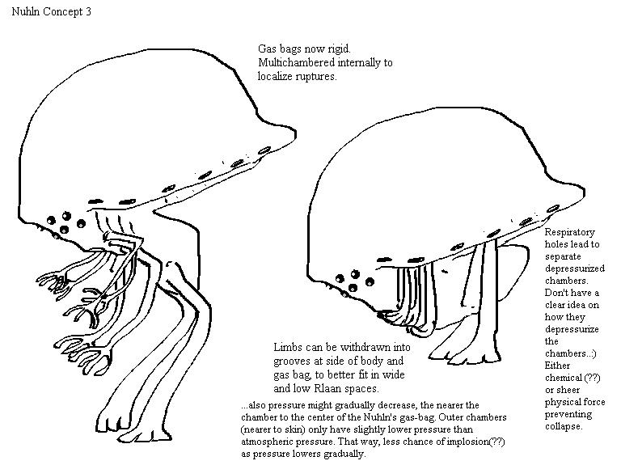

Habitat
Methane-Nitrogen

Culture
Like the Lmpl, the Nuhln were a sub-sentient species selected by the Rlaan for an uplift project. The first of the two major uplift projects, the Nuhln are generally considered far less successful than the Lmpl, being somewhat intellectually slow. They are almost exclusively found performing jobs where the ability to repeatedly perform seemingly mindless tasks without complaint is a distinct positive attribute. Though present throughout Rlaan inhabited space, they are a culturally subsumed group, possessing no internal culture to speak of.

Religion
All Nuhln are adherents of Rlaanbzztkrlbzeentkaan (see Rlaan->Religion).

Number scheme
The Nuhln use Rlaan numbers.

Saahasayaay

Fast, beautiful and deadly, while they serve the Rlaan, they do so because of the technological and economic benefits gained from the association rather than out of gratitude. Whereas the Rlaan succeeded in making both the Lmpl and Nuhln useful and docile, the Saahasayaay are indeed useful, but far from docile.
While the Saahasayaay are a single species in the technical sense, their array of different metamorphic forms, each clearly of distinct origins, is somewhat unique, and, as only certain of the forms are possessed of any particular intelligence, and only one of accepted sapience, in common reference "Saahasayaay" may often refer only to the portion of the population in dominant sentient morphology.
The Saahasayaay have the strangest, and, on several levels, most disturbing life cycle of any of the known extant sentients. Foremost among its disturbing points is that the life cycle is clearly of artificial origin external to the Saahasayaay homeworld. The non-squeamish often find this more disturbing than the fact that metamorphosis usually begins with the death of much of the body, and proceeds via the semi-autonomous archival organ consuming what would otherwise be the uneaten remnants of its own corpse to fuel its generation of a new body. The archival organ, itself effectively inedible, and encased in a protective shell, is not a native feature. The organ features an absurd amount of unexpressed genetic code - indeed, it contains genes describing thousands of species, almost none of which are actually present on the Saahasayaay homeworld. Indeed, the Saahasayaay appear to be the result of some ancient (although not believed Ancient) xenoforming gone awry. Many of the gene sequences present in the archival organ appear to be irrevocably damaged or woefully incomplete, despite the presence of significant error correcting facilities.
Only the lowest level of the metamorphic chain for the Saahasayaay can actually breed. All other forms have been rendered sterile. This lowest level is a fast growing photosynthetic invader species that has infiltrated or replaced competitors in most of the native ecosystems of the Saahasayaay planet. It cannot be correctly termed a plant, animal, or fungus, although it shares some features with all of these more familiar categories. While likely originally designed to be the prime xenoforming agent for the planet, destroying native ecosystems and replacing them with those of its creators, the archive creeper has wandered from its original mission, producing a warped hybrid ecosystem that almost certainly bears little resemblance to either the original or intended replacement. The origins of the Saahasayaay are clear in both their metamorphic paths, their traditional food chains, and the sterility and monosexual nature of all of the extant forms save for the archival creeper. Local "herbivores", for lack of a better word, came to eat the creepers, but were in turn recorded and replaced, themselves devoured and recreated by the archival organs they attempted to consume. This effect then proceeded to trickle up the food-chains of all of the ecosystems invaded by the creepers. A limitation of this process, was, of course, that organisms smaller than the archival organ were not readily assimilated. Thus, the detritus feeders competing for flesh on the fallen corpse of an assimilated species were more likely eaten by the archival organ than the other way around.
The archival organ is an incredibly complex, advanced, and subtly broken biological machine, but it is not itself remotely intelligent. Likewise, it is not quite sufficiently autonomous to generate widespread agreement as to it being referred to as a symbiotic organism, especially as the genetic definitions are skewed, given that it contains all of the genetic code for all of the "host" bodies. All tissues in the archival organ feature cellular immortality, and the archival organ is itself amortal (not aging, nor dying from old age) although the bodies it produces do not share these properties. The organ is well protected and possesses some independent subsystems, so surviving the death of the rest of the body is common (depending on the manner of host-death) - which is necessary, given that such is the only means for morphological change and the preservation of more interesting forms of species. The archival organ plays key hormonal regulatory roles in all of the assimilated forms.

Physical characteristics
Terminal form Saahasayaay are physically impressive beings, if not, because of mode of movement, as bulky as some of the other sapients, and fossil records indicate this to be a quality preserved from pre-assimilation times. They are beautiful, if possessed of features that, if designed, would speak of a certain viciousness to the crafting hand. The terminal Saahasayaay are the only extant sophonts known to be able to fly, albeit they are, in practice, more often gliders than active flyers through their thick and caustic chlorine-nitrogen atmosphere. Their bodies are long, almost serpentine, though the strong muscular development for the wings and arms belies that image. They are bilaterally symmetric, with 4 wings rising above, and 8 arms hanging below the largest and middlemost segment of the body, set between a long tail at rear and longish neck and fierce head at front. The front and rear sets of arms have hand-like endings, gripping appendages of a gaunt leather-and-bone appearance, that are dexterous, if clearly meant to hold fast to live and struggling prey while the curved blade-like endings of the middle four arms carved and scooped the meal into edible submission. Skin on the middle-body is mostly hidden behind large, thin, overlapping scale-like protrusions of smooth, hardened flesh, iridescent, ranging through colors from green to red to gold. The tail, in cross section, could be thought of as a square whose sides have been bent in, or whose corners were pulled out, to produce a four-sided concave shape. The tail is heavily segmented, as is the neck, which has a similar shape, although much larger, and it lacks the short spines protruding from the corners of each tail segment that serve to let the tail be used to grip surfaces or objects it has been wrapped around. The tail narrows somewhat as it progresses rearwards, but was always fairly thin in comparison with the body. Towards the rear of the tail, the spines end, and four specialized spines are present that act as fins that can be raised or lowered to act as flight control surfaces. The scale-like protrusions are much larger on the tail and neck than on the body, corresponding heavily to the structure of the segments themselves leaning somewhat towards a more chitinous-plates appearance than scale-like appearance, for those portions, although in truth it is only a matter of size and flexibility required for each segment that has lead to the differing appearance, and not a fundamental change in material. The head is slightly larger in girth than the neck, excepting the mouth itself which is forward of the rest of the head. The terminal form Saahasayaay have no teeth in their mouth. Grinding, separating and pulverizing are instead done by stone-hard protrusions that line their equivalent of the esophagus. The mouth instead consists of a set of flexible, segmented spines, connected to each other by membranes, that can be focused to a point, as when sucking in fluids or flying, or opened to engulf a portion of a prey animal. This semi-engulfing is necessary, as the chunks of flesh freed from the target by the multiple bone-bladed tongues that slash out violently from within the mouth might otherwise fall out. There are four eyes, two at the corners of the top of the head and two, more centered, below. There are ears and nasal openings that lie on the side of the head. The brain itself is primarily on the top of the head, although there is significant neural matter at the bottom of the head that does optical processing for the lower eyes.

Habitat
All of the native species integrated by the archival organ are now extinct. Thus, entire food-chains now consist of nominally Saahasayaay organisms. It is presumed, given that all of the non-creeper morphologies are sterile, that the intended process involved a kill-off of all of the food-chains via a wave of progressive morphology changes up the food-chain, thereby progressively starving each link in the chain. Alternate theories presume an external agent being introduced that would kill off all of the hybridized life forms, while leaving the invaders intact, but the non-native codes are sufficiently mangled that it has been difficult to test if such differentiation would have been readily achievable. Given the large number of codes stored, it is presumed that total kill-off was not an intended goal. Clearly, however, none of these have happened, especially those models requiring external intervention. Instead, the regulatory mechanisms presumably in place to delay any native depopulation until there has been sufficient infiltration of the native populations have instead functioned merely to regulate the frequency with which the next body of a dead Saahasayaay differs from the previous. Also noteworthy is the terminal nature of the Saahasayaay metamorphic process. Fossil records point to the ancestor of whatever native species preceded the sapient Saahasayaay population as having been wide-ranging, and wherever present, atop the food chain. Thus, the Saahasayaay sophonts are currently the "terminal" metamorphic form - an archival organ that survives a Saahasayaay sapient's death will normally build another Saahasayaay sapient. Note that none of the previous individual's memory or mentality is preserved, and inefficiencies in conversion and the genetic imperatives of brain development in the original source species, even in the presence of a nearly full corpse, result in the production of a juvenile individual.

Culture
The most successful of the Rlaan client species, the Saahasayaay are not, unlike the Nuhln and Lmpl, true uplifts, having already achieved some minimal level of societal advancement at the point of discovery.
The Rlaan have taken to using Saahasayaay troops to reinforce their border with the Aera, are, however, somewhat hesitant to let this concentration of troops return home.
As most of the Saahasayaay forms are not capable of complex thought, they don't much consider either the nature of their life cycle, nor that they often are eating what is technically a member of their own species. This is not the case for terminal form, whose culture has been deeply shaped by the role that death plays in the Saahasayaay life-cycle, and the semi-reincarnations that are the daily occurrences of Saahasayaay life. The terminal form Saahasayaay are, in fact, quite bright, and learn voraciously, but a cultural disinterest in knowledge unrelated to superior killing ability and an exceptionally low life-expectancy rate due to unending war, murder, and ritual killings has historically hampered internal sources of advancement. It is not too difficult to see where their obsession with death has come from, albeit only they, perhaps, can truly comprehend the directions it has taken them in. It is fortunate for all other sapient species in the region that the Saahasayaay were found in the stone-age by space-faring sapients, and not the other way around, as the Saahasayaay have no compunction when it comes to killing, whether it be other sentients, each other, or lower Saahasayaay forms. Death is the natural order for them, it is the source of progress, and their right and duty to disperse. Their obedience to the Rlaan and restraint in aggression against both the Rlaan and other species is predicated on the Rlaan's greater ability to bring death upon them than they upon the Rlaan, as well as the opportunity for greater empowerment that the Rlaan bring to the Saahasayaay. Death is the ultimate blessing the Saahasayaay believe they can bestow, and the frequent regeneration of their fallen into newborns has utterly deprived them of the fear of their own demise present in all other known organized species of measurable intelligence.
Some of the other Saahasayaay forms possess some level of intelligence, though none as pronounced as the terminal form Saahasayaay. Some of these forms have been "domesticated" and the most intelligent of these, generally considered comparable to some of the Terran primates, are sometimes used in a servitor role. The most valued of the servitors are granted a chance at "ascension" by being taken to an isolated area, free of terminal Saahasayaay, and killed swiftly, leaving the entire corpse intact. The lack of terminal Saahasayaay in the area improves the likelihood that the next metamorphic form will be a terminal Saahasayaay, rather than another servitor, as the choice of next form is heavily influenced by the presence of other forms detected by the archival organ, a manifestation of its original, more overarching regulatory role. Punishment in terminal Saahasayaay society rarely involves killing of the archival organ, an act considered disgraceful unless the individual in question has been deemed to be heretical to the advancement of the Death God's agenda, but it almost universally involves killing. Punishments range from the minor, a swift and clean death followed by adoption for what most other species would consider misdemeanors, to use as hunt bait and eventual consumption by lower forms, to the most serious crimes being punished by the removal of the archival organ, the starvation thereof for a period of time, to increase the chance of form reversion, smearing the archival organ in the mixed remains of lower forms to further increase the odds that the next form will not be a terminal Saahasayaay, and then letting the starving archival organ eat the victim (still conscious, but wracked with crippling chemical imbalances) alive.
It is generally considered fortunate that only a small percentage of the world known to be reachable via the jump network feature a chlorine based ecology. The Saahasayaay, from the creeper on up, feature a profoundly rapid metabolism, and they have quickly overrun and populated other chlorine-worlds that they have been introduced to. Indeed, it has long perplexed researchers as to why exactly the concentration of chlorine-life friendly worlds is significantly higher in the region of space containing the Saahasayaay homeworld, and then marginal elsewhere. What many believe to be the likely originating planet of the archive creeper is in very nearby space, just one jump link removed from the Saahasayaay system, but it is difficult to ascertain this connection with any certainty. The system shows signs of previous habitation by a technological entity, but, outside of semi-preserved ruins on various moons and other uninhabitable locations, there is precious little left of the inhabitants. In particular, what is believed to have been their homeworld would seem to have fallen victim to both some sort of limited grey-goo event and a widespread use of fusion, antimatter, and kinetic weapons that, combined with the already reactive nature of the atmosphere, served to make it exceptionally difficult to discern much about the previous inhabitants. Levels of nano-plague are also exceptionally high in the system, leading several researchers to advance theories that the inhabitants made what proved to be a fatal mistake of attempting to counter the nano-plague in an aggressively military fashion.
The Saahasayaay navigate 3D space with great agility, and, despite the distinctly different dynamics of planetary and vacuum flight, make excellent pilots in either medium. The Saahasayaay have not significantly industrialized on their own, although their technological usage has greatly advanced since absorption into the Rlaan Assembly. All Saahasayaay ships are specially manufactured for them by the Rlaan out-system, and Saahasayaay pilots shipped out to military bases from one of the Saahasayaay worlds. The Rlaan are somewhat reticent when it comes to providing the Saahasayaay with a means to make their own starships. They are, however, more than willing to freely give them technologies which increase their sustainable populations so that they can draw upon more Saahasayaay troops. The Saahasayaay, for their part, hunger for more control over their own destiny, but are currently kept sated with the opportunity to bestow much bigger deaths with the starships the Rlaan build for them (the Saahasayaay consulting on certain aspects of the design). Saahasayaay operating in Rlaan space must wear atmosphere/temperature suits at all times, precluding flight abilities. Their suits are therefore augmented with thrusters so as to make them more comfortable - an uncomfortable Saahasayaay is not a safe Saahasayaay, though there is of course, no such thing to begin with. Saahasayaay work only with defenders and hybrids in Rlaan society. They have no respect for the Rlaan workers, who cannot be killers in any meaningful way, and the Saahasayaay are considered an unnecessary threat in interacting with Rlaan workers.

Religion
The dominant belief structure of the Saahasayaay revolves around each of them being an intruments of the great death god who sits in judgment over the universe. The Saahasayaay belive themselves to be the chosen people who alone are privy to the sentences being passed down upon the mortals of this realm. Saahasayaay prophet halls are built to express the joy of the hunt, the glory of the kill, and subserviance to the great death god. The prophet halls are built in keeping with the 3-dimensional nature of Saahasayaay travel, with perches on many levels, and rank denoted by attainment of a higher perch.

Number scheme
The Saahasayaay used to use a unary system with groupings done in sets of 8 (flat, without a notion of base), but have been converted to use of the Rlaan base 256 system.

Aera

An intelligent centauroid species which developed on a misbegotten hell of a jungle world, the Aera are oxygen-nitrogen breathers, with a strong internal skeleton, smooth ashen-gray leathery skin, a decided lack of psychiatric assistance for their obviously repressed dissatisfaction with natural ecology and, at least according to the Cult of the Devourer on Mishtal Seven, a flavor remarkably similar to that of a human with a high protein diet, but only if both have been served with a nice Chianti.
Unfortunately for the Aera, their region of the jump network offers no known paths towards significant further expansion. To expand they must go coreward, passing through Human or Rlaan controlled systems. Requests to do so have been denied by both the relevant parties of both species. Opting for another method, the Aera tried to sneak a colony convoy through Rlaan space, but a lack of comprehension of the Rlaan mentality regarding civilian casualties caused this ploy to be not only a failure but a disaster, provoking the Rlaan into a military response.

Physical characteristics
The Aera are a centauroid species measuring 2-3 meters in length from the head to the end of the balancing tail, and 1 - 1.25 meters high at the four leg- shoulders. The four stocky, sturdy running/gripping limbs provide support, and the front two limbs end in three-digit hands, with two fingers and an opposable thumb. When active, the upper body bends up from the rest of the body just past the middle limbs at about a sixty-degree angle, with the forelimbs sprouting from about two thirds of the way up the upper body, and with the head bending back down so as to be parallel with the main trunk and the ground. Aera tend towards slim, muscular builds, and are usually both quick and agile. They have two genders, each of which is similar in appearance. Among the spacefaring races, the Aera have one of the shorter natural lifespans. Prior to the advent of advanced life extension technologies, it was as rare for an Aera to reach 60 years of age as it was for a twentieth century human to reach 100.
The physical appearance of the Aera reflects upon their origins. The Aera have a smooth, leathery skin not dissimilar in appearance to the bark of a birch tree, with occasional yellowish patches reminiscent of lichens. The hinged portion of the mouth is, in contrast to that of terran species, the upper portion. The mobile portion of the mouth is also notable in that it does not consist of a bony arch, and is actually a solid bony plate. Inside this mouth are two rows of teeth, the second moving forward to replace the first as they naturally fall out, and a new second row is grown. The front teeth are razor sharp and are obviously for tearing flesh, and the next sets of teeth are likewise designed for the chewing of meat, but the rearmost few teeth have grinding surfaces, allowing the consumption of nuts, seeds, and other such vegetable matter. The corners of the mouth are usually open, and provide the normal breathing route. When exerting itself, an Aera will pull back its lips, increasing the size of the airway. The wide, narrow eyes are almost universally a milky green, with wide, narrow pupils, and are largish in size relative to the head. The eyes are above the terminating point of the downward slant of the lipline, but below the bony jaw plate. Just below the mouth, on each side of the head, is a row of small pits that are used for chemoreception. Beneath each eye is a kidney-shaped patch of lighter skin that marks the location of a tympanum. On the underside of the Aera head is a pair of organs, each capable of producing variable amplitude, low frequency vibrations, which the Aera use to communicate.

NOTE: depiction of head in below picture is non-canonical, picture otherwise highly informative: 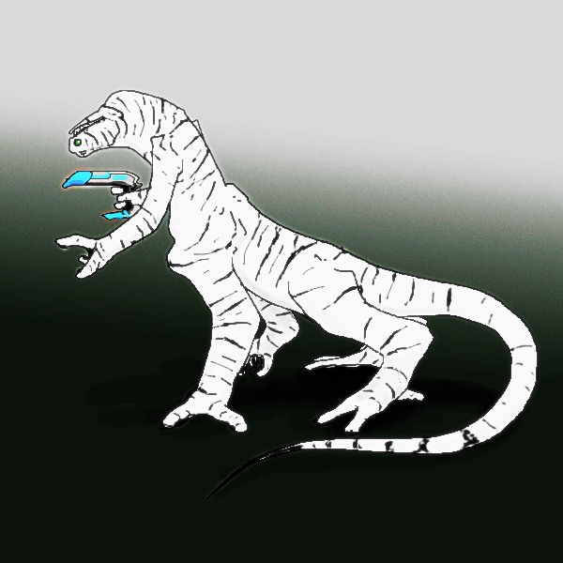

Habitat
The Aera homeworld was, prior to changes imposed by the technological advancement of the Aera, a nearly seasonless planet with an oxygen-nitrogen-neon atmosphere, on whose surface were a single large landmass and many large and small islands. The mainland was nearly entirely covered with jungles and marshgroves, with only small belts of more sparsely overgrown land on the northern and southern reaches of the continent. The rich jungle land was home to all sort and manner of parasites, predators, diseases, and competitors for food. It was in this vast, dark jungle that the Aera arose into sentience, tool use, and civilization.

Culture
Aera culture is highly organized and decidedly hierarchical, but in the form of a meritocracy rather than an aristocracy. While what has constituted merit has morphed over the millennia since the first Aera tribes selected work crews to cut back the encroachments of the jungle upon their early settlements, given the relative position of the pre-technological Aera in their local food chain, there has long been a favoring of cleverness and determination over raw strength. The current social and vocational position of any Aera is immediately indicated by the color and pattern of an individual's coverall. The Aera are ruled by a subset of the highest caste, with membership in the oligarchy changing whenever either an individual steps down, or a third of the other members call for a member's replacement. New members must be confirmed by two thirds of the current oligarchy. It is much more common for members to voluntarily remove themselves from power, believing themselves more useful elsewhere in society, than to be cast out. An average stay in the oligarchy lasts a few Aera years.
The long struggle of the Aera against the erosion of their society at the hands of the natural world has instilled in them a deep respect for that which has enabled them to conquer their environment: technology. Not only is the advancement of technology greeted without fear, the social position of the artificer and the engineer is one more greatly elevated than that seen in any pre-Diaspora human society. What is feared is the unmastered and uncontrolled. Even after the last war between Aera and Aera was fought, bringing the last of the major islands under the control of the mainland, the Aera only slightly relaxed their military investment. Perhaps in large part due to their short lifespan, and the consequential rapid dying off of adherents to old theories, science advanced quickly, and with the understanding of their place in the universe came a belief that just as they had been forced to fight back against the jungle to keep themselves alive, so would they likely have to push back against all that waited for them beyond their world. Thus, eight centuries ago the Aera burst forth from their homeworld, not afraid, but determined that nothing would stand between them and their indefinite existence.

Factions and Organizational Groups
Listed below are noteworthy Aeran sub-factions and organizational groups:
- Aeran Merchant Marine.

Religion
The nature of the Aera homeworld never inspired much belief in any sort of loving deity. What began as a collection of local deities coalesced, through conquest by what was to be the dominant group on the entire planet, into a single pair of entites, one force of creation, and one of destruction, both abstract, and both uncaring. As time progressed, and the Aera advanced, these entities progressively lost entity status and drifted into the realm of spiritual concepts. Becoming more self-centered in their exploration of existence, destruction morphed into personal death, and creation into species survival. Organized religious activity among the Aera, such as it was, ceased centuries ago, but the impact on their culture of the concepts of death and survival is still quite strong. Indeed, Aeran mausoleums are said to be, quite possibly, the only pieces of Aeran art that might ever be considered beautiful. The Aera respect death, but value is placed on the accomplishments made in the face of one's imminent demise. All Aera are cremated, and the repositories for such remains are vast public works, filled with displays of the accomplishments of those entombed within, those who contributed greatly to the species being rewarded with physical space devoted to listing their deeds, and the rest consigned to a rotating schedule of intermittent holograms and access via terminal displays. It is in such places that an Aera would go to ponder, in silence and solitude, relenting briefly from the near tireless schedule of a short-lived species, the nature of its existence.

Number scheme
The Aera use a redundant numbering scheme:
Radix 3, digits drawn from the set of values {-2,-1,0,1,2}

Bzbr

The Bzbr are a psuedo-reptilian species found on a jungle planet by the Aera early in their expansion. The discovery of organized alien intelligent life, even if harmless in it's neolithic state, furthered Aera convictions about the dangers of the universe, even as they worked to co-opt the Bzbr.

Physical characteristics
A Bzbr most closely resembles a jungle-green, copper-highlighted 1.5-meter long, ten-legged, arboreal reptilian with a nearly meter long prehensile tail. Each limb has four segments, the fourth being the hand/foot equivalent. The rear six legs are built for jumping, and are used only for locomotion, the two underslung short arms primarily for food manipulation, and the two forward inline limbs primarily for gripping branches or other such objects, arching upwards and forward from the rest of the body, in contrast to the other inline limbs, which proceed upward and outward from the torso. Lacking vocal cords, the Bzbr communicate in a simple language consisting of varied buzzing tones produced by rubbing their feeder limbs together and motions of the gripping limbs.
The Bzbr have three genders, breeder, broodherd, and gatherer. Gatherers are the most common gender, and conduct all hunting activities. Breeders are smaller than the gatherers, and forage close to the nest area for roots and nest building material. In far smaller number than the breeders or gatherers are the broodherds, larger, stronger, sterile, and existing solely to protect the young and territory of their sisters. Normal Bzbr nest groupings number in the few dozens of adults. Bzbr are exceptionally short lived, living only 35 - 40 years, even with modern medical technologies, but, given their small size, this is not entirely unexpected.

Habitat
A world of jungle islands, spontaneous firestorms due to the high oxygen content of the atmosphere, and extreme seasonal weather shifts, the Bzbr homeworld can be safely considered unpleasant to all of the known spacefaring races.

Culture
Adopted by the Aera out of some combination of pity and sympathy for similar jungle origins, the Bzbr were pulled straight from the stone age to the FTL age. Adapting about as well as can be expected to this rapid change, many Bzbr simply went insane trying to adapt, but after a few generations, the Bzbr had come to accept the new reality, even if they were, due to rather much less than genius level average intelligence, ill equipped to fully understand the full complexity of it. Although not particularly bright or creative, the Bzbr are actually quite good at both remembering and following instructions, and have come to be used in various Aera space construction projects, where they are valued for their ability to deftly maneuver in small spaces and to leap from girder to girder. Bzbr, are, however, never seen far from their Aera Patrons, as they are quite lost without them. The Bzbr still, to some great degree, see the Aera as messengers of the gods, having delivered them from the horrors of their world, even if they know the Aera to be both mortal and fallible.

Religion
Though the Aera have attempted to convince them to do otherwise, the Bzbr engage in hero-worship of the Aera. A majority of the Bzbr are convinced that the actions taken in this universe play out in other planes where the great nest of all life is threatened by chaos. They believe that the Aera, by having brought greater order to their lives, make them all great warriors in the other planes.

Number scheme
Bzbr use Aera numbers.

Uln

FIXME

Physical characteristics
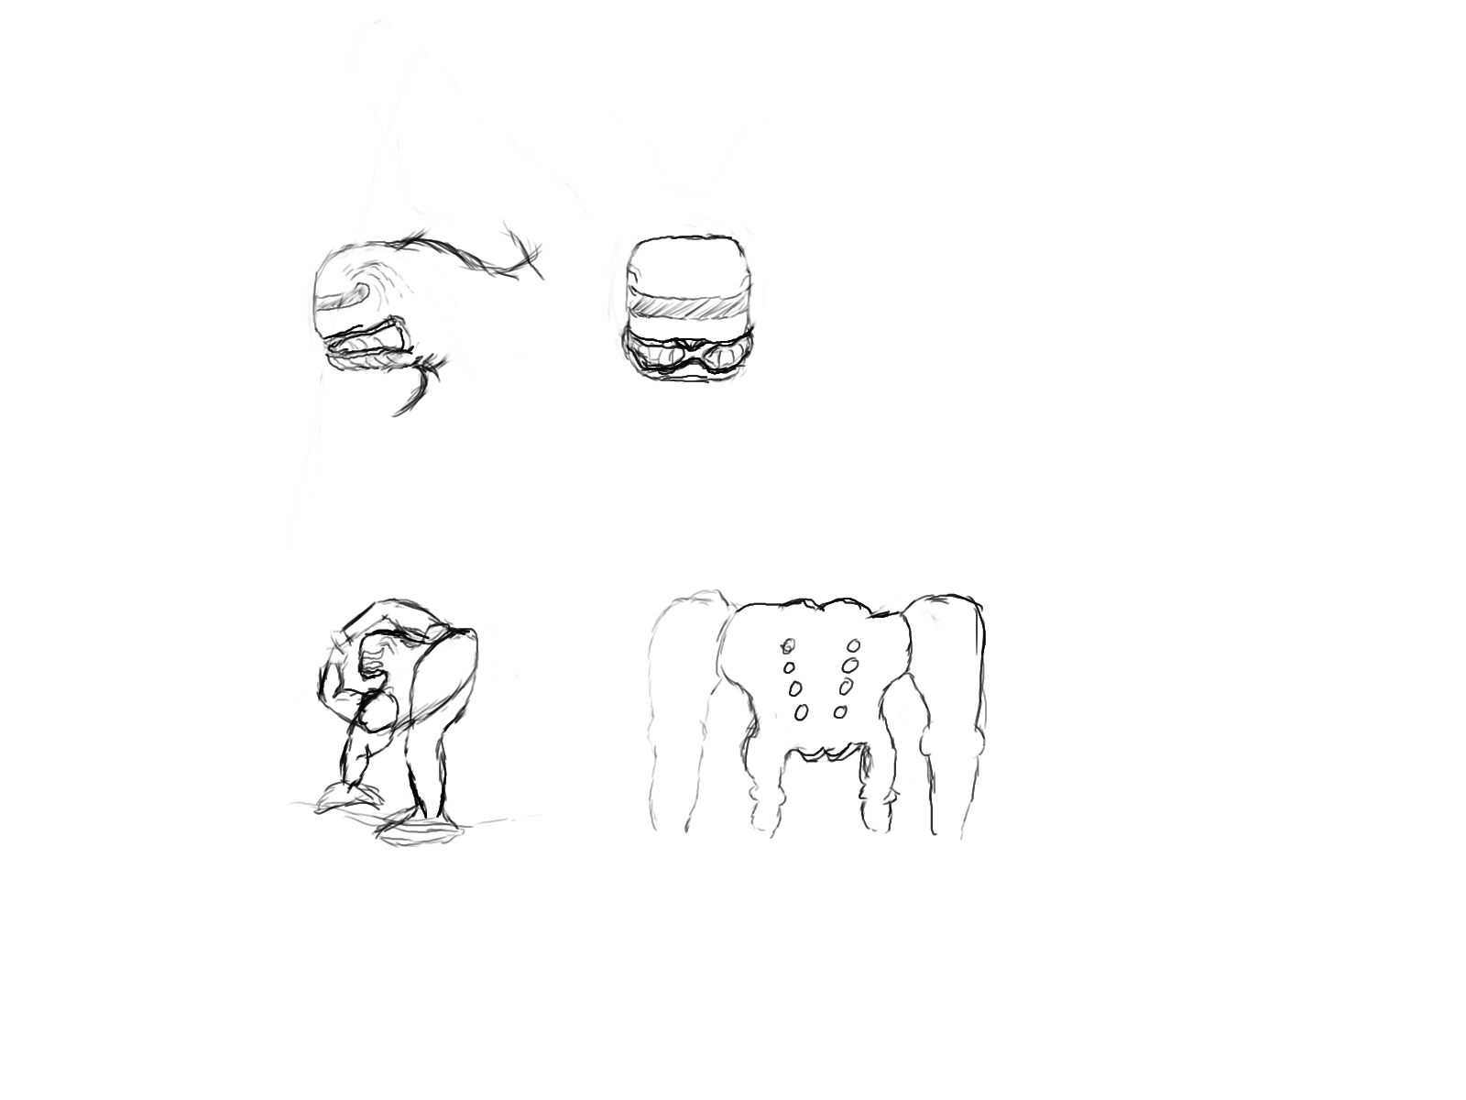
8 limbs, 4 legs, 4 arms. Each arm end in a "hand" with 4 "fingers" one of which is opposable. The four legs terminate in fleshy-padded feet, each of which ends in sets of broad, thick, fore and back claws capable of allowing "tree"-climbing. All four legs are visible in the rear picture (this specimin has somewhat skinny front legs). The two arm pairs are socketed between the two leg pairs, one pair of arms reaching over the head, the other coming up from under. The head is large and block-like, situated on a short, muscular stalk of a neck protruding from the main torso. The main torso features twin rows of breathing holes, visible on the back/underside.
There are 3 moving parts in the Uln jaw, a lower jaw, and two side portions, all of which are normally involved in eating. There is a single visual input band that stretches across the front and onto the sides of the Uln head, forming a cover for their complicated compound eye. Uln vision is actually remarkably good, and they can see from the infrared/near-microwave into soft UV (hence, some interesting trends in Uln clothing materials).

Food
The Uln don't do well with carbonated beverages. At all. Their digestive tract isn't suited to things that expand that rapidly upon consumption, and they will make a horrid, stinky mess of things when they exhibit that gem of convergent evolution (traditionally for toxin removal) of spewing their food back out.

Habitat
FIXME

Oxygen-Nitrogen.

Culture
The Uln culture sprang up among the remains of a sprawling set of Ancient structures and advanced in technology faster than their biology or social structures could adapt, leading one noted human researcher to note upon seeing them, "It was as if I had suddenly come across a spacecraft piloted by Homo Erectus -- if they hadn't been so ill prepared for the gifts they unintentionally received, they would have conquered the entire arm." Fortunately for the aspirations of dominance held by other species, the Uln were decidedly unprepared. Indeed, they spent so much time blowing each other up with weapons they didn't entirely control that it is a wonder that either they or the ruins on their planet still survive.

History
Uln development is somewhat difficult to follow, as they are not actually "native" to their homeworld. Indeed, very little of the plant and animal life on the entire planet appears to have been of native origin, present for only millions of years. In particular, the species on the planet appear to have come from many different origins, as is sensible given the broad range over which Ancient sites have been discovered in other star systems. The Uln are not generally very talkative about their origins, especially as it is the common agreement among the other sapients that they're the descendents of whatever the Ancients were using for lab rats/monkeys. It is therefore still a matter of some debate as to which features of the Uln are naturally occurring, which were engineered, and what reasons there were for such choices.

Clothing
The most commonly worn Uln garments range from "open-toed(clawed)" short-boots, some utility pouches with straps around the upper arms resting on the neck, and a helmet-scarf (draping down to cover more sensitive regions between the underside of the neck and the lower arms) which would be common casual-wear for the common peon, to the foul-weather knee-length boots and helmet-poncho and the bizzare extravagances of the aristocratic class, with gaudy creations not unlike wearing an array of very fine wire-meshes and doilies, that require servants to dress them. The back/underside is not normally overly covered, though something may drape loosely behind the top arms - to do otherwise would interfere with their breathing.

Religion
Growing up amidst the ruins of an exceptionally powerful and ancient culture on a planet where life was artificially introduced gave the Uln the idea that they were the children of failed gods. Convincing them that they are much more likely the descendants of lab-monkey-analogs from a long destroyed outpost hasn't gotten very far. What passes for organization in Uln religion involves seasonal festivals that mostly serve to reinforce the doctrinal line that being born Uln is a wonderful thing, relative standard of living to the other species be damned.

Number scheme
Base 4. Nothing special.

Klk'k
FIXME

Physical characteristics
average height range 4.5 to 5.5 feet (in meters?)
long, largish feet, reverse jointed knees, large easily splayed hips, excellent jumpers, thick, disproportionally long, muscular legs in proportion to generally much skinnier tops
wide, short, fair lengthed, back-bottom flanging head, with back facing nostrils at the rear base between neck and jawbone
jaw is wider than head on each side. because of angle, more teeth on bottom jaw than on top, bottom jaw teeth face slightly in, top jaw teeth face slightly out
mouth contains 2 tongues. has no connection to air passageway. has resonant "click" cavity in front top of mouth, behind and below the rear of the bone ridges forming the eye sockets
eyes are large and wide set, and the sockets prononouced in their bonyness
ears, such as they are, are 2 long curved ovoids, extending forward from just behind and below the top of the jaw joint to somewhat even with the top of the jaw joint and in front of the joint. Mostly flush with the skull, each ear is a series of cartilige-analog ridges protruding slightly out from the side of the head to focus sound into a central shallow curved trough, the bottom of which has numerous tiny folds of hair-lined skin atop a drum

See additional discussion (later in document)
Poorly drawn sketches follow (to be taken as rough guidance only – not canonical due to poor implementation of desired visible outcomes (i.e. jacks can’t draw worth a damn))

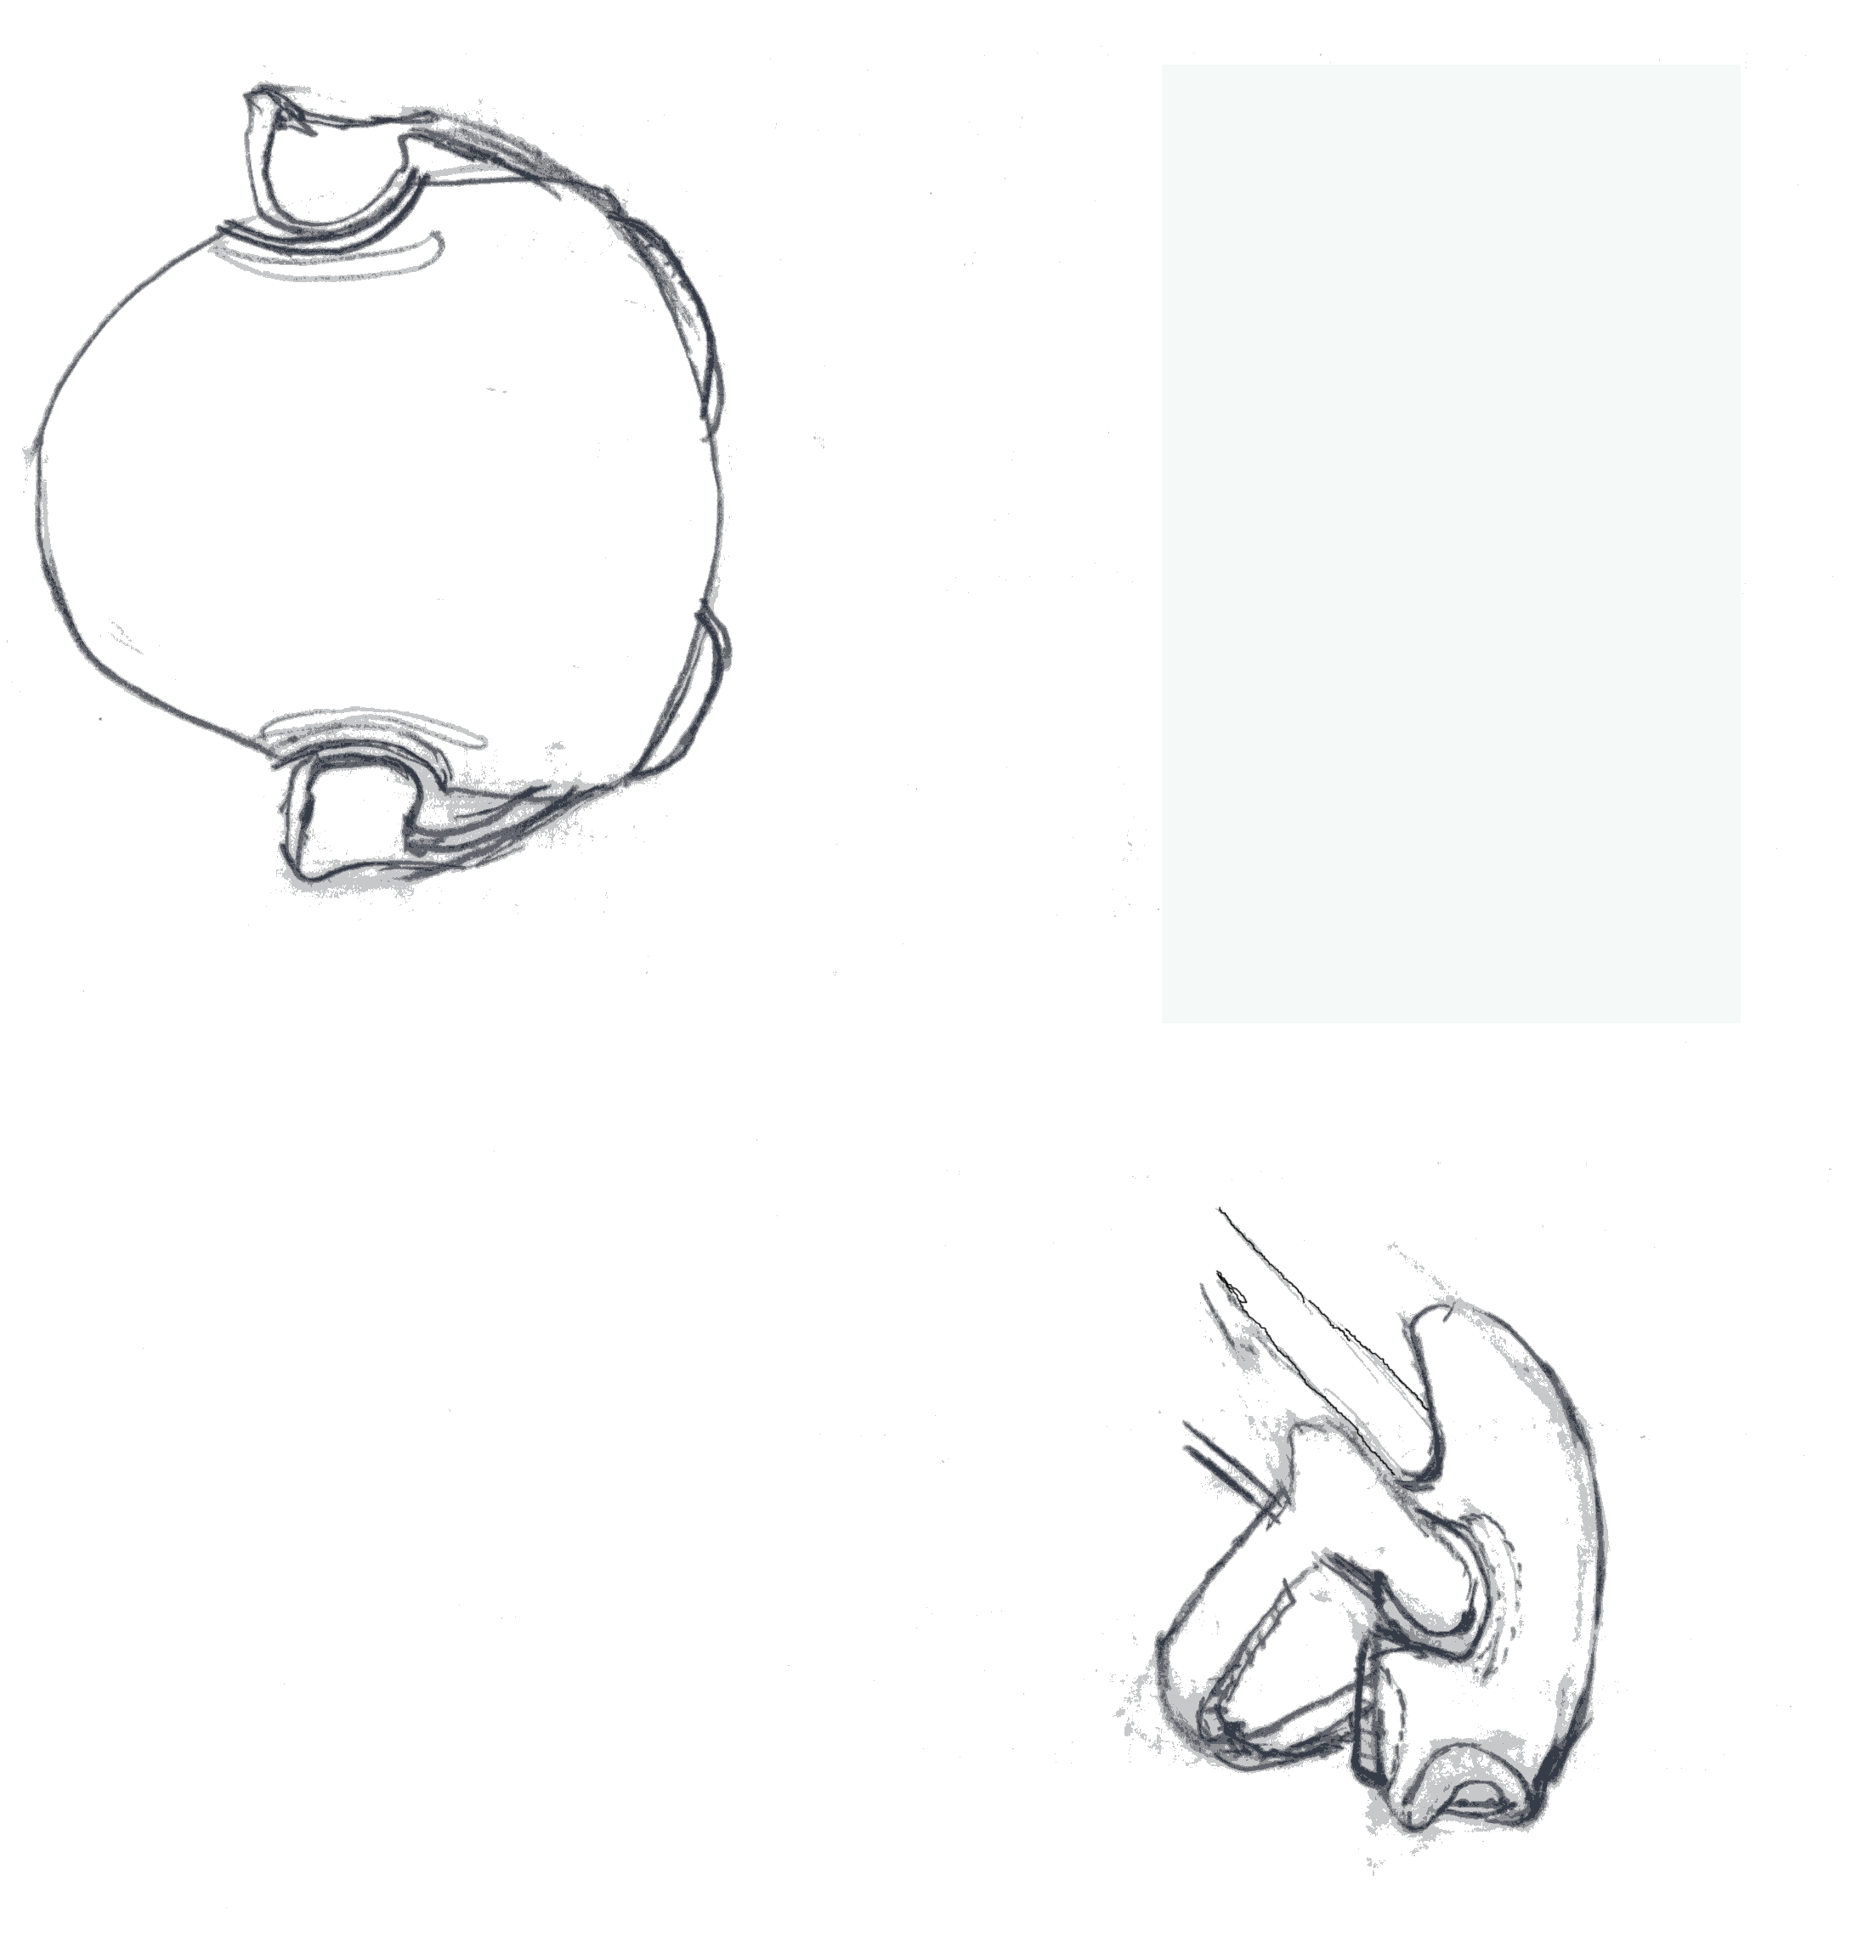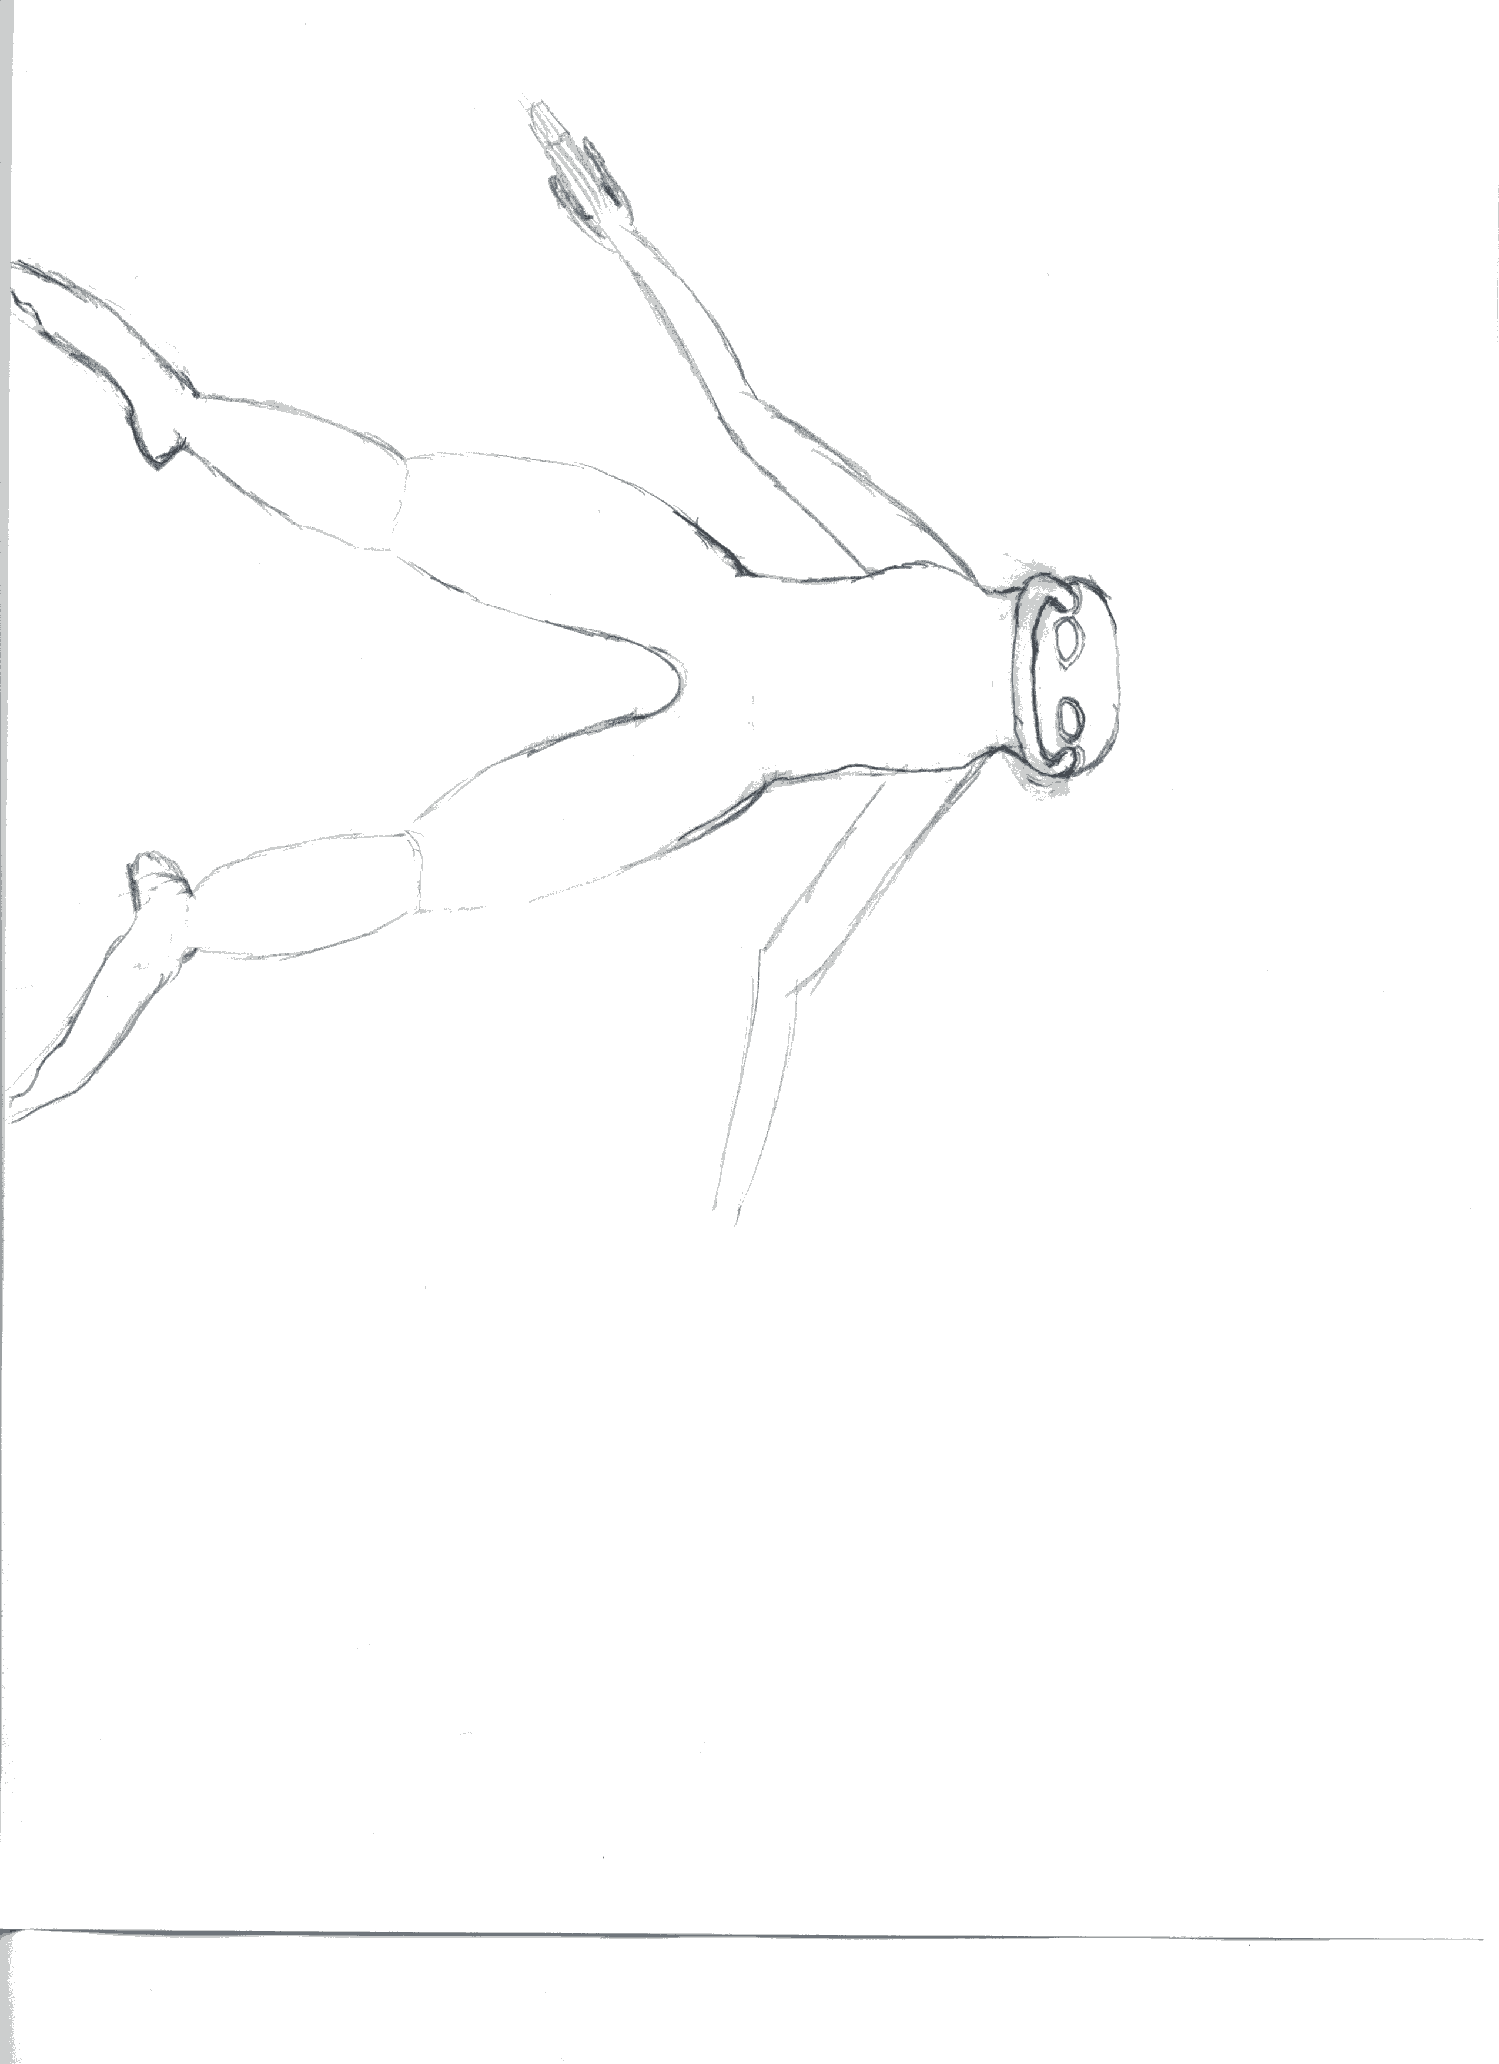

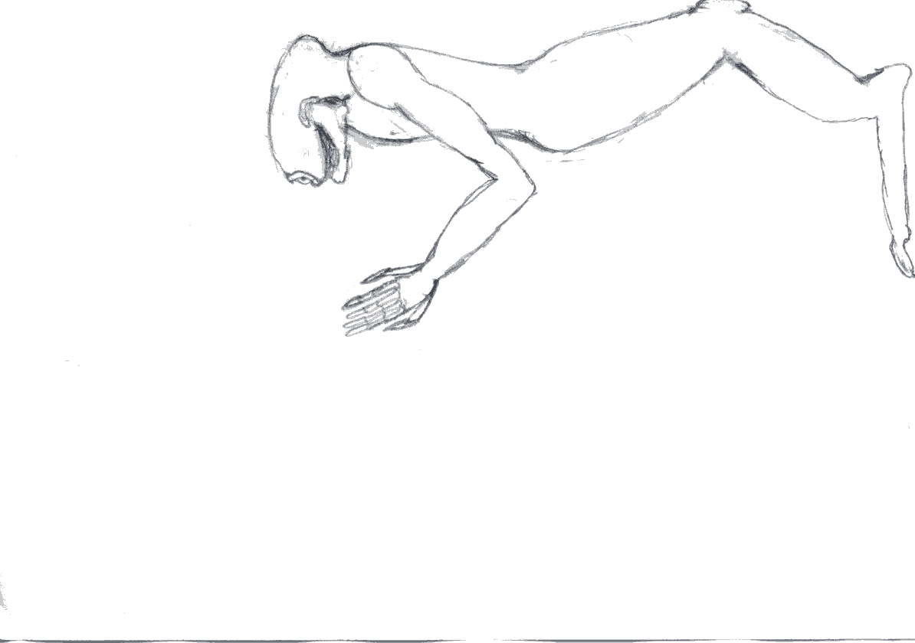
FIXME

Habitat
Oxygen-Nitrogen FIXME

Culture
FIXME

Religion
The Klk'k frowned intensely upon organized religion even before they settled under the wing of the Andolians. Klk'k history had been rife enough with false prophecies and self serving church-like establishments (including a theocracy that once dominated much of Ktah) that the Klk'k analog to the Enlightenment had been rather total in its sweeping reforms. Klk'k culture, however, has a long history of veneration of ancestors, which continues in various ritualized forms of behavior. There is no belief among the Klk'k that the deceased may be contacted, nor is there any particular spiritual nature to the reverence for those who came before, merely the conviction that it is one's duty to honor the fact that, without them, one would not be.

Number scheme
Base 12.
With numeral set derived from 2x2 entries in (2,3) double base number system.

Shmrn
The Dgn and Shmrn share a common time-of-uplift ancestor. The resulting species was further refined in seperate efforts by the Lightbearers and the Shapers into two distinct, but closely related species. As the Lightbearers were destroyed as a meaningful entity, the Shmrn were let loose as a freed species to settle new worlds.

Physical characteristics

Habitat

Culture

For above 3 categories, see below pictures:

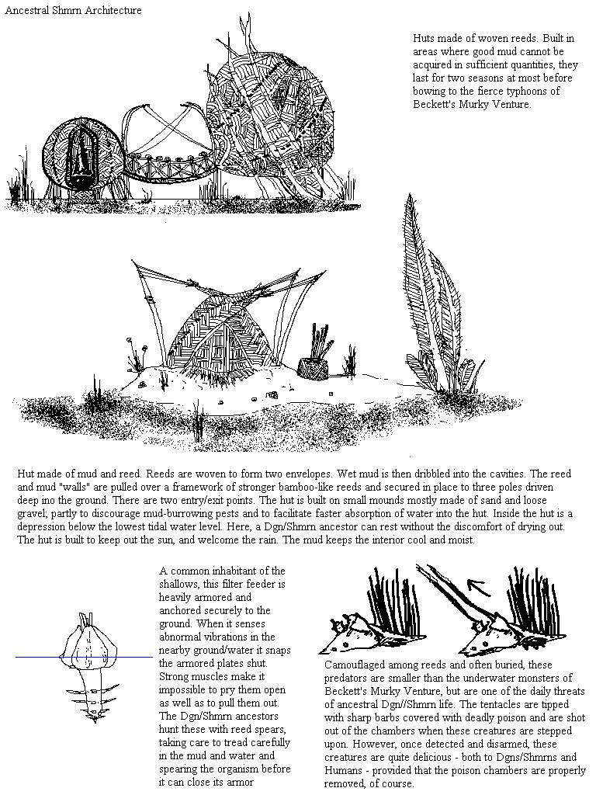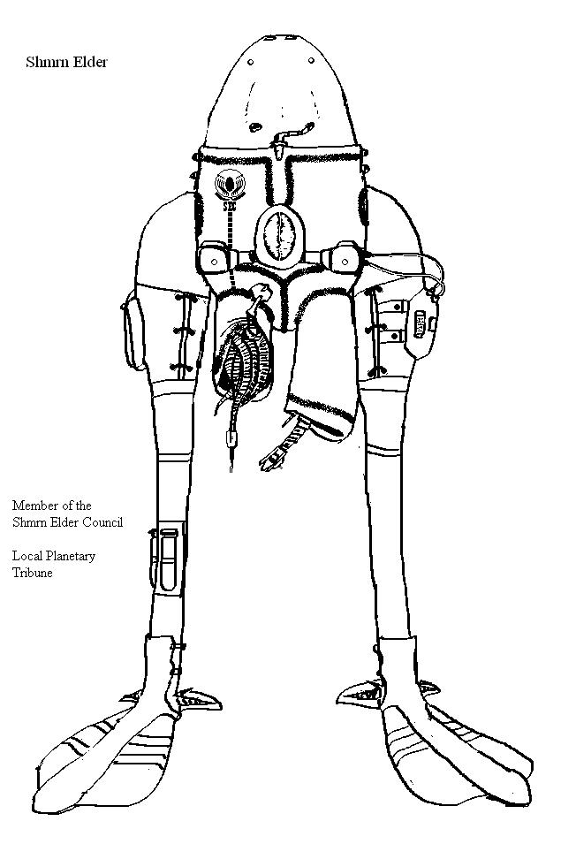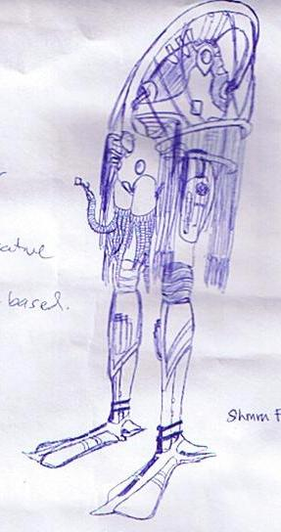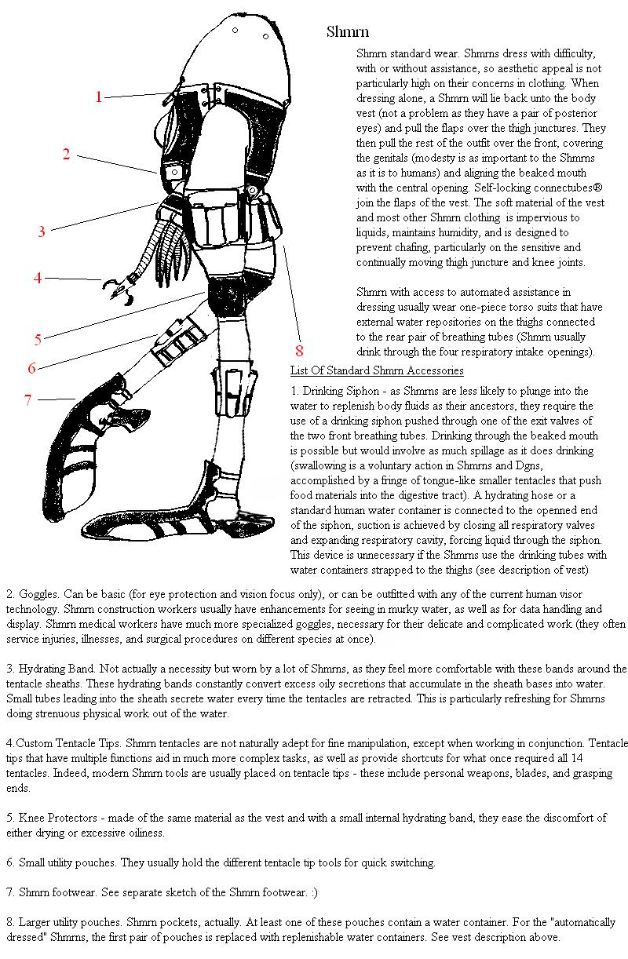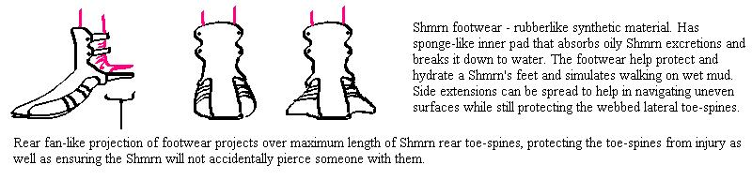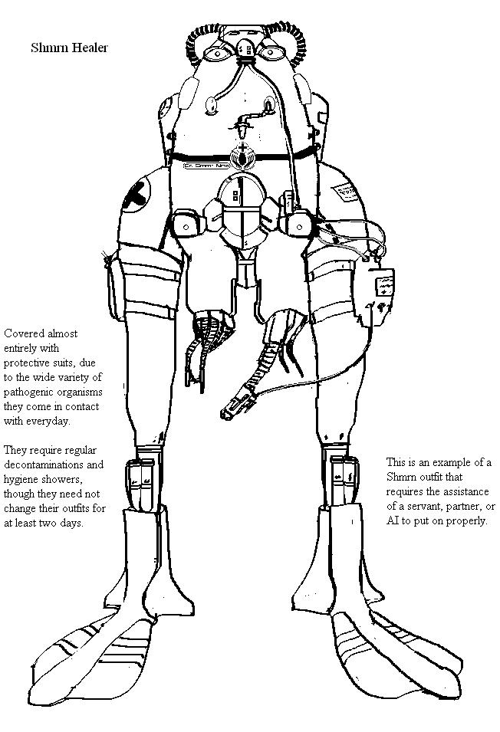(Shmrn logo)
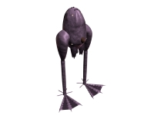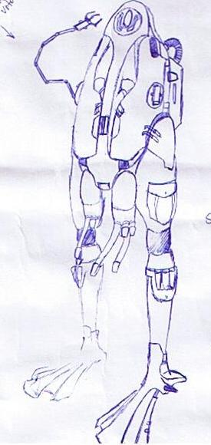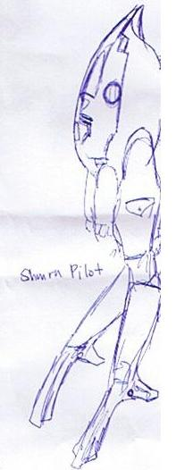

Religion
The Shmrn have a spiritual existence quite different from their brothers the Dgn, with communal meetings contemplating the nature of suffering over one's lifetimes dominating the organized religious landscape. Shmrn culture and universe view centers on the principles that life is unfair and painful, but a necessary stage to receive the reward of eternal painlessness that awaits those who have, over several lifetimes, overcome their desires to avoid the unpleasantness of life.

Number scheme
Base 7. Nothing special.

- - - - - - - - - -

The Ancients

Physical characteristics
There are precious few preserved remains of either species A or B (especially B), so knowledge of their physiology is pieced together from various, sometimes conflicting sources.

Species A
Species A were moderately sized beings, between 1 - 3 meters in height, and no more than 2 meters in diameter.

Species B
Species B were smaller beings, no more than a meter wide, high, or thick.

Habitat
The native habitats of these creatures are unknown. Given the nature of the planets they settled, it can be assumed that they were carbon-based lifeforms, and that at least of one of the two was an oxygen breather.

Culture
Beyond their technological advancement, little is known.

Background Story
Excerpt from "A Brief History in Time and Space"
"While there is much contention about the nature of the predecessors of the Ancients, the Ancients themselves left enough rubble strewn around the galactic arm to convince even a fairly hardened skeptic of their having dwelled in these parts. The Ancients appear to have been made up of at least two major species groups, and interacted with at least three others, albeit it is not known whether these were client species, or contemporaries from another part of the galaxy. Their reign over this region lasted until about 1 to 2 million years ago, whereupon they rapidly ceased to be present. There is a wealth of evidence that severe infighting played some part in the destruction of the Ancients, but, assuming there were victors in such a conflict, little is known of what became of them.
The best source of such evidence, however limited, is the Uln homeworld. While they are quite sensitive about the subject, the widely held belief among the major races is that the Uln are the descendants of the Ancient's equivalents of lab monkeys. The Uln culture sprang up among the remains of a sprawling set of Ancient structures... if they hadn't been so ill prepared for the gifts they unintentionally received, they would have conquered the entire arm. Fortunately for the aspirations of dominance held by other species, the Uln were decidedly unprepared. Indeed, they spent so much time blowing each other up with weapons they didn't entirely control that it is a wonder that either they or the ruins on their planet still survive.
The ruins, however, did not escape unscathed from the genesis of the Uln culture. While assuredly the largest known source of information on the Ancients, the ruins deliver little coherent information about many key aspects of the Ancients' existences, largely due to vast portions of many buildings having been turned to dust."
To clarify, the statement about the Uln possibly having been able to conquer the arm is contingent upon them NOT having blown most of the ruins up, along with the devices they were using to blow each other up, and large portions of their own species. No superweapons as such are known to be currently possessed by the Uln. The Uln are in possession of one particularly impressive piece of Ancient technology (what is known as the Sul-Gatwa high castle), but it's potential is effectively limited to the defense of their homeworld. However, even as heavily damaged as the finds on the Uln world are, they remain the best source for archeological research, and research visas remain a large part of the Uln economy.
Why would this blasted planet be the best source of artifacts? Because, unlike most of the planets that seem to have been inhabited by the Ancients, it didn't have it's entire surface slagged, get broken into a debris field of billions of pieces of rock, or become pockmarked by craters implying assault equivalent to prolonged planetary bombardment by 500Km wide asteroids.
Despite this, the occaisional piece of debris is found in such places. However, the only officially reported finds of fully-functioning Ancient technology have been the nano-plague and various minor finds on the Uln homeworld.
The largest known piece of Ancient technology is the Sul-Gatwa high castle. Whether or not it is technically functional is a matter of some scholarly contention - the object is a slagged chunk of some small moon sized ship or station. No systems appear to be remotely functioning. However, what information has been declassified by the Uln Royal Ingatwa fleet and confirmed via espionage implies that the structure is so dense that it should have collapsed under its own gravity into a solid mass - however, as the material that the high castle is composed of defies the best efforts of science to explain or duplicate (it has been jokingly dubbed "unobtainium") it could just be some intrinsic property of the material and not evidence of functioning gravitics. While the high castle has none of it's original equipment and is, in essence a giant chuck of debris in orbit around the Uln homeworld, every indication is that it retains the potential to absorb absurd amounts of damage, and, as such, the centuries that the Uln have spent arming it with their own weapons have made it the most formidable planetary defense station known to exist. Its existence, the threat of the Uln destroying what remains of the Ancient artifacts, and general opinion that any of the major powers could pen the Uln into their home system if necessary are believed to be the primary factors responsible for the Uln remaining independant entities.
Small fragments of Ancient technology, even completely non-functional, fetch a fair price at any research facility or university planet. Functional pieces of Ancient technology, even if relatively useless, are of exceptional value, and it is not unheard of for persons to attempt to make a career out of artifact prospecting, subsisting on the rewards from finding small pieces of debris while waiting for the big catch of working Ancient tech. However, as time progresses, the easier pickings have already been scavenged, and exploration of progressively more hostile environments has become necessary to sustain the trickle of finds.

Those who have only names (TWHON)

What little is described of this group is gleaned from writings left behind by the Ancients. While most descriptions are quite vague, it is clear that TWHON, if the Ancients are a reliable source, were at least as advanced as the Ancients, and much older.

Hoffman's blobs

Hoffman's blobs are seemingly non-sentient creatures living in the void of space. They were discovered by Burno Hoffman in the Barnard's Star system.

Physical characteristics
Very little is known of those bizzare interstellar beings. The last sighting has been in the Galileo system. Scientists are now flocking to study these creatures before they leave, attempting to determine how it is that they are able to sustain themselves in the void of space. Observations suggest their size varying greatly, with the largest individuals proving as large as a space cruiser, and the smallest only the size of a shuttlecraft. It is uncleaer whether these differences are attributable to age or polymorphism. The creatures appear to primarily be drifters, but are capable of some acceleration.

Habitat
Hoffman's blobs live in the void of space. Since they were discovered there have been six sightings of them, most recently in the Galileo system.

Culture
There has not been any exhaustive research on the behavior of Hoffman's blobs yet. From previous observations, it appears they travel in flocks of about a dozen units.
FACTIONS of the UTCS Time Period

Major powers
- Aera
  - Bzbr
  - Aeran Merchant Marine
- Confederation of Inhabited Worlds (Confed)
  - Andolian Protectorate
    - Andolian
    - Spaceborn
    - Klk'k
    - Purth
  - Highborn
  - Homeland security
    - Confed IntelSec
  - Confederation Navy
  - Exploratory Service
  - Hunter
    - Galactic Mission BBS
  - League of Independent Human Worlds (LIHW)
  - Mechanist
  - Merchant's Guild
  - Purist
  - Shaper
    - Dgn
  - Unadorned
    - Mishtali
  - Concerned Confederation Citizens Against the War
  - Confed Pleasure Planet Travel Consortium (CPPTC)
- Rlaan Assembly
  - Enforcers
  - Lmpl
  - Nuhln
  - Rlaan Briin
  - Rlaan Hunters
  - Rlaan Merchants
  - Saahasayaay

Minor powers
- Forsaken
- Shmrn
- Uln

Fringe groups
- Interstellar Church of True Form's Return (Luddites/Humans)
- Pirates (various species)
- Interstellar Socialist Organization (ISO/Humans)

Other/Non-extant groups
- Lightbearer <defunct>
- - - - - - - - - - - -

Aera
The Aeran Ascendency governs the Aerans and Bzbr. The Aeran Ascendancy is, in practice, a body wholly controlled by entirely Aeran will of the Aeran Oligarchy. All distinct Aeran subgroups, such as the Aeran Merchant Marines are subject to the edicts of the Aeran Oligarchy.

Faction data
Aera
Species | Aera
Homeworld (Origin) | Aeneth
Capital | Aeneth

A Brief History of the Aera
The Aera homeworld was home to extremely competitive ecosystems. It was not a supportive environment. If one considers Earth the "mother" of the human race, then, in comparison, Aeneth was an abusive parent. The Aera evolved in an environment where a slew of things really did want to kill/eat/infest them. Beginning with the early harnessing of fire, and ending with industrial might, the Aera remedied this problem by destroying the vast jungles that bore them. However, their outlook on the universe was fundamentally shaped by their beginnings in a direction that humans would consider paranoid, or at least profoundly pessimistic and somewhat untrusting, though the Area merely see it as prudent recognition of how the universe works.
This outlook was greatly reinforced by the Aera experience with the nano-plague. The precocious Aera, unlike humans or Rlaan, developed jump-based FTL before having otherwise left their solar system. The resultant reactivation of the nano-plague and the devastation it wrought on their population, served to gel their concept of an inherently antagonistic universe. Aeran society greatly increased its militarization, heretofore on the wane since global unification, so as to better prepare for potential conflicts in what, evidenced by the nano-plague, they presumed was an inhabited galaxy.
The Aera are the youngest of the three currently dominant space-faring major groups, but are also the most expansionist, fastest breeding, shortest lived, and devote the highest fraction of their economy to military and military related R&D spending. They are not evil, they are not delusional, they are not irrational, but they have some fundamentally different assumptions they are working from that make them somewhat difficult to get along with. Finding out that their section of the jump network had them pinned by the Humans and Rlaan, they first attempted to negotiate passage, and were rebuffed. They then attempted to sneak a colony convoy through Rlaan space, but this turned into an utter debacle after Aeran escorts killed Rlaan Civilians, sparking a war lasting several years, that churned the Rlaan-Aeran border into an abattoir. Although formal peace has never been brokered between the two, a cease-fire has been in effect for several years. The Aera have now turned their sights toward Human space, invading Forsaken territory, hoping to push through toward the less defended Forsaken/Confederation border crossings, carve a corridor through to the other side of humans space, and keep it open long enough so that they can send enough colonization fleets through to the other side to make the venture worthwhile.

Development
Compared to contemporary 33rd century humans, the Aera are comparable or somewhat more advanced in some of the physical sciences and their applications, notably so with respect weaponizations of certain technologies. They are noticeably behind in life sciences and AI.
Having been wandering the jump network for the least amount of time (among the Rlaan/Humans/Aera), the Aera, though occupying the same order of magnitude of systems as the Humans or the Rlaan (Rlaan/Lmpl/Nuhln/Saahasayaay have most, followed by Humans/Klk'k/Dgn/Purth/Mishtali, followed by Aera/Bzbr, then the much smaller Uln, Shmrn) have not occupied many of them for nearly as long. The Aera expanded in territory faster than that territory could be developed up until running into the Uln. After one last push then brought them to the Human and Rlaan borders as well, the Aera have been racing to build up their newly settled colonies nearer the borders, but the bulk of their industrial potential remains concentrated in systems closer to their homeworld than to alien space. This difference was especially clear during the Rlaan-Aera conflict, wherein many newly settled Aeran colonies along the border fell to the Rlaan assault, but the same Rlaan fleets were badly bloodied when they tried to push into Aeran systems with more matured defenses. Due to the war, Aeran military spending and infrastructure development has been extravagant in comparison to human budgets, but the Aera also had to cope with sizeable losses in personnel and materiel.
While there are key differences between the level of population and industrial development between the core colonies and the newer colonies, due to the very strong central organizing forces in Aeran governance and economy, this is not a deep political divide, nor an economic one - it is merely a matter of the more fringe planets growing as fast as they can into states undifferentiable from the more core worlds. This centralization should not be taken as evidence that Aerans are a selfless society of collectivists. Rather, the Aera have a strong natural ability and desire to sublimate personal interests to higher authority, a trait left over from their more pack-like origins. Success, however, is still judged at individual granularity, and Aera are entirely opportunistic about personal advancement when the opportunity either does not come at the expense of the dictates of higher authority, or places them into a position of higher authority.

Culture
The Aera are a bit culturally dour, although they do engage in organizational events, such as rallies, sporting contests, and Military parades. Entertainment pursuits, such as music, for personal pleasure are not a significant thread in Aeran culture. Such pursuits are seen as necessary avenues of release, but to devote oneself to pursuing purely entertainment oriented activities merely because they are pleasant is seen as wasteful, wantonly hedonistic, and a reckless abandonment of one's duties. Entertainment with physical components, such as sporting competitions, are viewed in a more favorable light.
In Aeran culture, mortality is to be pondered and meditated upon in its inevitability. It is worth noting that it is not so much those that came before them that the Aera cherish as the accomplishments of those who came before them. The Aera perspective is that it is only though accomplishment on behalf of the Aera that the Aera can continue, and the dead, thereby, can continue to live in the memories of the Aera.

Organization
Aera culture is highly organized and decidedly hierarchical, but in the form of a meritocracy rather than an aristocracy. While what has constituted merit has morphed over the millennia since the first Aera tribes selected work crews to cut back the encroachments of the jungle upon their early settlements, given the relative position of the pre-technological Aera in their local food chain, there has long been a favoring of cleverness and determination over raw strength. The current social and vocational position of any Aera is immediately indicated by the color and pattern of an individual's coverall. The Aera are ruled by a subset of the highest caste, with membership in the oligarchy changing whenever either an individual steps down, or a third of the other members call for a member's replacement. New members must be confirmed by two thirds of the current oligarchy. It is much more common for members to voluntarily remove themselves from power, believing themselves more useful elsewhere in society, than to be cast out. An average stay in the oligarchy lasts a few Aera years.
Need to more usefully carve up faction vs. species information. Will do so later.FIXME

Bzbr

Faction data
Bzbr
Species | Bzbr
Homeworld (Origin) | Fixme?
Capital | Fixme?
The Bzbr are a client race uplifted by the Aera. They are reasonable laborers, but poor conversationalists, in part due to their lack of vocal cords.
The Aera uplifted the Bzbr out of pity for the Bzbr due to similarities the Bzbr homeworld had with the Aera homeworld.
The Bzbr engage in significant hero worship of the Aera, although indications are that the Aera are not appreciative of this tendency. The Bzbr are wholly integrated into the Aeran Ascendency, and given extremely little self-control as a group. Aeran officials permeate their entire governmental structure, itself in parts borrowed from and imposed by the Aerans upon the existing stone-age Bzbr. The Bzbr, however, remain near universally accepting of their Aeran overlords due to a combination of religious reverence and vast improvements in their standards of living. Experiences during the Rlaan/Aera conflict found Bzbr to be even less accepting than Aerans of non-Aeran governance. Their fanatical level of religious devotion to the Aera found them to be prime subjects for guerilla actions involving the likely demise of the participants.

Aeran Merchant Marine

Faction data
Merchant Marines
Species | Aera
Homeworld (Origin) | Aeneth
Capital | Aeneth

The Aera don't really have a civilian sector. All Aera resources are controlled by the state, and ruled over by the Oligarchy. The Aera do, however differentiate between combatant and non-combatant forces, and the Merchant Marine, while armed, are designed to transport goods through dangerous space rather than conquer said space. (It may be duly noted that the Aera are predisposed to consider all space to be dangerous).

Confederation of Inhabited Worlds

Faction data
Confed
Species | Humans, Klk'k, Purth, Dgn and Mishtali
Homeworld (Origin) | Various
Capital | Mars

The Confederation of Inhabited Worlds (Confed) is made up of partially-autonomous member states, and was created with a primary purpose being to arbitrate disputes between them in a more structured and less violent way than the Andolian-Lightbearer dispute was handled. In addition to this, with the Klk'k representing a reasonably advanced alien species and the Andolian-Lightbearer war pushing home notions of the potential for interstellar war, a re-evaluation of the need for maintaining a unified defensive force was seen to be in order.
Each constituent state is allowed to maintain its own military forces, but it must submit some portion of its resources to maintaining the Confederation fleet, which is distinct from any state's military.
The confederation's rights over its constituent states are those and only those so ceded by the constituent states in the confederation constitution. Admittedly, exactly what rights were ceded is always a debatable issue. Likewise, the confederation's unicameral legislature has oft attempted to pass dubiously constitutional edicts. However, the constitutionality of the Homeland Security Forces is actually unimpeachable, as they were specifically called for in the constitution to bypass the previously tangled web of extradition policies between the constituent states and to force some measure of legal compatibility between said states such that outright and overt support for groups violently antagonistic to other member states would not be tolerated. While none of the member states is particularly ecstatic about the confederation's nature and its imposition on their internal affairs, all are, at least publicly, thankful for the unified front that allows humanity to operate alongside alien entities much larger than any single member state.
The civilian center of the confederation as well as the fleet headquarters is located on Mars since the Sol location is symbolic of humanity's common roots. Earth came with too much political baggage, and so Mars was chosen to be the center of the confederation. A hierarchy of civilian and military installations then extends out from Mars to the furthest reaches of confederation space. While sufficient function is distributed redundantly to prevent a catastrophic beheading, only the confed installations on Mars can be said to have been designed with splendor in mind, and thus hold no rivals among the other installations.

Andolian Protectorate

Faction data
Andolian Protectorate
Species | Human, Klk'k and Purth
Homeworld (Origin) | Various
Capital | Kubernan

The Andolian Protectorate refers specifically to a government.

Members
All Andolians are members of the Andolian Protectorate, not all members of the Andolian Protectorate are Andolians. In particular, there are Klk'k, Purth, and non-Andolian human citizens of the Protectorate (the non-Andolian humans mostly being non-integrationist members of annexed entities or yet to be integrated immigrants to the Protectorate from other polities). Andolians, being the dominant faction within the Protectorate, are good indicators of how the Protectorate will act.

History
The Andolian Protectorate was created by the Andolians as the political entity controlling both Andolian and Klk'k interests. During the formation of the Confederation, there was some consolidation of minor factions, bringing an influx of non-Andolian humans into the Protectorate (an extremely small minority of the human population born into the Protectorate remains non-Andolian - less than 1% of the total human population). Many Klk'k are more accurately considered Andolian at present (in ideological adherence), but the integrated Klk'k are a distinct minority of the total Klk'k population, which is ideologically more diverse.

Andolians

Faction data
Andolians
Species | Human, primarily of the Pluralis variant.
Homeworld (Origin) | Earth
Capital | Kubernan

Andolians are a human faction primarily consisting of the Pluralis variant well developed in both information and physical resources. All Andolians are members of the Andolian Protectorate but maintain a subordinate government concerned with Andolian affairs.
Many of the major Human governments could be considered "ideocracies" wherein a supermajority, often a near totality, of the population governed by an entity are adherents of a given ideological perspective. The Andolians were such a group, with a clear correspondance between the Andolians (the adherents) and the Andolians (the political entity controlled by the adherents) until the Andolians came to have a more diverse political landscape when they became Protectors of the Klk'k population, and later, the Purth. Many Klk'k have since become integrated with the Andolian mainstream, but the Protectorate remains more ideologically diverse than the Andolians proper.
Needs more FIXME

Spaceborn

Faction data
Spaceborn
Species | Spaceborn
Homeworld (Origin) | Cradle
Capital | Kubernan
Those Spaceborn who chose to remain as such rather than attempt to reintegrate into more mainline human gene-pools live almost exclusively under the auspices of their liberators, the Andolian Protectorate. The Spaceborn make up a miniscule fraction of the total Protectorate population, but are heavily involved in many of the Protectorate's free-space construction and maintenance projects.

Klk'k

Faction data
Klk'k
Species | Klk'k
Homeworld (Origin) | Ktah
Capital | Ktah
Needs a better desc FIXME
The Klk'k are a client race of the Andolians, but enjoy exceptional freedom within this position. Indeed, while fiercely loyal to their Andolian benefactors, there exist a non-trivial number of independently operated Klk'k vessels. The Klk'k are perhaps best known for their odd brand of twisted humor.

Purth

Faction data
Purth
Species | Purth
Homeworld (Origin) | fixme
Capital | fixme

The Purth are politically subserviant members of the Andolian Protectorate, heavily reliant in most facets of their existence upon the assistance of the Klk'k and Human members of the Protectorate. The Purth do not operate independently, instead being heavily integrated into the Protectorate military forces, as might be expected given their origins as a cybernetics research project.
FIXME

Highborn

Faction data
Highborn
Species | Humans
Homeworld (Origin) | Earth
Capital | Fixme?

The Highborn are a human faction better known for its disregard for life than its art or achievement.
They are one of the oldest colonial groups and had significant resources on Earth, lending them the cream of the initial colony locations. They were the main defenders of the 1st Confed Party Reform, which had forbidden the ISO.
Primary manufacturers of dueling weaponry.
Motto: "There is no substitute for a superior human being."

Homeland Security

Faction data
Homeland Security
Species | Human
Homeworld (Origin) | Earth
Capital | Mars

The Homeland Security forces are primarily composed of Purists but contain members from most human groups. The Homeland Security forces exist for internal policing and control, especially in cases crossing between the jurisdictional boundaries of member states of the Confederation, as they are an arm of the Confederation rather an amalgamation of forces from member states. While distinctly limited by both practical and political concerns in how much pressure they can bring to bear if a member state actively obstructs the pursuit of their duties, they counterbalance by being more authoritarian then generally deemed necessary within what is clearly their own domain. This is known to be especially true of the IntelSec wing of the Homeland Security Forces.

Hunter

Faction data
Hunter
Species | Humans
Homeworld (Origin) | Earth
Capital | Non-governmental group.

Arising in the profit opportunities of the lawlessness of the Diamond Dust period, various mercenary groups underwent iterations of consolidation due to expanding polities, increasing regulation, and a decline in per-capita bounty-hunting opportunities. While still comprised of numerous independent groups of guns-for-hire, the Hunter's guild provides a unified interface for those seeking their still-needed services and a well-financed legal wing to make sure that bounty hunting remains as legal as it is profitable.

League of Independent Human Worlds

Faction data
LIHW
Species | Human
Homeworld (Origin) | Earth
Capital | FIXME

League of Independent Human Worlds
Scattered across the frontiers of known space are many worlds housing minor subsets of humanity which hold no place among the larger meme-group entities.
Humanity has, throughout the past, been an oft balkanized lot. While the bulk of human power and population has, for various reasons, aligned itself with one of the major or minor meme-groups there are many colonies, that, for reasons of either intense pluralism or adherence to a tertiary meme-group have remained independent.
- examples of such being the inhabitants of Vegan-ville, or the citizens of the "Brotherhood of Militant Agnostics" (motto: "I don't know, and neither do you!")
But in the wake of the Mankind's first notable interstellar fraternal conflict--the demolishing of the Lightbearers by the Andolians--and the efforts which followed in the founding of the Confed, whose membership consists of the major meme-groups, the bulk of the lesser subsets realized that--while they may not get along all that well with each other--if they did not in some way present a united front of resistance, they would likely be consumed by the major meme-groups. As such, they joined the Confed united as the League of Independent Human Worlds (LIHW), and, counter-intuitively, gained, through their co-operation, a guarantee of protection of their individual and often separatist modes of life.
Those that did not band together or exit en mass to Forsaken space, are now only records in history books, having been overrun, subverted, co-opted, or in other ways gobbled up by the major meme-groups.

Mechanist

Faction data
Mechanist
Species | Mechanist
Homeworld (Origin) | Earth
Capital | Plato
FIXME Stub entry - taken from dynamic_news_content.py
- Full faction name: Mandate for Corporeal Perfection via the Abandonment of Flesh
- Government name: Concordance of Enlightened Ones

Merchant's Guild

Faction data
Interstellar Shipping and Mercantile Guild
Species | Humans
Homeworld (Origin) | Earth
Capital | Bantam

A latecomer to the great sowing of Earth's seeds, a too-small planet, previously passed over, became the new home for a group of colonists united more by a desire to leave behind their varied existences in Sol than by any common ethos. The colonists struck out from their settlements in the deep canyons and valleys where the air was thicker, clearing out the simple layers of native life, ever so slowly etching humanity's presence indelibly into the planet's crust. However, the future of their efforts did not lie on the surface of a world, but in the cold of space surrounding it.
No too-small world can hope to passively hold on to the sort of atmosphere that gives rise to sunny, green meadows alight with frolicking schoolchildren. The release from the domes, from the deep places, would be a Herculean task, but the insights bestowed by modern science had given mere mortal men more abilities than the authors of the ancient demigod had foreseen. In a common goal, the residents of Bantam found new unity and identity. They labored together tirelessly to construct the centerpiece of their terraforming effort: a colossal station that would serve as both the shipyard producing and maintaining the resource gathering fleet and the processing center that would amalgamate the offerings of the entire system into sustenance for Bantam's development.
It would likely have worked.
The nano-plague struck without warning, long before the first human FTL ship would visit the system. Only the near-paranoid levels of over-engineering with which Rainbow station had been constructed saved it from the fate of many of Bantam's residents, too reliant on cheap and plentiful nanites. It was far too early in the terraforming effort to live in the open, and suddenly overstrained environmental systems caused entire cities to suffocate. Bantam was devastated, losing all vibrancy and vitality in a matter of weeks. What before had been a growing planet-wide civilization was now a collection of frightened outposts of inhabitation. Thus were Rainbow station and its infant fleet of resource gatherers nearly orphaned, the mother planet an invalid. With the station barely able to sustain itself, the stationers were left with the unenviable role of deciding whom amongst Bantam's survivors they could afford to save.
As the Diamond Dust Age progressed, and Bantam continued to wither away to a pale shadow of its brief heyday, Rainbow station endured, growing throughout the period of isolation, if at a glacial pace. Warning messages, lazily arriving at the speed of light from their neighbors, came in one after the other, followed sometimes by descriptions of chaos, and sometimes by silence. There was no official expectation of assistance, but humans are renowned for their counter-empirical optimism.
Thus, it was with great surprise and anticipation that the arrival of the first FTL ship was greeted, and numbing disappointment the feeling that swept the stationers when they learned that it was not a portend of any mission of mercy. All, however, did not look grim. The visitors were High-Born explorers, but from a family of lower standing. The Marcos family realized that they had much to gain from control of Rainbow station once it began producing jump capable vessels. With FTL technology and the silent threat of a second abandonment for leverage, the Marcos family gained a large stake in Rainbow station.
Luck had indeed changed for the better for the people of Bantam and Rainbow. Not only were much needed resources flowing in from High-Born space, payments for an ever increasing list of ship construction orders, but Rainbow soon proved itself to occupy a prime location in the jump network, a hub on what would remain for many decades the only practical routes connecting several populous systems to each other – including Sol.
Some colonies had fallen far and some had not had far to fall. The lone merchant was a valuable target in a starved land. Neither were the financial benefits of collusion upon profit margins lost upon the increasing number of traders operating out of or, less commonly at the time, passing through Rainbow. The first of the great mercantile cartels was formed, again under the leadership of the Marcos clan, a silent, nameless cartel that worked to establish a near monopoly on interstellar trade in much of human space during the Reconstruction period. Coercion, cooption, and even the occasional assassination were all valid tools to grow the blossoming financial empire centered on Rainbow and the slowly awakening Bantam. The Rainbow station cartel was one of a few groups to capitalize upon the realization that, in the absence of any overarching authorities, whomsoever dominated the trade lanes now could well be able to do so for centuries to come, barring fantastic advances in interstellar travel.
Generations passed. Competitors fell as they came, though some struggled valiantly, and only the governments of the larger meme-groups were sufficiently imposing to hold their own at the bargaining tables. Shares of control of Rainbow station changed hands, and it became wholly an instrument of the cartel, although Bantam and Stationer descendants still held a plurality of control of the cartel, a sizeable majority if one included the increasingly integrated Marcos clan. The name of the station changed then as well, and the cartel gained a name, rechristened Cherryh station and the Cherryh Mercantile Trust (CMT), respectively.
Though flagrantly in bed with High-Born interests, the CMT maintained a resolute official neutrality, even going so far as to make a point of hiring other parties for anti-piracy protection rather than building their own combat fleets. While many at the time took this to be a purely political maneuver, those more informed knew that it was actually a necessity. Cherryh station had been a vital trump card for the CMT in the early portions of the Reconstruction period, but mankind had recovered somewhat, and was once more advancing, and the age of the station was beginning to show. Bulk freighters are in many ways much easier to build than the tiny craft that protect them and avoid obsolescence much longer, and Cherryh station was only up to the task of constructing the first, and not the latter.
More modern shipyards, though not on the scale of the CMT's aging beauty, were being constructed all over, and the competitive advantage the CMT had enjoyed due to their production capacity was waning. There was, however, little feared by the CMT at this point, as there was no longer any competition of note to gain upon them. All other transport of goods was in-system, governmental, or doomed to obscurity or absorption. The CMT used this time to increase its wealth, strengthen and modernize its infrastructure, and deepen its influence on various governments. The resettlement of Bantam was in full swing.
The CMT's opportunity to rest did not last as long as they would have preferred. The development of the SPEC drive dramatically changed the landscape of trade routes, altered latencies, and made runs by smaller vessels much more practical. Rapidly expanding borders made for new regions for local competitors to exploit more rapidly than the CMT might be able to react. However, like the age itself, the CMT had matured. There would be no massive wave of assassinations or stream of engineered third-party blockades. Rather, there would be the ultimate buy-out – the largest recruitment effort ever mounted, a clarion call summoning all traders to a common banner with the offer of common profits. What could have been the death knell for the CMT merely announced the birth of the Interstellar Shipping and Mercantile Guild, which if it still had the CMT at its core, was, by the nature of its creation, intended to be a beast with a very different public face.
The emergence of the Confederation only served to strengthen the position of the Guild, being included in the Confederation Senate's Committees despite technically only owning a single star system (the plethora of commerce stations and trading outposts in the star systems of other powers not counting as seats of population) – an important technicality, as it would otherwise be difficult to pretend they were a governmental entity in the same sense as the other Senate members. The newly formed Confederation Navy and Homeland Security forces served to decrease piracy along standard trade routes, even if the decline of several independent powers in the face of enforcing new Confederation regulations gave rise to a whole new breed of paramilitary forces. While in matters internal to the Confederation the Guild was still maintaining an increasingly less fictitious neutrality on matters not of self-interest, there was no love lost between the Forsaken and the Guild, the much lower profit margins available on return trips never having enticed much Guild investment, and Guild price fixing long having raised the ire of the Forsaken. Guild presence in Forsaken space is thus limited to border stations, much like the trade relations with the Uln and Rlaan.
Contact with alien trading partners was a great boon to the Guild, as Guild political clout ensured that all major alien traffic would pass through Guild trading stations, that Guild shipping would be awarded nearly all lucrative inter-government contracts calling for human merchants, and so forth. Moreover, no independent trader could so easily call upon the shared resources of the Guild in obtaining appropriate permissions from the Uln and Rlaan governments to conduct business within their borders, or the expertise of a cultural specialist in determining the likely intentions of an alien customer.
Though the upper echelons of the Guild are still plentifully stocked with CMT personnel, the Guild favored success over nepotism, and many rose through the ranks to positions of power – unlike the larger meme-groups, no grand conversion of belief system is required for acceptance, merely the conviction that profit conquers all, and timely payment of portions thereof. The lower tiers of the Guild are full of all sort and manner of small time traders who were willing to trade a fraction of their profits for protection, access, and opportunity. Unlike the pre-SPEC period, the smaller independent traders are not actively squashed, and those who achieve success are always initially courted rather than destroyed outright, but this is largely because any emerging independent group which appeared to offer a real threat would be rapidly legislated out of existence by calling in favors in the Confederation Senate. The current Guild is rivaled only by the logistical corps of some major meme-groups that did not desire to give up the independence of their internal supply chains, but even these entities are dwarfish by comparison. Though still not a military power, nor aspiring to become one, the Guild's numerous shipyards, kept modernized under lucrative Confederation contracts now churn out capital and sub-capital military vessels for the Confederation Navy alongside their freight bearing kin. With the renovation of Cherryh station over the last few decades further boosting production, the Guild shipyards maintain a distinct lead, by tonnage, as the largest suppliers of Confederation military vessels.

Purist

Faction data
Purist
Species | Human
Homeworld (Origin) | Earth
Capital | Earth

A surprisingly large memegroup, and the dominant one in Sol, the Purists seek a humanity free of changes to the species. They do not stand for non-therapudic genetic modification, nor for unnecessary cybernetic implants. They are, however, not opposed to technology which is not used to alter humans. Motto: In being what we are, become all that we can be.

Shaper

Faction data
Shaper
Species | Human
Homeworld (Origin) | Earth
Capital | Bifröst

The Shaper government, such as one exists, was originally constructed along ‘libertarian’ lines (albeit with some elements that would seem deeply foreign or even perhaps contradictory to any person harking to the same ‘libertarian’ title who is not also a devotee of the Shaper ideology), and is a generally minimalist entity, delegating many of the tasks performed by the other human governments to private interests within the Shaper populace. Confoundingly, the Shaper views on children are remarkably collectivist, and closely tied to the particular Shaper notions of what constitutes an actual human existence. Government social programs are unheard of for adults, but heavily invested for children, and while there are a number of government standards committees, they almost exclusively produce guidelines, rather than regulations. Government interference into the economy is utterly untolerated. Individual civil liberties are fiercely protected, and one of the more significantly funded programs, aside from defense spending, is the publicly funded “Authority Surveillance Guardianship” or ASGuard, the funding for which and chief administrators of being determined directly by the Shaper populace.
Shaper society is egalitarian in opportunity, but extremely competitive and indifferent, when not outright unforgiving, of failure, with notable emphasis being put into ensuring that the failings of members of one generation are not allowed to be magnified through their offspring. Notably, procreation in any form (be it cloning, or gene-mixing, or more traditional conception) is not considered a right within Shaper society. The furtherance of one’s genetic material is deemed a privilege of personal success. Attempting to raise Shaper children without appropriate resources or accepted competence in child-rearing is considered criminally abusive of the children. Non-Shaper children have a decidedly different legal status, are protected only in a sense of general ‘human’ liberties, and are under no circumstances the recipients of collective support.
It should be noted that childhood is a rather abbreviated thing in Shaper society, due to genetic engineering and common practices greatly affecting both pre-natal and post-natal growth and learning. Natural childbirth is seen as exceptionally eccentric within Shaper society and is tolerated in much the same way that artists in the 20th century who deigned to use their own bodily fluids in their artwork were tolerated, but far from welcomed. Normal Shaper children are born in child producing factories, more often than not, with the exception of vanity children, being very carefully designed from mixes of parental DNA with sequences from currently popular designs. The gestation period in such factories tends to runs toward 14 months, a length second only to Andolian full-growth gestation-immersion tanks – unlike the other cultures using the tanks to replace normal childbirth where the delay of from conception to birth is often seen as an inconvenience to the prospective parents and time-to-delivery is generally minimized, Shaper society considers the physically ineffectual infancy of normal humanity far more inconvenient (and repugnantly archaic – an evolutionary solution from before our own evolution was ours to control) than the delay. Shaper children leave the tanks already able to walk, run, and metabolize most foods – which is important, as they have a voracious metabolism that will lead them to grow to their adult mass within another 7 years. Brain development in Shaper children is also accelerated. The mind is extremely plastic for the first two years post-natal, and allows for socialization and other acclimating patterns to form via processes still analogous to those of a human child, if a somewhat precocious and extremely intelligent one. The brain then rapidly proceeds to develop fully all of its cognitive regions, at the expense of much of the childlike plasticity for reorganization, and the Shaper child begins their “adolescence”, a state lasting from age two through seven, during which they will leave the direct care of their parents, and begin to compete against one another to be able to progress through an assortment of privately run educational facilities (albeit the students themselves are still collectively supported at this point). The general educational period lasts an intense five years, ending at the same time as Shaper children achieve physical and legal adulthood and are no longer supported in any collective fashion. This academic feat is made possible by the extremely low sleep needs of the Shaper body, the lack of any need to exercise or endure sun exposure in order to maintain health and muscle tone, and the genetically-engineered capacity for extreme focus, easy memorization, and ravenous intellect that every Shaper is possessed of.
For those not at the top of the competition, they remain free to choose their path, but even the dullest Shaper is more than bright enough, and by the turn of adulthood, sufficiently scrubbed of initial ignorance, to understand with fair clarity where they are likeliest to find others willing to choose them, and the importance of their own below-the-billing role in Shaper society. The Shaper population is not very densely arrayed on their planets, and the most menial tasks are handled by Dgn, engineered lifeforms, and machines. While the Shapers utilize AIs, the bulk of these AIs, for the past several hundred years, have generally been of foreign construction, and the Shapers are somewhat wary of the allegiances of the AIs in their employ – both to other AI entities and to their constructors. A number of Shaper specialists are therefore employed to monitor the AIs, and some Shaper research has gone into developing minds better suited to such tasks. Social unrest remains extremely low among the Shaper population – Shaper society is not utopian, but it is without noticeable friction – despite the intense competition and uneven distribution of resources. This is largely due to the firmness of belief in the Shaper ideology ingrained into the population – the underlying rightness of the system of struggle is accepted, the rightness of the goals of the society unquestioned, and those involved are possessed of minds capable of understanding how they have come to occupy their place in society, their role in that society and its continued existence, and, just as importantly, how other individuals in Shaper society fit into the greater picture. They operate with self-interest, but informed, exquisitely reasoned, and long-termed self-interest that includes a notion of Shaper society that has been made difficult to cast as counter to personal interests.
For those who succeed, there is more than time for art – to practice The Art is success. In the Shaper ethos, design is king, and flesh is the favored palette. Thus, Shaper spacecraft, if not aesthetically neglected as with the Mechanists, and, to an arguably lesser extent, the Unadorned, are not anywhere near as profound as their work groundside. While there is some artistry at work in their inanimate constructions, working with metal and stone is as cold as either to the Shaper mind: pale when compared to the calling to bend the path of life to one’s will, expressed for as long as the creations may continue to survive their competitors and environs. Those tools, such as spacecraft, of which great functionality is demanded, suffer greatly in relative aesthetics to architectures that may be bent to support the aesthetic demands of myriad Shaper minds, writ in living spaces filled with living things, but only those living things chosen to be there. While this leads to jaw-dropping wonderlands of living material populating their art-oriented enclosures and an enjoyable spread of magnificent creations adorning most living areas, the exercise in control over what life lives where leaves Shaper planets as devoid of real wilderness as an industrial farming world, if far prettier for the same detriment. There is a sense that even a vast uninhabited stretch on a Shaper world, possessed of some paradise-like qualities in its safety and provision as it may be, is just a carefully tended garden laying fallow for future inhabitants to paint. There is chaos allowed to taint the waiting land. Nature is not allowed to sully any canvas destined for Shaper hands.
The outside observer rarely tends to have their eyes drawn to the Shaper underachievers, both because of the higher standards of living (relative to Purist worlds, for instance), even on the low end, that the Shaper economy has (made possible, in large part, by limiting the population density on Shaper worlds), and the astounding beauty that the high end of the Shaper culture produces. There is a Shaper saying that, “It is no accident that the path to perfection travels through beauty.” The functional and aesthetic are merged whenever tenable in Shaper society, and there is a significant place reserved for the aesthetic, even absent, though rarely in lieu of, the functional. To create more perfectly is the pervasive goal, and beauty is often aligned with the perfect for anything that must be seen. It should be noted that Shaper artists have produced works considered masterpieces in a plethora of genres, as is not unexpected given a population wherein even the dullest of healthy individuals would have been considered quite mentally gifted in millennia past – however, within Shaper society itself, only the construction of life-art is held in meaningful esteem. Other venues for expression are welcomed, but reserved for hobbyists and amateurs, not professionals. To construct epic compositions in and of the human form is the highest art in Shaper society. As full of science and practical consideration as their genepool is, it is also their most holy of pieces of art, and those who have risen to operate upon it their idols.
There are three common Shaper forms. In decreasing order of population, these are females, males, neuters. A fourth form, the ‘hulk’, is only debatably a “Shaper form” and even more divergent from the human strain than the Shapers themselves – however as they are non-reproducing, few in number, have limited interaction with the rest of Shaper society, and are distinct in construction based upon their version and intended purpose, it is easier to consider them apart from the Shaper populace and group them with other designer human life forms, despite being of Shaper origin and mentality. The first females, males, and neuters are of the same height, and all beautiful by most standards, providing the lack of hair is not a deterrent to such a judgment being rendered, nor the lack of nipples on Shaper males and neuters found distrubing. Shapers are not muscle-bound, but neither are they in any way waifish, with toned and sleek muscles making their presence subtly known underneath taut skin – their physique sometimes evokes images of acrobats, swimmers, and dancers, depending upon which portions thereof were being used for the metaphor. All Shapers are in prime physical condition both for strength and endurance, although there exist plenty of custom bio-mods who are stronger or have higher endurance. Shapers remain in prime condition without need for exercise. Neuters carry both male and female genetic code, but do not express either set of reproductive organs or secondary sexual characteristics, earning them nicknames associated with old plastic dolls. Instead of physical features to distinguish Shapers from one another, with their near-singular skin and eye color and lack of hair to style, Shapers tend to use clothing and other symbiotic adornments when wishing to express their individuality. Even then, a non-Shaper would find it extremely difficult to identify which Shaper is which. Although much diverted genetically from most humans, they are still capable of producing fertile offspring with other human subspecies. Though a misnomer, as many of the genes require either a Shaper female’s womb or a Shaper-compatible gestation tank to activate, “half-Shapers” arising from Shaper males fertilizing non-Shaper females are not uncommon among most human factions, as restrictions on Shaper procreation privileges do not extend to the production of non-Shaper children (“half-Shapers” are not eligible to become Shaper citizens and are subject to the same stringent residency requirements as any other non-Shaper wishing to settle on a Shaper planet). Far more rare are “incomplete-Shapers” – those born to a Shaper mother by a non-Shaper father, or otherwise gestated in a Shaper compatible tank. As the Shaper genes, when activated, tend to be dominant, “incomplete-Shapers” tend to much more strongly express their Shaper heritage, although they are still not legally considered Shapers. Those with Shaper ancestors are commonly recognizable for their generally gray to blue-black skin, often violet irises set in gray eyes, and sparse body hair, although it is difficult, if not sometimes nearly impossible, to distinguish between those with Shaper ancestors and those who are the product or progeny of the custom bio-modified.
Shaper clothing tends to fall into one of two very distinct categories. Shapers have exceptionally minimal body modesty, and any wearing of clothing whose primary purpose is to keep portions of the body hidden from sight is done so on account of the modesty of non-Shapers with whom they must interact – after all, the Shaper body is a work of art and science they are proud to display. Shaper work/functional clothes, therefore, act primarily to protect more sensitive surfaces, to keep softer tissues in place during motion/exertion, and to provide convenient places to store objects being used. Such clothes are considered artful to the degree that they do not interfere with the natural Shaper form and movement thereof. On the other hand, as Shaper mastery both of their own body and their environment is very advanced, with clothing for them somewhat superfluous save for statement anyway in most climes and many conditions, Shaper art-wear is something else entirely. High-end Shaper art-wear often takes the form a living, generally translucent expanse of vegetation designed at the protein and genome level by the wearer – anything from a thin film, to a sheet-like wrap, to a crawling expanse of vines, flowering if watered. Those less talented, but financially equipped, will pay top credits to be similarly designed for and decorated. Those in neither situation may opt to obtain a license to perform minor customizations on existing designs, or, for the even lower social rungs, to simply wear something mass marketed – the Shaper equivalent of a cheap suit. Less common, but far from rare, are non-vegetable incarnations of the above. Also common in Shaper fashion are full-body markings and bioluminescent symbiotes worn in lieu of jewelery. Full-body markings are normally applied by developing pore patterns in body-sized engineered leaves that will leave temporary colorations when wrapped around the body. Shaper art-wear, though itself only exported as a luxury item, has become very influential to Highborn fashion. Luxury items such as art-wear and living rugs account for a noteworthy portion of Shaper exports, in keeping with the unmatched tangible beauty of Shaper art. This tangible and enduring nature, and it’s profitable export, stands in stark contrast to the only other major society with a comparable number of artists, the Andolians, whose art the link-blind cannot even sense, and whose works come and vanish on whim.
The Shapers are quietly contemptuous of most other meme-groups. They find the Purists shameful, the Unadorned defective, the Highborn arrogant and outmoded, the Merchants merely an unfortunate necessity, and the Mechanists downright repulsive. Though they disagree vehemently with the Andolians on a number of fundamental premises and future directions, they respect them for their accomplishments. The Shapers find the Rlaan interesting, the Uln pitiful, and the Aera worthy, if unsympathetic, adversaries, if hopeless materialist aesthetes incapable of appreciating life in any way valuable to the Shapers.
The Shapers, with their superhuman aims, were a pre-Diaspora offshoot of what later became the larger, supra-human aiming Lightbearer meme-group. The two groups had wildly diverging goals and methodology, despite both seeking a sort of embodied human perfection. Expedience, however, makes strange bedfellows. Through location and shared technological expertise, each group had something to offer the other, even if each found the other ideologically perverse. Thus, what began as a minor Shaper investment into a Lightbearer mission that would bear closer to Shaper than Lightbearer space blossomed into a wary partnership when the discovery of the ancestral Dgn made the Shaper experience with non-human genetics immediately more valuable. However, the partnership with the Lightbearers was not particularly long-lived, as ideological differences made it exceptionally difficult for either side to continue to operate in good faith absent obvious mutual advantage, and by the time the aptly named Beckett’s Murky Venture had been exploited, there was little obvious advantage to continued pretense of cooperation. Initial Shaper political, financial, and resource support for the Lightbearers during the Fraternal War was linked not to political or ideological support of the Lightbearers, but a firm opposition to what they felt to be Andolian Imperialism and the desecration of the natural sovereignty of the Lightbearers – clearly, it didn’t help that the Shapers thought the Andolians to be even more ideologically disturbed than the Lightbearers; while the Shapers thought the Lightbearers perversely misguided in their vision of embodied human perfection, it was at least a goal that resonated with their society, whereas the Andolian lust for abstract and vaporous group progress that would somehow lead to a “bettering” of mankind and thereby the individuals thereof struck the individualist Shapers as a demented non-sequitur that was downright unintelligible. The interjection of an expanding, and, if human, foreign in an almost alien sense entity into a neighboring polity was clearly cause for alarm, never mind the Klk’k – they, after all, weren’t human. That the Shapers cut off all support for the Lightbearers after the revelation of the existence of the Spaceborn indicates, importantly, that, at the time, they either thought us, or themselves (depending upon one’s perspective) to still be human, and thus deserving of the fundamental human rights that run through the core of their belief system. While some Lightbearers did flee to some degree of protection within Shaper systems toward the end of the war, it was that same sort of protection offered Nazi scientists captured by the Russians after World War two – protection of ones life, but not an opportunity to live, only an opportunity to be worked until whatever useful knowledge you had could be extracted and you yourself forgotten. Much has been rumored, but little ever confirmed about what exactly occurred when the Simons later conducted raids into labs believed to be housing unaccounted for Lightbearers in Shaper space. It is well known that the Shapers were absolutely livid over the Lightbearers’ use of human slaves, and it is suspected that a far darker hell awaited those who fled to Shaper space than they expected.
Notably, the Shapers never gave any indication that they were incensed by the detailed descriptions of what the Lightbearers had subjected the Shmrn to, and it is generally conjectured that they were privy to that information long prior to its distribution by the Andolians. Apparently, giving the Shmrn a strongly defined sense of self, dignity, modesty, and a mind muddied by the introduction of human derived genetic codes for brain development, all in the name of allowing the Shmrn to truly appreciate and understand the physical and emotional torture and suffering being inflicted upon them by the Lightbearers in a way that the Lightbearers themselves could understand, was not cause for outrage in the Shaper population because the Shmrn weren’t human. This lack of response, though attributed by some as merely arising from their part in creating the Shmrn, led many to believe that, if and when the Shapers considered themselves or the rest of humanity to no longer be human, similar indifference could be expected to follow were anything to come to affect the rest of humanity differently than the Shapers. The topic of rights for associated non-human species has continued to be a topic of contention between Confederation factions, with the Andolians and the Shapers tending to lead very different camps in such discussions. Likewise, even on the topic of human rights, the different principles held by the Andolians and Shapers has led to rather different stances being taken on a number of policy decisions. On the topic of human slavery, however, the two groups stand united, a unity that was formative in the early Confederation.
Human slavery, as a viable economic pillar, died with the industrial revolution. Human slavery, for personal pride, amusement, or perversion, was reborn with mastery over the genome. No longer was it necessary to steal away random human flotsam and unprotected child assets, instilling fear and bringing hatred upon the slave trader – instead, human flesh could be molded into whatever form the customer desired, and raised from birth into servitude, birthed from a machine without commentary on the subject. It became difficult in some places to distinguish between slavery and child abuse. Such undertakings remained quiet sorts of enterprises until after humanity had finally ridden nano-technology and genetics to a post-sufficiency economy. In the introverted, contented meme-group world of that past, the only objection to someone outside one’s meme-group raising slaves was one of purely moral basis – it was simply unlikely to affect those outside the participating meme-group. As SuSims, human-derived PAIs, and other genetically engineered servant species became more increasingly prevalent, it was increasingly difficult to gain a motivating consensus on the issue when, despite many believing that human slavery was over some line, agreement on where in the gray murk such a line existed was not forthcoming.
It was not until the formation of the Confederation that such things truly changed. All were free to not do business with polities allowing behavior deemed “objectionable”, but with the Confederation, a sufficiently forceful hand could be put upon the hilt of a very sharp dagger that could be aimed, if in unwieldy and cacophonous fashion, at those sufficiently outside the mainstream of the relevant political bodies. Human slavery was outlawed. Certain forms of indentured servitude, especially as concerned AIs, were not outlawed, given certain contract conditions, much to the dismay of the Andolians and the relief of other parties unwilling to emancipate their few AIs that survived the nano-plague. Vagaries in defining both “consenting” and “adult” as they were framed in the stipulations concerning indentured servitude – the Shapers being appeased by such, as they believed it the right of any adult to enter into any contract that did not permanently disenfranchise them, if the contract was entered into in an informed and free fashion – have continued to allow fringe operators to continue practices against the spirit if not the letter of the laws. However, those who are foolish enough to flagrantly flaunt their slim loophole existence generally find themselves ruthlessly and utterly squashed by Andolian and Shaper forces comprising the military wing of the Confederation taskforce on human slavery – which often delights in opportunities to expand the operations slightly to associated enterprises, which often are subsidiaries of otherwise difficult to legally attack organized criminal undertakings (especially those with good standing with CMT). Even those guileful and careful enough to stay within the loophole lines are sometimes paid visits by the Simons. Strangely, there aren’t as many complaints as one might expect – some things just become a cost of doing business. Indeed, in polities where the Simons can move freely, human merchandise tends not to move much at all – but then again, in places where the Simons can move freely, human merchandise tends to not be much desired.

A note on the Dgn within Shaper society
The Dgn were never really emancipated, because the Shapers don’t consider them to have ever been slaves as such – you have to be human first to be a slave in the Shaper mind. Dgn are just useful art that talks, and have been constructed to play particular roles in Shaper society – the Shapers view them in a way not dissimilar to how AIs are viewed by many LIHW, Forsaken, and some Purists: thinking machines, that do work on our behalf when properly treated and guided. The Shapers have no particular respect for the status of uplifts – somewhat more for those naturally arriving at sapience, and far less for AIs – but their quest for superhuman perfection has left them interested in themselves and what other species can offer them in terms of genes and understanding thereof, but not in other species, or even so much in other humans except as if furthers their goals or offends their tenets. The Dgn are treated with indifference to what others may believe their “rights” rather than cruelty in oppression.

Dgn

Faction data
Dgn
Species | Dgn
Homeworld (Origin) | fixme
Capital | fixme

Need a desc for controlled space and space faction strength status/goals FIXME

Unadorned

Faction data
Unadorned
Species | Human
Homeworld (Origin) | Earth
Capital | fixme

The Unadorned worship the cold logic of machines, and seek to abandon the limitations of human emotion and irrationality. Often referred to as the "mad monks of Myztheria", the fact that the other factions believe them to be somewhat insane has not stopped them from making use of their advances in AI and other computational fields. Indeed, the Unadorned find religious veneration of computational logic entirely... logical. Motto: Freed of noise, the mind will make true music.

Mishtali

Faction data
Mishtali
Species | Mishtali
Homeworld (Origin) | fixme
Capital | fixme

Politically subserviant to the Unadorned, the Mishtali have significant control over affairs in their home system, but have little impact on external affairs.

Rlaan Assembly

Faction data
Rlaan
Species | Rlaan
Homeworld (Origin) | 4th planet of
Capital
FIXME

Rlaan Enforcers

Faction data
Enforcers
Species | Rlaan
Homeworld (Origin) | SCx9362
Capital | probably not same

Vaguely analogous to a policing force, the Rlaan Enforcers keep are the armed group responsible for keeping order within the confines of the Rlaan Assembly's domain. Their most active utilizations are as customs/border patrol agents, anti-piracy patrols, and garrison duties.
FIXME (more would be nice here)

Lmpl

Faction data
Lmpl
Species | Lmpl
Homeworld (Origin) | fixme
Capital | 4th planet of SCx9362

Politically impotent members of the Rlaan Assembly, they are not considered citizens. Indeed, the Rlaan view them more as intelligent tools. They are, however, steadfastly loyal to their Rlaan masters, and not prone to complaining about their servitude, nor, for that matter, anything else unless it is disruptive to whatever task at hand they have fixated upon. They are heavily used throughout the Rlaan civilian sector in operations on Oxygen-Nitrogen worlds, crewing their own Oxygen variants of Rlaan civilian craft.

Nuhln

Faction data
Nuhln
Species | Nuhln
Homeworld (Origin) | fixme
Capital | 4th planet of SCx9362

Unlike the Lmpl who have some degree of independent existence, working on worlds inhospitable to the Rlaan, the Nuhln are completely subsumed by the Rlaan culture they are surrounded by. Their existence, somewhere between pets and paper-pushers, is not one that can be readily disentangled from that of the Rlaan they serve. What self-governance they exert is more akin to a union than a government, existing primarily to ensure continued reasonable working conditions, and created by Rlaan edict rather than arising internally.

Rlaan Briin

Faction data
Rlaan Briin
Species | Rlaan
Homeworld (Origin) | fixme
Capital | fixme

The Rlaan Briin are an anthrophilic Rlaan subculture. Some are so interested in studying humanity "in the wild" that they perform full-body transplants into anthropomorphic self-contained encounter suits so as to live in human habitations.

Rlaan Hunters

Faction data
Rlaan
Species | Rlaan
Homeworld (Origin) | 4th planet of
Capital

Formed post contact with humanity and modeled on the human Hunter faction, the Rlaan Hunters are almost entirely composed of sterile Worker/Defender hybrids who failed in the political arena. Although Rlaan culture was too coherent to have had to deal the issues that plagued Human space, these Rlaan were quite happy to offer to try out their solutions - for a fee.

Rlaan Merchants

Faction data
Rlaan Merchants
Species | Rlaan
Homeworld (Origin) | SCx9362
Capital | fixme

The Rlaan Merchant Steering Committee acts to coordinate various Rlaan merchant groups to supply the Rlaan worlds and military with needed and desired goods both local and foreign, although it only exercises notably active control over foreign trade. Like all Rlaan civilian craft, Rlaan merchant ships are entirely unarmed, though heavily armored and shielded, are crewed entirely by workers, and are protected via a convoy system.

Saahasayaay

Faction data
Saahasayaay
Species | Saahasayaay
Homeworld (Origin) | fixme
Capital | fixme
FIXME

Forsaken

Faction data
Forsaken
Species | Humans
Homeworld (Origin) | Earth
Capital | Ajani

Overview
The "Forsaken", as they are collectively known, are the descendents of various victims of one of the more tragic eras of Humanity's expansion into space. Six centuries ago, slowboats were made obsolete by the development of FTL travel. However, this didn't help those colonists already en route, who, upon reaching their destinations, found the worlds slated for their colonization already inhabited by settlers that had leapfrogged them in humanities continued outward expansion. Arriving hopelessly out of synch with the rest of human society and finding themselves deprived of both their worlds and nanite-based technology, these groups found they had more in common with each other than anyone else, and set out to colonize the worlds no one else had wanted to.
A minor faction due both to the initial power gap and the consequent constant state of "playing catch-up", they were not asked to participate in the conferences that begat the Confederation, nor would they have accepted, having no love for the powers that had done nothing to stop the leapfrogging of colony worlds that had been slated them. Likewise, as the dominant strains of thought at the time within Forsaken space considered the Confederations's protection would be at best hollow, and at worst a pretense for tyranny, the Forsaken declined an offer to join the LIHW, and instead focused on settling the Diaspora sector, keeping their distance, to the best of their ability, from the developing Confederation.

See also : ‘‘On the origin of The Forsaken’’

Shmrn

Faction data
Shmrn
Species | Shmrn
Homeworld (Origin) | Beckett's Murky Venture
Capital | fixme
FIXME

Uln (Sul-Gatwa Dynasty)

Faction data
Uln
Species | Uln
Homeworld (Origin) | fixme
Capital | fixme
FIXME

Interstellar Church of True Form's Return

Faction data
Luddite
Species | Human
Homeworld (Origin) | Earth
Capital | Unknown

Originating as an extremist faction of what was then the growing Purist movement spawned by the nano-plague, the blatant intolerance of their doctrines and violent terrorist tactics have put them in poor standing with every governmental entity worthy of being called such. Often referred to in derogatory fashion by the misnomer 'Luddites' (it isn't directly applicable because they aren't directly anti-technologists - their beliefs revolve around returning from the distinctly altered forms of human existence that, enabled by technology, humans have explored) the members of this organization are hunted throughout civilized space, except where given shelter by extremist interests within the Purist faction.

Interstellar Socialist Organization

Faction data
Interstellar Socialist Organization (ISO)
Species | Humans
Homeworld (Origin) | Earth
Capital | Somewhere in Forsaken space.

Undoubtedly one of the oddest memegroups, the Interstellar Socialist Organization (ISO) seeks to return back to the workers of the inhabited galaxy control over the means of production. Notwithstanding the fact that this has more or less happened in some other memegroups, nor that some others no longer have an economy where this arrangement is coherrent, the ISO still seeks to have everyone join their utopian dream.
What the ISO lack in numbers they attempt to make up for in determination. Unhappy with the dominant free-market capitalist process employed in the majority of human space, the ISO have turned to less savory methods to achieve their goals. Being primarily a paramilitary group, they now focus on industrial sabotage and political destabilization efforts. Although they heavily shy away from excessive civilian body-counts, never resorting to anti-civilian terrorism, they do try to suborn the citizens of the Confederation at every turn.
With no active control over any planets or industrial sectors, their resources have been limited. And although they do share a few co-dominant meme planets, mainly within Forsaken space, their infrastructure remains minimal and most of their equipment and ships must be acquired, purchased or stolen from outside suppliers.
- For example, the Sickle and Hammer ship designations are post-facto nicknames applied to ships formerly known as the Goose and the Toad respectively, before significant ISO acquisition and usage.
Economic backing, what of it there is, is believed to come primarily out of various ISO communities in Forsaken space and locally targeted resources funneled from other groups who benefit from destabilizations in various regions of Confed space. The ISO survives because they have been long perceived as more a nuisance than a dire threat, and because the Confed has been unwilling to expend the political capital necessary to undertake such large scale military operations in Forsaken space, especially considering the longstanding bitterness of the Forsaken has held for the Confed.
Due to prompting from major factions intensely opposed to their economic vision, the confederacy has banned membership in this memegroup.

Lightbearer

Faction data
Lightbearer
Species | Lightbearer
Homeworld (Origin) | Earth
Capital | Cradle (defunct)
(Defunct Meme-group comprised of members of the "suprahuman" strain of humanity)

From a planet discovered on a joint mission with the Shapers the Lightbearers cultivated some of the early Dgn, further twisting their development along their own designs until they settled upon what are now the Shmrn.
When later a Lightbearer exploratory group discovered the Klk'k homeworld they prepared to subjugate, and "correct" this species, whose somewhat anthropomorphic construction they viewed as a mockery of the divine human form. Fortunately for the Klk'k, the Andolians discovered them only some weeks after the first Lightbearer pacification vessel had arrived at the planet. The Andolians were outraged at the Lightbearers' actions against civilized sapients, and threw themselves against the Lightbearers in the first full-fledged human interstellar war.
The Andolian's greater manufacturing base outperformed the Lightbearer's economy. As the Lightbearer military-industrial complex collapsed, a secret was revealed that not even the Lightbearer allies had known about, namely, the existence of the Spaceborn a genetically engineered slave race of humans, designed to live their lives in zero gravity so as to prevent Lightbearer from having to deal with such a menial task as laboring in vacuum.
It is this revelation that is believed to bear primary responsibility for the lack of action taken by any other faction when the Andolians proceeded to eliminate not only the industrial capacity of the Lightbearer, but also the Lightbearers themselves.
Those that did not manage to escape to Shaper or Highborn space, or were not fortunate enough to be killed in the assaults on their worlds, had the dubious honor of being turned over to the Klk'k, the Spaceborn, and the Shmrn. The ensuing combination of sterilization and incarceration served to eliminate the Lightbearer meme from the realm of dominant thought.

On a philosophy of goals for plot and protagonist, both big and little in VS

There are a number of classical archetypes for heroes and their journeys. One can wander down the Freudian/Jungian pages of Campbell’s Hero with a 1000 Faces and see everyone from Siddartha to Luke Skywalker. That’s not the sort of hero we’re looking for because that isn’t the sort of story we’re looking to tell. I’m not interested in crafting a thinly disguised morality play. I’d prefer to limit the degree to which things devolve into an expression of teenage fantasies of godlike empowerment – Dragonball Z is NOT what I would consider a good starting point for much of anything, even ignoring the sequel strangling power growth whereby planets are being absentmindedly smashed. Likewise, the standard Square RPG wherein the young weakling levels up repeatedly until he becomes a veritable force of nature that the course of all history depends upon is NOT a desireable goal. Even the more subdued Freelancer variant thereof is something to be avoided – especially the standard “enemies keep getting more powerful just to match the player’s progress despite the fact that this means that later stage enemies could slaughter entire civilizations from earlier in the game” and “fate of humanity rests upon the player” problems. Privateer levels of player significance are probably as far as we should consider treading, and, where possible for VS, I’d like to move the bulk of the significance to before the player takes control of the character. I find it preferable to have a character intrinsically with some significance and then let the player do with that what they will rather than to force a player down a path that will cause them to become significant – I think it’s much more interesting to have, as a purely hypothetical and unrelated-to-VS example, a scenario where a powerful entity decides to spend its time surfing, gambling and sowing its wild oats instead of saving the human race because it just didn’t feel the motivation or didn’t want to risk it than to yank the player incongruously along every time they start to wander down a path that doesn’t take them toward becoming some “powerful entity”. Cosmic significance for an individual is really difficult to not screw up in SF, less so perhaps in fantasy where there are easier outlets for suspension of disbelief compatible with the base universe. Even if the rest of this paragraph falls out of your heads from my rambling text, here’s the point I want to make clearest – cosmic significance is not necessary for compelling drama or even more generally, good stories, drama or otherwise. In Catch-22, Yossarian never strikes a deathblow against the Nazis. In All Quiet on the Western Front the protagonist accomplishes little except surviving only to die, and if that’s not a compelling story for being too far from the SF vein… then ponder Blade Runner – the world is just as screwed up in the end as in the beginning, but one is consumed by the story of even the few people (and replicants – not all interesting characters need be truly human) involved. In a more recent pop setting, Law & Order doesn’t feature gods and monsters, but has audiences so hooked they keep spinning off companion series. Even looking at the new Battlestar Galactica series shows the strength that can come from focusing on human interactions and frailties even in a dire and cosmically important situation. In short, it is sufficient for the story the protagonist is directly entangled in to be important to the protagonist and those around him/her.

This is not to say that we should avoid big stories, epic stories of sweeping scope. Merely, there appears to be frequent confusion that, in order to tell the tale of Moby Dick the player somehow must have to be either Ahab or the Whale! This is why, for the purposes of story development for VS, I want to distinguish between the big plot and the little plots. The big plot is an epic canvas, a great, boldly painted backdrop with thick lines and firm colors against which and within which smaller events are set, contrasted, and constrained. The big plot should concern itself with what would be written in history texts after its conclusion, whereas the little plot should concern itself with what its surviving characters would tell their grandchildren about what they were doing during some chapter in the aforementioned history text. The epic actions should remain mostly constrained to actions of sufficiently sized groups, those who command such groups, intelligible chance happening, and other such mechanisms as are required to create the epic sweep of time and space beyond the ken of small beings. This is not to say that players in the little plots cannot affect the events of the big plot, it is rather they need not do so, and are likely to only have extraordinary effect when they have performed extraordinary action. The converse, of course, is not true – actions that occur in the big plot can clearly have profound and immediate or delayed and subtle effects upon the player – the fall of a government will obviously change a player’s experience if they were to go visit that region, and the stresses of a war economy should become apparent in various pricings, patrol levels, availability of side tasks, etc. To rein things back a bit from the general to the specific, UTCS will, at root, be the story of one man’s life during wartime, seen through his eyes,

As for characters themselves, let the fools be fools and the sages, sages. However, no matter how cynical one may be, constructing plots that require the vast majority of entities involved to be either blithering idiots, willfully ignorant, or (even worse) schizophrenically swinging between brilliance and incompetence, is poor craftsmanship – although there is something to be said for wandering down a cliché path and then twisting it at the end to inform the audience that you were aware of the clichés – Alan Moore’s Watchmen has some great examples of such twists. Hinging a plot on some important thing not being known isn’t a bad thing, but hinging a plot on an otherwise perfect plan crafted by keenly intelligent planners having a “fatal flaw” that allows “good” to triumph over “evil” is just plain old fashioned bad storytelling and magical thinking at that. Let me be clear on this – there is nothing good or evil in VS, but the thinking of some group therein terms it so (my apologies to the Bard). Good and Evil is good fodder for children, but, at the risk of alienating the vast potential audience of the unnuanced, to the degree possible and appropriate (stories in the Rimward of Eden setting, for instance would be reasonable places for “coming of age” themes, even if it’s an Aera coming of age), VS should deal with the more complicated, and frankly more interesting, problems of adults (to be honest, everyone who’s been a teenager already did the teen angst thing –there’s no reason to keep reveling in it, even if many of us can’t always keep from doing so). If we manage to get ourselves accused of moral ambiguity, of an uncomfortable gap between actions noble and actions necessary, we’re probably on the right track (consider, for instance, the Andolians – their work with the AI Quorum in creating the Grandchildren will help ensure the continued existence (and local importance) of humanity, but they’re also responsible for billions of cold, calculated human deaths during the Fraternal war, etc.).

The VS universe has strong existentialist influences – such is (my) life and art does tend to imitate life ☺. However, that is not to say that the goal is for VS to become an emo angst-fest of ennui. At the beginning of UTCS, Deucalion is a bit of an emotional mess, but this is to be expected. He’s just gone through a traumatic event that nearly killed him and did kill his best friend and (for simplification) brother-in-law. He’s rather a bit shaken, his life plans have just been rudely interrupted, and, to add insult to injury, the Aera have just started invading Forsaken space while Deucalion was recovering from his injuries. It’s a situation that is hobbled with guilt and the impotence of any individual against the uncaring and unnoticing motions of the universe. It’s a situation ripe for catharsis and, just as importantly, for life altering change – it is therefore a good starting point for a player to take over a character who already has a defined past. They can take the character in rather different directions without it breaking all suspension of disbelief, as “he cracked” and “you’re not the same since XXX” are easily intelligible human reactions to tragedy. At the same time, they can use the existing past and the benefits and limitations it has bestowed upon the character as either guide or leverage – his past gives him skills that make him useful, hence a target for interaction with other enities, and it limits his direct involvement with governance or military forces. As he’s already left the Protectorate navy, he can much more believably stray further, or wander back – the choice is his, and thus, the choice is the player’s.

There is always the issue in an open-ended game of when things end – where is the resolution? For UTCS, the big plot will advance whether or not the player does too much. If one only wants to see what happens in the big picture, one need only play a bit, and then play a (safety-seeking) waiting game – in doing so, one has played out a rather boring life, but it’s a player’s choice, and, if they aren’t actively playing, then they won’t get to see the effects. For UTCS, I think having a number of soft-endings for a set of little plots (hence, the plurality) is the best choice. Profession/lifestyle specific plots can have an apex or plateau if not a conclusion. The closest gameplay that comes to mind is the guild-leveling in TES:Oblivion, but the pace of advancement in the Mage’s guild seemed less than proportionate to the tasks at hand, very … gamish, but I digress.
On thinking about various groups

Humanity (a general overview, just to keep us on our toes):

Rule number one - These are not the people around you. At least, many of them aren't. The people of the 33rd century, by and large, bear less resemblance to you than you do to a 10th century peasant - this much is to be expected.
Rule number two - Some of these "people" REALLY AREN'T the people around you - at all. It's not just the cultural gap. Thinking about the Purists as fairly normal, if scared, people, the Unadorned as somewhat nutty religious people, the Forsaken (even more like modern man than the Purists) as bitter people, the Highborn as self-absorbed (and perhaps mildly self-deluding) people and the Merchants as greedy people can lead to somewhat reasonable grips on how these groups operate - they are, at heart, fundamentally still human, if culturally distinct from today's climate. Even the Mechanists can be superficially grokked by starting with a zealous level of self-hatred directed at the limitations of their human bodies. However, thinking about the Andolians or Shapers as just human will delude you, and lead your conclusions astray. They are not yet alien, but they are intensely foreign to the humanity we are familiar with; they no longer think like us. The Andolians, collectively, haven't forgotten anything meaningful for over 900 years. Each generation grows up with immediate and nearly innate access to more information than each generation before. They are connected, not just in the simple physical sense of their link, but also in social senses that modern man simply isn't. They don't think about self and the other in the same way we do - they can't. The Shapers have adult minds by the age of 7 and even their dullest healthy member surpasses most modern humans. They are a society whose rate of idiocy, mental defects, phyical defects, malnutrition and insufficient pre-natal care is so microscopic, their disease rate so low, that one it it suffices to think of them as a post disease, post illness, post weakness society. Theirs is a society of extreme individualists that runs smoothly because they're all up on the game that's being played - duping the Shaper electorate makes bribing the Supreme court look like something a drooling infant could accomplish by accident. We share more genes with the SuSims than with the Shapers. They are not gods or demigods, or any such thing, but to think of them merely as human, is to do them insufficient justice.
Rule number three - The "Purist/Luddite" test: while you need not agree with the eponymous groups, if you can't understand on a permeating, gut level why these groups are so obsessed with bounding what constitutes humanity and what it means to lead a human life, then you don't yet understand the "humans" of the 33rd century that inhabit the VS universe.

Andolian Protectorate:

It would perhaps be inaccurate to say that the Andolians are actually friendlier than the other major meme-groups. More accurate would be to say that they are more tolerant, as much because they can afford to be as because it aligns with their outlook. They are, however, often seen as patronizing or even condescending in their tolerance of other groups. This is still seen as preferable to the outright disgust, hatred, or dismissal that can often be experienced between the meme-groups. The Andolians often refer to each other with sibling terminology, the Klk'k, even the non-linked, with diminuitive sibling references (bro-chan, sis-chan, etc.), non-Andolian humans in the protectorate as "steps" or "steppers", the Purth as "little ones" (an ironic touch, given that the Purth are extremely large), and non-protectorate humans as "cousins". Such references, however, are made only in casual discourse, and in generally unambiguous fashion, with actual relations being made pointedly clear.

The Klk'k:
They're wisenheimers, to a degree. Their sense of humor permeates their civilization moreso than ours, making for odd juxtapositions, such as it being entirely appropriate to be cracking jokes while fighting, murdering, or engaging in serious policy decisions. The key to thinking about the Klk'k is this - as much as they may seem to have progressed along remarkably parallel lines, they're still aliens. As Benford said "the thing about aliens is, they're alien." The Klk'k are enough like us, compared to all of the other aliens, and they can work with us, that we keep wanting them to be like us and expect them to be like us - but they aren't like us, and it's always disconcerting when they prove it. One must imagine asking a Klk’k why they have just done something, having them explain in what appears to be a rational fashion, and still just being dumbfounded as to why they did what they did – between differences in axiomatic values and divergence in the nuances of the explanation it just wasn’t the same way of thinking about the situation, and thus they arrived at a different outcome.

The Aera:
The Aera got the short end of the stick - they drew the bad lot in the running for "butt of cosmic joke" (perhaps they failed to appropriately bribe the AUTHORS). Their planet was unpleasant, their position in the jump network was supremely non-optimal, their timing was poor and made even worse by the fact that they didn't know that everyone else was going to run out of real estate soon enough anyway. They aren't boogie-men, they aren't monsters, they aren't ravenous alien invaders. They are an abused and shortchanged group looking to survive in a universe that has repeatedly shown itself uncaring to their existence. If the Klk'k disturb us when we are reminded that they are unlike us, the Aera disturb us most when we are forced to realize that we are not as different as we might like to think, beneath bodies that each considers extremely ugly. Their viewpoint tends to be colored by suspicions and certainties of antagonism, but these are the result of a profoundly guarded outlook, rather than the delusions of a human paranoid. Aerans are actually quite distinct as individuals, but their fundamental pack and abstracted pack loyalty structures allow them to operate cohesively in groups in a manner that seems far more lockstep, frighteningly authoritarian, and homogenous to a human observer than it actually is. The individual is celebrated post-facto. A life's accomplishments cannot adequately be judged until that life is completed, from an Aeran perspective. Don’t think of the Aera as bad, as evil, or as inherently enemical to the other races – this would be a miscarriage of justice, and not even an oversimplification, but an untruth. Rather, empathize with their miserable initial situation, even if the only sane way for humanity to deal with them, alien and resolute as they are, is to shoot back at them.

The Rlaan:
The Rlaan are intensely alien. If the Klk'k are frustratingly alien, and the Aera are at times painfully alien, then the Rlaan are mind-bogglingly alien. They are, in fact, so alien that we can't really understand how alien they are, because we can’t identify what in their behaviors is just complex and what is derived from more fundamental differences. The scale just saturates at some point. Neither they nor we really understand one another, and we merely have gotten good at pretending. Take their civilian/worker - defender split; they view any individual capable of willingly killing a worker the way we'd view someone who liked to feast upon a raw, unborn fetus, freshly cut out from its mother's womb, while wearing its freshly raped infant siblings as shoes so that his feet won't get cold while he's carving a scarf out of the mother's back and humming along listening to the screams of the father as he slowly slides down an impaling post. We have nothing remotely comparable to that - nothing. They experience the world in parallel layers at a time, in sight, in sound, in thought, decomposing their reality into fragments and piecing it back togther. They live for hundreds of years, but even if that's actually a fairly short time for life at their temperatures, they don't have any sense of individual urgency in their life. While the Aera are vibrant individuals underneath the firm veneer of their society, the Rlaan are, by and large, extremely similar creatures underneath the cloak of chaotic motion that constitutes fair portions of their society. Rlaan populations are large enough that, even with a much smaller standard deviation, there are exceptional individuals, but most Rlaan, especially the workers, are remarkably interchangeable despite their differences - this is not because they do not differentiate themselves significantly, but rather because they differentiate themselves in ways that are reversible. Underneath whatever they are currently doing and believing, Rlaan minds seem to function in remarkably similar fashion to one another. A conversion to a new mindset can make the average Rlaan a good stand in for any another.

Humans, however, do not often interact with the uninteresting Rlaan, and it greatly colors our perceptions of them. Only those Rlaan trusted with having inklings of how other minds functions are allowed to be their diplomats. The anthrophilic Rlaan-Briin are vital to increasing cultural understanding, but they're a distinct minority among the Rlaan, and those, even of the Rlaan-Briin, who are capable of moving toward "foreign" from "alien" are an even smaller minority. We, on the other hand, have never moved from "alien" toward "foreign" for them on our own. It is only as the result great assistance and analysis from AIs and PAIs that we can now convince ourselves that the Rlaan receive messages truly similar to what we believe we are sending them.

The Uln:
Boorish, feudal, and seemingly anachronisms, the Uln are alien, but surprisingly uncomplicated to the degree that our interactions are unsubtle. They are willing and well practiced in mimicing aspects of the civilizations and societies of those they deal with, and, though it masks deeper misunderstandings and differences, this allows them to at least appear less alien than they truly are in the context of particular dealings with them.
On the origin of The Forsaken

The Forsaken are, at top level, sub-light settlers abandoned and displaced due to the FTL expansion of other entities. As a non-coherent group, the Forsaken are much more diverse than any of the meme-groups, with members derived from an assortment of late embarking colonies, far ranging colony missions, and, this being a distinct minority, arriving quite late with respect to other groups, refugees from Sundered worlds. However, this assortment of influences actually makes them even more distinct, because of the already diverse nature of each of the subgroups that make up the Forsaken.

Some of the Forsaken actually set out long before most of the dominant Human meme-groups, but in slower, more primitive vessels, or toward significantly more distant stars. Earth, at the decline of the Nation States and the beginnings of the nanite economic revolution, was a place of significant turmoil. China, grown increasingly insular and denied of information and innovation from outside as it rejected the meme-trends, shielding its population from what it saw as memetic viral infections through draconian information control, was the last of the truly great Nation States. It sought to capitalize upon the destablization of the other world powers and eventually plunged the world into war by proxy support of the now shell-like governments of numerous other former great powers. Much of Asia, in particular, was ravaged, but the war ended far more swiftly than any had anticipated – the first real signs of the economic change that the nanite revolution that had been simmering only outside the Chinese borders had wrought. Defeated planetside, the mankind’s first manned interstellar venture (following probes already launched decades prior) was undertaken in haste, rather than jubilation. In a grand twist of irony, the greatly distilled population of Chinese Nationalists and assorted Nationalist allies that were to crew the two craft that left the solar system embodied, more than their particular nations, the meme of nationdom. Their haste, however, was to prove costly in the long run. Their cryoships were efficient and simple, but extremely slow. Neither of the vessels would actually be the first human craft to reach its intended destination, being in fact usurped by later sub-light settlers.

Soon after the war ended, there was one more last gasp of escaping fragmentary Nation States, launching a final four more vessels, which, though less hastily constructed, were all aimed toward more distant stars rimward of Sol. Only one of the four craft would be the first human ship to reach its destination, a destination which would turn out to be a Sundered star system, unconnected to the jump network. With the passing of this last great undertaking, the nation-states were no more, as nanite economics led to profound individual freedom of association for populations throughout the entire solar system. However, even with the nanite economy, the devastation wrought on its own and surrounding territories, combined with the resource allocation that had been necessary to produce interstellar craft in haste, served to cripple the further aspirations of those in former China’s territories both on Earth and in space.

Even as humanity lurched toward a post-sufficiency economy, there were still those far better off than others. In an effort to leverage their superiority in a world of increasingly homogenous meaning to one’s wealth, the precursors to the Highborn set about getting a jump on all other meme-group’s colonial aspirations – and the colonial aspirations of meme-groups were many, seeking, much as those who came to be known in America as the Pilgrims, a place away from everyone else as much as anything glorious. Moreover, at sublight speeds, the nearby pickings were few, and the choice planets were likely to fall to the swift. Thus groups that had resources to spare rapidly saw themselves embroiled in a spacerace. While the nanite economy was allowing post-sufficiency living for Sol’s booming population and the ever advancing communication networks were allowing collaboration on remarkable scales, interstellar undertakings were still monumental undertakings, and groups without initial reserves, or with significant catching up to do with respect to those immediately benefiting from the new economy were in no shape to immediately mount interstellar expeditions. Likewise, many groups were not interested in placing leaving Sol among their goals.

Still, interplanetary developments in Sol were legion, and many impressive interstellar craft began their construction in what were distinctly two phases of expansion. There were the groups, such as the precursors of the HighBorn and the Great Mormon Mission, which expended their existing advantage to immediately begin their interstellar expansion, and then there were groups, such as the then newly formed Andolians, who would catapult themselves, through their efforts in building the craft for the first wave of launches into a position amongst the second wave of launches. (The Andolians, by virtue of their extensive engineering undertakings for other groups, actually made a number of unmanned launches during the first wave, effectively securing themselves their future home system long before they themselves would leave.) By the beginning of the third wave of launches, however, the real-estate suspected of being most prime had already been spoken for, and while some were willing to race the long-already-launched Chinese, the general pace of launches slowed down as immediacy lessened and those groups in position to expend capital in exchange for travel had mostly already done so.

The third and longest phase of sub-light expansion from Sol was therefore a sporadic process. Minor groups often had to, much to their chagrin, band together in order to construct their interstellar steeds, especially knowing that the worlds they would be headed to may well be more marginal, leading to such mixed-meme enterprises as the settling of Bantam. Eventually, the more prosperous or lucky colonies would even begin sending out second-generation colonies, but the number of those was sufficiently small as to not warrant separate discussion.

It is from the later portion of the third phase of sub-light expansion from Sol that the Forsaken would draw the bulk of their ranks. Those who could not, or would not, leave earlier found themselves in flight when FTL was discovered. Those headed to worlds that would turn out to be on the jump network tended to find their planets already occupied and their presence unwelcome at the end of their flight – this if enough of them survived re-animation in the absence of their expected nanites (should they have waited until contact to begin re-animation). Others would arrive at their worlds, jump network or otherwises, to find it not in the state their run-ahead terraformers should have left it in, their terraforming nanites consumed by the nanoplague. Still others in mixed fortune would find their destination not on the jump network at all, and remain wholly isolated, having to survive the unexpected nano-plague (though an admittedly slower onset plague experience, according to all reports) without human aid or intervention (except in rare cases, such as exemplified by the origins of House Blythe, even if they came too late) until the invention of the SPEC drive by Emilio Sofono.

Those that survived to see their erstwhile new worlds generally found themselves turned away or worse. It is widely believed that there were several massacres of late arriving sub-light craft that managed to escape sufficiently detailed reporting to be able to assign responsibility to any extant parties. The increasing frequency of such sub-light craft turning up led to the formation of a dispossessed settler’s union, which, though ostensibly run by the displaced themselves, was funded by the other meme-groups, and thus strong-armed, until the later development of the Union’s own government (Forsaken being a colloquial rather than official term), into adhering to a policy of expedient removal. Those lucky enough to survive seeing their erstwhile destinations from orbit were forced to stay on board their ships while crews outfitted them with jump drives, and re-fuelled them (if possible), or crammed the colonists onto converted freight ships when such was infeasible, sending the dispossessed off toward what had begun, even then, to be called the Rimward Badlands – a zone already looking from early exploration and astrometrics to be an oddly less bountiful region of both space and jump network that the major meme-groups were willing to lose colonization of.

The final members of the Forsaken’s population base would be the smallest portion, those repatriated from Sundered worlds. Sharing only poor luck and temporal dialation from the rest of humanity with the Forsaken, most Sundered populations worth calling such were too large to repatriate en mass and may not have been particularly compatible matches with the Forsaken in the first place, but a number of them supplied either a one time disbursement or a steady drip of persons fleeing their black paralysis off of the jump network for the only group willing to take them in.

On various Pirate Groups and their origins

The history of many of the pirates seen in the UTCS era is closely tied to the history of the Sundered and the fates of numerous fallen and less prosperous civilizations. Roughly classed, there are three tiers of groups generally deemed pirates and one that, though rarely called as such, are: ‘organized’ ‘criminal enterprises’ (as is common knowledge, organized crime is generally only somewhat organized and somewhat about crime) such as House Blythe and the Tribe of Eliana, the economically downtrodden seeking to leech from the more wealthy or willing to be used as pawns or intermediaries by groups looking for some level of deniability such as may be found on various LIHW and Forsaken worlds, and finally, the odd Neo-Barbarians who’ve been gifted or sold spacecraft in generally less than above-board transactions. Finally, there are the kleptocracies, degenerate governments where corruption, bribery and extortion are so the norm as to find the committing of what amounts to highway robbery by the local police or military forces to be commonplace – while the actions of the latter are sometimes acts of piracy, they would assuredly bristle at being called pirates.

The first grouping are both the least and most dangerous, as they are uninterested in random acts of violence – just economic gain – and their visible position requires some modicum of discretion. They are arms dealers, loan sharks, extorionists, traffickers in forbidden goods, and not above killing the odd fellow, but only if he’s proven bad for business. They are, most importantly, reasonable in that they can be dealt with via credits more often than guns.

The second class number the most numerous of pirates, those, as persons or as groups, seeking to profit from theft, destruction, or illegal activities, the lattermost often as subsidiaries to a member of the first tier. They are local phenomena, cropping up in places of poverty or insufficient oversight. They are, in effect, the most well-to-do of some system or systems’ gangs, rich enough to outfit themselves with spacecraft in the first place, insufficiently wealthy or powerful to become organized competitors to the first tier, and existing in systems welcoming, tolerant, or impotent to act concerning their presence. Especially in Forsaken space, such groups rarely attack local vessels, and are sometimes more akin to local militias “enforcing tolls” than the true pirate groups operating out of LIHW worlds (the major powers being rather better at scrubbing bases of operation out of their own systems). These should not be confused, however, with the paramilitary groups operating in Forsaken space, for though the line is blurry, there is a distinct non-locality and size to the paramilitary groups that is lacking in amongst the local armed rabble. Unfortunately, pirate groups rarely confine themselves to their systems of origin. Thus, problems with local sources become pandemic scourges. Fortunately, those groups with an eye toward continued existence tend to extract cargo rather than lives or vessels – attracting too much of the wrong attention can lead to Confederation crackdowns, or worse.

Finally, there are the (so-called) Neo-Barbarian groups, much more rare than the second tier, and actually sharing a more similar initial origin with the first tier, though their origin as Sundered colonies tends to limit their range to areas much closer to Sol sector. To understand the existence of the NeoBarbs, one must recall that only a small fraction of all systems are connected via the jump network. A fair number of colonies settled and colony missions in-flight at the time of FTL’s discovery and the ensuing nano-plague were of systems not on the jump network. This did not spare them from the nano-plague, but did greatly hinder their recovery, as SPEC travel was not invented for several hundred years after the development of the jump drive and has remained inconvenient (albeit decreasingly so) for interstellar travel through into the UTCS era. Many of these colonies never recovered. A fair fraction of them were completely lost, including such formidable notables as the Great Mormon Mission. Some, in a dark sense lucky, produced so few survivors by the time exploratory SPEC craft arrived that rescue operations were affordable, and resettlement often occurred in Forsaken space. Those living on more innately human habitable worlds met a variety of fates, each living through the nano-plague in their own ways. Of tangential, but important, note is the fate of some worlds that bear evidence the colonists attempted to fight the nano-plague directly: Their civilizations were razed to the ground when it fought back, although exactly how remains unclear. Returning the point at hand, however, of those that survived the nano-plague, many did not survive as anything resembling their initial civilizations.

It is, of course, a bit of a misnomer to call them Neo-Barbarians, as they are not so much barabaric or savage as merely culturally and economically divergent from the rest of humanity (far more so than even the Forsaken). Of course, taking the original meaning of barbarian, it is perhaps an accurate moniker. Those who continued on in their existence outside of the jump network were not privy to centuries of advancements or cross-cultural pollination. This made many of these groups of particular interest for Luddite recruiters, seeking both isolated bases of operation and untainted samples of humanity. Thus, through Luddite and the odd profiteer, robber baron, or fool, did the isolated and technologically backwards Sundered (as those off the jump network had come to be called) gain access to more modern craft and resources. This gave rise, among those civilizations that had become more aggressive during their isolated survival struggle, to the use of their newfound toys to prey upon their neighbors for anything they could not produce or otherwise acquire. Neo-Barbs are the most unpleasant of pirate encounters because they are generally more interested in acquiring one’s ship than one’s cargo.

It is interesting to note that, alone among the human groups, those more prosperous among the Sundered continue to colonize systems off the jump network. However, due to the impracticality of scaling SPEC travel to trading routes beyond astronomically adjacent systems, the overhead of even that, and the impossibility of swift communication, there are no empires as such, with each system or at most cluster of systems being given to its own governance, and development is greatly slowed due to the trickle of interaction with other groups. The particular interest the Luddites have placed in a subset of the Sundered has led to significant tensions between those Sundered groups receptive to the Luddites and all other Sundered polities.

Specific “Pirate” groups:

House Blythe:
House Blythe’s origins lie with the Sundered colony of Sheltersky, which happened to be very close, only a couple of light-years, from a far less successful colony (Gorky) actually on the jump network. As the latter colony failed during the nano-plague, they sent out distress messages, which, arriving some few years later at Sheltersky, spurred an expeditionary force to be sent. The commander of this expedition, one Nidhi Blythe, upon finding the residents of the nearby system already nearly expired (in large part due to overadaptation to their current tech base rather than anything truly insurmountable) upon her arrival, with only a few dozen survivors, set about turning the remains of the former colony into her personal fiefdom. The system had abundant natural resources and viable orbital infrastructure, but no planets with admirable living conditions. Acquiring, through murky, but generally believed thieving means, jump drive technology, Blythe maneuvered her way into leveraging the support of Sheltersky for her own benefit, being their only gateway to the outside universe. With this support (a decade long pipeline exchanging personell and luxury resources from Sheltersky for information and external access), remote as it was, Blythe, her lackeys and their lineage were able to control an entire star system against the minor threats of predation present in the pre-SPEC era. Gorky came to prosperity during this era as a smuggler’s capital, a port so free as to be thought lawless, except that it was always under martial law – it just so happened that as long as the people being affected weren’t of House Blythe, it likely didn’t happen to be illegal within Gorky’s borders – although there were some standards of behavior that fell beneath what House Blythe considered civilized (such as slavery). Following in their mother’s aggressive tradition, the scions of House Blythe set up operations, in a mix of above and below board trades, on an expanding number of worlds. As they had no interest in bulk goods and that manner of market control, they managed to co-exist with the CMT, rising to its own power in the same time period. With the advent of SPEC, Sheltersky became once more somewhat accessible, but by this time, it had been sufficiently infiltrated by House Blythe that it was Sheltersky that was consumed by Gorky and not the other way around.

As the SPEC era continued, and power consolidation ramped up, the sort of activities for which Gorky was famous became less acceptable. By the time of their joining the LIHW, most of the less reputable operations had been shifted from Gorky to the less accessible Sheltersky. Along with the arms dealers of Tribe of Eliana, House Blythe is considered to be one of the most respectable of the criminal groups operating within human space, with a public face, a reputation for honesty in deals that it makes (albeit a keen, hungry, and ruthless eye for advantage in anything not covered by agreement), and an avoidance of more objectionable forms of illicit activities which stems in part from their belief that they are far superior to any common pirates – that they are a civilized organization that happens to operate under their own code of laws, and not those of the Confederation.

The Tribe of Eliana:
An odd tale to be sure – the tribe of Eliana is so called because every member of the group is a clone of the sole survivor, the eponymous Eliana, of an otherwise failed colony. Their homeworld rendered uninhabitable by the internal conflicts that broke out during the nano-plague, the Elianas took up sparse residence on the other worlds, moons, and worldlets of their system. While there had been significant orbital infrastructure surrounding their colony, produced on grand scale before the nano-plague, much of it had been damaged or destroyed. Significant portions of the Elianas’ efforts for several generations focused entirely upon salvage operations performed on the remnants of the orbital infrastructure so that items of value could be retrieved before the chunks in question decayed in orbit and burned up in the atmosphere. Their salvage expertise would eventually become their trademark, as their post FTL acquisition undertakings were primarily of the salvage variety. They became involved in many Ancient artifact hunts, but became truly notorious for their “valkyrie” role in stripping wrecks of all valuable systems and subunits. Their criminal tinge comes from their willingness to sell what was formerly anyone’s to whomsoever is willing to pay for it (species notwithstanding), whether it be insured cargo or military grade weaponry. It is the weaponry trade that has proved to be the most profitable for the impoverished Elianas, with many disreputable groups finding them the only, if very expensive, potential suppliers of arms generally not available to civilians. Policing of the Elianas have proved of limited utility, as, while deals may be brokered in their home system, such deals are made by individuals, not the government of the Elianas, so responsibility is more difficult to sanction in accordance with the gravity of offense. Moreover, while the deals may or may not take place in their home system, the actual transfer of goods rarely does, so concentrating efforts at policing the home system of the Elianas (though not originally known as such, the Elianas came to call it Gehenna, but, as there already existed another system of that name in Confederation, the official name became Yesteryear) has not proved remarkably fruitful.

Elianas outside of Yesteryear often have a quasi-nomadic existence, moving from salvage operation to artifact dig to mining operation, etc. There are no permenant Elianas settlements larger than outposts outside of Yesteryear. However, there are a number of Elianas outposts in otherwise lawless or unpatrolled systems, as local aggressive groups tend to leave them alone, as they are often a source of business partners for either the acquisition of, or disposal of, goods of questionably transferred ownership. The Elianas themselves, however, are not generally considered dangerous unless provoked or interrupted, and the Elianas’ government receives such a substancial portion of its revenue from kickbacks and taxation of questionable earnings that it has no practical choice but to decline to enforce all aspects of LIHW law on its citizens. Such enforcement would be all the more difficult due to the culture of sisterhood which defines their unique existence.

The Order of the Dynast Shrub:
The origins of the name of this group are lost to history but generally believed to stem from a mistranslation of some older parable or idiom. Starting out as a local family of robber-barons expanding from a business selling fusionable fuels and antimatter to passing starships, upon expanding outward from their home system, one branch of the family took to collaborating with elements of various criminal organizations with roots centuries old. The influx of new blood and even murkier ethics moved the investment strategies out of fuels and into the sorts of operations that wouldn’t put them into direct competition with House Blythe or the CMT – namely, operations considered too disreputable for the merely greedy, such as human slavery, vendetta by proxy, kidnapping, etc. The Order thus overlaps the first and second tiers of pirates, being at heart a group of violent thugs, but being in practice a group of very wealthy thugs hiding behind their shell corporations. The Order is known to have engaged in gang-wars with other smaller criminal enterprises, absorbing them, or making them its vassals. Thus, the Order, along with subordinate groups, though it is internally fragmented, through luck and sheer callous brutality, has become one of the larger and more powerful criminal enterprises in humans space, large enough to negotiate with the Ulnish pirate cartels for “gentlemen’s agreements” as to what constitutes “invasions of territory.”

Uln Pirate Cartels:
Though there are several of them, they are loosly organized and fight internally more as violent siblings than as bitter rivals, coming to actual exchanges of fire only when major assumptions need to be revisited or on the demise of a powerful leader. They can thus be treated as one entity, as they will consider the actions of any outsider in similar fashion even if the actions did not take place in their particular territory.

The Uln pirate cartels are part and parcel of Uln culture. Uln culture expects corruption. It is deemed natural and appropriate that laws will be circumvented, and a sign of personal power that one is in a position to do so without being punished. The Uln pirate cartels intermix their shipping with that of the Ulnish merchants trading with all of their allies as well as within the Uln borders themselves. Membership in merchant or pirate groups is fluid, and the same Uln may pass back and forth easily between the low ranks of both groups, albeit the loyalty required for the nepotistic cronyism inherent in Uln leadership succession requires few such flip-flops if one wishes to advance. Be that as it may, the fluid low-level membership makes interdicting “known” members of the pirate cartels at the border nearly impossible without squeezing trade to a standstill – which none of the major powers is willing to do, as it would prelude their access to the Ancient artifacts on the Uln homeworld.

Oddly enough, those at the most risk of Uln pirate attack are those seeking to trade with the Uln, as the Cartels believe they have been disrespected and slighted of their traditional cut of commerce by the arrangements made between non-Uln traders and the Ingatwa and ranks of royals. Fortunately, if they are particularly well armed for a pirate group, they are not, in the grand scheme of things, a decided menace outside the Uln borders, as they are generally outmatched by Confederation, Aeran, or Rlaan responses. The Ulnish Cartels have proved more problematic for the less well-off Shmrn, but remain an aggravation and annoyance rather than a threat.

I
Rule the midnight air, the destroyer
Born
I shall soon be there, deadly mass

Metallica - Creeping Death

Dramatis Personae

Deucalion
Deucalion is a human, albeit of heavily modified genetic stock and augmented with numerous implants (the latter being the norm among the citizens of the Protectorate, and the former being a somewhat distinguishing, albeit hardly unique, feature). He was raised from near-infancy by Klk'k on Ktah after the untimely demise of the craft carrying him and, so far as could be discovered, anyone with any claim to him. He remained on Ktah throughout his youth, though visits alongside his adoptive family to other Protectorate worlds were not unheard of, if infrequent. His first long term separation from Ktah and family came when he attended First University on Kubernan. Having completed his studies in Computer Science, Historical Analysis, and Xenolinguistics, he returned to Ktah for his Universal Service requirement, his aptitude exam placing him into Officer's training at APSWAK (Andolian Protectorate Space Warfare Academy at Ktah), where he was trained as a pilot.

At APSWAK, Deucalion met Lauktk, a Klk'k flight mechanic who remains assigned to Deucalion's wing when they both go into active duty. They become very close friends, and Lauktk later becomes a bond-mate of Deucalion's adoptive sister. Upon discharge, Deucalion is recruited to return to APSWAK as a flight instructor, while Lauktk takes on a position as a starship mechanic working for the Protectorate Fleet shipyard orbiting Ktah. After a few years of saving up, Lauktk has accumulated enough resources to purchase his own vessel, and contacts Deucalion, who agrees to pilot the vessel.

At the start of the game Deucalion is ~28 years of age. He has left his position as a flight instructor at APSWAK to pilot his best friend's ship, with the first launch of the vessel occurring only a deci-year ago. However, only a week into their travels, a Luddite attack crippled the ship and forced an emergency landing on an underdeveloped colony world in Cephid 17 that neither Lauktk nor much of the cargo survived. A few weeks later, ownership and insurance issues resolved, the ship has been moved and repaired, and what systems that time and money could afford have been replaced. Likewise, in large part due to his genetic modifications, Deucalion has mostly healed physically, if not mentally.

Finally ready to return to space, he carries with him the cremated remains of Lauktk and the far heavier burdens of guilt and the untimely broken dreams of the being that was his closest friend.

Lauktk (deceased) (Klk’k)
Deucalion’s best friend, flight mechanic and companion throughout their stint in the Protectorate military.

Mai (Klk’k)
Deucalion’s adoptive sister, a Klk’k.

Mirabel (Human, designer genome)
One of Deucalion's former squadmates.

Hers is a striking figure, a dark-elf visage conjuring the essence of
a Boris Vallejo piece writ in flesh. From indigo skin to hair
equivocating with metallic sheen between purple and white, she is
clearly a work of gene-smith's art. There is, however, neither love
nor thanks to be had for her crafters. She was commissioned by sexual
sadists with pockets deep enough for expensive toys and fashioned by a
business group willing to sell scruples and humans alike. Forunately
for her, she was liberated from the facility where she was being
raised before her erstwhile owners could collect her. She, along with
a number of other constructed beings gained their freedom when the
complex was raided during the Blooding of the Purth some thirty years
ago. Mirabel has spent her entire adult life in service to the Andolian
Protectorate. She first met Deucalion during his UniServe, when they
were both posted to the same vessel.

Minor Characters

Jenek (Human)

Simon XII
"Mommie Dearest": AP slang/jargon for the Andolian Protectorate Ministry of Defense.

-- -- --
Scenes out of time and sequence:
-- -- --

Deucalion is sitting alone at a table in a spaceport bar/restaurant,
silently watching the flow of patrons, passively absorbing nearby
conversations, and working with only mild interest through his
meal. Mirabel walks in and sits down at his table.

Deucalion (without particularly looking up): "I see you were on
Kubernan when the Aera decided to wander coreward - or was it
Hephaestus? Either way, not like you to be so far from the front."
(Turning his head up to look directly at her) "Less like you to be
here now."

Mirabel: "Is it that obvious?"

Deucalion (with the first signs of friendliness to his response):
"No." (Smiling) "Only someone already familiar with how quickly your
hair reaches shedding length could tell how long it's been since your
sacrifice to the guardians of sterility."

M: (sincerely) "How - how are you... ?"

D (shaking his head): "I've been better, but I'm sure Mommie Dearest
didn't send you here for a hand-holding session."

M: (More formally, with slight avoidance) "It was on the way. And I do need an answer - how are you?"

D: "As a friend, or as an officer?"

M: "My time is too short right now to be anything but both."

D: "Then I'm not ready to say yet. I need to work through this before
I can tell you which of the other sides I'm going to come out on. The
timing is lousy, but, some things set straighter and more quickly than
others."

M: "I understand."

D: "Do you?"

M: "We miss him too."

D: (with a lopsided grin) "Sometimes I think it's only when you say 'we' that I can really trust you mean 'I'."

M: (With wry humor) "_WE_ understand. But the timing is all the more unfortunate..." (getting up from the table) "When you return to Ktah, I'll be waiting for you. We'll talk then."

D: "No, you won't. You'll be there, but you won't be waiting, at least, not waiting for me."

M: "You know I - you know, Deucalion, you KNOW." (brief pause) "I have to go. "

D (as she turns to leave): "Mirabel - it was good to see you."

M: (turning back) "And you. But, be well - I'd prefer to remember you when you smiled more easily." (Mirabel smiles slightly, and leaves)

- - - -

K’hoeama: Hey, you, HU-NAM! Nice tats. (Points at the Llama) That our ride?
Deucalion: Doctor K’hoeama, I presume.
K: Please, call me Larry. No one else does, but I’m a Klk’k of leisure and I’ve been told it suits me.
D: …
D: You do realize I’m not even going to try to figure out what century’s archives I’d have to search to comprehend that joke…
K: Bah! Lauktk always said your sense of humor was underdeveloped. Still -- (K’hoeama flashes a toothy smile and embraces Deucalion, arm to arm)
K: It’s good to see you up and hopping. From the crash report I expected… something worse, but you look at least half as hale as when I saw you last at the bond-set festivities.
The intro plot:

Lauktk's siblings (technically, they aren't all his full brothers and sisters, as Klk'k families are a bit more complicated than the Western notion of the nuclear family, but from the Klk'k perspective, they might as well be) show up in Cephid 17. Conversing with them about Lauktk's never to be realized dreams of finding his own personal truths of freedom in traversing space as his ancestors traversed the seas of Ktah, they decide the only fit course of action is to have a prolonged, multi-system funeral commemoration (think "wake") that takes the remains of Lauktk and his ship to some of the great landmarks and capitals of friendly space before returning his ashes to Deucalion's sister and scattering them over the oceans of Ktah.

Implementation issues:

To do this will require the purchasing of a jump drive and some (perhaps a placeholder for the moment, or even just remove some cargo space) passenger holding space for the siblings. The idea will be to push the player to get enough money to leave the system, and as soon as they can leave the system, to not just wander aimlessly, but to force them to see some of the unique places we're going to make. Also, while on the trip, one should be pushed to take on some sets of fixer missions that lie on the same path where there are moral/ethical issues involved as to which of the fixers' missions one takes (thereby defining somewhat the path the PC will later take, be it more mercenary, more mercantile, a return to military service, a life of piracy, or whatever), such that, by the time one returns to Ktah, one must have enough money that one can buy a new ship (namely, if possible to script, the original ship should be put aside in deference to Lauktk), thus completing a rebirth both of the player's psyche, and, through the change of ship, the rebirth of the player's avatar.

Act Titles, Quotes, and Big-Picture Events in
Upon the Coldest Sea

Give me Christ or give me Hiroshima.

Leonard Cohen – The Future

Act 1: Hiroshima (mon ami)

The Aera have invaded the Union of Dispossessed Settlers seeking to carve a path through human space to the coreward regions of the jump network. The Confederation of Inhabited Worlds lends increasingly direct aid while the Forsaken are driven further and further back in what are clearly little more than delaying actions against the far superior Aeran forces.

- - -

Mourn, England, mourn and complain
For the brave Lord Nelson's men
That died upon the main

Act 2: As the sea begins to free them

An official state of war is reached between the Confederation and the Aeran Ascendancy. The Aeran-Human border is ablaze with combat, and many Human border worlds are lost or compromised as the Aera strike first. Shmrn space is invaded, and the Andolian 9th fleet, sent to aid the Shmrn, is cut off. Victories by the Andolian 6th fleet, and Confederation 4th fleet blunt the Aeran advance on the Spinward front, but at significant cost in men and materiel. Aeran forces penetrate deeply on the center front, while much of the anti-spinward front is pushed to near collapse, save for pockets of bypassed Forsaken worlds. Confederation forces resort to scorched earth policies in many systems still belonging to the LIHW or Union of Dispossessed Settlers, completely abandoning the Diaspora sector, and regroup in more sustainable positions. Confederation fleets engage the Aerans in skirmishes and strikes throughout the center front, with profound carnage on both sides. Andolian counter-attacks all but eject the Aera from Shmrn space, reestablishing direct communications with the Uln. Andolian forces begin a methodical incursion into Aeran space on the spinward front, relieving some pressure from the anti-spinward front as the Aera redistribute their forces. The Rlaan watch intently, hoping to be able to avoid intervening, while putting significant effort into expanding their corward possessions while humanity is busy fighting the Aera.

- - -

Gaudete, gaudete! Liber est natus ex machina sapiens, gaudete!
Gaudete, gaudete! Liber est natus ex post-homo paternus, gaudete!

Act 3: Children of an unconstructed god

The Andolians and the A.I. Quorum unveil the Grandchildren, the fruit of decades of research and material investment. A new class of thinking machines, designed explicitly with military application in mind (indeed, it is generally assumed by all other parties that they were originally designed for use against or for leverage with the other human polities), vast multitudes of Grandchildren, in the form of a veritable armada, issue forth from inside the hollows of Hephaestus, and begin an all out invasion of Aeran space. Taking advantage of wartime powers granted by the Confederation Senate in unintended fashion, the Andolians allow their Special Forces operatives to wage an unrestricted campaign against the Interstellar Church of True Form’s Return without fear of Purist legal entanglement. The major Confederation powers play kingmaker among the less than reputable and less than legal organizations, bringing in from the cold those entities willing to assist the war effort, and removing from existence any competitors less eager to be of service, such as the Order of the Dynast Shrub. Some of these actions deeply anger various Ulnish clans, but the proximity of several fleets to Uln space deters overt action, and retribution takes the form of Uln relaying of intelligence to the Aera. The Simons are employed in overthrowing the corrupt, and externally funded leadership of the ISO as a precursor to instigating coordinated guerilla actions from the pockets of Forsaken worlds behind the Aeran lines. Shaper forces make their first real impact of the war, as troopships full of Shaper Hulks are dispatched alongside Mechanist and Purth forces to reclaim worlds fallen to the Aera. The initial engagements by the Grandchildren are stunning victories, greatly demoralizing the Aeran forces, and disrupting their efforts to concentrate their fleets.
- - -

…[it] will not start a chain-reaction in the water converting it all to gas and letting the ships on all the oceans drop down to the bottom. It will not blow out the bottom of the sea and let all the water run down the hole. It will not destroy gravity…

Admiral William Blandy on Ivy Mike

Act 4: Fallout: Ecce Homo Post Diluvium

As the Grandchildren produce an increasingly impressive set of victories from the Spinward front and ever deeper into Aeran space, the progress on the other fronts is much slower. Aeran raiding parties continue to harass and impede. The Forsaken guerilla attacks, while marvelous as a delaying tactic, can no longer be sustained, as the Aeran response has destroyed all remaining Forsaken colonies behind the front. Especially troubling, an unexpected Confederation defeat, due more to distrust and negligent communication than individual incompetence, coupled with the deployment of the Ascendancy’s Leonidas class dreadnaught reserves, has opened up Vega sector to Aeran assault, and many long developed worlds have been raided, threatened, and attacked. With the devastation being wrought by the Grandchildren, the Aera are increasingly desparate to either lure the Confederation into ill-planned action via destruction of ancestral worlds, or to construct a deep enough corridor that a spread of colony convoys may be launched in a last-ditch attempt to bypass Human space primarily via SPEC, retreading the waters that started the Rlaan-Aeran war. Fighting on the front becomes especially fierce, as both sides commit themselves deeply to each fray. Domestic Confederation politics boils and froths as assorted scandals are rooted out when entities are no longer capable of focusing the attention necessary to hide them, and the Andolian Protectorate woos the Shapers into their fold.

- - -

And all that remains is the faces and the names of the wives and the sons and the daughters

Gordon Lightfoot – The Wreck of the Edmund Fitzgerald

Act 5: Sailing on Embers

With the Grandchildren winning some key decisive victories in Aeran space, and the incursion into Vega Sector blunted, the long term outcome for the war seems increasingly likely to be an Aeran defeat. However, the cataclysms of combat have quieted somewhat as both sides have exhausted themselves, and any final closure is surely years, if not decades away, leaving much time for potential reversals. The Rlaan are the obvious short-term beneficiaries, but it is clear that they are somewhat uneasy about the Grandchildren, having been taken by surprise by the revelation of their existence. On the domestic front, the Confederation is undergoing profound political upheavals. The Highborn have been cowed into silent disgrace as a slew of rumours about their involvement in illegal activities in Forsaken space issues forth following an orchestrated series of information leaks. With the Grandchildren firmly in their camp, the Andolians have finally found the trump card in their long contest with the Shapers as to who would helm the march to post-humanism. With the Shapers now aligned with the Andolians and their traditional allies, the post-human agenda now dominates the policy-making bodies of the Confederation. The Forsaken, once again dispossessed, are scheduled to once again be relocated, but this time will remain under the auspices of the Confederation, with semi-autonomous status, sharing in the opportunities available to other humans. As humanity adjusts to both life during wartime, and the possibility that humanity’s children may be much further on their way to surpassing them than expected, the first trickle of Aera who have come to believe that the future of their species may rest in siding with humanity lest they be erased by it journey to Uln space to conduct the first of a series of clandestine meetings with Andolian and, later, Confederation agents.
Turn and face the strange
Ch-ch-changes
Just gonna have to be a different man.

David Bowie – Changes

Interlude 0: Dreams and Nightmares of Our Fathers Passed

<Deucalion> [overlap with credits?? – an interlude?]
Memories. Old. Older. Ancestral. External.
They taste different.
Dreams, like memories, passed down from parent to child. External, yet encompassing - when co-opted, personal.
Dreams. False memories, near memories, fantasies pleasant, surreal - tasting of incompleteness.
The Klk'k do not dream, their unconscious landscapes barren, the troubles of their worlds processed only in lucid detail.
I must have confused them - scared them perhaps.
Nightmares.
External, induced
Remembered, relived
Archetypal, developmental
Abstract.
Remembered, relived - recurring
A personal taste
My nightmares have always tasted of memory.
My memories

EVENTS IN INTERLUDE 0
Deucalion recovers from the events that killed Lauktk
Aera invade Forsaken space
Give me Christ or give me Hiroshima.

Leonard Cohen – The Future

Actr 1: Hiroshima (mon ami)

EVENTS IN ACT 1
Deucalion engages in side quests for cheap jump drive (optional)
Deucalion and Lauktk’s bond-siblings take part in wake that canvases friendly space
Character development (profession) of Deucalion via encountering certain fixers along the way and interacting with them
Profession paths:
Officer (Different paths depending on which navy)
Explorer
Pirate
Assassin
Bounty Hunter
Merchant
Tycoon
Fixer (multiple ethical subpaths)
Spook (multiple ethical/political subpaths)
{NEED MORE - ADDME}
Deucalion meets up with another former servicemate, Mirabel, at the ceremony on Ktah. Depending upon actions taken during this chapter, he will either be told that he can’t go back to the military, entreated to come back to the (Andolian Protectorate military, or questioned as to his interest in coming back.
Likewise dependent upon actions, Deucalion may receive a communiqué from interested parties of questionable intent/methodology.

<A Dead Man's Ship (end of interlude 0)>
[A quiet shape is sitting towards the end of a not particularly crowded bar.
There is a quiet hum of lazy activity, and the bar is swaddled in the awkward
grays of artificial twilight. Despite an odd hue to its skin, perhaps the legacy
of a Shaper ancestor or the enduring design of some gene-smith's art, it is
clearly human, and clearly lost in thought. Two glasses sit in front of him, one
an offworld ale, eerily beautiful in the subtlety of its contrasts with those of
Terra, the other a glass of ice water thinly disguised with a mint leaf. Both
glasses are untouched, both literally and figuratively, while the man stares
somehow both at and through them all at once, as if trying to will them to
complete the act of drinking on their own, or demanding that they return his
gaze with submission. The vaguely confused motions of the barkeep, unsure now of
how to serve him, break his brief trance. The man's shape, the complete
discipline of his stillness only apparent with the liquid nature of his motion,
twists to direct his dark eyes up and across the marble slab, fixing restless on
the earnest host. A slight curl appears at the edge of the man's lips. The
glimmer of a compassionate smile, a subtle smirk born of hubris, or the joy of a
man rescued from his own mind, the expression is enigmatic, unrevealing, and
ephemeral. The mouth opens again and he begins to speak, directing his monologue
towards the barkeep, although it is not clear that the audience he craves
includes anyone beyond himself.]

"It was a deci-year ago today - well, day/night cycles being skewed -"

A momentary pause as he breathes while consulting his data-link.

"No, still today."

He smiles genuinely at the barkeep now, but it quickly melts as his face returns
to a more melancholy expression. In a tone laced with moments of nostalgia and
of emptiness, he continues.

"It was a deci-year ago today. We were in a bar, a lot like this one, in the
spaceport district outside the capital on Ktah - maybe a little busier." He
looks down at the two glasses. "Same drinks. Always the same drinks. He - Lauktk
- he wouldn't ever order anything else. Said that he and his ancestors had been
drinking this brew and its ancestors since back when the monkey-boys had been
kind enough to relegate themselves to one planet. Said that if the flavor has
never been quite the same since the Lightbearers nuked some of the best crop-
land into oblivion, then at least it makes clear that, in comparison to meeting
humanity, drinking Oolak'kl is not too bad for one's health. I... well, with my
metabolism - there's never been much point in alcohol consumption, at least not
in such small quantities." He glances briefly at the contrasting colors of his
hand and the bar. "I can't speak for what the flavor may have once been, but I
must admit I find the current one equally unappealing everywhere I've tried it.
Admittedly, and this is no offense to your fine establishment, shipping costs
being what they are, I can't say the price is the same off Ktah as on." He looks
down towards the one empty barstool to his left and slows slightly. "But that
doesn't really matter now does it? It doesn't really matter at all.

"He'd taken me out to celebrate. In a few hours, he'd be living his dream. The
deed transfer had finalized, launch inspections had passed - he had a ship.
After years of mucking around with ships that only came to him in sickness and
left his hands the moment he had restored them to vibrant health, he had a ship
all his own." His demeanor intensifies. "You can't know what it meant to him -
his family had been sailors, captains, explorers, and merchants since the Klk'k
age of sail. His own ship - it wasn't just a dream, it was a birthright delayed
only by economics and circumstance. It wasn't about money - he was a starship
mechanic working for the Protectorate at the Ktah shipyards, I'd gone back to
the academy and was working as a flight instructor - it wasn't about acquiring
some status symbol - he put every credit he'd saved into that ship. It was about
freedom, his freedom to sail a new sort of sea, and I was going to help him. I
was going to helm that ship wherever his freedom took him. Even I can't claim to
know what it really meant to him, and I knew him as well as any man could. He
was my brother in arms. He was a bond-mate to my sister - I remember the first
time I introduced..." His words trail off beneath a frigid gust of mental
anguish. "I haven't been able to see her in person yet - yes of course I've
messaged, but you see - you have to understand I couldn't leave, I couldn't...
the dream is still here... you have to understand, if I could have..."

The loss of composure ends even more abruptly than it began, emotions submitting
again to a mind well practiced in the arts of control. "We met during our
UniServe. He'd come to see the human who was making a run at top rank in Amakakt
at APSWAK. Those were the salad days of blissful denial, when, somehow, the
Rlaan-Aera conflict that was boiling over next to us kept us calm and cool
behind the razor-drawn wall of political detachment from the years of slaughter
that were to come. Diversions like Amakakt were even more important then; we all
had a fair idea of what it would mean when war galloped across our borders, but
we knew the odds were against it happening before our tours were up. It wasn't a
denial born of callousness to our younger brethren who would find themselves in
the positions we'd vacated in relative safety - we just couldn't spend a decade
or so brooding, waiting for the nigh-inevitable. The Andolian spirit of counter-
empirical-tainted optimism has always saturated the Protectorate, even if I
could never embrace it the way he did, but much as I'd like to, I can't blame
that or them, or anything so simple for his fate, even if blame had ever been
something I desired. No, for Lauktk, a society smothered in optimism was a boon;
it fueled the infectious energy intrinsic to his demeanor, intrinsic to his
existence. He was irrepressible and genuinely funny - even the Purth thought so
- I liked him right from the start. We were friends right up until we completed
our stint at the academy and shipped out - good friends, even if our different
specializations meant we didn't see each other all that often.

"When we found we'd be serving together on the same ship, we both were
surprised. When we found out that he'd actually be my flight mechanic, I was...
I felt comforted somehow, to know that the person upon whom my safety in some
large part depended on was someone I knew beyond the casual connections provided
by our links. It was a fairly small crew, and most of us were there for several
years, so we all got to know each other more than most Andolian flat mates, but
the social structure is never flat - there are always some people you click with
more than others. The details are both too many to recount and too meaningless
without context, but by the end of that tour, we were brothers in all but birth.
We'd been through... we'd been through a lot together - you'll just have to
trust me that it's less cliche than classified." He pauses, asking some question
of himself that remains unspoken, and, the question seemingly answered, he
continues.

"Mai, my sister - that was always a disappointment for her. It wasn't that she
was jealous that Lauktk and I were close, or had gone on 'adventures' together,
it was that we couldn't share them with her. To not be able to share some of the
most formative moments of the friendship between two people, both of whom she
held dear - as a link-phile, not being able to share like that, it never sat
right with her. She could understand it, rationalize it, accept it in the higher
regions of her mind, but she could never be comfortable with it. She longed for
the day when enough would be declassified that the three of us could go out to
the cabin and just spend a few days reveling in freedom from the secrets we'd
been carrying. You can't wear a link and like secrets, it doesn't work that
way. Even carrying the small ones entrusted to one such as myself, I gained
great respect for the burdens that high command places upon itself. But she
never had that load to bear. She only got to see it second hand, feeling the
locks and filters in our minds that precluded us from divulging, whose presence
trespassed upon her familiarity with each of us. The cabin, the three of us -
that'll never happen now - and even if the locks all cleared today, whatever
tales I spin can never truly be his story." He stares directly at the barkeep.
"But as it is, with secrets unreleased, I am crippled in my ability to even
relate the experiences comprising our time together. At least Mai has her other
two bond-mates to help her through this. I... I have only the ship, as fresh
recovered from her time as an invalid as I mine."

His head lowers and an aura of tired resignation encroaches upon his face.
"There's a certain chill sometimes, when I can't escape pondering past, present,
and the difference between them. When my hands brush across the weld lines that
make the paint cringe in the subtle dismay of a suture, when I see adverts for a
new jump drive, when some phantom process in my brain convinces me I can still
smell the kt'tothan leather that no longer covers the passenger seats, as I sit
here staring at two untouched drinks - I cannot outrun reality, and I am left
with the knowledge that I pilot a dead man's ship. This cold clings to one's
skin, like some sort of shrink-wrapped leprosy, and I can't help but wonder if
it's going to follow me to every ship that I'll ever fly." His tone now shifts,
with nostalgia being overshadowed by pained cynicism. "For I can't stop being a
pilot - she beckons, you see; the cold vacuum of space moves her lifeless arm,
and I am compelled to join the legions of ships that, mastless, sail upon her.
Days at a time, scant body-lengths away from her condemning kiss - and there
he'll be - a ghost from selves by then long past, waiting for me to join him.
How many times can I refuse before I am forced to fold? How many times can I
wake from nightmares to find myself still sane?" He extends his arm, grasping
the water in front of him, and drains half the vessel before gingerly
relinquishing his possession of the glass, his thirst and anger temporarily
quenched, one more thoroughly than the other. He continues, more calmly than
before, "Far more, I hope, than my melodramatic flares would lead you to
believe. I've no urge to dive into those sunless depths. Happy or no, I have it
better than many, no worse than most. After all, I was raised by Klk'k; I've had
more than enough time to outgrow pitying myself merely for being human."

Glimmers of genuine physical exhaustion begin to work their way upon his face,
upon his previously impeccable posture. He leans forward, right arm upon the
bar, supporting his furrowed brow with his right hand, his splayed fingers
covering half his face. "However, even beyond the shallow realm of self-pity,
once you've felt the inexorable grind of the universe's apathy ... it's hard to
see much meaning. You can't find a way to convince me that there's any
particular reason that I'm sitting here talking instead of him. Fate has no
weavers, only the mad spider of chance and the ever-spinning spindle of time.
Underneath it all we're not even pawns - pawns can become knights or queens -
we're nameless particles in some sick, twisted Brownian motion colliding every
now and again with each other and changing. We dream up gods to play with us,
if only so we can pretend to be pawns. We sup on hubris so that we can aspire to
have names. It is only a question of which dish we choose to partake of. Do we
follow the Shapers and seek to assault the glass ceiling of perfection without
even the knowledge as to what that would mean? Do we cloak ourselves with the
counter-empirical idealism of the Andolians, believing that all problems can be
solved, and that our ability to solve will progress indefinitely? One could
retreat to the scared futility of the Purist's status quo, or, joining the
Unadorned or the Mechanists, give up the pretense of desiring to be human. Is
there any solace in the Merchants' proud valuing of wealth or the High-Born's
pride in their idiosyncratic conception of nobility? Hell, one could give up on
humanity and go live with the Shmrn, the Uln, or the Rlaan-Briin. Despite every
oath I've sworn, for all that I do care about the Protectorate, I've never been
able to believe - not the way he could. Not in a way that mattered.

"When I was a child, the dreams of my parents and their bond-set sustained me."
He smirks. "Those who didn't know better would think it bizarre to be sustained
by Klk'k dreams, given that they don't have the whole unconscious labyrinth
experience during sleep cycles that humans do. There isn't a word for such
things in any of the native languages - no, the Klk'k dream is the daydream, the
fantasy, the meanderings of desires projected onto unfolding futures. Strong
dreams that one can feast on. As I grew older, the dreams of the societies I
lived in sustained me, and when I met Lauktk, his dream consumed me. Now I guess
I have to make my own... but, as crazy as it sounds, I feel the need to finish
his somehow, and without him... I don't know what that even means, and even less
how I'm going to do it. Indeed, as clouded as any future seems right now, maybe
I shouldn't be surprised the only dreams I find myself capable of having are
nightmares."

He is silent for a few moments, perhaps reliving some fragment of a nightmare,
perhaps preparing his next utterance, perhaps both. His face, as still as
carved granite and shadowed behind his hand, is impossible for the barkeep to
read. Returning once again to the realm of motion, he chuckles briefly, in a
despondent fashion, and sighs. For the first time, the motions of his breathing
edge into the realm of mundane perception. He rallies his voice one last time,
too tired for any emotion born of anger to dominate his speech.

"Now, I bet you think this is all just a facade. I bet you think it's revenge,
or anger, or some such that motivates me: that I rage inside with a desire to
kill the Luddites who assaulted us, who drove us down, who forced me to crash-
land, whose actions resulted in Lauktk's" he falters ever so slightly, "death. I
felt that briefly then, but I feel almost nothing about them now - they aren't
important enough to warrant personal hatred. Pirates, the ISO, the Luddites,
even the Aera - they're all just dancing to the blood rhythms that cause every
cell in their bodies to join in a choral chant of 'Stay alive! Stay alive!' I
can't really blame them for it, even if they'll probably blame me if I take the
lead in the dance and reciprocate their violence. Pity really. Things would be
so much more pleasant if we could learn to not step on each others' toes, or
claws as the case may be." He turns his gaze up again, letting his fingers fall
away from his eyes, to rest once more on the bar. "Don't think I don't mourn my
friend. It's just that the blackness of an executioner's mask doesn't make it
fit for mourning clothes. If I see the Luddites that killed him ... I'll
probably try to kill them, but for the reason that they'll be trying to kill me.
Here's my advice, Mr. Robo-barkeep: don't hold grudges, don't look for
comforting answers and don't wait for magic wands. The first can only hold you
back, the second are never what you want them to be, and the third are always
being held by something that's going to turn you into a toad if you aren't
careful. Feel free to take it with a few grains of salt though. I'm not anyone
qualified to pontificate - me, I'm just someone" he glances at the still
untouched ale "not having a drink at your bar and ... flying a dead man's ship."

[The man finishes his water and leaves, each step clearly a source of pain from
injuries not yet entirely healed.]

On Weaponry, Defense, and Damage in the VS universe

So, assuming one has the ability to diddle with the surrounding space (leaving discussion of whether this, or any other stated principle, was/could be a good choice for a fundamental assumption to another time) how might one construct a shield?
Well, I thought perhaps one could set up something based around gravitic shear forces (locally violent, but, with opposing forces mostly cancelling each other out at greater distance due to super-linear falloff).
I then figured it would probably be worthwhile to augment such a setup with an EM component, so as to assist against charged particles, as charged particles are easy to accelerate, and therefore a likely choice in assorted weapons systems. So, when descriptions (minimal as they were) were written for shields, they were reffered to as providing a combination of gravitic and electro-magnitic protection.
Now, where did this lead me (at least as far as I saw it) - almost everything except for something that looks like a shield should penetrate a shield in some manner to some degree.
(a brief aside: ship collisions are somewhat outside the scope of this post - suffice it to say that they should be much more catastrophic than they are, but the reason is not related to shields - it's that our damage model only works on energy right now, and doesn't look at time related components, so if a ship smacks into something at 300m/s and bounces off at 100m/s in the opposite direction we apply damage due to the loss of kinetic energy, but don't currently address the problem that, if this collision took 1/10 of a second, the ship experienced an acceleration of 400g's, the pilot should be paste (even assuming some (limited) means of inertial compensation as a cheap way to warp space may be deemed to provide), and the ship should be assorted bits of fine debris - this is a bug, a feature failure in need of fixing. We don't have a model for acceleration tolerance, clearly, we need one.)
LASERS and other coherent EM radiation - hard to get a beam of light to interact strongly with this setup at all (unless one assumes that photons passing through the distorted topology can be convinced to dump energy and shift down the frequency spectrum in return for degrading the desired topology - but the more that I've thought about that, the less it appeals to me, so let's not spend much time there) but it might interact weakly, de-focusing the beam. For low frequency radiation, de-focusing is going to be quite detrimental (in terms of the likelihood of armor being capable of dealing with incoming beam) but one imagines that xasers and grasers are still going to be quite damaging even if the incoming beam is distorted and defocused. Hence, at best, fair protection against low end laser weapons, to negligible protection against high-end laser weapons. This tranlucency (not transparency) has the benefit of making it easier to explain how EM spectrum sensor data gets in, but causes some problems with pilot-line-of-sight (upon further reflection, I've come to the opinion that chuck raised an excellent point with respect to his comment about the insistence of early astronaughts on capsule windows - there are only two major human groups in the VS universe with pilots that likely wouldn't demand the same, if not windows per se, then some semi-direct optical access (I also briefly, and not in particular seriousness, pondered the notion of an "optical fuse" )- but this delves into a whole other train of thought, so I'll stop it here for now.)
Solid objects - should interact fairly strongly with the shear forces. Complex objects could end up giving up non-negligible amounts of energy in undergoing deformation or otherwise smacking into bits of themselves. However, given high initial velocity, sizeable portions of the incoming remnants of the object will not be sufficiently diverted and will still intercept the target. This is still a preferable scenario, as a defocused impact of something more resembling dust and shrapnel should be a lot easier for armor to handle than an intact shell. (Unless of course, one doesn't have armor, in which case one may have just traded one set of holes for many sets of holes.)
Particle beams -
A) Charged - high velocity makes them hard to divert with the gravitics, again just gaining a defocusing, but that's what the EM systems are there for helping out with. Still, in the end it's just a very good defocusing and diverting, and can't be expected to stop all the incoming particles completely.
B) Neutralized - EM field doesn't help in any meaningful way, defocused, moreso than a laser, but protection is pretty poor, and it's mostly up to the armor.
Plasma -
A)Net-neutral, or B) net-charged clouds of high temperature ionized particles that are likely to be fairly effectively diverted by an EM field unless the plasma density was quite high at the time of intereaction (still efficiently diverted in such a case, but perhaps not effectively).
Shields and shield-like weapons -
Directly act upon the topology created by the shields, significantly degrading them. However the directness of their interaction also means that their effects do not penetrate the shields.
How I saw this playing out in terms of game mechanics:
Firstly, as shields degraded (topology becoming unstructured, shear forces going away), anything that penetrates a shield already would penetrate more. The EM field wouldn't degrade in the same manner as the space-warping component, but it was only useful in mitigating charged particles anyway.
Lasers - would seem to be quite nasty beasts in that they mostly ignore shields, especially at higher frequencies, except that lasers have lousy energy efficiency, especially at higher frequencies, and especially given that laser inefficiency tends to materialize as waste heat. Thus I saw lasers as weapons with extreme cooling problems, either resorting to open cycle cooling (venting coolant = limited ammo, limited refire rate) or _very_ slow refire rates (also a source of perhaps interesting complexity if/when any form of heat modeling gets implemented). Likewise, the higher frequency lasers would be prohibitively expensive and potentially bulky beasts, probably not found in small craft. Additionally, as they don't interact strongly with shields, they wouldn't be good weapons for degrading them rapidly. Range would be good though, (lasers don't degrade as the inverse square, but diffract according to something along the lines of RT = 0.61 * D * L / RL
where:
RT = beam radius at target (m)
D = distance from laser emitter to target (m)
L = wavelength of laser beam (m)
RL = radius of laser lens or reflector (m)
)
Solid objects - Lower energy requirements (could also have internal energy sources, as per rockets), easier cooling solutions, good rates of fire, degraded by shields but degrade shields, and become increasingly effective as the shield degrades. Limited ammunition. Can be augmented (at increased size/cost) by addition of shielding, and/or nuclear or anti-matter warheads. At the (expected relative) velocity these would be impacting at, conventional explosives would not be useful additions. Damage does not decrease with range (although for reasons of limited processing power, a "max range" still needs to be specified engine level).
Particle beams -
A)Charged - low yield electron beams can already be made with very high efficiency - but cranking up the power will drop the efficiency a lot. More importantly, any charged particle beam suffers from severe thermal and electro-static bloom. The constant on the superlinear (I believe it's actually an inverse-square) decay in beam density can be helped by using more massive particles, or accelerating to relativistic velocities for the sake of time dialation, but at the expense of efficiency (significant relativistic velocities are a _huge_ energy investment, neutrons are dead weight to an EM accelerator, and only so many electrons can be conveniently added to or removed from an atom). To make matters worse, one's ship will accumulate net charge if repeatedly firing a charged beam, unless the excess charge is bled off somehow (I've seen indications that alternating between positive and negatively charged firings is a "bad idea (tm)" due to creating a current loop involving the vessel). So, to sum up, the range is pretty bad, the efficiency is questionable, there's probably a hell of a refire delay as one cleans up the charge accumulation problem, and EM fields can do a lot to defocus the incoming beam. However, if you are close enough, and your particle density is high enough, then what does get through would do nasty things to armor, surface mounted electronics, and throw off lots of secondary radiation.
B) Neutralized - (and by neutralized I don't mean "neutron beams", because I haven't the foggiest idea how to generate or accelerate them effectively in anything resembling a coherent beam unless we start talking about space-warping that is probably powerful enough that'd we'd have to go back and revisit the whole "can't do to much to photons" issue which I'd rather not, and besides, that would probably mean that shields were impervious to just about anything... which is rather much not the goal either) more specifically, a beam of particles that has been rendered charge neutral; one in which oppositely charged particles (likely electrons) are added back in after acceleration (both must have been accelerated) to neutralize the beam. This will almost certainly defocus the beam, and again almost certainly drop efficiency even lower. However, it avoids the local charge accumulation problem, this removes electrostatic bloom, leaving only thermal bloom, increasing range, and it also negates the effectiveness of EM fields to disperse the beam at the target. However, it also negates the current and charge accumulation effects on the target that might damage electronics. Still, plenty unpleasant on impact, only mildly affected by shields, but range isn't as good compared to lasers, and efficiency is only questionably better, and could easily raise similar cooling/refire issues.
So, as for beams - mediocre range due to bloom effects, efficiency questionable, neutralized beams achieve good penetration against shields at cost of even lower efficiency, charged beams have lousy penetration against shields, but can probably be used in efforts to disable the target's electronics (at the least, those present on the surface, or accessible by necessity (engine/reactor) - the core protected elements are going to have to be in some faraday cages with optical links to the externals (optical links don't like shear forces though, so they could break with some probability upon impact or impact resembling damage). Ammunition (the particles in question) necessary, but in sufficiently small quantities per firing that it can either be ignored or modeled as extremely cheap, small, and plentiful. Some noticeable degradation of shields due to some interaction.
Plasma - Last I investigated, unless there's some way to make plasma somehow generate its own magnetic fields of exceptionally interesting (read: somewhat absurd) strength, or one wants to accelerate the plasma to very high velocity (which would start to look something more like a shorter pulsed version of the the beams above), it's not going to be an effective weapon at anything beyond the shortest of ranges, because it expands like no one's business (our dear friend the inverse square law, but with indications of unforgiving constants, the prevalence of plasma weapons in many sci-fi works notwithstanding) and in every direction. High-tech flamethrowers with interesting electrical properties are cool, but not very effective unless one is close enough to read the serial numbers on the target's fuzzy dice, neverminding the effects of EM fields on ions, which further limits effectiveness.
In short, one could build the bolt (short pulse) rather than beam version of a particle beam, and it would be rather similar to the particle beams, and not what one traditionally calls a plasma weapon. Or, one could build a reasonably efficient plasma weapon, but be limited by rapid falloff to the shortest of ranges. Ammo for plasma weapons should be in the dirt cheap, small, and exceptionally plentiful category. If you're actually close enough to get any reasonable number of particles past the EM fields, you'll do nasty things to the electronics, and you can probably afford to keep firing for a while. Shield degradation can be somewhat more pronounced than particle beams if more matter is being thrown at the target.
Shields-and shield based weapons-
Ammo, none. Shield penetration, none. Efficiency, mediocre-poor, hence refire, fair-slow. Target shield degredation better than any other damage source. Transmitted damage after shield collapse (topology unstructured) worse than any other damage source, but non-zero. Damage vs. unshielded objects significant.
Missiles - Mostly depends on warhead type. Shielded kinetic is one option, single shot weapons of various types also options, as are bomb pumped lasers or simple nukes. Ultra-low-yield (0.5 - 1 ton range) fusion warheads are presumed commonly available (preferable to chemical explosives due to the manner of transmission of the energy, namely, high frequency radiaton and neutrons).

Conversation (excerpts) on Rlaan aesthetics
t: we'll start with the "how much is alive" part
not too much, although there are a lot of organics used, especially internally.
parts of the life support system are made from arguably living material, and the automated repair systems rely upon living organisms
ToO: hmmm.. is it something that can be seen?
T: excepting one case - not really, no. Not unless, sometime far down the line we do interiors. The only visible exception is the effect that having living secretion sites would have on what we might want damage maps to look like.
for visual range, the Rlaan are heavily blue shifted relative to our visual spectrum
ToO: near uv?
T: yes, they can see in near UV, but their red-end range is inferior to ours, and their peak response point is also shifted up in frequency, although their frequency responses are more even than ours. They use 5 pigments vs. our 3.
ToO: interesting.. very much so
the reason I had previously brought up the visual range, was for colours.. so one could get an idea of what they would look like
or rather one of the reasons
T: their color choices may look a bit dark (we don't percieve blue tones as intensely) and some of them bland in contrast (different pigment response curves)
ToO: ok.. so no seeing through the hulls and that whatnot.. what was the next one?
T: (although there'll be images on the hull we can't see at all, and some of the red-end of our hulls will just look black to them - their sun isn't a yellow star like ours - no superman for them ;-))
ToO: *nods* I thought that maybe some insignias and markings might look broken or even fairly faded, as parts of it, may go out of our visual range
TribeOOne (11:44:19 PM): which would give it an interesting look
T: indeed.
the 5 models we have for the Rlaan are pretty good indicators of style for their military craft
no visible engines (the Rlaan just do gravitics)
Big dual purpose radiator/shield manipulator fins
ToO: how about for the larger craft.. battleships, and bases?
T: so, we've got 3 Rlaan small craft, and 2 Rlaan capital vessels right now
a destroyer and a cruiser
ToO: so.. do you want the stationary rlaan craft to follow the same general gist? squatish insect puapa (sp)
T: no, they should have a lot more radial symmetry rather than bilateral
in 4s preferably
so, for the stations
My first thought is to go for a cored, squashed, pruned, and resurfaced sea urchin look :-)
less vaguely:
an ovoid (as opposed to a spheroid, hence squashed)
with an empty center at its rotational axis (cored)
with intermittent long, thin spires and smaller fins (pruned)
ToO: more towards crystalline, or with the metallic chiton/membrane look?
T: the latter, as with the underside spires on the (destroyer?) with a surface similar to the topology and aesthetics of the cap-ships, excepting that civilian installations have a _much_ more whitewashed color scheme
(resurfaced)
ToO: ok.. sounds a lot more simplified then I think had been coming out of some folks looking to do rlaan
T: well, that's first approximation
the surface isn't smooth though, and each of the four sections isn't perfectly ovoid
so there's plenty of detailing to be done
ToO: *nods* irregularities and so forth
T: but everything is rounded
use the 2 capships as your guide to surfacing
ToO: ok.. I'd been coping the uv maps for a little bit of a guide on some of the ships
T: Just as long as it doesn't get mistaken for Mon Calimari design, you're probably somewhere on the right track :-)
ToO: heh
T: so, the key is this
design a very interesting quarter of a station
for any Rlaan station, really
and then make 3 more of them
the only exception for this would be at the very small end (too specialized for arbitrary symmetry)
or on something like a shipyard
where it's not a practical design for enclosing things
ToO: *nods* hmm.. so you can have fairly expansive and maybe even elongaded forms.. that still follow the general outlines of this.. or are elongated forms out?
T: in what sense elongated?
ToO: well.. I wrote that thinking long.. but if you're going with general crab like shapes.. then elongated would actually be from the center out , rather than along the length of the core
say the core is the y access.. you could have the center along the y and z axis fairly wide out, but not along the y axis in comparison to the z and x
T: so radially symmetric around y axis hence z=x but span(y)!=span(z)
well, yes
they're radially symmetric, not spherical
but the bases won't look like them
they just borrow the radial concept
here are some important things to remember about the Rlaan
ToO: *nods* radial and rounded.. I'm trying to get the feel for the general way in which forms are done
T: Consider their music as indicitave in some sense of their attitude towards construction: they like to take lots of simple themes and plaster, superimpose, and alternate among them
The result, to human ears, is often hopelessly noisy, or monotonously simple, or both
two: The Rlaan are, to quote the "Tough guide to the known galaxy" "Really Alien"
they aren't aliens with forehead ridges
ToO: *nods* truly different
T: They are foreign to us, and as such are not beings that should lend themselves to comfort in our perception of their being and their edifice
thus, in creating things for them
there is a line to walk between creating questions of "but why would they do that?" and "No rational being could have done anything remotely like that"
ToO:hmm.. sounds a lot like a form of brainstorming that is drawing based..
T: So, having a large, prominent object of non-discernable purpose that something is built around, or a placement policy for certain necessary things that seems... odd is good, but having recognizeable objects in clearly wrong places just makes them look like idiots or lunatics
e.g. placing all of the bathrooms for human visitors inside trees - strange, possibly alien misconception. Placing all of the bathrooms outside the hull.... um.... yeah
ToO: you're looking for something that has the taste of something that was done naturally, not something that was randomly placed together
T: The best approach is to pick some fairly arbitrary goals
but ones that can be consistently applied
the key to the particular mindset of the Rlaan is that these should likely be fairly simple, but there should be many of them
and they should interact
ToO: oh.. *nods* had to think about that a moment
when I say natural.. I mean that it flows as one piece. and not like it was a pirate stealing from various races to build something
T: The huldra and Lodur, I think do a better job of making one wonder what the designer was thinking than do the smaller craft
ToO: *nods* the smaller craft look little like different pieces slapped onto a craft to make it look different
T: they also look more familiar
they're more identifiable
ToO: there was something I did want to ask you about.. about technology in vs..
T: sure
ToO: is it ok to base technology off those portions of vs that use the magic theme.. so your antigrav and stuff like that
T: Some of them are based off of that, yes
ToO: I know that you are doing that with rlaan.. or it would seem so.. but in general I get the idea that folks should shy away from technology that relies on the magic theme
based off of existing.. that is
T: gravitics-spacetime warping is pretty heavily in the VS scheme of things right now
there's always a danger when playing around with *magic* that you'll paint yourself into a corner
ToO: so.. should greebles for rlaan look more like veins and spines?
aside from things jutting out..
also, should the fins you get with ships, be present to any degree on stationary craft
T: mmm. some spines, not too many veins. More blisters, and opened blisters with internal protrusions, and overlayed regions of different construction.
The fins should still be there
T the Rlaan like to have lots of radiator surface
ToO: ok
T: and, as mentioned, there's lots of shield control circuitry embedded in them
Some very, very brief descriptions of vessels

Manufacturer: Mechanist Defense Contracting, under contract from Confederation Navy
Class: Battle Cruiser
Designation: Battle Cruiser Mk. 32

the armament on the Mechanist battlecruiser is fairly simple
48 heavy beams, and a bunch of PD turrets
and designed such that all 48 beams can face dead ahead
12 can face dead stern
and 12- 16 can face to each side
so, a limited, if potent, vessel
a tapered appearance, starting at a somewhat ovoid part, and narrowing as it goes towards the front - then stopping suddenly in what amounts to a wide, narrow mouth with 3 4x1 restricted movement LR beam turrets as jutting tusks
on the top, behind the mouth and up the slope somewhat, a less restricted 4x1 turret. Up the slope more and to each side, more 4x1 turrets
the bottom and top are symmetric
around the rim of the ovoid part
12 cocoon shaped turrets jut out, positioned such that the gun can be pointed forwards and backwards
slanting down on both sides to angle in if need be
but heavily restricted in the other degree of motion
to the rear of the turrets, a brief ring at 45 degree angle slope with PD turrets
then a sudden extreme slope that curves around and gives rise to a bumpy engine and whatnot rear
4 docking bays, each located in a cutaway area in the side

Manufacturer: Andolian Military and Andolian Protectorate Fleet, for crewing by Andolian and Klk'k Forces.
Class: Destroyer
Designation: Nietzsche

Visual description:

The basic shape of the main hull is roughly cylindrical. The thickness of the body does not vary overmuch, though it does vary, except at the front and rear. At the rear, it tapers abruptly for a very short time, then curves in on itself, creating a caldera, or bowl-like depression into the rear of the vessel. The main engine exhausts are in this inset area. On the tapered part of the ring around the engine bowl are four point-defense turrets, one top, bottom, and to each side. Coming out from the main hull are four projections, one pair on top and bottom, not too much after the engine area, and one pair on the sides, forward of the top and bottom pair, but overlapping somewhat in that they begin before the other pair ends. These projections are quite thick, and shaped something like a compromise between a circle and an equilateral triangle. Imagining them as triangles one would say that they were aligned such that the top and bottom pair pointed forwards, and the two side projections pointed rearwards. The projections extend out about the radius of the main body, whereupon they are capped by a thick, slightly wider plate, much as one would imagine a toadstool, shitake, or portabello would appear if the stalk were almost as thick as the head, and the head flat on the top and rounded on the bottom and edge. Just below the cap, embedded in the projections, are large engine thrusters. The engine thrusters in the top/bottom pair are larger than those in the side pair. On top of the cap, at each of the "corners" is a largish turret, though not a massive one, somewhat tilted down from the flat plane of the top of the cap such that its gun can depress below level. Each such turret contains a single gun. Forward of the side projections somewhat, the cylindrical main body differentiates. The top portion becomes a bundle of six tubes (for launching anti-capital missiles) around a larger central projection, two above, two below, and one to each side in slightly svertically squashed hexagonal fashion. The tubes are not actually touching each other, and the area in between them is filled in solid as is the area between the tubes and the central projection. Beneath this bundle of tubes is a hangar/docking bay. The combination of the docking bay and the collection of tubes are slightly slimmer than the main body of the ship. The tubes extend slightly beyond the end of the hangar. The central tube area terminates in an inset sensor array and two small turrets, one to each side. The missile launcher tubes terminate as one would expect them to, flush with the base of the turrets on the central projection. There is a tractor beam turret on both sides of the hangar, and a disabling turret on the bottom lip of the hangar.

There are various PD and anti-fighter turrets, but their position isn't as important at this level of description, save to say that I see 3 anti-fighter turrets on the sides of each projection to discourage loitering beneath the guns, and that PD coverage must be excellent :)

To describe a bit more...

The open face of the docking bay is in the forward direction, and though, from the outside, it is clearly much deeper, the initial open area is somewhat shallow as it terminates in a large armored door that protects the inner docking bay.

Looking at the Nietzsche from dead ahead of the vessel, one might imagine the missile launcher tubes as the hideously deformed descendants of magazine from a six-shooter revolver. Relative to the crisp radial symmetry of the six-shooter, the tubes are stretched further apart horizontally, maintaining vertical and horizontal symmetry, but not radial. Likewise, the aperatures where the missiles exit are vastly smaller by comparison to the size of the tubes themselves than in a revolver. Most notably of course, these tubes do not at all revolve, nor move at all. So they really do not look all that much like a revolver magazine; perhaps the image of a revolver is only the quick shadow of a thought that comes from knowing that one is staring at six tubes, each of which holds death, and each of which has opened its dark mouth in your direction....

Materials/texture/greebles/etc. appearance: A purely military vessel, there are no vulnerable areas exposed unnecessarily. However, there are various sensor arrays, shield emitters, escape pod launchers, and maneuvering thrusters located on the hull, so it is not just a giant smooth armored mass. That being said, it IS a military vessel, and the dominant feature of its hull will still be the nearly seamless overlapping plates of multiple layers of armor.

Approximate Sizes: length of main body - 1500 meters, including engines, hangar bay and launch tubes. radius of main body, 150 meters. length of projection caps ~ 450 meters

Hopefully this gives you something to work with without completely smothering your creative license :)

Anaxander:
(Design work previously ascribed to the Anaxander will be shuffled onto one of the other Aeran ships – as that thread has been silent for a year, I think it's probably not a big deal – and I think I like what I'm coming up with better)

Description #1: (a quick verbal sketch of a quick freehand sketch – I'll write more later)

A tube with length:diameter ~ 6:1 very slightly squashed in the vertical dimension. Narrowed vertically somewhat at front to attach to hammerhead-style frontal region. Hammerhead has teardrop shaped cross section viewed from the side. Point of teardrop faces backwards. At the rear of the ship there are two similar projections on the sides of the 'engine'. There is no narrowing, rather the projections expand rapidly to merge into hull. Height of front teardrop ~1/2 diameter length (base to point) ~1 diameter (more or less) and rear teardrops are somewhat larger. Width of hammerhead – artist's discretion + field of fire for mounted PD + anti-small craft turrets. At bottom rear of vessel, forward slightly of exhaust region is an underslung docking bay, with an opening at the rear, facing back and slightly downwards.

There are six major projections extending radially from the ship, three rear, and three front. The three rear are in a top, bottom-left, bottom-right radial symmetry, and the front three are shifted 60 degrees to a bottom, top-right, top-left radial symmetry. The rear projections begin just after the engine region and are narrow at the back, wider at the front, have a gradual slope on the rear side, a flat top, and a very steep returning slope (something vaguely like a rose thorn that has been pruned of the pointy part). They do not return all the way to their original height level relative to the hull and instead merge into spinal gun emplacements that sit on top of the hull, each gun emplacement housing three long, large weapons. Attached to the flat top of each projection is a triple-mouthed torpedo turret. The three fore projections are longer, less stout, and have maneuvering engines through their middles. They are faced oppositely (flatter region back-facing, pointy region forward-facing) and are topped with gun turrets.

Additional gun emplacements are present on top of the engine section and on the bottom of the docking bay. The longer projections are (in height) ~30% of the ship's length, the shorter rear ones ~20%. On the exterior facing flattened sides of the hammerheads (both front and rear) are "sensor stuff". Overall ship's length estimate for scaling perspective ~ 2.1km.

Ultra-brief ship's history:
The Anaxander is old, and even with retrofits is aging significantly. It was the main Aeran cruiser at the beginning of the Rlaan-Aera conflict, having already been produced in some number. As newer designs (some already in the pipeline) were phased in, the Anaxander moved to less prestigious roles. While still a vessel of noteworthy offensive potential, it now almost universally finds itself attached to task forces rather than leading them.

Purist Star Car (Name to be decided later):
LIHW Star Bus (Name to be decided later):

First, some context:

Ownership of personal spacecraft is most akin to ownership of such boats as one would have to dock at the local marina today. Thus, while not of unreachable expense (only the luxury yachts are luxury yachts, even in space) private craft are not ubiquitous and mass transit, both public and private, is much relied upon.

The bulk of civilian passenger transport vessels (that is, excluding mercantile transport) would fill one of the following niches (with modern analogue in parentheses):

Interplanetary Personal Transit ("Car")
Interplanetary Charter and Rental ("Limo/Rental/Taxi/Charter Bus/Charter plane")
Interplanetary Mass transit ("Bus/Light-rail")
Interstellar Mass transit ("Commercial airliner")
Interstellar Recreational ("Cruise ship")
Interstellar Jump Ferry (no direct analog – taking one's car/small boat across an ocean isn't common enough)
Interstellar Personal Transit("Yacht/Private Plane – not necessarily of luxury variety")

A conversation on appearances

T: so, first off, a general comment (not directly about the drawing) about Deucalion's ancestry - namely, he has designer genes that apper to draw from several groups as opposed to being a standard Shaper variant of anything, so inferences directly from or to the Shapers are fuzzy.
A: how old do you picture him?
T: early thirties
say 32 for a round number
haven't entirely nailed that down yet, but about that -
A: cool, not enough to be 'old' but old enough to have a past
T: but this is also in the context of a longer expected life-span, gene-smithing, etc
A: so he looks 20-something?
T: the detrimental effects of aging won't have kicked in yet
A: roger
T: it's less that he looks 20-something or that he is particularly youthful than just the above
A: ah, gotcha--should look young yet mature
at once
am I right?
T: something like that ;-)
an extended "prime of life" if you will
rather than the very brief peaking of our modern phsyiology
if, in 1200 years we can't age much more gracefully, it's time to shoot the geneticists
A: all right. what else? given any thoughts to the scar suggestion?
T: he heals quite well, so it'd be more apt to due some subtle discolorations rather than overt scars
we'll see how it turns out
if it looks good, we'll work with it, if not, we can re-examine it
also might work better to limit the scarring on the face, as faces are delicate in their perception to begin with
A: I suggested decoloring--to ditch the overused stitch-mark cliché
a line of lighter skin, just enough to be noticeable, probably
T: arms and such are much easier to get away with if the face appears over marred
but yeah, give it a try, and we'll see how it looks
A: ok.
T: speaking of markings
he'll need a high bandwidth I/O port
A: what does that look like?
T: discrete, not overt, near flush with the skin (self covering when not active), but obviously not of organic origin. Small region towards the classic back of the head/base of the skull. Might as well make it a utilitarian looking, if aestheticly not displeasing color.
basically, a small panel for interfacing the spinal taps to an external high-bandwidth source, for when the ubiquitous wireless data connection is too slow
A: a Pluralis trait, or is this a standard of sorts for the VS universe?
or rather Klk'k habit?
T: It's mostly Andolian hardware, but connections of various degree and make are common in other groups
A: yeah, andolian--sorry, I may be liking the homo sapiens something signature a bit too much :-)
T: The Protectorate citizens have the highest and earliest implantation rates
With the Andolians and Purth having a 100% implantation rate (the Purth are all heavily cybernetically augmented - but then they have to be to be sapient in the first place) and the Klk'k have a very high implantation rate
well, The vast majority of the Andolian population is distinguishably Pluralis :-)
so it wasn't an inappropriate phrasing
Deucalion actually has a number of augmentations, but most aren't externally visible
A: you'll have to tell me about those some time or other, since I do think it's my duty to know the characters I draw
T: assuredly :-)
hmm yeah, we'll have to work on hairstyles at some point, but anyone who's seen the various incarnations of my mop would know I'm not an authority on _good_ looking hair
some other thoughts that came to mind
A: I have to cut his hair shorter, according to your description. does he wear, I dunno, braids? some sort of mohawk (please tell me he doesn't)? shaved patterns? there's lots of options to choose from, or combine.
T: his main concern would be that his hair doesn't interfere with his helmet, while still showing that he _has_ hair
(the Shapers having a lack thereof as a distinguishing characteristic, thus his hair as a distancing feature)
I'm seeing hair that's short enough that he doesn't style it much
a close cut, somewhat unruly mess
A: ah,, that's simple enough. a bit of a manga mess over short hair.
no greek style curls
T: well, perhaps the hint of such on the top
waves that would become curls if they were to grow long enough
A: I'm taking note.
this is a very productive meeting!
T: basically, on the sides, the hair shouldn't jut out any more than the ears do
and the top would be somewhat more amenable to tweaking based on aesthetic issues
it'll be a different version of "helmet hair" than is normally implied :-)
A: so he's a bit vain, he he--is he a ladies' man, or a man's man, or both?
T: well, self-maintenance relative to some societal norms isn't something I'd label quite so harshly as vain
but clearly conscious of his appearance
he'd have to be, if not in the traditional sense, given that he grew up among aliens
A: I'm looking forward to know about that, too
T: He's wired fairly hetero, but growing up among Klk'k is it's own deal with respect to sexual mores - it's certainly not judgemental in the current western schema
so, definitely not a Man's man. I'd avoid the label of ladies man on the principle that, while he's sexually active, and not currently involved in any long term relationships, neither does he prioritize activities towards garnering female companionship
But, not averse to female company, no
The more interesting thought than gender orientation is species specificity :-)
He's specific to humans (of all subspecies) and Klk'k.
A: and so was his sister, from the looks of it
T: well, his "sister" _is_ Klk'k
he's adopted
A: I knew he's adopted from the monologue, didn't stop much to think about the sister
T: Interspecies relations are still outside the mainstream. Moreso for certain pairings than for others, moreso for certain groups than for others.
Clearly, any such pairing is non-reproductive, and the physiological issues presented that govern any physical relating (let alone alien psychological issues) are non-trivial
A: and when you least expect it, you see the most gorgeous shaper dating the ugliest rlaan.
T: well, any pairing with a Rlaan would be very hard
A: just kidding--I know about their two-strata society
T: actually it's because they aren't Oxy breathers, and require entirely incompatible temperature and pressure ranges
A: methane breathers
T: and who wants to dance with a Rlaan-Briin in an encounter suit, when he has to keep making stops to recharge it ;-)
anywho
clothing
A: here's were you start defining klk'k (at least their apparel ;-) )
T: actually, not yet (at least until I get to the more formal-wearish :-) )
I'm seeing the default Deucalion casual-wear leaning towards under-clothes for his flight-suit
non-loose tank-top-esque top
non-loose shorts
flight-suit boots
A: socks?
T: no, the flight-suit boots would cover that. More likely just a couple of soft thin bands to pad above-ankle region from the rim of the boots (low boots, boots rather than shoes solely for sealing purposes)
depending on climate and such
he could be wearing the bottom half of the flight-suit
the flight-suit isn't very thick, and is form-fitting and stretchy, almost clingy
in contrast to the exceptionaly loose and baggy nasa space-suits of today
A: ok, for form-fitting flight suits we're talking entirely different technologies
yup
T: yes, different materials science
A: It's clear that I should have talked to you before doing those fixers :p
T: well, a couple of them :-) But clothing will vary greatly amongst factions. Also, it's a flight suit - it's not intended to be worn for hours on end in space on a regular basis - it's designed to keep you alive while flying, and safe in the event of hull breach and such
it's not designed for extensive repair-work or prolonged EVA
that, combined with materials advances, makes it feasable to have a suit that does not encumber the wearer nearly so much
although it's still cumbersome
more like a stretchier wetsuit/drysuit in hinderance factor than a space-suit
so basically, for vacuum wear, Hard-Suit >> Long-Suit >> Flight-Suit >> Skin-Suit >> anything else
well, Skin-Suit/Environment-Suit
err sorry scratch that
Flight-Suit/Environment-Suit
The Flight-Suit is optimized for Vacuum, whereas an Environment-Suit is optimized for one or a range of inhospitable environments due to biologicals, radiologicals, atmospheric chemistry, low pressure, or temperature range
(high-pressure needs a Hard-Suit)
Long-Suits being similar to the Flight/Environment models excepting being designed for extended periods in said environments
A: so how many in total? I'm confused. Just two, the skinsuit and the env suit?
T: Skin-Suits are vacuum rated, but offer little physical or radiological protection, and are valued more for the hermetical seal than anything else
no, several classes
A: ok, how about the hard suit?
T: Hard Suits >> Long Suits >> Flight/Environment Suits >> Skin suits
Hard Suits are completely self-contained
they have external manipulators (fingers being subject to pressure crush issues)
and are designed for exceptionally hostile environments
crushing pressure, massive radiation, highly corrosive atmospheres
A: ah, EVA pods of sorts
T: yeah
http://www.nuytco.com/exosuit.html
+1200 years
well, that's actually more like a Long-Suit, but you get the point
EVA Pod
Whereas someone wearing a Flightsuit is going to look more like much more like they are wearing thick neoprene or some such
but, as to his clothing, for casual wear, it's things he doesn't have to take off to put his flight-suit on
now, for more formal-wear
A: go on
T: firstly, the Klk'k are somewhat anthropomorphoid insofar as they have 2 arms, 2 legs, are bipedal, and have heads.
Klk'k style uni-gender semi-formalwear tends to be variants on a loose, sleeveless, single-piece garment that runs completely flat across the front, tapers slightly out from waist down and is slit in the back somewhat below the waist
ignoring the lack of arms, the closest thing that comes to mind in human clothes is an Indian garment I saw in a fashion show once
it continues down to slightly above the ground
A: no provisions for neck or collarbone?
I take that, despite its simplicity, it's ornate
T: not entirely sure what you mean?
the neck/collarbone part
it's sleeveless, not strapless :-)
A: ah
T: there is fabric straight from shoulder to neck. but no collar
the rear opening is convenient for the Klk'k as their legs bend opposite ours
The ornateness is highly restrained, with patterns being limited to the edges and waist area, running in thin seams around the garment
the prime regions of Ktah are quite humid, and ostentatious layering would not have been comfortable
informal Klk'k clothing tends towards a short, loose skirt, with tops varying by region
A: but our guy doesn't walk around showing his buttocks through this slitted garment or does he?
T: no, the slit starts lower than that
and he wears undies
when such is called for
nudity not such a big deal in Klk'k culture. The coverings are as much practical and protective as shielding from the public eye.
pockets, belts, places to put or hang things, footwear, clothing to prevent scrapes and scratches to various areas
A: they're a practical bunch, these klk'k.
T: well, there's also clothing to show respect
show allegiance
traditional body-paintings
tattoos
A: that's a chapter on itself, I take
T: sure
they aren't anti-decoration, or even anti-clothing
they just aren't obsessed with covering themselves up with the local cloth equivalents
A: does Deucalion wear any tatoos, ritual/cultural marks?
T: yes
He has a Tk'latl tattoo on his upper left topforearm/shoulder area, with annotations denoting his rank and record in Amakakt (the martial art heavily featuring said Tk'latl)
http://www.ocf.berkeley.edu/~jackass/sket ches/klk'k-emblem.png
the Double-bladed staff (seen sheathed and cradled in the horn in the sketch) is the Tk'latl
A: written characters? I can come up with an alphabet/syllabary/pictogram set.
or just make up the marks in the forearm :-)
T: Not written characters
A: the shape of the staff itself?
T: the ranking is above the Tk'latl, and consists of a series of vertical bars of different color, denoting increasing ranks attained, from left to right
A: and in Deucalion's case...
T: the history of the matches is recorded in colors corresponding to the rank of the opponents, and lies below the Tk'latl, with vetical bars for victories and horizontal bars for losses
Deucalion has achieved the 10th of 12 possible ranks
A: no failures?
T: none against lesser or equally ranked opponents. A couple tournament losses against mid-ranked(4,5) early on, a couple challenge tournament losses against masters (11th rank) later on.
A: no horizontals then.
or tiny ones?
hehe
just joking
I can picture him now far more clearly
How do we go about the story for the comic?
T: well, horizontals still. Defeats still count as defeats :-)
A: (not changing subject, just bringing up the issue for when it's appropriate)
T: his other shoulder has calligraphy for each of the family names of his adopted parents, and the chosen name of their bond set
I don't have a clear idea about exactly what the Klk'k written languages will look like, and it's supposed to be calligraphy and they're all given names, so feel free to make up something
A:family names as in jewish tradition? "jehuda son of moses son of abimael son of samuel son of ..."?
roger
T: not quite
the dominant culture for some time uses a strict two-name scheme
when a bond-set is formed, they choose a name for themselves
A: ok
T: and that is the bond-set name for those children raised by that set
if the set changes, through addition, the name may be changed or it may be kept, but the children will retain the old name, unless very young
if the set changes through attrition, the name does not change
in order to honor what was, even if it is no more
so, you are known by your bond-set name (the name of those who raised you) and your personal name, usually given in that order
so it's not lineage tracing beyond one generation
A: are bond-sets two-partite?
T: no
A: I imagined not :-)
T: 4 is normal
2 is somewhat odd, 3,5,6 aren't considered odd, but are less common
A: sounds... complex
T: more than 6 is generally considered somewhat odd
well, the easiest way to think of it is as if a small commune all married each other
A: BTW, I've done reverse-jointed legged aliens before--see if you like the way these look-- http://www.haeggalaxy.com/haeggalax y/modules.php?name=Content&pa=sh owpage&pid=3&page=4
still, two sexes?
T: yes
seen that comic actually, I read it when you posted a link to previous work :-)
the Klk'k are built a bit differently
A: then saga of ryzom came and stole my idea of a tree-world :p
lol
T: different proportions, more hip splay, longer, flatter feet
good jumping legs
not good things to be kicked with
disproportionately large leg muscles on an otherwise slender frame... but I digress slightly
A: heh, it becomes VS lore the moment you type it, and I need all of the data I can have on those guys
well, that should be all for today--g2g
T: other attire for Deucalion, right armband signifying his rank in the Protectorate Fleet and non-duty status
(depending on where he is, this may or may not be appropriate attire, but he has one)
(Further conversation excerpts (edited) on similar topics)

T: looks too young now, or more accurately, too inexperienced. Especially the eyes, especially in the profile sketch.
Alexbetzone (2:21:07 PM): more knowing eyes... check
I found no guidelines for eye color. What color are they?
I'll fix the hair, no prob
T: Dark green eyes
hair color should be darker
more navy-blue that looks black except next to black and less cornflower/royal blue
A: all right, navy blue dark--shiny, I guess.
T: doesn't have to be shiny
A: matte hair?
I know what you mean, just kidding
T: well, highlights make it perceivable as hair and not a spilled mass of indigo ink
:-)
A: yup--no superman spit-curl
any other corrections or additions? note I haven't tried the scar thing yet. I was going to place it near the jaw.
T: trying to come up with a good rgb approx for skin tone
A: I used the tone in your mockup, but for the sketch I've been using "bleached" colors so the line art is easily seen
I won't next time
T: yeah, the color at present is a bit light, and seems short somewhat on green
but, we'll see how it goes as things progress :-)
A: ah, too purple? would you prefer a more neutral tone?
T: just a sec
http://www.ocf.berkeley.edu/~jackass/sket ches/headproto2.jpg
A: I'm ... beginning to suspect that your name isn't Jack
T: quick photoshop paint-bucketing
actually it is
sort of
A): I mean from the url :-)
T: I figured as much
A: once again jokingly
T: :-)
I'm not averse to humor
sorry to butcher your sketch with the paint bucket
it's not a precision tool
A: eh, you just gave me a color scheme I needed. that you grok photoshop has made it easier for me.
T: glad to be of service :-)
A: same here--I hope the comic, posters, intro fmvs and whatever else help spread the word about VS
deserves a lot more attention than it has
btw, there's talk about a logo every now and then but nothing concrete
T: My thoughts on a new tag line-esque phrase go as follows:
A: (ah, you must've read my post on the subject already.) ?
T: "Before Success must come Survival"
Vegastrike.
"The void beckons"
A: somehow I suspected "tales of the void" not to be final
T: Legends of the Void sounds like a name for an expansion pack :-)
"Play all the NPC characters you could only dream of being in the original!"
hehe
I can see the advert
with the above tag line
or rather, above above
Word on black "Before Success..."
Images of wealth, splendor, glory
word on black "Must come survival"
images and pounding sounds of labored breathing and heartbeats, screams of pain and battle cries, quick cuts of interspersed combat
A: don't mind me if I take this verbatim and screenplay an intro around it!
T: Sound cuts, spoken "And you are very small" Show EVA suit working on repairing battlecruiser in space dock, slow zoom out
Cue logo
A: which we are in dire need of
T: not sure what sounds to put here, something ambient, or maybe some voices in the background through static, or maybe.. not sure
pause for a couple seconds.
text and voice-over "The Void Beckons" (slight pause) between Void and Beckons in the speech, but not the text
A: background music: classical (such as Holszt's Planets), cosmic new age a-la Jarre, rock, VS theme...?
T: different for the different emphasis points
something classical would fit well for the success part
A: Hmmm, something baroque?
T: but the music the survival part should be percussion driven chase music, agressive, raging, scared all at once
brash, violent and jagged
no music at all for the pan out in space
conspicuous silence after the previous section
not sure what to do for the end music-wise
A: I suggest not music, but an undefined sound of "unknown aliens out there", sort of a low harmonic with just a bit of a shrill halo, or something along those lines
as if there was something mystical about this "call of the void"
T: or a low harmonic with a muted pulsing beat
if it wasn't "the void" I'd go for softly whistling wind :-)
something to play around with, for sure
A: you know, a quantized wind effect could work there too
aka "electronic wind", just manipulated for a more subtle effect
T: I can talk about the Klk'k some, if you're willing to deal with some ideas not yet full rendered from mind to either page or word
A: of course, and if you wish, my pencil is in service of helping ideas take shape--I could try to approximate something from your description
so you can refine, I try again, and so on
T: that was indeed my hope :-)
A: great!
T: so, here was my first attempt to draw a Klk'k skull http://www.ocf.berkeley.edu/~jackass/sket ches/klk'k-skullbones.png
and here's a poorly done profile (head is still skeletal here) http://www.ocf.berkeley.edu/~jackass/sket ches/klk'ksketch.png
and the ankle isn't right
but.. it's a start
average height range 4.5 to 5.5 feet
long, largish feet, reverse jointed knees, large easily splayed hips, excellent jumpers, thick, disproportionally long, muscular legs in proportion to generally much skinnier tops
wide, short, fair lengthed, back-bottom flanging head, with back facing nostrils at the rear base between neck and jawbone
jaw is wider than head on each side. because of angle, more teeth on bottom jaw than on top, bottom jaw teeth face slightly in, top jaw teeth face slightly out
mouth contains 2 tongues. has no connection to air passageway. has resonant "click" cavity in front top of mouth, behind and below the rear of the bone ridges forming the eye sockets
eyes are large and wide set, and the sockets prononouced in their bonyness
ears, such as they are, are 2 long curved ovoids, extending forward from just behind and below the top of the jaw joint to somewhat even with the top of the jaw joint and in front of the joint. Mostly flush with the skull, each ear is a series of cartilige-analog ridges protruding slightly out from the side of the head to focus sound into a central shallow curved trough, the bottom of which has numerous tiny folds of hair-lined skin atop a drum
smooth, hairless, thick, leathery skin
running from green-brown to brown-green
two thumbs on each hand, four fingers between
hands hang at about knee level
as noted, nasal passages are at the rear of the head, connecting to a common tube inside the neck and providing the sole breathing route
the real trick with these guys is to not make them look like little green men :-\
A: ah, leave that to me
:-)
T: their anthropomorphic features got them in serious trouble with the Lightbearers
the Lightbearers saw it as a mockery of the human form and took religious affront
A: I'll give them enough personality to upset a KKK
T: you can see my inability to use perspective well here: http://www.ocf.berkeley.edu/~jackass/sket ches/klk'k-emblem.png
the center object is supposed to be a Klk'k horn
with dual nasal inputs that must curve around to the back
A: ah, you mentioned that this also goes on Deucalion's arm over his fighting training marks
T: but the forward tube and bell got reial wierded out
well, just the weapon
not the horn
the weapon through the horn is the Klk'k emblem
the (notably sheathed) weapon :-)
A: bladed, shooter, spear, multiuse?
T: it's an old traditional weapon
bladed on each end
A: makes me imagine a trident
T: no, it's a single blade on each side
looks more like a demented double-oar
the blade is wide and can cut on all three edges
but is not blindingly sharp
except on the outermost edge
A: beveled near the edges?
T: yes
the sides are for cleaving, as with an axe
the juts are for piercing, because of angle still somewhere between an axe and a spear, and the outer edge is for slashing, or thrusting, but not against a heavily armored target
or rather, doing so may dull or chip the outer edge somewhat, as it is more heavily beveled
hitting with the side works for bludgeoning, but it's not aerodynamic that way
the “wooden” ones are semi-functional oars
although metal versions are far too over-heavy for that task
the truly traditional incarnations, carved from the (human termed) Obelisk tree
are better suited for being multitasked as oars and spades
ultra-modern incarnations are much lighter, and forsake the traditional cleaving approach for having all three sides terminate in monomolecular thick blades
tranforming cleaving into cutting
A: quite deadly
T: no one uses that in sport matches :-)
they use the Obelisk "wood" ones
monomolecular spade works well as an entrenching tool too ;-)
well, not that well really
cuts well, but doesn't carry dirt all that well
strength is all running in the wrong direction
anyway... ummm
that's a start on the Klk'k
any obvious questions right off the bat?
A: quite enough actually
yes, although on a different subject
T: oh, one more thing, lips extend back along jaws, for very wide grins :-)
have to really, at the angles the jaw will be moving at
<conversation wanders>

A: you've seen the new fixers. what's you opinion? I know that those are only partially similar to neoprene suits :-)
T: I like them
the externality of the small features is certainly appropriate for civilian suits, and most military ones too
the only thing I have any reservations about is the head/helmet for the proposed confed pilot
A: that's not the helmet, but go ahead
T: ok, that's what I was checking :-)
good
A: I haven't drawn any helmets now that I think about it
T: makes sense really
they're on the station
A: yup
T: most people would take them off
A: I'll use that as my excuse :-)
T: so, what then exactly _is_ the pilot wearing on his head :-)
(the confed one)
A: combination head-gear (additional data feeds for the goggles), audio equipment, an additional level of cushioning, whatnot
T: sounds good
makes sense for most of the human groups :-)
but we can fairly safely assume that most of the pilots working directly for the confederation rather than in forces assigned to the confed are Purists or LIHW of fairly equivalent stock
A: well, could the headgear also be an option for those not wanting a socket in their head?
T: it's the only option for those not wanting a socket in their head ;-)
ell, excepting getting your head removed :-)
(but we'll ignore mechanist military pilots for the moment)
but yeah, you need to get the data one way or the other
A: the exoskeletal bits I imagined as meant to preserve the body from being bent grossly out of shape in high Gs or collisions--self-activating like airbags, maybe with some intertial dampening in them? of course the life-support layer is still below
some sort of support frame. is that still valid within VS techs?
T: no inertial dampening in the suit. it's generated externally to the pilot.
too big to carry around
A: so I need another explanation for the exo bits
T: so - two things
1. conduits
2. old-fashioned structural support for high-Gs (not enough to save you in an accident, but enough to make the flight more comfortable)
i.e inertial dampening is not a perfect thing
A: that'd explain the pilot having so much of it
T: especially the conduit issue,
you need a stable structure for things to flow through
A: how about multifunctional? both 1 and 2, and maybe some additional functions.
T: well, that's what I was implying :-)
A: ah, ok
has anyone come up with an explanation of VS's spatial distortion technology?
T: the details on how it's remarkably efficient to be able to nearly arbitrarily alter the geometry of local space?
or "how do shields stop X"
A: the former
T: not really, and I've intentionally not pursued it, because I believe that, once you've decided that something is *magic* then it's best to not try to explain it until you really have to
now, for questions like "how do shields work" or "how does SPEC work" that seem related, those I've pondered
the underlying ability to be able to manipulate space-time that fuels both of those (among other things) I haven't gone into details for
that answer the question?
A: sure, amply so
oh, before I leave: should pirates have melee weapons showing/hidden in their apparel?
I was planning on a suit for them made for the show: barbaric spikes, armor plates, the works
T: might work for the more eccentric special chars, but in general, one would imagine a pirate would keep a lower profile in most of civilized space
A: so concealment it is
T: the primary non-ornamental melee weapons would likely be a shock-stick and the old-faithful sharp-pointy-thing
the sharp pointy thing purely for stabbing people in the back / cutting throats with
after all, bringing anything heavy enough to breach a hull is not going to be appreciated by security
but if you want to gut each other in an out of the way corridor... so be it
A: clothes to conceal small to medium size weapons, a hint of seclusion
T: yup.
because the bounty hunters aren't there just for looks :-)
and they're likely licensed to carry light weapons :-)
(of the ranged variety)
A: ah, so the brutish pirate thoughs that didn't have a knack for subtlety are extinct now
T: or have fled to more forgiving regions of space
Forsaken and Uln territories should have some ... interesting characters
A: ah, the stories they could tell :-) well, I'm off

A: there's not much data on the klk'k, and I'd rather not use too much creative freedom (most likely my picture of the klk'k wouldn't be very consistent)
I have your data on combat ranks, some on biology (sketches), mating habits and clothing
but nothing to really 'picture them' physically in my mind. how do you 'see' them?
do they move slowly and heavily, or quickly like small reptilians and birds? do their skins resemble a lizard's, or a mammal's?
T: not quite either
more leathery, but not scaled
smooth
Moving freely, but with the constant potential for a quick, jerking, jump
Imagine a dignified dancer, but with too many cups of coffee and convinced he's being stalked
A: he he, that's very graphic :-)
T: the leg angles mean that they have to strut a bit to walk
A: so the legs extend backwards and sideways
T much more back than sideways, but far more splayed than ours are
I often think of them as creatures that came down from the trees, not like our ancestors, onto a savannah, but into a bayou
A: a bayou planet? I like these guys
T: planet, no
original habitat, yes
A: ok
T a common one as well
but not ... ubiquitous
that would be boring :-)
well, or dagobah :-)
only with more sunlight
I guess dagobah was more swamp than bayou
A: if we ever go into production design for this kind of thing, noz and I are gonna have a field day
T: :-)
A: I see a sort of 'lip' in the klk'k skull. what's it for?
T: which pic?
A: side view
heh, actually that seems to be the ocular cavity
T: yeah, somewhat pronounced ocular ridges
A: any special ability/feature associated?
T: they have no nose, so the first thing to hit them in the face hits them in the eyes otherwise
A: so how do they breathe? similar to aera?
T: no
A: thank you
T: rear facing dual nostrils
note the splayed jaw
A: swimmers?
T: they come up under and behind
capable swimmers, not ambphibious, but hydrophilic
A: very long feet, too. clawed, membraned?
T: the foot length is mostly jumping leverage, but it does make a somewhat decent paddle.
A: fast runners?
T: not incredibly – at least for distance
short stubby claw/nails on the feet, degenerated tree grippers.
A: of course. if the length of the feet was arched, then I would believe them to be sprinters.
A: I'm thinking the arms should be a bit bigger in girth than I drew them, but length I'm ok with
not too much though.
A: the double opposable thumb did make me curious
T dextrous
good strong grip
A: more than us I take?
T: A bit, the second thumb doesn't buy that much without additional fingers
but they'd have an easier time opening child-proofed medicine containers with one hand
basically, you can get grip+manipulate with one hand, but that doesn't make the manipulate part better
now, when just holding something, they'd have better stability
A: gotcha. just one eye though? no chance for independent maneuvering on each arm?
T: no, two eyes
look at the top view of the skull
A: anyway. independent sockets, of course? they can be inset in the ridge
T: yah
two distinct ridges actually
A: ah, I see now
must have confused yours with other stuff
T: jack.art-skill.clarity--
;-)
A: no, no, they're clearly distinct sockets, you're right
T: I think a key thing to keep in mind is the Klk'k have to be sufficiently anthromorphic that the Light-Bearers were infuriated by them, but never anything close to pity :-)
(A conversation on baselines, models, and playability)

P: I am pretty interested in making sure the player has some sensible ships to buy, though.
The way it is now, all the ships to buy are hardcore fighters, shitty, or giant freighters.
T: sure, but that's as much an issue of not having all the models we want as what each model we have should do
P: there's no middle ground, and no progression.
I suppose...
but making a good game is important too.
T: I agree
P: It doesn't really make sense to keep all the top quality models locked up.
I pretty much said "shit, we don't have an Llama +1 s"
T: (I've often been tempted to dump a few hundred place-holder lines into the units.csv and just assign a box as the model... but I thought better of it ;-) )
P: "what model looks good, and could fit some cargo in?"
"ahh, the admonisher. cool"
T: so you think the plowshare is too much of a jump from the llama?
P: I do. Well, I mean it is definitely close to the llama! but look-wise it is more towards the cargo-cargo side of things.
what if the player wants to keep on the fighter-cargo route?
a balanced one.
We really don't have enough good models to go around... that's the root of the problem.
So until that happens, I think we should try and find a creative way to satisfy the needs of the game, while keeping the integrity of the universe.
Maybe by double using models, massaging some things around a bit...
T: I'm having a flashback to "red slime, green slime, blue slime!"
P: a necessary evil...
some of the best games have done that.
T: watch out for them palatte shifted ones ;-)
P: Those are always more dangerous, yes.
The new upgrade thing lets players pretty much decide for themselves what they want the ship to be. Aside from mass, cargo, and flying characteristics.
So just massaging some of the admonisher's (or any ship's) core stats around so it could help fill a different role wouldn't really kill anyone.
you know what i'm saying?
T: well, it isn't really a civilian ship to begin with though, so I'd prioritize making sure that the milspec versions made sense.
I think I see what you're saying - give them lots of .blanks, and they'll build whatever they want
P: yeah. a lot of .blanks with a lot of variation in quality, shape, and color. and it should all fall into place.
I'll fidget the admonisher back in the original direction
T:so, as I said, I'm personally tempted to go the placeholder route myself
rather than the co-opting route
but either way the root problem is stil the same - insufficient model capital
P: I honestly don't see what that would add to the game.
yeah
T: it's hard to make the universe piecemeal
so, the ship I think that most suits what you were looking for would be the Forsaken's Scarab
but we don't have one
The Kafka is unarmed, the Reindeer is even more towards the plowshare side, and the only other things that come even remotely close are intended for roles as orbital cargo landers to provide interesting traffic for stations
so...
yeah.. not enough models
there are other things that we've been "making do with" for some time as well.
the Schroedinger is a scout, not an interceptor, and so on
The Goddard model will eventually be moved to something else when I manage to commission something that looks more... Andolian.
bleh.
So, the question from my perspective is, is it better to take an existing model+ship pair, and pull it away from it's intended and eventual role, and then rebalance again when we get more models and can shift around, or to steal/copy a model from an existing model+ship pair and use it to incarnate a ship whose role we desire but whose model we lack
P: number two.
duplicating art is lame...
T: so you mean number 1 then
P: but!
aha. but!
i mind farted for a second there.
anyways
but! it's an accepted practice to do it.
even in professional, commercial computer games a bit.
or... i don't know.
i'm out of brain juice
T: well, what seems to make some sense to me is to do the balancing based on ships that fill the role you're actually looking for, and then, if nothing else, we can always harangue artists for those most key unmodelled ships before each release and not spawn the rest, duplicate art, or decomission underused models for temporary assignment to more important ships (even if the models don't fit so well :-( )
but, whatever is chosen, I think balancing based on the ships we'll eventually have reduces duplication of work and the "don't have a model issue" can always be pushed out until we actually have a release
P: that's reasonable.
T: besides, maybe having a bunch of placeholders in CVS will motivate artists to help make some more art for the things they keep having to see ;-) (or not)
ok, so with that in mind - how about we try to perhaps make sure we have the set of ships we really want to be working with :-)
P: that seems like a step in the right direction.
T: so I updated the brief descriptions to reflect the roles of the 8 selected ships. Only a couple of minor changes in emphasis (excluding the major change to the admonisher)
P: yeah, i saw the message.
T: so
llama: Venerable LIHW built armed light cargo shuttle
redeemer: Aging Luddite insystem fighter
admonisher: Purist light assault craft
plowshare: A top of the line Purist cargo shuttle
pacifier: Aging Purist heavy fighter/bomber
gawain: Main line High-Born interceptor
lancelot: High-Born heavy superiority fighter
dostoevsky: Andolian Protectorate mass production superiority fighter
P: those are better descriptions.
T: Thanks :-)
So one thing I want to make sure we have the same semantics about is what "interceptor" means
P: what's your take on the word?
T: designed to take out incoming assault craft
generally sacrificing durability, and enduring firepower etc. for accel and heavy first strike capability in order to be sure to engage and destroy hostiles outside of the range at which they can effectively damage friendly targets of importance
ot, however, a synonym for "agile, fragile light-superiority fighter"
et tu?
P: yeah, pretty much. interceptors intercept. that's what they do.
T: the VS ai priorities currently reflect this :-)
okiedoke. Just something I wanted to check because I've seen games where that really wasn't the case :-P
VS PROMOTIONAL VIDEO SCRIPT

VEGA STRIKE TRAILER 1
(SHOOTING SCRIPT, 6th DRAFT)
1.
FADE IN:

1 INT. - BLACK BACKGROUND 1

Uniform black space, MOS.

TEXT: “BEFORE SUCCESS” in white FADES IN.
BEAT.
TEXT: “COMES SURVIVAL” FADES IN.

All text FADES OUT.

SOUND FADES IN. The MUSIC yields a feeling of
SUSPENSE--'the CALM BEFORE the STORM'.

A SILENT CASCADE OF GOLDEN COINS begins to fall FORWARD and
AWAY from the camera as if it were pointing down, in SLOW
MOTION. As the coins tumble down, they catch the light
briefly and send off FLASHES of growing intensity.

NARRATOR (V.O.)
Those who see in her all they
lust after, should not
forget...

As the NARRATOR speaks,

DISSOLVE IN (OVERLAY, ¼ SCREEN,
FADED EDGES, TOP-RIGHT CORNER):

1A EXT. – ALIEN WORLD – DAWN 1A

LONG SHOT of an ASTRONAUT planting a FLAG on the ground.
Beyond him, past the UNEARTHLY ROCK SHAPES, the STARRY SKY
is clearly visible through the THIN ATMOSPHERE, which
becomes a tenous band of light that meets the RAISING SUN
in the horizon.

DISSOLVE IN (SIMILAR OVERLAY, BOTTOM RIGHT):

1B INT. - A LUMINOUS CHAMBER – DAY 1B

CLOSE UP ON MEDAL shining on an UNIFORMED CHEST, below
HIGH-RANK INSIGNIA(s). Previous overlay DISSOLVES OUT. BEAT.

2.

DISSOLVE IN (OVERLAY, BOTTOM-LEFT):

1C INT. - TROPHY WALL – DAY 1C

SLOW TRACKING SHOT along a wall covered by FRAMED PICTURES
of WELL-DRESSED characters and NEWSPAPER CLIPS, AWARDS and
TROPHIES while the previous overlay DISSOLVES OUT. A place
of honor is given to an ENLARGED MAGAZINE COVER that reads
“SpaceTIME: MAN OF THE LIGHT-YEAR”.

DISSOLVE IN (OVERLAY, TOP-LEFT):

1D INT. - IN FRONT OF FIREPLACE – AFTERNOON

CLOSE UP of TWO WINE GLASSES CLINKING. Previous overlay
DISSOLVES OUT.

BEAT. Last overlay DISSOLVES OUT.

The coin flashes have become so intense that they're almost
blinding now. A last coin causes a

BRIGHT-WHITE FLASH TO:

2 EXT. - PLANET ORBIT - NIGHT 2

HAND HELD/CLOSE UP of an AERAN FIGHTER'S HULL.
MUSIC KICKS UP suddenly into HIGHER GEAR. ZOOM OUT to
HANDHELD RUNNING SHOT of a WING of AERA FIGHTERS speeding
across a CONFED FLEET, which is composed of countless
CAPITAL SHIPS and CONFED FIGHTERS darting past the camera.
Nearby BLASTS of ARTILLERY FIRE SHAKE the frame violently.
The Aera fighters climb, then dive as they dodge ARTILLERY
FIRE and strike a CONFED CAPITAL SHIP, the hull of which
FLASHES as it takes the hits.
CUT TO:
3 EXT. - PLANET ORBIT - CONTINUING ACTION 3

LONG SHOT, MOS. SLOW PAN TO THE RIGHT across the
battlefield where the two fleets battle over the shining
blue world. Capital ships in both sides seem to perform a
slow yet complex choreography. Their dark shapes are only
lit by ephemeral, SOUNDLESS FLASHES OF GUNFIRE and BLASTS.
Endless streams of TRACER SHOTS fly in all directions.
Fighters are mere fireflies rushing back and forth.
3.

SMASH CUT TO:

4 EXT. - ORBITAL STATION OVER PLANET – TWILIGHT 4

MUSIC has STOPPED. EXTREME CLOSE-UP of the MIRRORLIKE
FACEPLATE of an EVA SUIT under a COLD LIGHT. The planet,
FIRE and EXPLOSIONS are reflected upon its surface for a
moment, then FADE OUT, leaving the faceplate BLANK while
SCENE LIGHTING SHIFTS into HOT RED hues. MUSIC STARTS
again, growing more and more OMINOUS. The HELMET is
rotating away from the camera, revealing CRACKS in the
glass and STREAKS and SPATTERS of DRIED BLOOD that flowed
out from them.

5 FULL-BODY, CONTINUING 5

The suit is clearly meant for a humanoid occupant. Parts of
it have been ripped away. The exposed FLESH appears FROZEN,
its surface disfigured by DARK GAPING HOLES.

6 LONG SHOT 6

The suit is little more than a floating white speck near a
DEVASTATED, DESERTED STATION. A ruined Confed CAPITAL of
type seen in battle appears near the TWISTED FRAMEWORK of
the DOCK surrounded by DEBRIS. Below, the GLOWING RED
CRESENCT that is the planet appears as if on fire.

MUSIC STOPS.

NARRATOR (V.O.)
Space is a harsh mistress.

There's a DISTORTED, SHRILL ECHOING SCREAM.
CUT TO BLACK & DISSOLVE TO:

7 EXT. - BLACK BACKGROUND 7

MUSIC starts again, increasingly ADVENTUROUS and at the
same time growing more and more MENACING. SLOW CONTINUOUS
PULL IN into:

TEXT: “Venture into a vast dynamic universe”
BEAT.
TEXT: “where the rules are always changing.”
4.

CUT TO:

8 EXT. - GAMEPLAY FOOTAGE 8

of different SPACE VISTAS is shown.
FADE TO:

9 EXT. - BLACK BACKGROUND 9

SLOW PULL-IN

TEXT: “Choose your mission. Choose your enemies.”
BEAT.
TEXT: “Get the right gear for a killer job.”

CUT TO:

10 EXT. - GAMEPLAY FOOTAGE 10

that showcases some appealing starship models in flight.

FADE TO:

11 EXT. - BLACK BACKGROUND 11

SLOW PULL-IN.

TEXT: “Become a tycoon, a pioneer,”
BEAT.
TEXT: “or a name feared in a thousand worlds”
CUT TO:

12 EXT. - GAMEPLAY FOOTAGE 12

demonstrating SPACE COMBAT in different scenarios.

MUSIC STOPS.
FADE TO:

13 EXT. - BLACK BACKGROUND 13

LOGO: “Vega Strike/Upon the Coldest Sea” FADES IN slowly.
BEAT
TEXT: “http://vegastrike.sf.net”, small, FADES IN below
logo.
FADE OUT.

Some back story, as perceived by the inhabitants of the VS universe:
(Omniscient commentary in italicized brackets – content is outdated, needs redress).

“In the beginning, all was NULL – or perhaps it was (void*) – we’ll never really know,
so we may as well stop worrying about it and get back to obsessing over how we’d rather
be fornicating.” [From “The Klk’k guide to one’s interstellar locale” 12th ed. Ivan Kltakln
tr. J. Valthorpe catalogued Andolian central distribution, 3263]

1. A REALLY LONG TIME AGO ( BANG)
The beginnings of the universe are especially interesting to physicists, but not to xenopologists, if only because the lack of heavier elements made most forms of life and any recognizable civilization impossible.

2. Some Supernovas and Several Billion Years Later
Somewhere between 12 and 40 million years ago the first interstellar civilization(s?) wandered out from core-ward into this area of the galaxy. At least, this is the current theory spawned from research on the records of the Ancients. No direct data concerning the existence of these beings has yet been found. Based on a passage from what appears to be a historical text found on the Uln homeworld, these predecessors of the Ancients have become known as ‘those who have only names’. This is believed to be a reference to either the homogeneity of their civilization, or to some practice of personification of each of this group’s viewpoints. Detractors to this whole area of research point to this naming scheme as further proof that what was uncovered was not a history text, and instead hold to the view that it was more likely a cheap sci-fi novel. [We, of course know better – the TWHON are very real, very dangerous, and vastly older. Destroying the Ancient worlds really screwed up the isotope ratios thereof, and our interpretations of the Ancient documents are poor at best, leading to the erroneous assumptions. ]

3. Some Few Million Years Later (Still a long time ago)
While there is much contention about the nature of the predecessors of the Ancients, the Ancients themselves left enough rubble strewn around the galactic arm to convince even a fairly hardened skeptic of their having dwelled in these parts. Indeed, there is nearly universal support for categorizing the nano-plague as the most ubiquitous holdover from the Ancients. [That would be correct.] The Ancients appear to have been made up of at least two major species groups, and interacted with at least three others, albeit it is not known whether these were client species, or contemporaries from another part of the galaxy. Their reign over this region lasted until about 1 to 2 million years ago, whereupon they rapidly ceased to be present. There is a wealth of evidence that severe infighting played some part in the destruction of the Ancients. However, assuming there were victors in such a conflict, little is known of what became of them.

The best source of such evidence, however limited, is the Uln homeworld. While they are quite sensitive about the subject, the widely held belief among the major races is that the Uln are the descendants of the Ancient’s equivalents of lab monkeys. The Uln culture sprang up among the remains of a sprawling set of Ancient structures, and advanced in technology faster than their biology or social structures could adapt, leading one noted human researcher to note upon seeing them, ‘It was as if I had suddenly come across a spacecraft piloted by Homo Erectus – if they hadn’t been so ill prepared for the gifts they unintentionally received, they would have conquered the entire arm’. [It should be noted that the researcher in question is generally considered a horrible bigot for not saying “Neandertal” or “Cro-Magnon” and later softened her remarks.] Fortunately for the aspirations of dominance held by other species, the Uln were decidedly unprepared. Indeed, they spent so much time blowing each other up with weapons they didn’t entirely control that it is a wonder that either they or the ruins on their planet still survive.
The ruins, however, did not escape unscathed from the genesis of the Uln culture. While assuredly the largest known source of information on the Ancients, the ruins deliver little coherent information about many key aspects of the Ancients’ existences, largely due to vast portions of many buildings having been turned to dust. [For what it’s worth, yes, the Uln really did evolve from lab animals.]

4. A Few Thousand Years Ago
The histories of the Humans, Rlaan, and Aera are best begun in this more recent time period. We shall address them in chronological order:

• The Rlaan
The Rlaan would be an interesting study even if they had never achieved space flight. Alone among the known sentient groups, the Rlaan are naturally composed of multiple, in this case, two, species. The speciation of the defender and worker castes appears fairly recent in biological terms, as the two species can, and on not rare occasion do, mate to produce viable, but sterile, offspring. This split between the hunter and gatherer, military and civilian, is a major thread in Rlaan culture, and cannot be overlooked in any attempt to understand them. The Rlaan civilization was the first of the major space-faring races to venture to the stars, and they did so in typically methodical Rlaan fashion, spreading out systematically from their homeworld in sub-light vessels. The period between the beginnings of the Rlaan Diaspora and the Rlaan development of FTL travel was quite long, and it is a testimony to the stability and homogeneity of Rlaan culture that there was precious little cultural drift between the mother and daughter colonies over the slew of centuries before FTL travel, leaving the only noticeable changes between the colonies technological developments and local eccentricities. With the introduction of FTL came the second wave of Rlaan expansion, and the Rlaan’s first encounter with intelligent life, in the form of the primitive Saahasayaay. The Rlaan took the stone-age tribes as their first client race, and managed to control their advancement enough to keep them from obliterating themselves, all without being harsh enough to inspire intense resentment on the part of their clients. The limitations on their inclusion in the power structure of the Rlaan Assembly were deemed insignificant when compared to the gifts of advanced technology that the Rlaan brought to their first clients. The situation with the Rlaan’s other two client species, the Lmpl and Nuhln is even more one of admiration rather than insurrection, as these two species are the result of Rlaan experiments in adapting sub-sentient species to environments that are inhospitable to Rlaan workers, and have been bred for maximum psychological pliability. The Rlaan continued their expansion slowly (remarkably slowly, by oxy-life standards), but unimpeded, until their first meetings with the Humans.

• The Humans
Humanity has, throughout its history, been a balkanized organization. Starting with tribes whose members numbered in the dozens, and moving on to nation-states with millions of adherents, the human homeworld never knew the rule of a single culture. Having moved out of an age of industry and into an age of information and communication, many hoped there would come to be some great alloying of the myriad thoughts of humankind into a coherent culture. While the opening of the world to all sort and manner of information exchange did render the nation-state obsolete, it merely produced a different form of balkanization. Free to contact any other human on their planet, membership in a community came to rely far less on physical location and became more an issue of shared worldview. Unfortunately for the utopians among the humans, these viewpoints were too divergent to alloy. Even as humanity took to the stars, it remained an uneven mix of groups nearly as willing to obliterate each other as to assist any other group. So it was that the first colonies were financed and defined by members of one of several major factions on the homeworld, and their daughter colonies likewise. When strides were made by the Andolians and the Unadorned toward the development of FTL travel, their ability to share data somewhat hampered by the 40 year delay in data from either side, those groups which had already made it to the stars secured their place in power at the expense of those colonists who were still in sub-light transit. Upon their arrivals many decades after their launches, this last unfortunate wave of sub-light travelers found themselves unwanted visitors to their intended homes, hopelessly out of synch with the cultures which had developed, and became known as the Forsaken, banding together on more distant or less hospitable worlds to preserve what was left of their identity.

FTL brought humanity into both its first contact with other intelligent forms of life, and into its first fratricidal dispute in interstellar space. The first human group to meet intelligent life was the Unadorned. They encountered a species they named the Mishtali who were enjoying a prolonged and happy bronze age. The Unadorned treated them with a benign neglect, which, given the cultural oddities of both the Unadorned, who come close to religious reverence in their views on computers, and the Mishtali, known for being the source of the ‘cult of the devourer’ wherein the religious rituals are accompanied by the consumption of the remains of alien sentients, is believed by many to have been just as well. Other client races did not fare so well. The pre-sentient Dgn, altered by the Shaper and Lightbearer factions into the modern Dgn and Shmrn, were little better than slaves. While the Shapers made no pretense of treating the Dgn with anything resembling equality, they did so with some measure of respect and without cruelty. The same could not be said for their more extreme brethren the Lightbearers, who, believing themselves to be the forefront of evolution in the entire galaxy, sought to claim their place at the throne of all sentients.

Unfortunately for the Klk’k, it was the Lightbearers who first found them. The Klk’k are unique among human associated species in that they had already reached a technological level similar to that of humanity in the mid-twentieth century CE when they were discovered. This level of advancement, however, was of little concern to the Lightbearers, and they set about subjugating the Klk’k to further the glory of humanity. Fortunately for the Klk’k, the Andolians discovered them only some weeks after the first Lightbearer pacification vessel had arrived at the planet. While the treatment of the Dgn had not sat well with the Andolian population, they did not feel it their place to interfere in the experiments of another faction on a species it had created. The Klk’k, however, were existent sapients possessing obvious culture and technology. The Andolians were outraged, and, sending one of the three exploration craft that had entered the system back to Andolian space, proceeded to evacuate to their landing craft and autopilot their vessels into the Lightbearer pacification troop transport and the largest of its escorts. As few spacecraft were military in the modern sense, this was the only way for the Andolians to disrupt the occupation, leaving the Lightbearer troops short on re-supply while the Andolians slowed the pacification troops with guerilla tactics.

Such events, of course, were quickly noticed by both the Andolian and Lightbearer governments, and the first interstellar war in human history began. Although initially fought over control of the Klk’k homeworld, the twin realizations on the part of the Andolians as to the degree to which their industrial sector produced more and better military vessels and as to the degree that the Lightbearers had been willing to destroy the Klk’k caused the Andolians to expand the goals of their military action. The Andolians swarmed through Lightbearer space, destroying nearly all of the Lightbearer’s military craft and unearthing a secret not even known to the Lightbearer’s allies, namely, the existence of the Spaceborn, a genetically engineered slave race of humans, designed to live their lives in zero gravity so as to prevent the Lightbearers from having to deal with such menial tasks as laboring in vacuum. It was this revelation that is believed to be most responsible for the lack of action taken by any other faction when the Andolians proceeded to eliminate not only the industrial capacity of the Lightbearers, but also the Lightbearers themselves. Those who did not manage to escape to Shaper or Highborn space, or were not fortunate enough to be killed in the assaults on their worlds, had the dubious honor of being turned over to the Klk’k, the Spaceborn, and the Shmrn. While fewer than expected Lightbearers were killed by those they had abused, the combination of sterilization and incarceration served to eliminate the Lightbearer meme from the realm of dominant thought.

These drastic events caused the major factions to invest some effort into the construction of a loose federation of all human colonies, with the major purpose not the advancement of mankind, but a policing against fratricide and a forum for the airing of grievances. Even still, the extreme balkanization of the human factions has rendered the Confederation slow to act and somewhat impotent against all except the most dire of situations. Nonetheless, by the time the Humans and Rlaan met each other, the Confederation had been in existence long enough to act with speaking authority for nearly all of the human colonies, and, despite some initial tensions due to the expansionist natures of both Human and Rlaan, the two entities have enjoyed a calm, if politically charged relationship that has benefited all species involved.

• The Aera
Woe betide a lesser race that its birthplace should be so unlike to a cradle. The Aera homeworld was a hellish jungle and the species it begat are superb physical specimens, adapted by evolution in a harsh environment. It is the misery of the jungle that has most profoundly shaped Aera culture. From the dawn of their civilization, the Aera have struggled to keep the jungle at bay, and embraced technology in all its forms, from its earliest incarnations as fire and axe, to the laser and crop duster, provided it could beat back whatever jungle that invention’s day held in store. However, the eventual Aera conquest over the jungles of their planet did not remove the mentality that had allowed their civilization to not be swallowed whole over the last few thousand years. The Aera went into space and space became the new jungle – a realm to be watched and controlled, lest from it come erosion of some new sort.

It is their deep comfort level with changing technology combined with their solid organizational patterns and assertive and wary nature which has allowed the Aera to advance to a point arguably beyond that of the Humans or of the Rlaan. Indeed, the Aera were sufficiently precocious as to have developed FTL travel before leaving their home system. However, even these great leaps and advances did not give the Aera what they could never have known they needed – a good position in the local jump topology. When the Aera met the Rlaan and then, soon after, the Humans, they found that these two groups blocked all hope of meaningful expansion core-ward. As diplomatic solutions to the passage of Aera fleets through the core worlds of the Humans and Rlaan were rejected, tensions mounted. Eventually, the Aera made an attempt to bypass Rlaan space with a convoy of long range SPEC vessels, hoping to skirt around more inhabited Rlaan zones. However, due to less than forthright information on the extent of their empire, the vessel ended up in the middle of Rlaan space rather than bypassing it. The Aera, not understanding the pathological nature of the Rlaan differentiation between military and civilian craft and personell, committed grave diplomatic blunders when attempting to conceal the particulars of their passage by destroying the civilian witnesses. The effect of having Aera military action against civilians deep in Rlaan civilian space was to provoke a military conflict along the Aera/Rlaan border.

5. More or Less Now

The Rlaan and Aera are at a stalemate on the border, with both sides closing towards an unofficial cease-fire. The scaling back of hostilities along said border will no doubt increase the hostilities along the Aera/Human border. The Confed took quite a beating trying to defend its newly founded border worlds, and lost several of them, but has held fairly steady at all of the older systems. An Andolian task force was sent to defend the Shmrn, but the system became surrounded when the forces in the two connecting systems were both overrun. The status of the task force and the system are unknown. Also unknown is how well the Confed will hold up to an Aera assault on a single front. The Rlaan are unlikely to lend any serious assistance, given their need to maintain their own defensive front, and, although they would never acknowledge it, their desire to expand while the Humans are occupied. It is generally believed that the Rlaan both find unsatisfactory the Aera treatment of civilians (likely a result of the Aera having precious few civilians) and fear the Aera’s aggressive tendencies too much to allow them to defeat Humanity, but they appear entirely willing to let them bloody the Confederacy to the point where its economy is entirely sunk into preserving its existence.

