 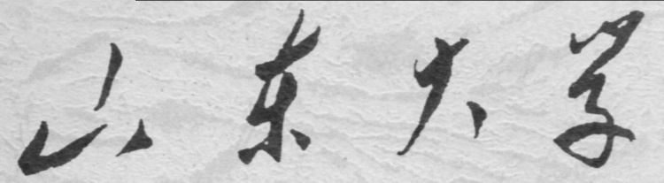

**崇新学堂**

**2022－2023学年第一学期**

实 验 报 告

课程名称： EECS designlab

实验名称： 第五次硬件实验

专 业 班 级 崇新学堂21级

学 生 姓 名 刘浩、施政、张原、池弋

实 验 时 间 2022.10.18

**Step1 and 2**

We completed the procedure and used three k values, **k**=1, **k**=5, **k**=10, to test whether our simulation works correctly. Below is our program and images of the results of our experiment.

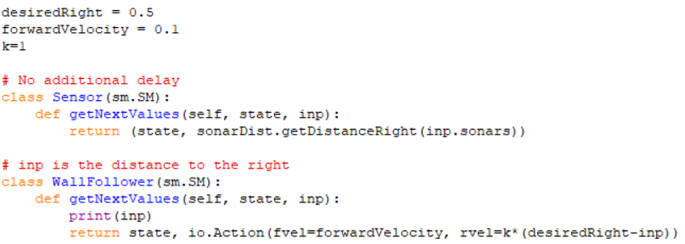

**Check Yourself 1.**

The input of WallFollower is the distance from the wall, and the out put is io.Action (The behavior of the car). The sign of **k** is rad/m .

**Checkoff 1.**

When **k** = 1, T=0.1, V=0.1 the distance to the wall is between 0.35 and 0.65, its period is about 30s. When **k** = 5, it is between 0.43 and 0.57, its period is about 13s. And if **k** = 10, it is between 0.45 and 0.55, its period is about 9s. We find that as **k** continues to grow, the distance is also getting closer and closer to our expectations, and the period is getting shorter and shorter. So we suspect that when **k** increases, the distance becomes more and more desirable, so there is no **k** to make this approach the fastest.

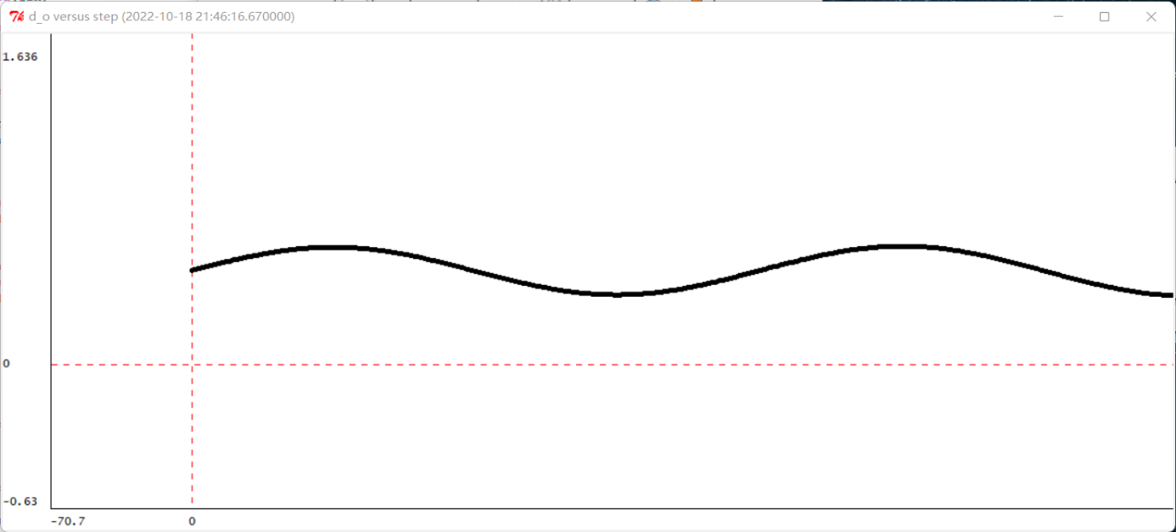

**k=1**

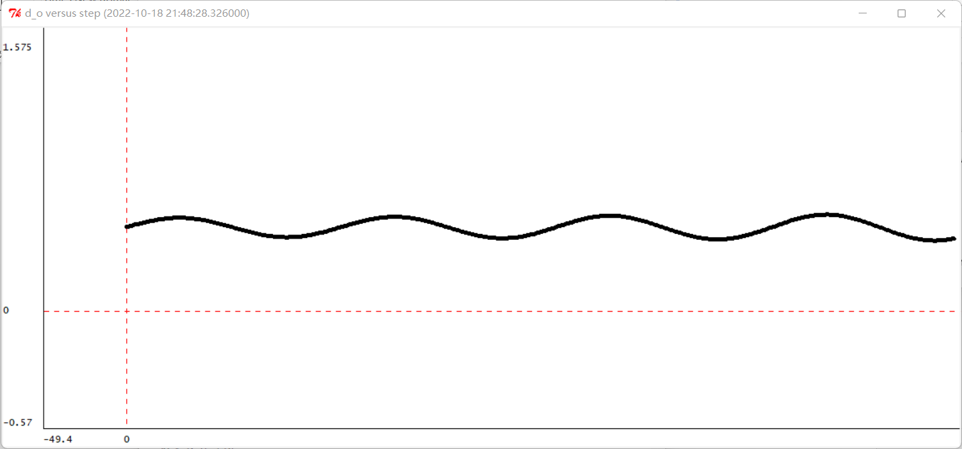

**k=5**

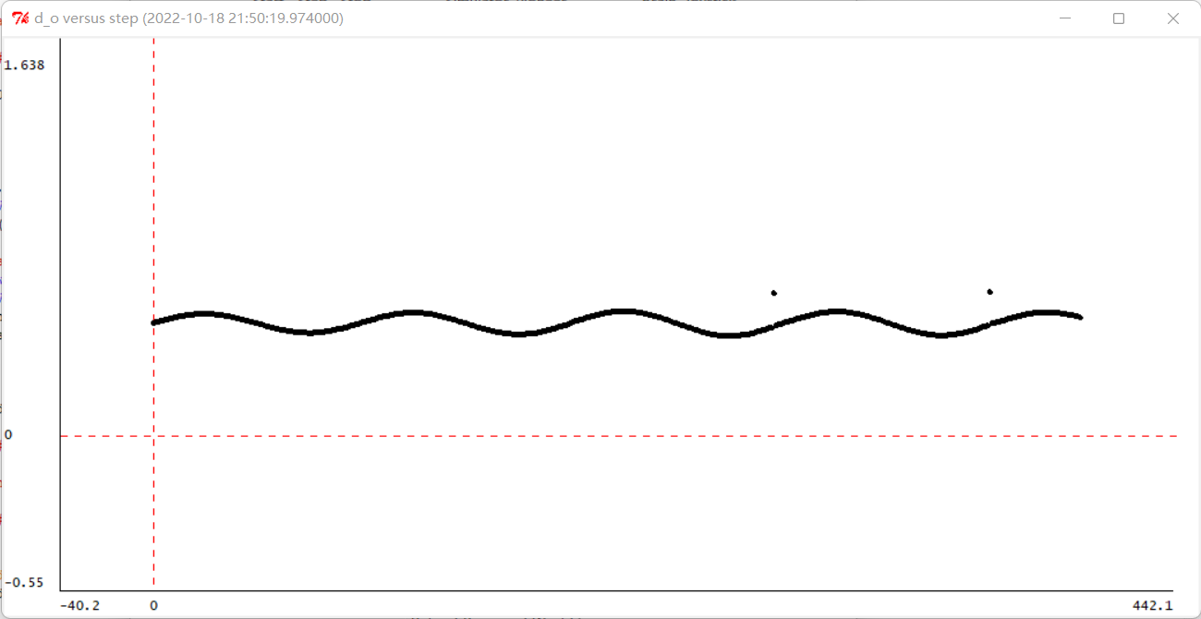

**k=10**

**Step3 and 4:**

Controller model: $ω\left(n\right)=k∙e(n)$

Plant 1: $θ\left(n\right)=T∙ω\left(n-1\right)+θ\left(n-1\right)$

Plant 2: $do\left(n\right)=TV∙θ\left(n-1\right)+do\left(n-1\right)$

**Step5 and 6:**

The H and p that we have calculated is as follows:

$$H=KVT^{2}R^{2}/(KVT^{2}R^{2}+{\left(1-R\right)}^{2})$$

$$p=\sqrt{1+kvT^{2}}e^{±inφ},φ=arctan\sqrt{kvT^{2}}$$

**Step7:**

When k = 1, T = 0.1 second, and V = 0.1 m/s, p $≈e^{±in∙1.81}$, the real and imaginary parts of pn is as followed.

$$p=e^{±in∙1.81}$$

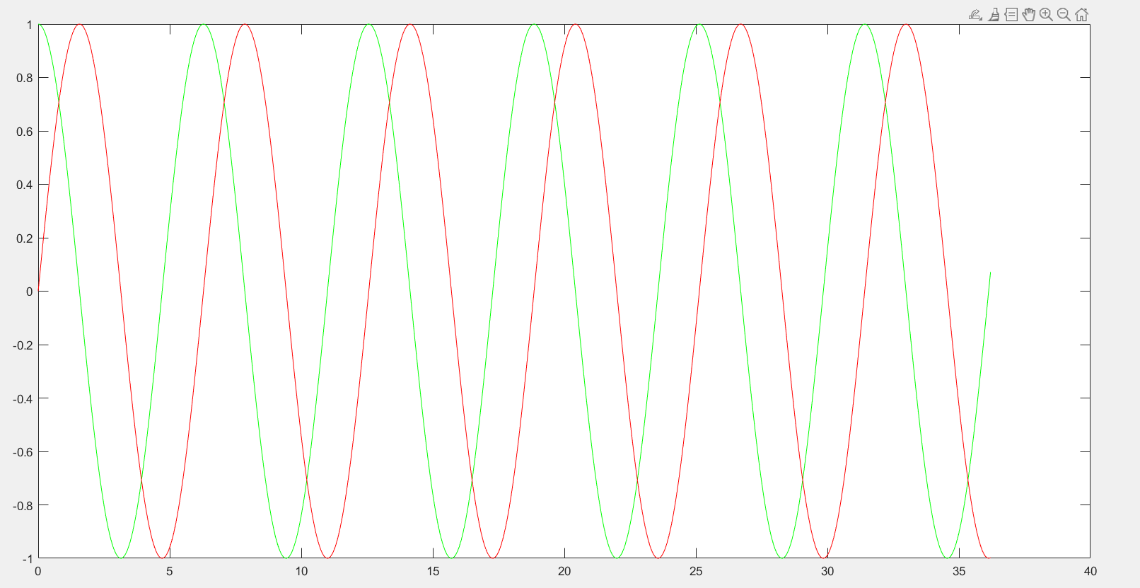

Green represents real and red represents imaginary

**Checkoff 2.**

The pole in this system represents a change in the direction of rotation of the trolley. But this result is a exact value, but in step one, because of measurement interval, the tipping point is often a range, but the exact position is always in that range. The period is the same.

**Check Yourself 2:**

The system block diagram is as follows

Delay

$$e(n)$$

$$ω\left(n\right)$$

K

**Controller model**

Delay

$$ω\left(n\right)$$

$$θ\left(n\right)$$

Delay

T

**Plant 1**

Delay

$$θ\left(n\right)$$

$$do\left(n\right)$$

Delay

VT

**Plant 2**

Finally, block diagrams of the entire system can be combined in the following ways

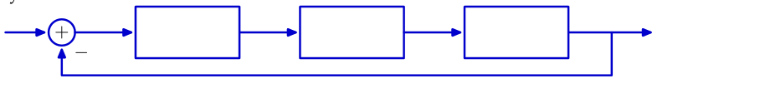

Plant 2

model

Plant 1

model

Controller model

**Step8 and 9:**

The program of our group is as follows:

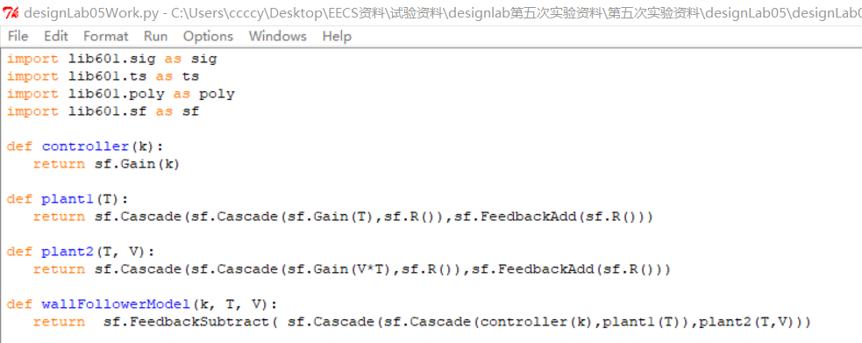

**Step10:**

When T = 0.1 seconds, V = 0.1 m/s, k=1, the pole is (1.001+0.032j), the period is 3.43

When T = 0.1 seconds, V = 0.1 m/s, k=1, the pole is (1.005+0.070j), the period is 1.57

When T = 0.1 seconds, V = 0.1 m/s, k=1, the pole is (1.010+0.098j),

the period is 1.134

When k getting bigger, the period is getting shorter, so there is no appropriate k to make the period the shortest.

**Checkoff 3.**

The results in step 10 is not a exact value, it is a relative value to measure the length of the period, the smaller the period, the less time it actually takes. But the results in checkoff1 are exact value, it is the actual time required for the trolley to finish the work. The same thing is both results can reflect the time required to complete this task, and the different thing is that step 10 is a relative value and checkoff1 is an exact value.

**Summary:**

1. In this lab, we learned system functions and poles and applied them to a real system.

2. When we solve the system functions, due to the complex relationship between the cascade and feedback of the system, it is difficult for us to write the system functions in the form of general difference equations, and finally we use operator expressions to solve them.

3. In this lab, we are exposed to a more complex system than lab four,

and we are able to break down complex systems into several simple systems and analyze them step by step, so that our ability to analyze the system has been improved.