 

**崇新学堂**

**2022－2023学年第一学期**

实 验 报 告

课程名称： EECS

实验名称： Designlab9

专 业 班 级 崇新21

学 生 姓 名 张原 刘浩 施政 池弋

实 验 时 间 2022.11.21

**Step1** **Building the circuit**

According to the circuit diagram below, build the actual circuit on the breadboard.

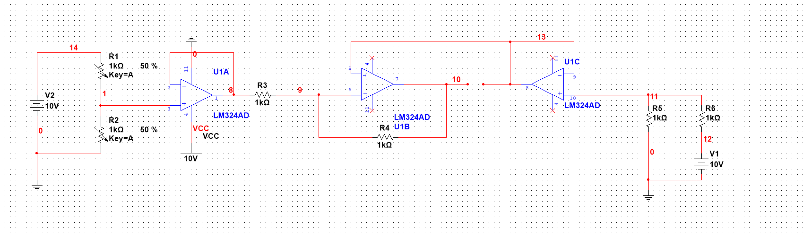

**Figure 1 circuit**

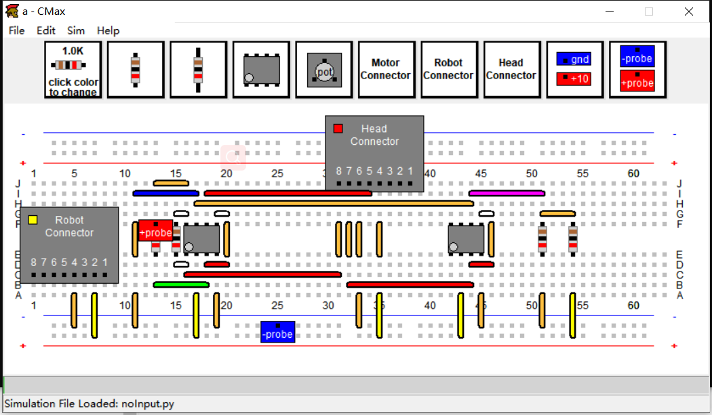

**Figure 2 CMax circuit**

The actual circuit is as follows:

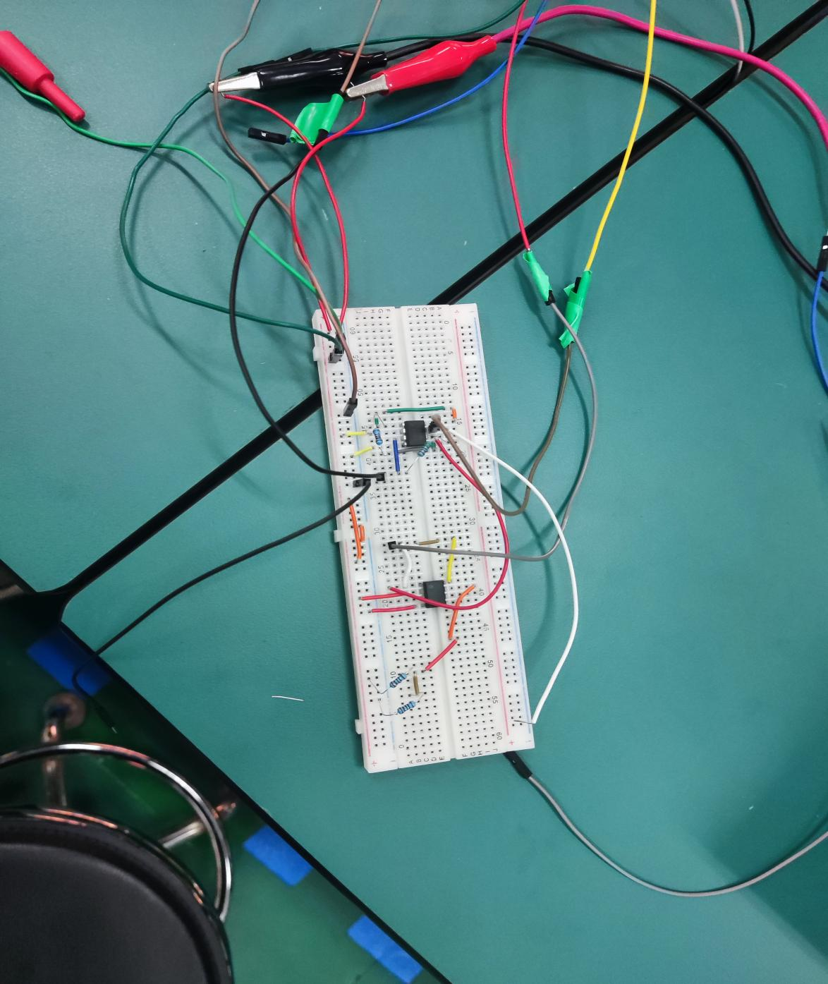

**Figure 3 actual circuit**

Since the 10V voltage source on the car is broken, it cannot be powered, and can only be powered by an independent power source.

**Check Yourself 1. measuring the voltages across the motor**

By lighting at different positions,we got the voltage variation of the motor terminals.

At the following voltages,forward and reverse rotation of motor can be observed.

|  |  |  |  |
| --- | --- | --- | --- |
|  | Left side light | Light in middle | Right side light |
| motor+ | 8.41V | 5.34V | 1.46V |
| motor- | 5.05V | 5.03V | 5.11V |

**Step2.Turn toward the light**

After connecting to the power supply and the motor, the head can turn normally along the light.

The specific results are in the folder-----Result/head Turn toward the light.mp4

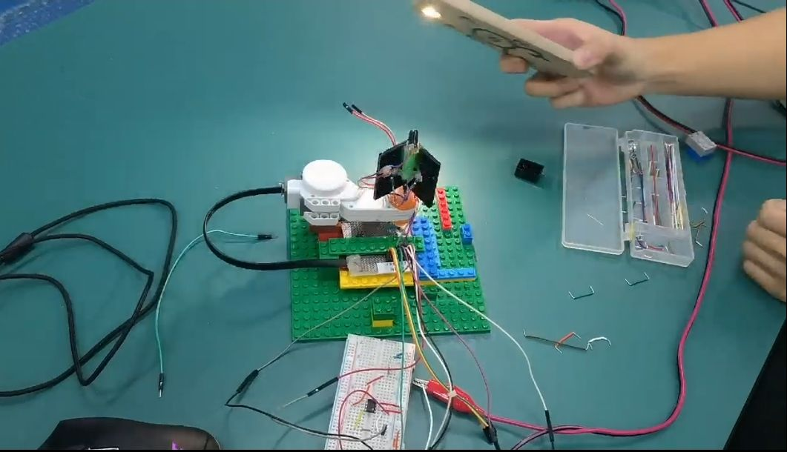

**Figure 4 Turn toward the light**

**Step3.Connect the pin**

When doing the experiment, we found that the link of port 1 of the car was unstable, so we linked port 2 with the middle pin.

**Step4、Step5 and Checkoff 1 .Explore the gain effect**

In this phase, we obtain the response results by modifying the number of gain and running the code.

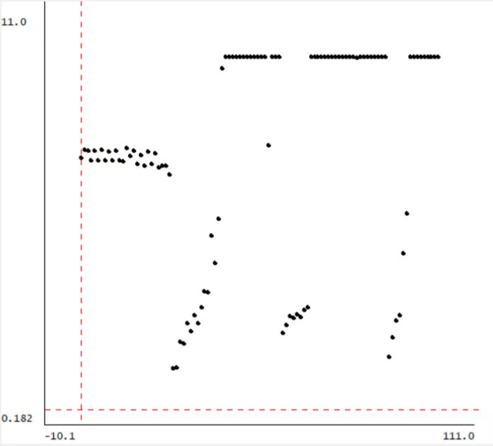

**Figure 5 k_c=0.5,far light**

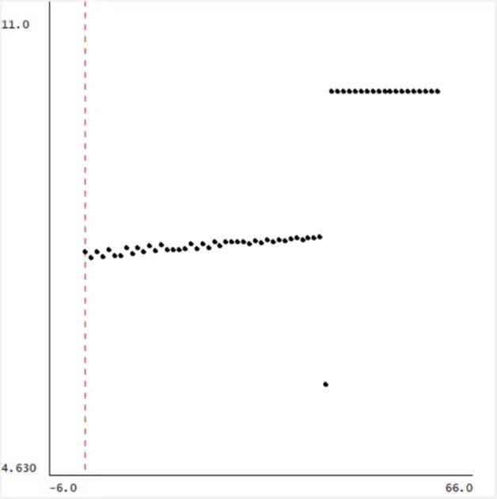

**Figure 6 k_c=0.5,near light**

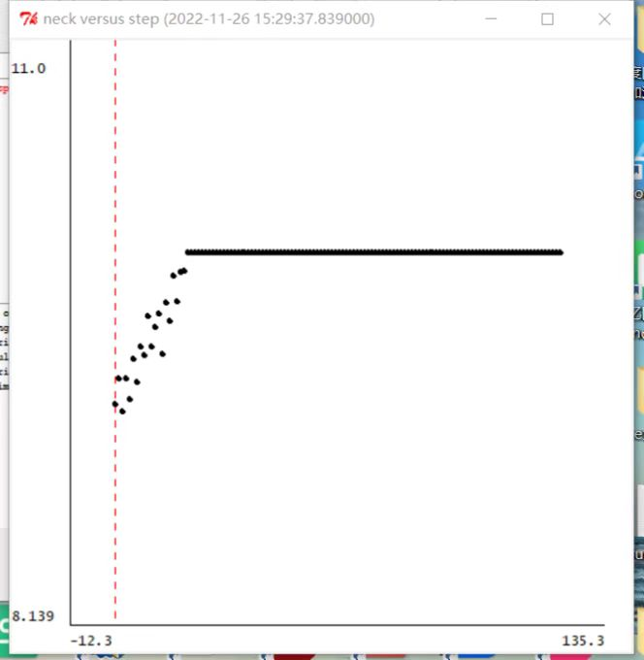

**Figure 7 k_c=1,far light**

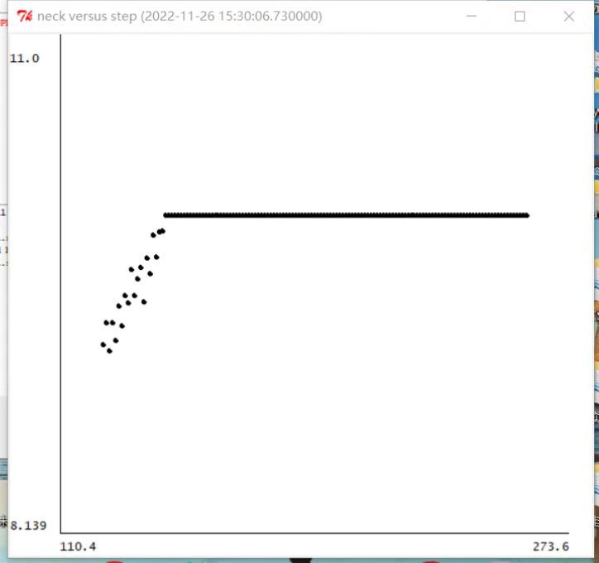

**Figure 8 k_c=1,near light**

We found that in the far light, perhaps because of the influence of the ambient light, the head steering is unstable, and the oscillation phenomenon occurs.

**Step6、Step7 and Checkoff 2. Analog Bull’s Eye**

**Uncorrected:**

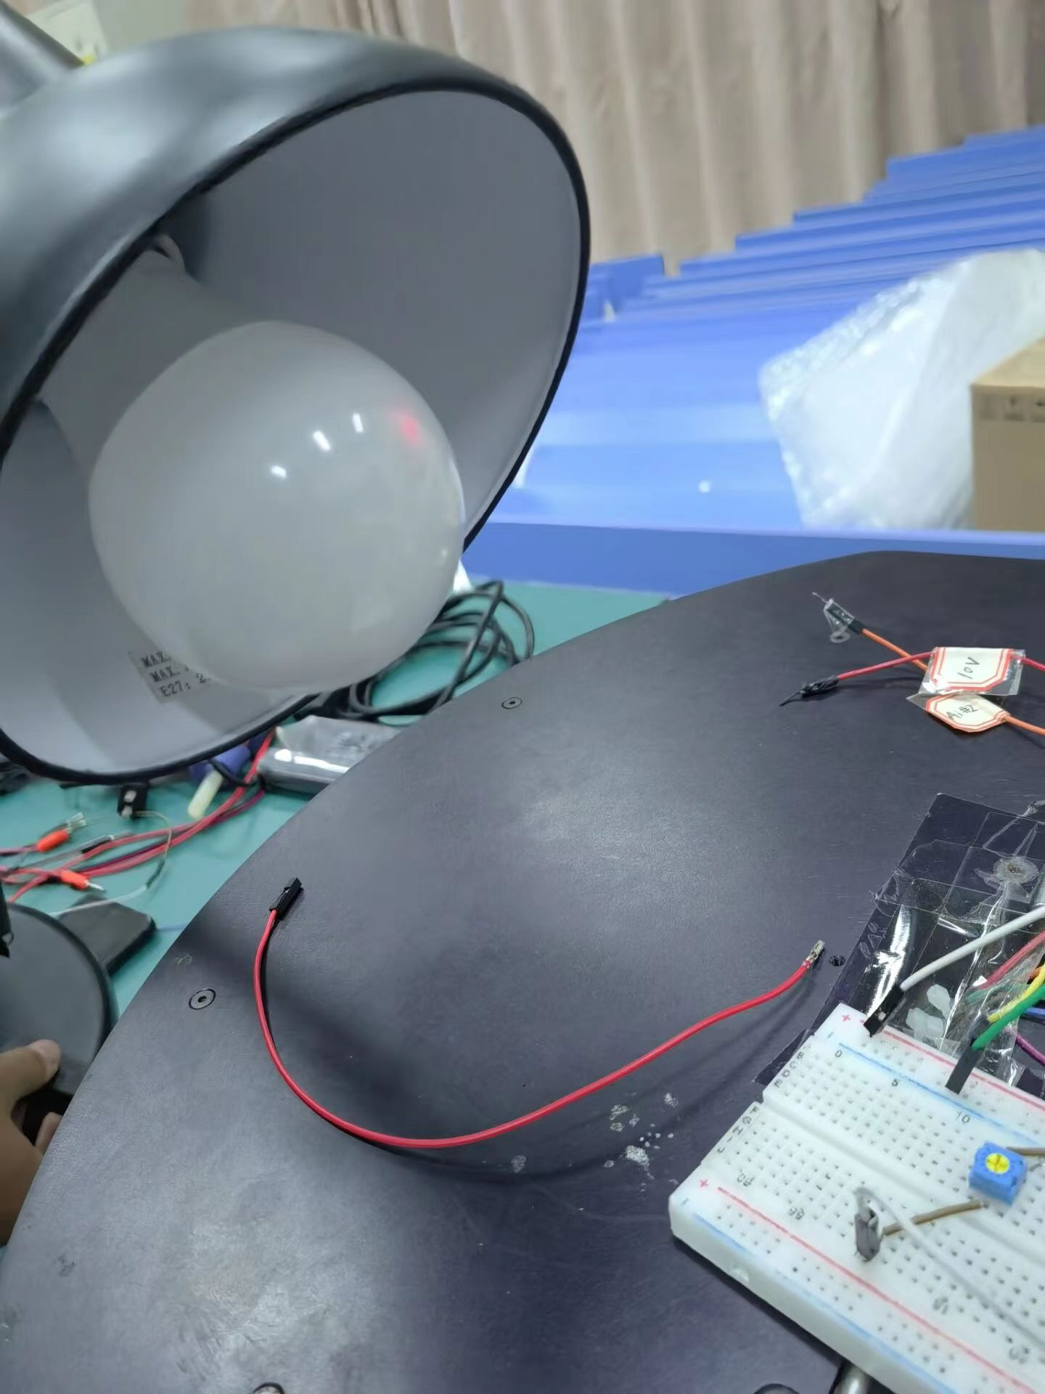

**Figure 9 towards centre of light**

**Corrected:**

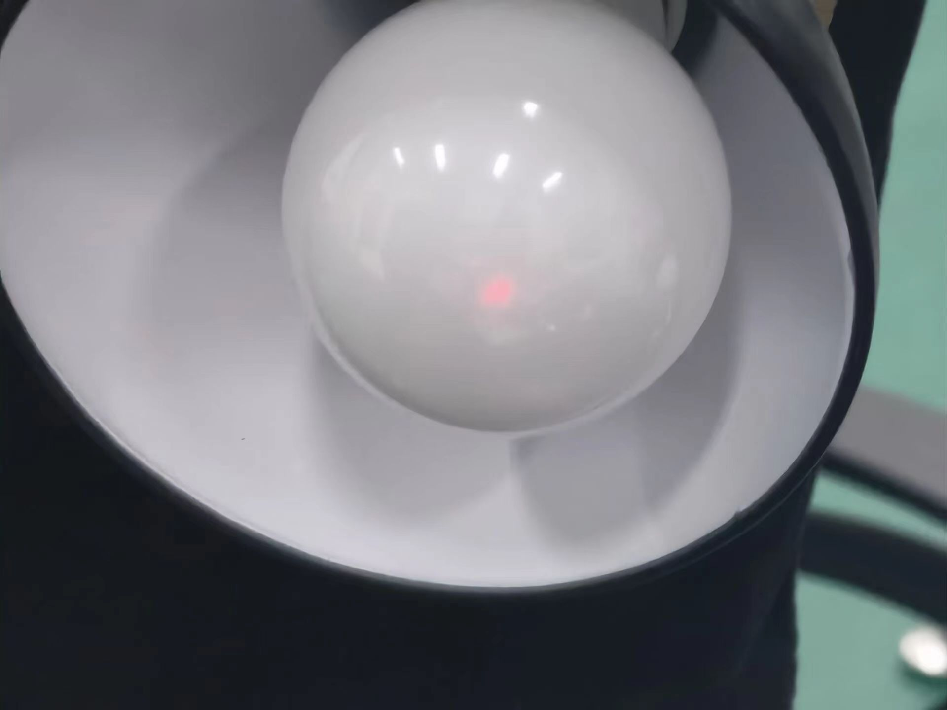

**Figure 10** **towards centre of light**

For the error, it can be reduced by means of series resistance

# Summary

1.When we built the circuit for the first time, we could only use LM358P because there was no KA334, and found that the circuit could not work properly. After the investigation, we found that the voltage difference between the forward input and reverse input of LM358P is too large, and there is no amplification voltage.

2.In the experiment, we realize that the hardware device is susceptible to environmental influence, which leads to the desired effect not being achieved.

3.This experiment, let us have a deeper understanding of the sensor, because this head can be said to be a light sensor. The optical signal is converted into electrical signal, and the electrical signal is used to change the electronic device