 

**崇新学堂**

**2021－2022学年第一学期**

实 验 报 告

课程名称： The Introduction of Electric Engineering and Computer Science

实验名称： design lab 9

专 业 班 级 21崇新

学 生 姓 名 周子爱 陈雨昊 温彦智

实 验 时 间 2022年11月23日

**Step 1.** **Build your circuit on a proto board. Start with a gain that is appropriate for the values of ks that**

**you measured in Software Lab 9, but be sure your circuit can be simply modified to obtain higher**

**or lower gains.** 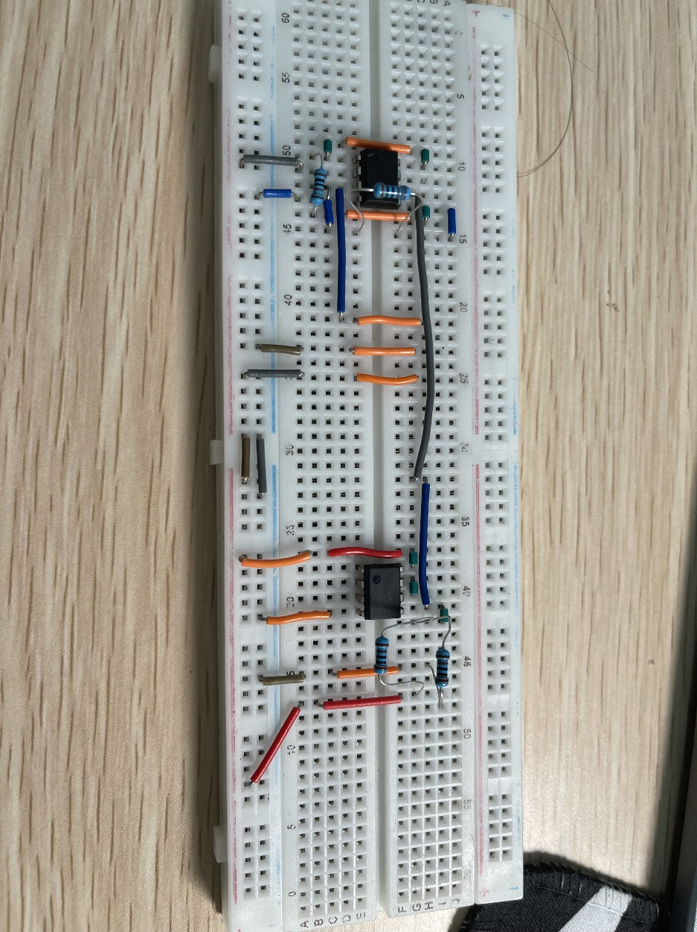

The operational amplifier on the right is the new LM358, and the one on the left is the KA334.

**Check Yourself 1. Verify that your circuit works by measuring the voltages across the motor, being sure that they behave appropriately as you change the light levels on the eyes. Demonstrate the correct behavior to a staff member, who will give you a black cable with which to connect the motor. (Remember that a positive voltage drop across the motor will turn the head to the left) 测量电机两端电压**

**First, we measure the votages across the motor to making sure that they behave appropriately as we change the light levels on the eyes. Then, we open the power and turn the car on, the head is always heading to the light and following to the light’s moving.**

**Step 2.** **T urn off the robot power (which will also turn off power to your circuit), and plug in the black Step**

**cable. Make sure there is a light in front of the robot to which it can turn, and then turn on the**

**robot power just long enough to see how your system behaves, and then turn it back off. If the**

**circuit was wired correctly , the head should turn toward the light. However, if the circuit is wired**

**incorrectly , the head will likely slam against a stop, and the op amp will overheat.1 If the latter**

**happens, then remove the black wire and retest the the head, as in the previous Check Yourself.** 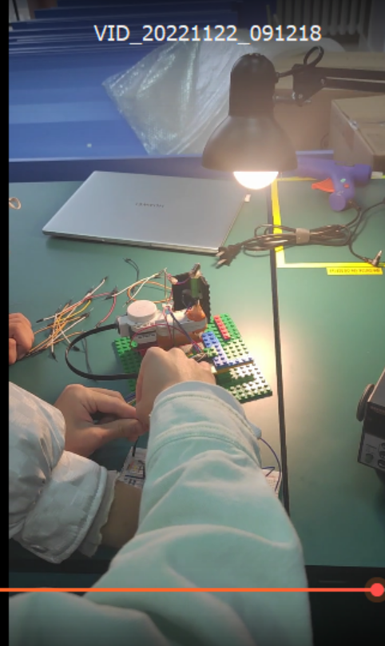 电脑游戏的人

**Step 3.** **Connect the middle pin (pin 2) of the neck potentiometer on the head connector to the first analog**

**input on the robot connector, so that so that the voltage on that analog input is proportional to**

**the pot’s α value. The α value is zero when the pot is turned all the way clockwise. The diagram**

**below shows the resistances between the pins of the potentiometer, for reference. Make sure that**

**you connect pins 1 and 3 on the head connector to power and ground respectively.** 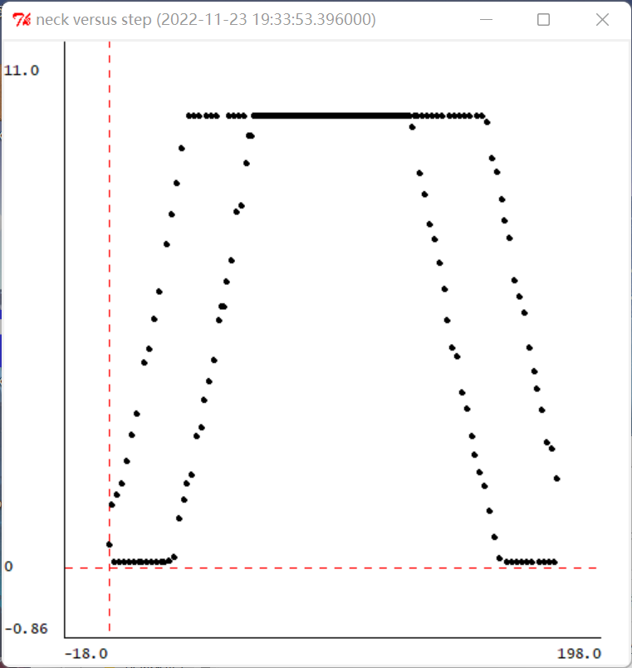

**Voltage image with counterclockwise rotation first and then clockwise rotation**

**It can be seen from the image that the voltage is approximately proportional to theα.**

**Checkoff 1. Wk.9.2.1: Illustrate your circuit and its performance at two different distances with the two gains you investigated. How does the settle time vary with gain and with distance? Keep your plots and measurements to discuss in your interview.**

# 核对 1.Wk.9.2.1：用您研究的两个增益来说明您的电路及其在两个不同距离下的性能。稳定时间如何随增益和距离而变化？保留您的绘图和测量值，以便在面试中讨论。

**The following are some pictures obtained by connecting pioneer to run MIT Program in the laboratory. They are four pictures with different values of gain and different values of distance between small lamp and car.**

**By analyzing the following pictures. We find that when the distance growing, the time of the system used would be more. And the velocity of the head become slower than before. Whatever, the accuracy of directing to lights didn’t changed. It’s stable.**

1. **：**

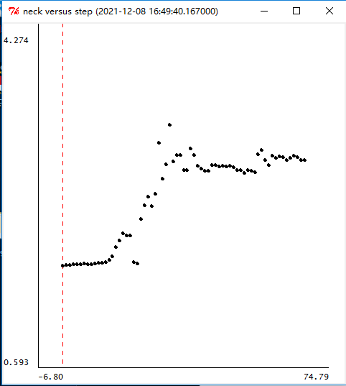

# 

1. **：**

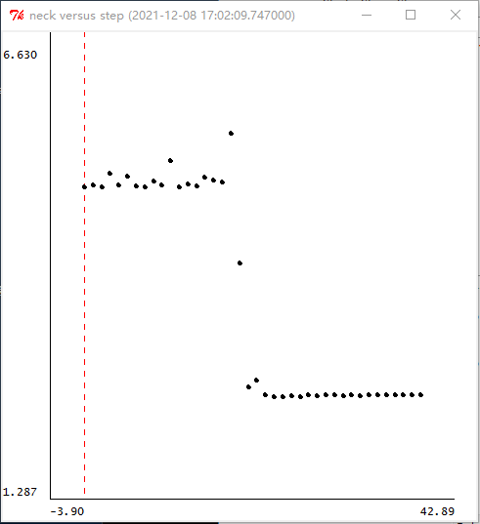

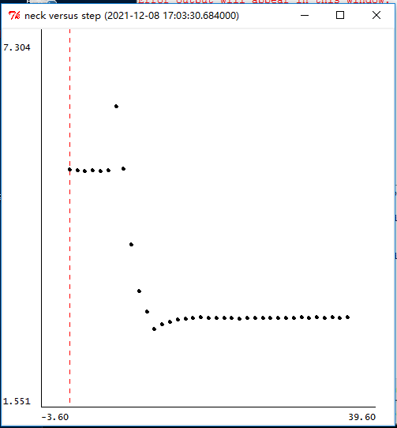

**Step 6. T urn off the power to the robot. Plug the laser connector (small black wire with round connector Now tur n on the power to the robot, and measure head tracking as you did in Step 4 but using a standing lamp (with a shade). The laser light should strike the shade, ideally in its center!**

**near the yellow cable coming out of the robot) into the laser on your robot head.**

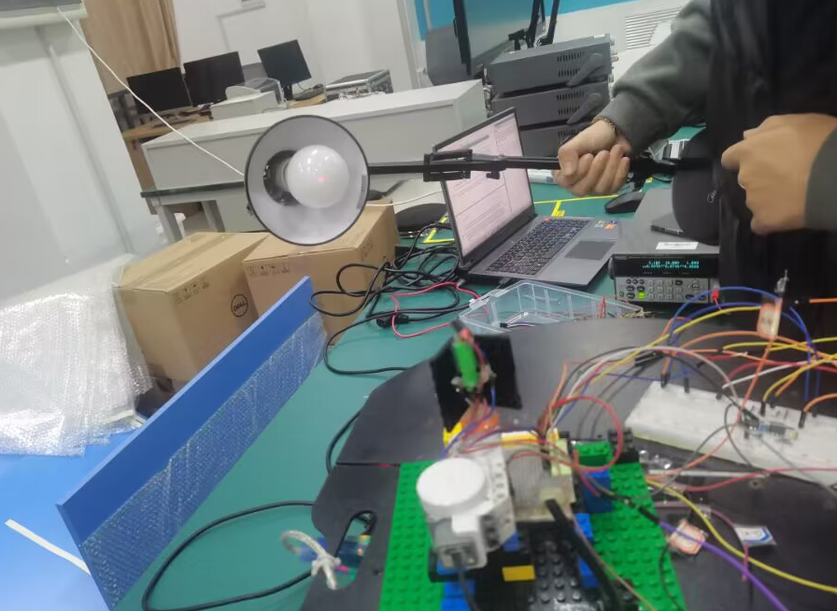

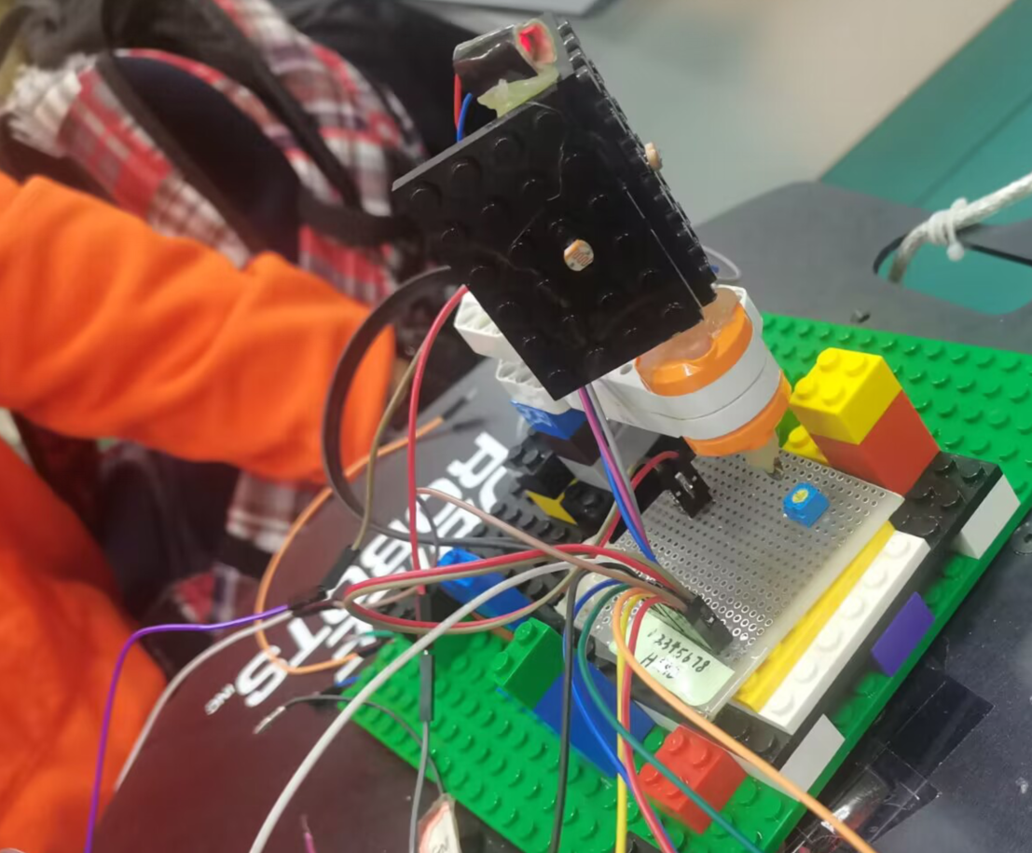

After connecting the laser power supply, turn on the light to complete the trolley steering, and turn off the light and the laser hits the center of the bulb.

**Checkoff 2. Wk.9.2.2: Demonstrate the pointing accuracy of your head. Discuss what you did to your circuit to improve its accuracy. Describe the fundamental limitations to its accuracy**

**At first we fight that our car’s head can turn to the light, but it didn’t look at the right of the light. So we examined the circuit and changed the amplification factor of the amplifying circuit. Also, it is not a sensitive circuit.**

**We found that the voltages of the input01 is different when the light is different, so maybe the voltage of the photosensitive when it turning to the light is a important limitation of the accuracy. Also, magnification of operational amplifier is the fundamental limitations to its accuracy.**

**After a period of experiments, we found a way to improve the accuracy: First, let's make the left and right photoresists ensure that the received light intensity is roughly the same (natural light intensity), and measure the resistance difference between them. On the side where the measured photosensitive resistance is relatively small, we give it a resistance with a difference in series connection.**

**Under the same light conditions, the resistance difference between the two photoresists will change with the change of light intensity, but the added fixed resistance cannot change. That is the fundamental limitations to its accuracy.**

# Summary

**We have been preparing for this experiment for nearly two weeks, and we have read a lot about basic circuits.**

**This experiment made all of us very excited, especially when the experiment was successful - when the head of the car moved with the light source, I almost jumped up. We immediately took a close-up of the situation and recorded a video. In short, the excitement filled the whole screen. Designlab8 we did it four or five times and failed to do it ultimately. We asked other groups which we found whom exactly the same. Many groups gave up, but our group insisted on doing two classes. Of course, it still ended in failure. This Wednesday, we came to do the experiment of designlab9.The circuit of designlab9 uses series circuit with designlab 8. Through the circuit of designlab9, we found that this circuit can miraculously complete the task of designlab8. Therefore, when the head of the car moves sensitively with the light source, we realize the unfinished task of designlab8 have successfully beening solved now.**

**Through this experiment, we learned how to use photoresist to control the rise and fall of voltage, and how to use the circuit principle and related hardware facilities to rotate the motor to rotate the headlight source. In fact, in this course, my partners and I have a comprehensive understanding and in-depth discussion and understanding of circuit structure and design. We know how it works well, and we are familiar with the mode of operation of the car and some built-in features.**

**Through experiments, we have a new understanding of the working mode of the circuit and understand the difference between simulation and theory. We have learned how to use operational amplifiers to build simple circuits to control the rotation of the head and have a more comprehensive understanding of the control and contribution of hardware to the system. We have a more comprehensive understanding of the design and use of the voltage divider. At the same time, I understand how to use pure hardware knowledge to solve some programming problems. In the next experiment, I hope our circuit is more accurate, and we will have a better job next time.**