C_3 generic=1 family liftable nonabelian
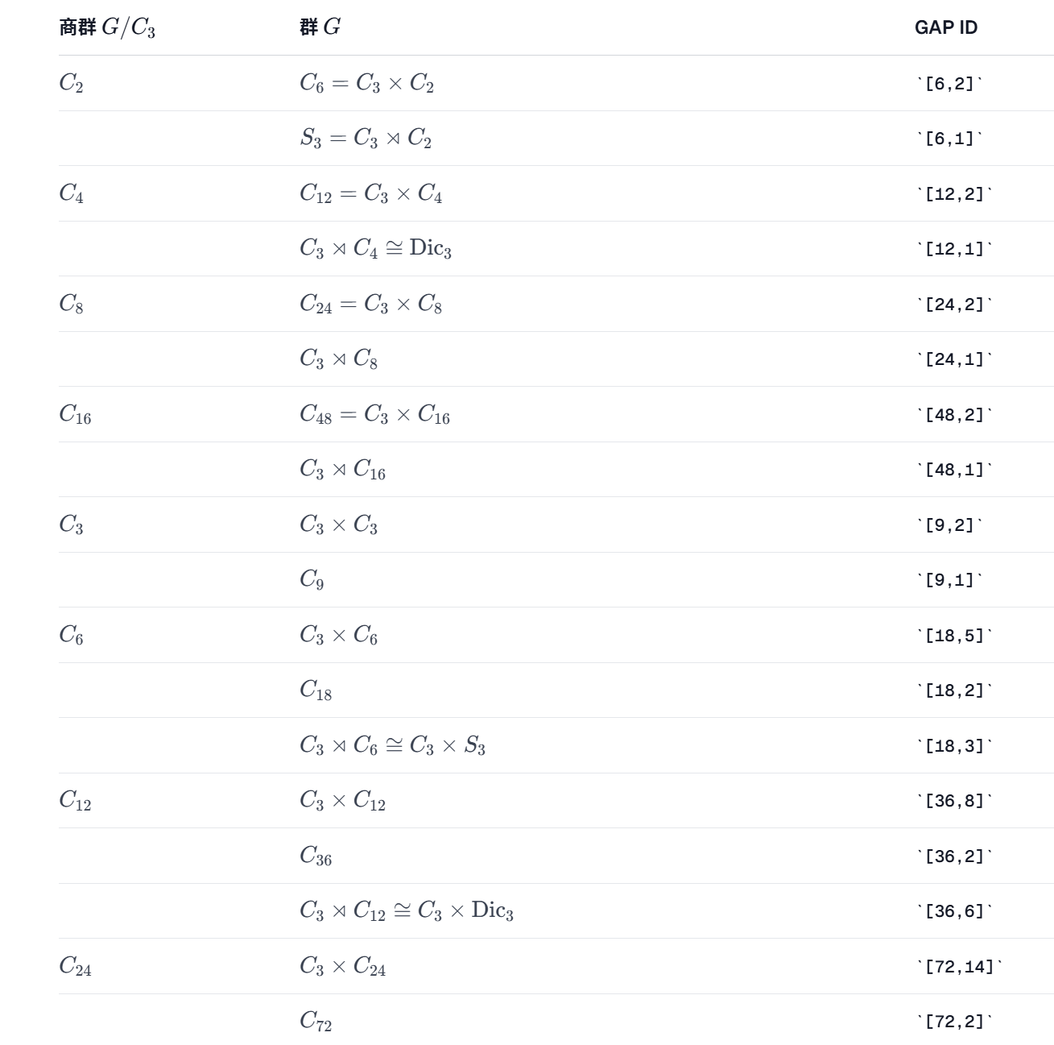
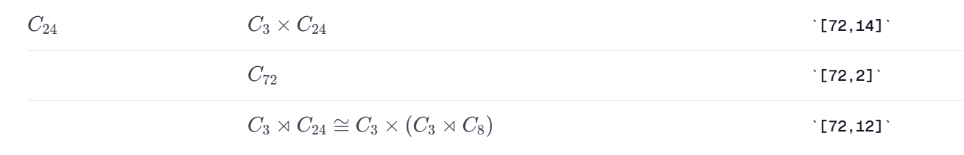
[6,1]:
Family 1 (H ID = [ 18, 3 ])
coefficient-field conductor = 1
admissible split primes = [ 5, 7, 11, 13 ]
coefficient candidates = [ [ 1, 0, 0, 0, 0, 0, 0, 0, 0, 2 ], [ 1, 2, 0, 0, 0, 0, 0, 0, 0, 0 ],
[ 1, 1, 1, 1, 1, 1, 1, 1, 1, 1 ], [ 1, 2, 3, 4, 5, 6, 7, 8, 9, 10 ], [ 1, -2, 3, -4, 5, -6, 7, -8, 9, -10 ],
[ 1, 0, 0, 0, -1, 0, 0, 0, 0, 3 ], [ 4, 12, -7, 5, -10, 6, -5, -14, 8, 3 ],
[ -8, 2, 14, -1, -14, 4, -5, -12, 12, 9 ], [ -10, 2, -13, 3, -8, 12, 5, 15, -3, -4 ],
[ -2, 12, -1, -12, 8, 1, -4, -7, -8, -7 ] ]
prime batch 1: prime 5, members prepared = 10, status = smooth
status = generically smooth
reason = explicit member has zero-dimensional homogeneous Jacobian ideal after good finite-field reduction
smooth witness coefficients = [ 4, 12, -7, 5, -10, 6, -5, -14, 8, 3 ]
good reduction prime = 5
------------------------------------------------------------
FULL DATA FOR STATUS = generically smooth
G ID = [ 6, 1 ]
H ID = [ 18, 3 ]
represented Ext^1 vectors = [ [ ] ]
includes split zero class = true
|Z intersection [H,H]| = 1
projective action type = liftable
H matrix image order = 18
determinant values on H generators = [ -1, 1, 1 ]
symplectic kernel order = 9
Ker(det|H) contained in <input K0,mu_3> = true
number of stored H matrix generators = 3
H matrix generators:
generator 1 = [ [ 1, 0, 0, 0, 0, 0 ], [ 0, -1, 0, 0, 0, 0 ], [ 0, 0, 0, 0, -8/13, 17/26 ],
[ 0, 0, 0, 0, 3/13, 31/26 ], [ 0, 0, -31/23, 17/23, 0, 0 ], [ 0, 0, 6/23, 16/23, 0, 0 ] ]
generator 2 = [ [ 1, 0, 0, 0, 0, 0 ], [ 0, 1, 0, 0, 0, 0 ], [ 0, 0, E(3)^2, 0, 0, 0 ], [ 0, 0, 0, E(3)^2, 0, 0 ],
[ 0, 0, 0, 0, E(3), 0 ], [ 0, 0, 0, 0, 0, E(3) ] ]
generator 3 = [ [ E(3), 0, 0, 0, 0, 0 ], [ 0, E(3), 0, 0, 0, 0 ], [ 0, 0, E(3), 0, 0, 0 ],
[ 0, 0, 0, E(3), 0, 0 ], [ 0, 0, 0, 0, E(3), 0 ], [ 0, 0, 0, 0, 0, E(3) ] ]
dim strict cubic invariants = 10
dim matrix centralizer = 6
family dimension = 4
cubic invariant equation basis:
basis[1] = x4^3+4913/12167*x5^3+13872/12167*x5^2*x6+13056/12167*x5*x6^2+4096/12167*x6^3
basis[2] = x3*x4^2-8959/12167*x5^3-15130/12167*x5^2*x6-4672/12167*x5*x6^2+1536/12167*x6^3
basis[3] = x3^2*x4+16337/12167*x5^3+9052/12167*x5^2*x6-5340/12167*x5*x6^2+576/12167*x6^3
basis[4] = x3^3-29791/12167*x5^3+17298/12167*x5^2*x6-3348/12167*x5*x6^2+216/12167*x6^3
basis[5] = x2*x3*x5+16/17*x2*x3*x6+31/17*x2*x4*x5-6/17*x2*x4*x6
basis[6] = x1*x4*x5+16/17*x1*x4*x6
basis[7] = x1*x3*x6+31/17*x1*x4*x6
basis[8] = x1*x3*x5+6/17*x1*x4*x6
basis[9] = x1*x2^2
basis[10] = x1^3
------------------------------------------------------------
[12,1]:no such family
No need to consider [36,6]
[18,3]:
Family 1 (H ID = [ 54, 12 ])
status = generically smooth
reason = explicit member has smooth reduction at a good split prime; hence the characteristic-zero member is smooth
smooth witness coefficients = [ 1, 0, 0, 0, 0 ]
good reduction prime = 11
------------------------------------------------------------
FULL DATA FOR STATUS = generically smooth
G ID = [ 18, 3 ]
H ID = [ 54, 12 ]
represented Ext^1 vectors = [ [ 0 ] ]
includes split zero class = true
|Z intersection [H,H]| = 1
projective action type = liftable
H matrix image order = 54
determinant values on H generators = [ -1, E(3), 1, 1 ]
symplectic kernel order = 9
Ker(det|H) contained in <input K0,mu_3> = true
H matrix generators:
generator 1 = [ [ 11/5, 12/5, 0, 0, 0, 0 ], [ -8/5, -11/5, 0, 0, 0, 0 ], [ 0, 0, 0, 0, 5/3, 2/3 ],
[ 0, 0, 0, 0, 16/15, -2/15 ], [ 0, 0, 1/7, 5/7, 0, 0 ], [ 0, 0, 8/7, -25/14, 0, 0 ] ]
generator 2 = [ [ E(3)^2, 0, 0, 0, 0, 0 ], [ 0, E(3)^2, 0, 0, 0, 0 ], [ 0, 0, E(3), 0, 0, 0 ],
[ 0, 0, 2/5*E(3)-2/5*E(3)^2, E(3)^2, 0, 0 ], [ 0, 0, 0, 0, 5/7*E(3)+2/7*E(3)^2, 2/7*E(3)-2/7*E(3)^2 ],
[ 0, 0, 0, 0, 5/7*E(3)-5/7*E(3)^2, 2/7*E(3)+5/7*E(3)^2 ] ]
generator 3 = [ [ 1, 0, 0, 0, 0, 0 ], [ 0, 1, 0, 0, 0, 0 ], [ 0, 0, E(3)^2, 0, 0, 0 ], [ 0, 0, 0, E(3)^2, 0, 0 ],
[ 0, 0, 0, 0, E(3), 0 ], [ 0, 0, 0, 0, 0, E(3) ] ]
generator 4 = [ [ E(3), 0, 0, 0, 0, 0 ], [ 0, E(3), 0, 0, 0, 0 ], [ 0, 0, E(3), 0, 0, 0 ],
[ 0, 0, 0, E(3), 0, 0 ], [ 0, 0, 0, 0, E(3), 0 ], [ 0, 0, 0, 0, 0, E(3) ] ]
dim strict cubic invariants = 5
dim matrix centralizer = 4
family dimension = 1
cubic invariant equation basis:
basis[1] = x4^3+125/343*x5^3-1875/686*x5^2*x6+9375/1372*x5*x6^2-15625/2744*x6^3
basis[2] = x3^3+6/5*x3^2*x4+12/25*x3*x4^2+19/343*x5^3+141/343*x5^2*x6-69/343*x5*x6^2+152/343*x6^3
basis[3] = x1*x4*x5-5/2*x1*x4*x6-1/2*x2*x4*x5+5/4*x2*x4*x6
basis[4] = x1^2*x2-17/12*x1*x2^2+11/24*x2^3
basis[5] = x1^3-11/8*x1*x2^2+9/16*x2^3
------------------------------------------------------------

Family 2 (H ID = [ 54, 12 ])
status = unknown
reason = no smooth witness and no family-wide singularity certificate completed within the configured bounds
------------------------------------------------------------
FULL DATA FOR STATUS = unknown
G ID = [ 18, 3 ]
H ID = [ 54, 12 ]
represented Ext^1 vectors = [ [ 0 ] ]
includes split zero class = true
|Z intersection [H,H]| = 1
projective action type = liftable
H matrix image order = 54
determinant values on H generators = [ -1, E(3)^2, 1, 1 ]
symplectic kernel order = 9
Ker(det|H) contained in <input K0,mu_3> = true
H matrix generators:
generator 1 = [ [ 1/9, -4/9, 0, 0, 0, 0 ], [ -20/9, -1/9, 0, 0, 0, 0 ], [ 0, 0, 0, 0, 0, -1 ],
[ 0, 0, 0, 0, 1, -7/5 ], [ 0, 0, -7/5, 1, 0, 0 ], [ 0, 0, -1, 0, 0, 0 ] ]
generator 2 = [ [ E(3)^2, 0, 0, 0, 0, 0 ], [ 0, E(3)^2, 0, 0, 0, 0 ], [ 0, 0, E(3), 0, 0, 0 ],
[ 0, 0, 0, E(3), 0, 0 ], [ 0, 0, 0, 0, E(3), 0 ], [ 0, 0, 0, 0, 0, E(3) ] ]
generator 3 = [ [ 1, 0, 0, 0, 0, 0 ], [ 0, 1, 0, 0, 0, 0 ], [ 0, 0, E(3)^2, 0, 0, 0 ], [ 0, 0, 0, E(3)^2, 0, 0 ],
[ 0, 0, 0, 0, E(3), 0 ], [ 0, 0, 0, 0, 0, E(3) ] ]
generator 4 = [ [ E(3), 0, 0, 0, 0, 0 ], [ 0, E(3), 0, 0, 0, 0 ], [ 0, 0, E(3), 0, 0, 0 ],
[ 0, 0, 0, E(3), 0, 0 ], [ 0, 0, 0, 0, E(3), 0 ], [ 0, 0, 0, 0, 0, E(3) ] ]
dim strict cubic invariants = 6
dim matrix centralizer = 6
family dimension = 0
cubic invariant equation basis:
basis[1] = x4^3+x5^3
basis[2] = x3*x4^2-7/5*x5^3-x5^2*x6
basis[3] = x3^2*x4+49/25*x5^3+14/5*x5^2*x6+x5*x6^2
basis[4] = x3^3-343/125*x5^3-147/25*x5^2*x6-21/5*x5*x6^2-x6^3
basis[5] = x1^2*x2-7/4*x1*x2^2-1/2*x2^3
basis[6] = x1^3+3/2*x1*x2^2-11*x2^3
------------------------------------------------------------
[36,6]: no such family
[24,1]: no such family, no need to consider [72,12]
[48,1]: no such family.

