Project Design Phase-II
Technology Stack (Architecture & Stack)

Date | 18 june 2026
Team ID
Project Name | Online Complaint Registration and Management System
Maximum Marks | 4 Marks

Technical Architecture:
OCMS - SYSTEM ARCHITECTURE
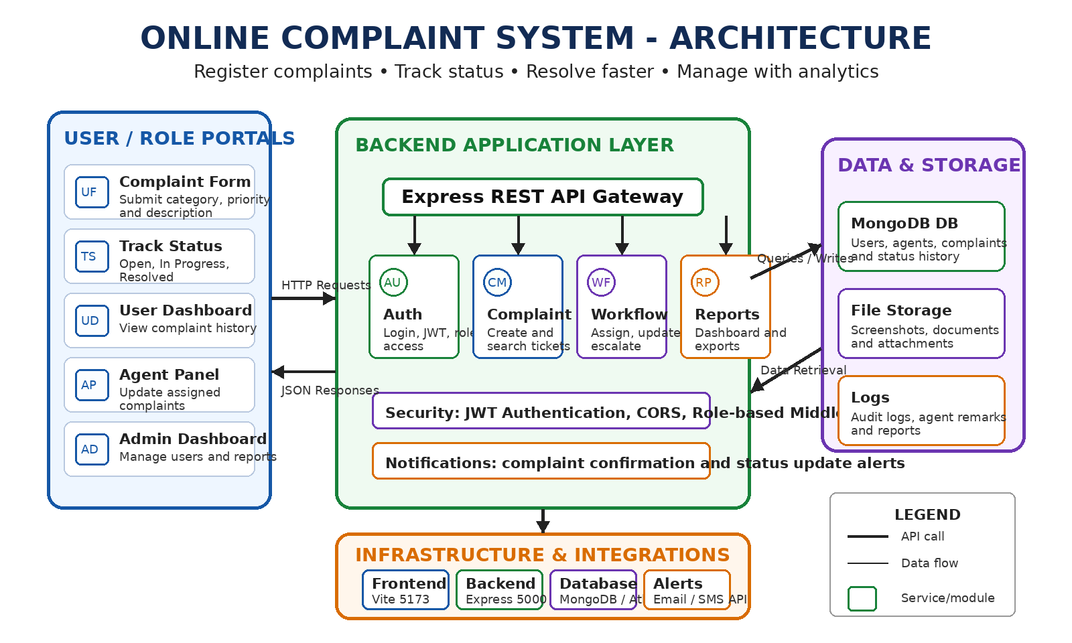
Table-1 : Components & Technologies:
S.No | Component | Description | Technology
1. | User Interface | Responsive web application for users, agents and admins to submit complaints, track status and monitor resolutions | HTML5, CSS3, JavaScript ES6+, React.js, Vite
2. | Application Logic-1 | User registration, login authentication, role-based access and session management | Node.js, Express.js, JWT
3. | Application Logic-2 | Complaint submission, category selection, priority assignment and complaint search | Node.js, Express.js
4. | Application Logic-3 | Agent assignment, complaint status workflow, resolution remarks and escalation handling | Node.js, Express.js
5. | Database | Stores users, agents, complaints, attachments, status history and analytics data | MongoDB, Mongoose ODM
6. | Cloud Database | Cloud-based deployment support for secure and scalable complaint records | MongoDB Atlas
7. | File Storage | Stores complaint screenshots, documents and supporting attachments | Local File System Storage
8. | External API-1 | Email or SMS alert service for complaint registration and status updates | SMTP Email API / Twilio SMS API
9. | External API-2 | Authentication token verification and protected route authorization | JWT Authentication
10. | Machine Learning Model | Not applicable for current implementation; can be added later for category prediction | N/A
11. | Infrastructure (Server / Cloud) | Frontend: Vite (5173), Backend: Express (5000), Database: MongoDB | Local Host Node Runtime

Table-2: Application Characteristics:
S.No | Characteristics | Description | Technology
1. | Open-Source Frameworks | Uses open-source libraries for rapid development, maintainability and community support | React.js, Express.js, MongoDB, Mongoose
2. | Security Implementations | Secure authentication, password protection, role-based access and protected complaint APIs | JWT, Middleware Security, Route Protection
3. | Scalable Architecture | 3-Tier architecture separating frontend portal, backend services and database layer | React + Express + MongoDB
4. | Availability | Stateless REST APIs support reliable access for users, agents and admin dashboard modules | JWT Authentication, REST APIs
5. | Performance | Optimized frontend loading, efficient database queries and faster complaint status updates | Vite, MongoDB Optimization, React Rendering

