StatAve
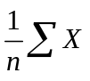

StatAveDev
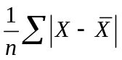

StatChiTest
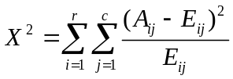

StatConfidence

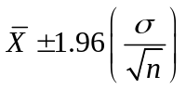
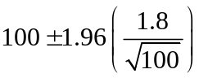

StatCorrel
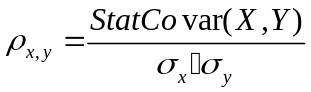

StatCover
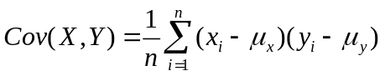

StatDist
Beta Distribution
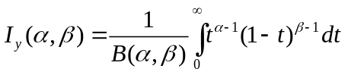 where y is (x-A)/(B-A)

Binomial Distribution
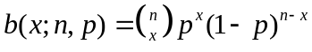
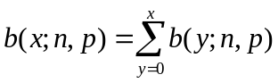

Exponential Distribution
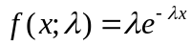

F Distribution
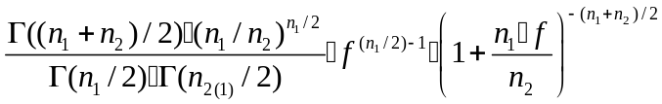

Gamma Distribution
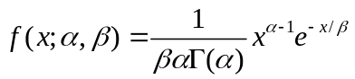

HyperGeometric Distribution

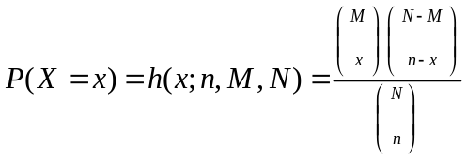

LogNormal
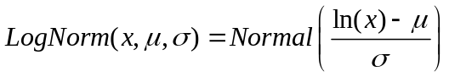

Negative Binomial Distribution
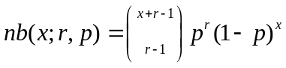

Normal Distribution
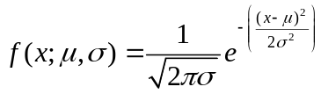

Normal Standard Distribution
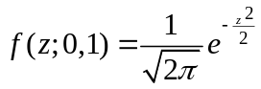

Poisson
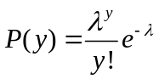
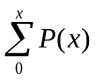

Student’s T
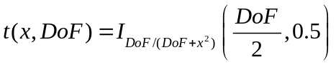

Weibull Distribution
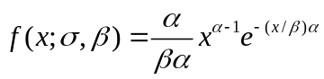

StatFisher
Descritption
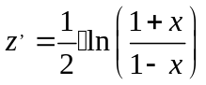

StarFisher-inverse of the fisher transformation

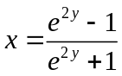
StatGeoMean

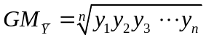
StatHarMean
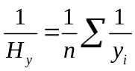
StatKurtosis
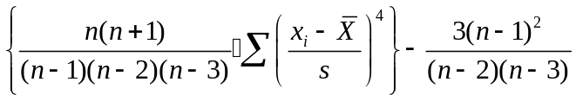
StatPearson
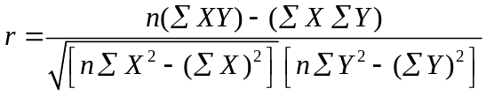
StatPermute
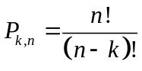
StatRSQ
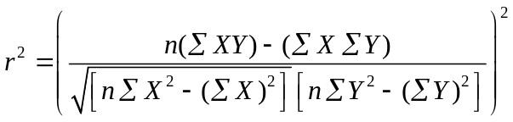
StatSkew
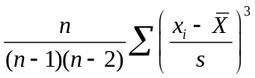
StatSlope

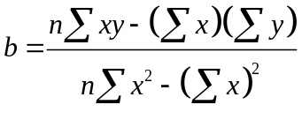
StatStdDev

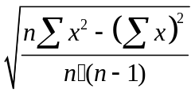
StatStdDevP
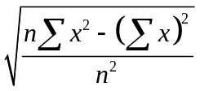
StatStdErrYX
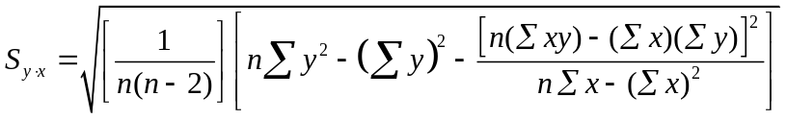
StatSumSq
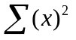
StatSumX2Y2
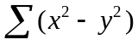
StatSumX2pY2
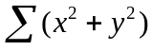
StatSumXmY2
StaTTest
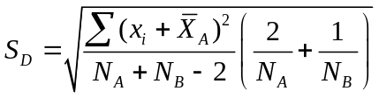 and 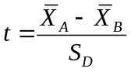
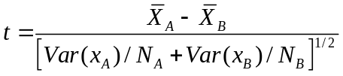 And for paired- 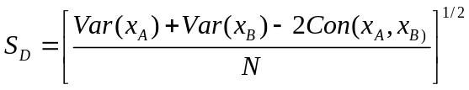and
StatVar
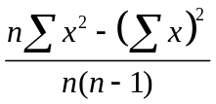
StatVarP
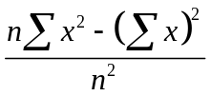
StatZTest
