Software Architecture and Design Specification
Project: Vehicle Parking System
Version: 1.0
Authors: Project Team
Date: 30-09-2026
Status: Draft

Revision History
Version | Date | Author | Change Summary
1.0 | 30-09-2026 | Project Team | Initial SAD draft

Approvals
Role | Name | Signature/Date
Product Owner | Anirudh G Achar |
QA Lead | Daruru Bhuvan Sai |
Test Engineer | Y V BHAVANA |
Developer | Kshitij Gupta |

1. Introduction
1.1 Purpose
This document specifies the architecture and design of the Vehicle Parking System (VPS).
1.2 Scope
Covers driver services: registration, slot search, online reservation, payment, and ticketing; and staff services: lot configuration, occupancy monitoring, attendant management, and reporting.
1.3 Audience
Developers, QA engineers, system integrators, parking facility operators, and assessment evaluators.
1.4 Definitions
VPS, ANPR, QR, RFID, API, JWT, RBAC, TLS, ADR.

2. Document Overview
2.1 How to use this document
Provides architectural deliverables including UML diagrams, architecture rationale, threat model, and API design.
2.2 Related Documents
SRS, STP, RTM.

3. Architecture
3.1 Goals & Constraints
Goals: secure, reliable, 99.5% availability for reservation and payment services, entry/exit transactions within 3 seconds. Constraints: no double allocation of slots (atomic slot locking), payment gateway integration via REST APIs, data-protection compliance, tolerance to intermittent gate-controller connectivity.
3.2 Stakeholders & Concerns
Drivers: fast booking, clear fees, data privacy
Parking Attendants: simple override interface, real-time occupancy
Admin / Facility Operators: configurability, reporting
Developers: modularity.

3.3 Component (UML) Diagram

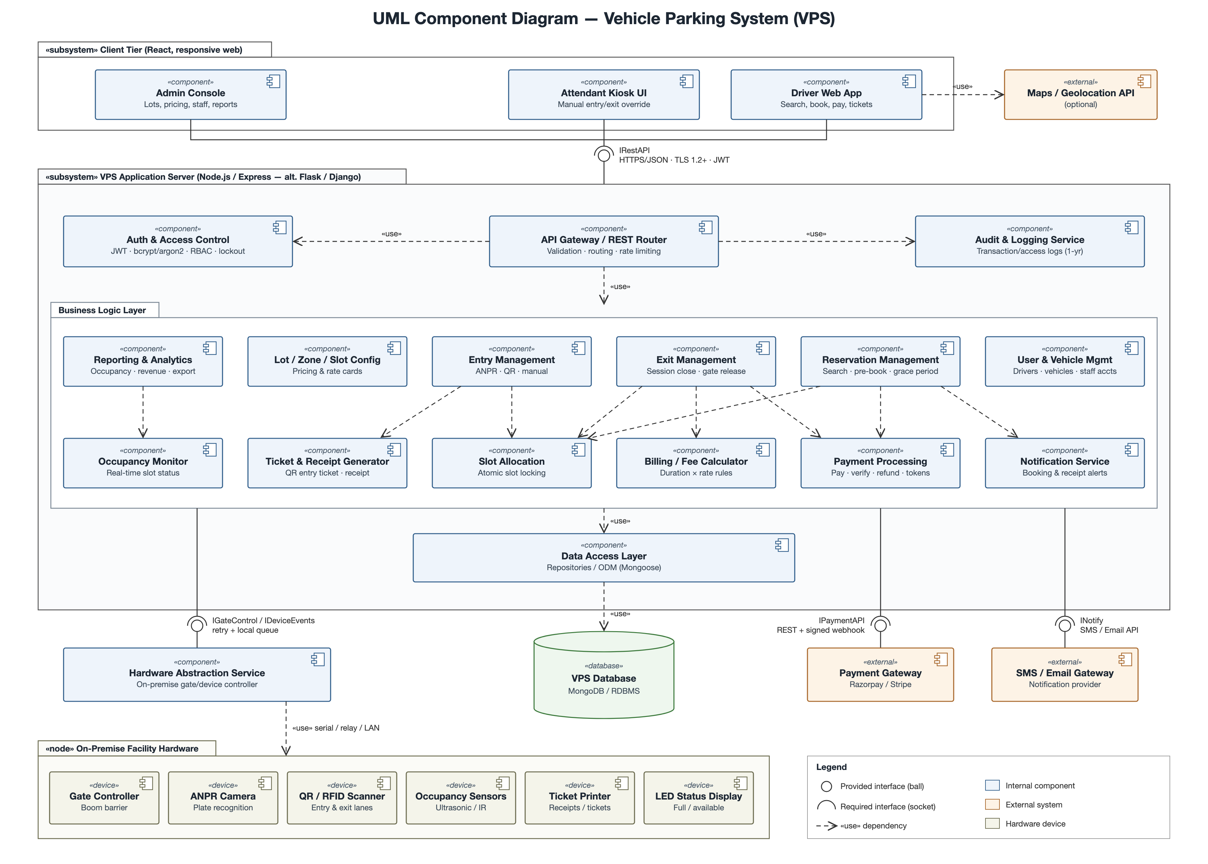

3.4 Component Descriptions
- Driver Web App: slot search, reservation, payment, and tickets for drivers.
- Attendant Kiosk UI: manual entry/exit override and occupancy view for attendants.
- Admin Console: lot, zone, slot, pricing, staff account, and report management.
- API Gateway / REST Router: validates and routes all client requests.
- Auth & Access Control: JWT authentication, password hashing, RBAC, account lockout.
- Audit & Logging Service: records transaction and access logs.
- Entry Management: captures vehicle entry via ANPR, QR, or manual input and creates sessions.
- Exit Management: closes sessions and releases the exit barrier after payment.
- Reservation Management: slot search and online pre-booking with grace period.
- Slot Allocation: allocates the nearest matching slot using atomic slot locking.
- Billing / Fee Calculator: calculates fees from duration and rate cards.
- Payment Processing: online and at-gate payments, refunds, and payment verification.
- Ticket & Receipt Generator: issues QR entry tickets and receipts.
- Notification Service: sends booking confirmations and receipts via SMS/Email.
- Lot / Zone / Slot Config: facility, slot, and pricing configuration.
- Occupancy Monitor & Reporting: real-time occupancy, revenue, and usage reports.
- User & Vehicle Management: driver profiles, vehicles, and attendant accounts.
- Data Access Layer: repository/ODM access to the database.
- Hardware Abstraction Service: interface to gate controllers, scanners, sensors, and printers.
- Database: user, vehicle, slot, session, reservation, and transaction data storage.
- Payment Gateway / SMS-Email Gateway: external services for payments and notifications.

3.5 Chosen Architecture Pattern and Rationale
Layered architecture chosen for clear separation of concerns, with a separate hardware abstraction service to isolate gate hardware from business logic. Microservices rejected as overly complex for the system scale.

3.6 Technology Stack & Data Stores
React front end, Node.js/Express REST APIs (Python Flask/Django as alternative backend), MongoDB (relational database for the Flask/Django variant), JWT authentication, TLS 1.2+ encryption. Razorpay/Stripe sandbox for payments.

3.7 Risks & Mitigations
Risk: double allocation of a slot under concurrent bookings → Mitigation: atomic slot locking.
Risk: network loss to gate controllers → Mitigation: local queuing with retry/backoff and manual attendant override.
Risk: payment gateway downtime → Mitigation: signed webhook confirmation with retry and at-gate payment option.

3.8 Traceability to Requirements
VPS-F-001 (Capture vehicle entry) → Entry Management
VPS-F-002 (Auto slot allocation) → Slot Allocation
VPS-F-010 (Calculate parking fee) → Billing / Fee Calculator
VPS-F-011 (Verify payment before exit) → Payment Processing
VPS-F-020 (Online slot reservation) → Reservation Management
VPS-NF-001 (Transaction response time) → Web UI / API Gateway
VPS-SR-001 (TLS 1.2+ enforcement) → All Components
VPS-SR-003 (Role-based access control) → Auth & Access Control

3.9 Security Architecture
Threat Modeling (STRIDE): Spoofing → JWT authentication and account lockout; Tampering → signed payment webhooks and server-side fee calculation; Repudiation → audit logs; Info disclosure → TLS, hashed passwords, tokenized card data; DoS → rate limiting; Elevation of Privilege → RBAC.

4. Design

4.1 Design Overview
VPS designed with layered modules for separation of concerns and easier maintenance, with gate hardware access isolated behind the Hardware Abstraction Service.

4.2 UML Sequence Diagrams
Sequence diagrams for the Vehicle Entry & Slot Allocation flow and the Vehicle Exit, Fee Calculation & Payment flow.

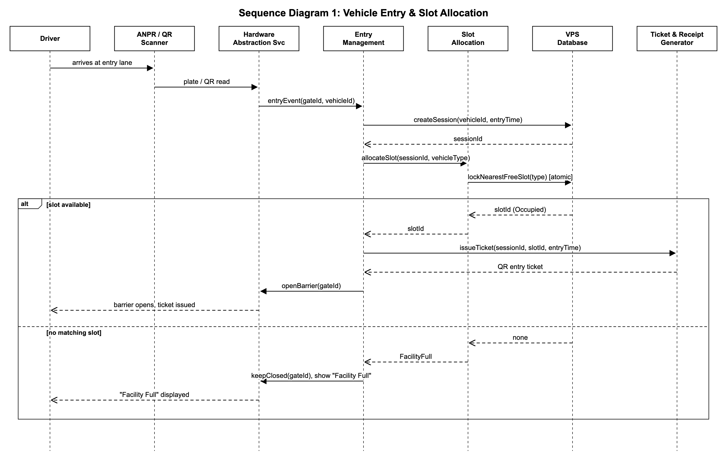

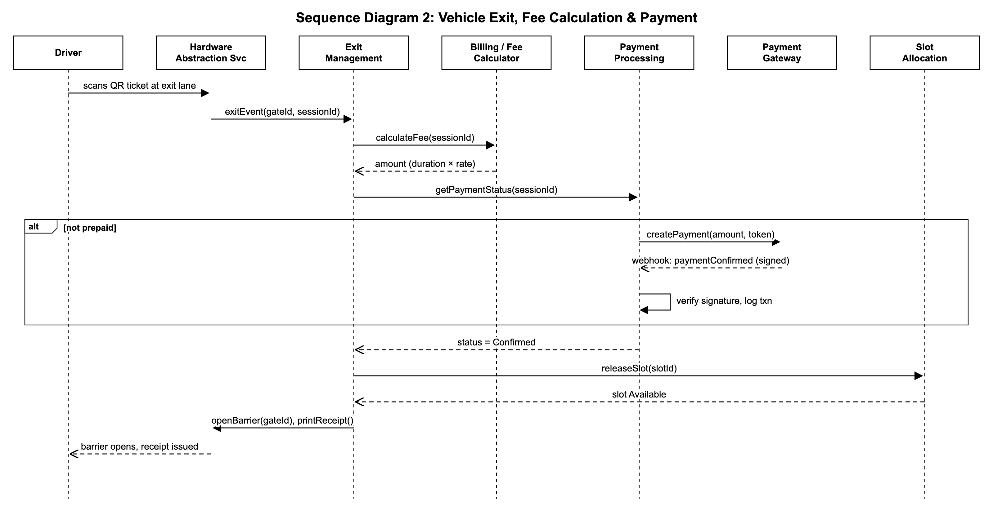

4.3 API Design
Interface definition for Reservation Management, Entry Management, and Exit Management.
Endpoint: /api/reservations
Method: POST
Request: {vehicleId, facilityId, zoneId, startTime, endTime}
Response: {reservationId, slotId, status, holdExpiresAt}
Errors: 401 Unauthorized, 409 Slot unavailable, 422 Outside operating hours.
Endpoint: /api/entry
Method: POST
Request: {gateId, plateNumber | qrCode, vehicleType}
Response: {sessionId, slotNumber, entryTime, ticketQr}
Errors: 400 Invalid ticket, 409 Facility full.
Endpoint: /api/exit
Method: POST
Request: {gateId, sessionId}
Response: {duration, amount, paymentStatus, receiptId}
Errors: 402 Payment pending, 404 Session not found.

4.4 Error Handling, Logging & Monitoring
Standardized error messages. No passwords, tokens, or card data in logs. Monitoring includes entry/exit transaction time, payment failure rate, gate-controller connectivity, and service uptime.

4.5 UX Design
Responsive web UI with high-contrast text, screen-reader-friendly labels, and clear fee breakdown; simplified kiosk-style UI for attendants at entry/exit points.

4.6 Open Issues & Next Steps
Future enhancements: slot-level occupancy sensors, native mobile app, dynamic pricing.

5. Appendices
5.1 Glossary: VPS, ANPR, QR, RFID, JWT, RBAC, TLS, ADR.
5.2 References: IEEE 42010, OWASP, NIST SP 800-160.
5.3 Tools: SVG, Swagger.

